- Open Internet Explorer and type www.aimonline.vic.edu.au into the address field. This is the Central Server site. Click the On Demand link.  - From the On Demand page click the Teachers and Administrators – On Demand Testing Login link.  - Type in your school’s User ID and Password (for the Central Server) that was provided by the VCAA.  - From the Home menu, select Test Bank, then Download Test, then Public.  - Enter details in the Search Criteria window (e.g. Year Level) to narrow down to the type of tests you wish to find, then click [Search].  - From the Search Results list. Select a test by clicking on it to highlight the row then click [View].  - The Test View page provides information and details about the test.  Special Note:  * Linear tests will provide information for all the questions in the test. It is also possible to preview the questions.  ** It is not possible to preview questions of an Adaptive test.  - To preview the questions of a linear test, click [Preview].  - Once you have identified a test that you would like to use at your school, click [Download].  - A message box will appear to advise that the test has been successfully queued for download to your school. Click [OK] to close the message box.  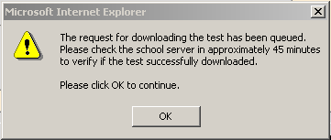 | 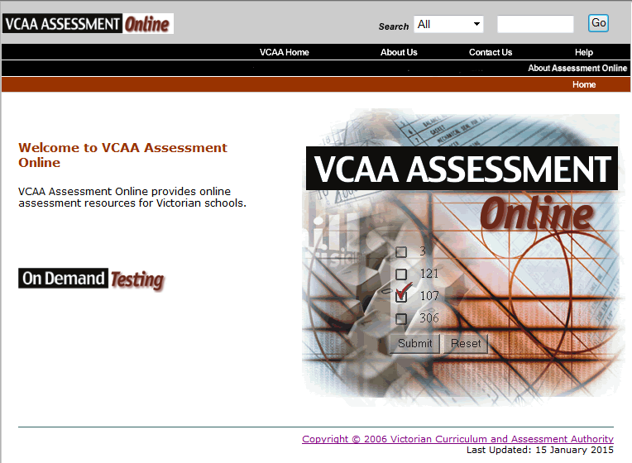  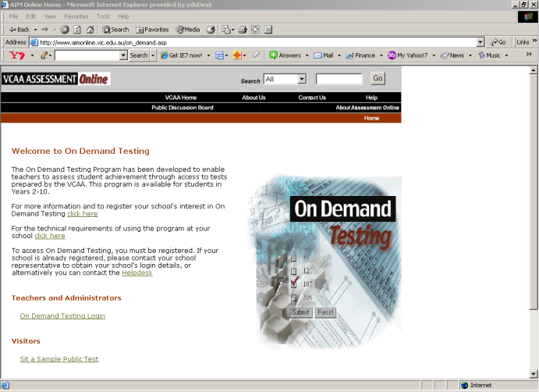  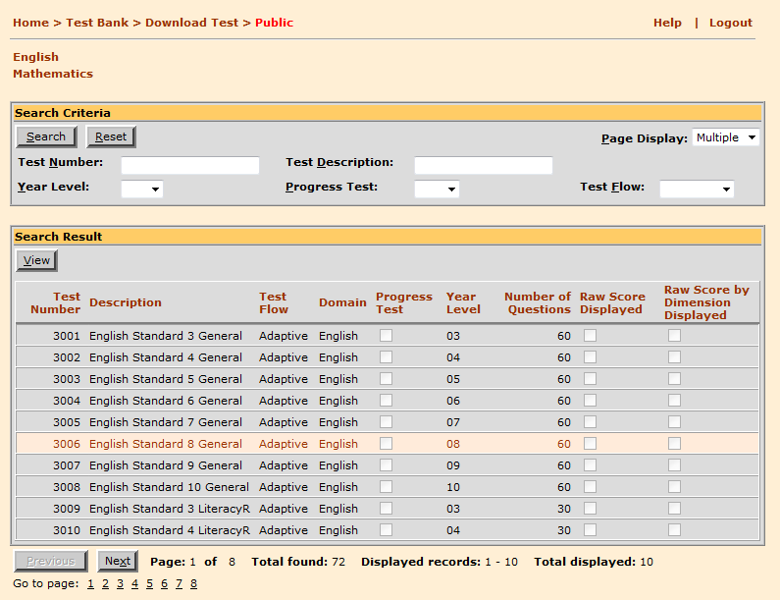  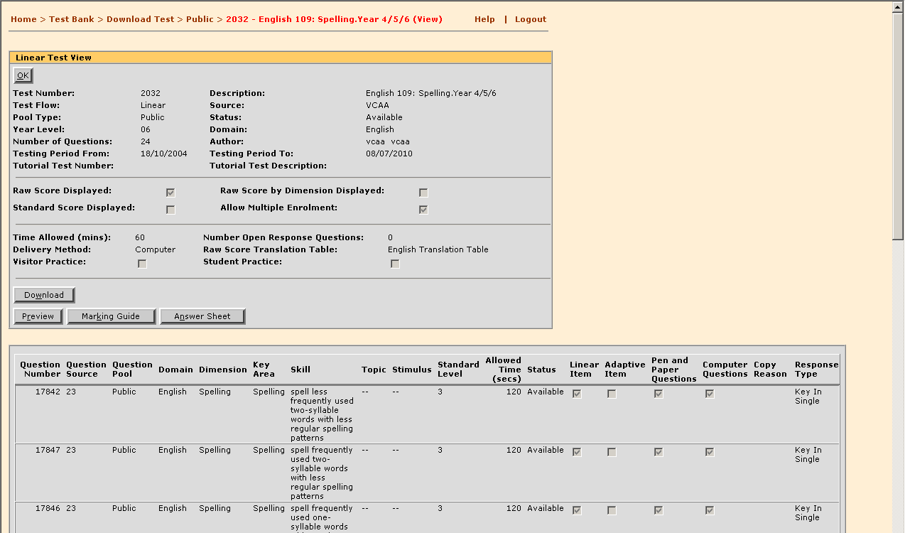  - Click [OK] to return to the Search Criteria screen and search for more tests to download.

