2020 VCE Further Mathematics 1 examination report

General comments

In 2020 the Victorian Curriculum and Assessment Authority produced an examination based on the VCE Mathematics Adjusted Study Design for 2020 only. Students were required to undertake one selected module.

Students generally found questions accessible, with some challenges in relation to the application of key knowledge and key skills, in particular Questions 13, 15, 19, 26 and 30 from the Core.

Specific information

This report provides sample answers or an indication of what answers may have included. Unless otherwise stated, these are not intended to be exemplary or complete responses.

The statistics in this report may be subject to rounding resulting in a total more or less than 100 per cent.

The tables throughout indicate the percentage of students who chose each option. The correct answers are indicated by shading.

Section A – Core

In 2020, the Core section comprised two components: Data analysis (Questions 1–20) and Recursion and financial modelling (Questions 21–30).

|  |  |  |  |  |  |
| --- | --- | --- | --- | --- | --- |
| Question | % A | % B | % C | % D | % E |
| 1 | 1 | 98 | 1 | 0 | 0 |
| 2 | 3 | 6 | 12 | 73 | 7 |
| 3 | 2 | 7 | 59 | 5 | 27 |
| 4 | 7 | 13 | 50 | 24 | 5 |
| 5 | 8 | 4 | 5 | 4 | 78 |
| 6 | 17 | 7 | 1 | 72 | 3 |
| 7 | 69 | 15 | 14 | 1 | 0 |
| 8 | 3 | 6 | 8 | 78 | 4 |
| 9 | 2 | 8 | 9 | 77 | 3 |
| 10 | 57 | 5 | 3 | 24 | 11 |
| 11 | 0 | 1 | 2 | 1 | 95 |
| 12 | 21 | 70 | 4 | 6 | 0 |
| 13 | 11 | 23 | 21 | 10 | 34 |
| 14 | 14 | 6 | 74 | 4 | 2 |
| 15 | 17 | 24 | 9 | 43 | 6 |
| 16 | 5 | 7 | 13 | 67 | 8 |
| 17 | 2 | 88 | 4 | 3 | 3 |
| 18 | 5 | 8 | 73 | 9 | 4 |
| 19 | 45 | 7 | 9 | 32 | 6 |
| 20 | 17 | 12 | 8 | 57 | 6 |
| 21 | 85 | 5 | 2 | 1 | 7 |
| 22 | 35 | 6 | 55 | 1 | 3 |
| 23 | 1 | 5 | 80 | 14 | 1 |
| 24 | 3 | 8 | 5 | 80 | 3 |
| 25 | 8 | 79 | 5 | 3 | 4 |
| 26 | 5 | 18 | 6 | 51 | 20 |
| 27 | 6 | 77 | 6 | 5 | 5 |
| 28 | 13 | 5 | 58 | 9 | 14 |
| 29 | 14 | 54 | 14 | 11 | 7 |
| 30 | 10 | 41 | 18 | 15 | 15 |

Data analysis

Students generally answered the questions in this section very well, particularly questions that required standard, routine calculations or interpretations (Questions 1, 2, 3, 6, 7 and 8). Students did not score as well on questions that required the use or analysis of graphical or tabular information (Questions 4, 15 and 19).

Question 4

There are 252 data values. ; therefore, there are 126 values above the median.



So the position of the third quartile can be found by counting back from the last column  
(6 + 3 + 10 + 10 + 15 + 23 = 67). The 63rd and 64th values both occur between 30 and 30.5.

Question 13

The answer here comes from the definition of the least squares line. Many students appeared not to be sufficiently familiar with this.

Question 15

Correcting rainfall in March for seasonality requires determining the percentage change needed for the index of 0.741 to increase to 1 (an increase of 0.259).

For a seasonal index less than 1 using (1-S.I.)/S.I. x 100%



Question 19

With 12 monthly values, the median number of passengers is midway between the 6th and 7th values when the values are placed in ascending order. These values can be read off the graph as both being just above 460 000. From the options available, the median is therefore 461 000.

Recursion and financial modelling

Students generally scored well in this section, particularly in the understanding and application of recurrence relations.

The most challenging questions involved forming a rule for a compound interest investment (Question 26) or a change in condition part way through the problem (Questions 29 and 30).

Question 26

The growth factor per quarter was .

As interest was compounding quarterly, the number of compounding periods in  years is equal to ****, which is the required power.

Question 29

The value after 3 years is 

Solving  gives 

Question 30

Three steps are required.

Step 1: Use Finance Solver to find the balance (after the one-off payment) that leads to $686 904.09 after 10 years.

N = 120

I% = 2.8

PV = –519 320.2967

PMT = 0

FV = 686 904.09

P/Y = 12

C/Y = 12

Step 2: The balance after the first 10-year period (before the one-off payment) is   
$519 320.30 – $10 000 = $509 320.30

Step 3: Use Finance Solver to find the original investment balance.

N = 120

I% = 3.2

PV = –369 999.99 ≈ 370 000

PMT = 0

FV = 509 320.30

P/Y = 12

C/Y = 12

Section B – Modules

For 2020 only, students were required to complete questions from one module.

Module 1 – Matrices

|  |  |  |  |  |  |
| --- | --- | --- | --- | --- | --- |
| Question | % A | % B | % C | % D | % E |
| 1 | 83 | 10 | 1 | 2 | 4 |
| 2 | 1 | 4 | 7 | 8 | 79 |
| 3 | 19 | 7 | 4 | 64 | 5 |
| 4 | 1 | 2 | 90 | 5 | 2 |
| 5 | 4 | 4 | 3 | 86 | 3 |
| 6 | 7 | 73 | 8 | 7 | 4 |
| 7 | 16 | 38 | 20 | 13 | 12 |
| 8 | 5 | 9 | 14 | 14 | 57 |
| 9 | 5 | 63 | 21 | 6 | 5 |
| 10 | 19 | 12 | 11 | 16 | 41 |

Students did not score as highly on questions involving the use of a matrix recursion relation of the form  (Questions 7 and 10).

Question 7

Students needed to form an initial state matrix 

Friday represented 4 iterations (days) after Monday



Question 10

Since the columns of the transition matrix add to 1, then  and 



Solving gives  and hence .

Using these values and checking all options leaves E as the only correct option.

Module 2 – Networks and decision mathematics

|  |  |  |  |  |  |
| --- | --- | --- | --- | --- | --- |
| Question | % A | % B | % C | % D | % E |
| 1 | 1 | 2 | 5 | 89 | 3 |
| 2 | 1 | 2 | 2 | 93 | 2 |
| 3 | 5 | 81 | 8 | 3 | 3 |
| 4 | 1 | 58 | 39 | 2 | 0 |
| 5 | 13 | 13 | 12 | 56 | 6 |
| 6 | 16 | 6 | 11 | 5 | 61 |
| 7 | 4 | 31 | 32 | 21 | 11 |
| 8 | 3 | 9 | 8 | 5 | 75 |
| 9 | 8 | 18 | 60 | 9 | 4 |
| 10 | 24 | 36 | 12 | 20 | 7 |

Students did not score as highly on questions that included the interpretation of a directed graph (Question 4), the definitions of different types of graphs (Question 7) and modifying the conditions of a project’s critical path (Question 10).

Question 4

It is possible to reach vertices T and V directly and vertex X indirectly (via vertex V).

Many students may have missed vertex X as the third possibility.

Question 7

If the graph is drawn, it is clear that it is connected (there is a path between all vertices), bipartite (vertices can be divided into two groups), planar (it can be drawn without edges crossing if strawberry is moved to the top) and that it forms a tree (no cycles).

Therefore, option E is correct.

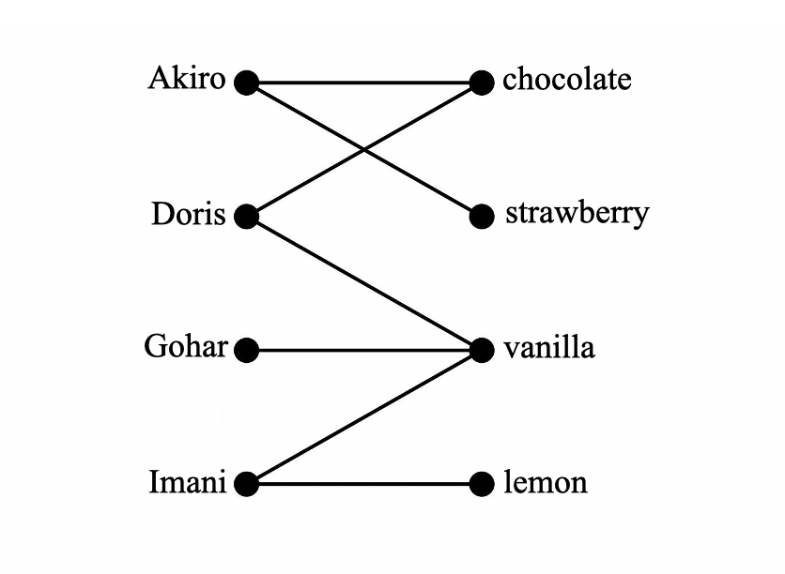

Question 10

The original critical path for this directed network is A-C-E-F-G-I, taking 25 weeks.

If F is completed first, the new critical path will include a dummy from end of F to start of H since H must follow F.

A-C-E-F-dummy-H-I

If F is reduced to 3 weeks, the completion time will then be 24 weeks, which is a reduction of 1 week. Therefore, A is correct.

Module 3 – Geometry and measurement

|  |  |  |  |  |  |
| --- | --- | --- | --- | --- | --- |
| Question | % A | % B | % C | % D | % E |
| 1 | 5 | 21 | 4 | 10 | 59 |
| 2 | 4 | 82 | 6 | 6 | 2 |
| 3 | 2 | 5 | 83 | 7 | 3 |
| 4 | 14 | 74 | 2 | 8 | 1 |
| 5 | 4 | 22 | 5 | 65 | 3 |
| 6 | 3 | 15 | 64 | 8 | 9 |
| 7 | 7 | 8 | 7 | 6 | 70 |
| 8 | 24 | 8 | 57 | 5 | 6 |
| 9 | 14 | 9 | 29 | 11 | 36 |
| 10 | 5 | 9 | 45 | 32 | 9 |

Students did not score as highly on questions that included the use of a scale factor (Question 9) and applications involving bearings (Question 10).

Question 9

The scale factor of 1.25 for length is equivalent to as a fraction or  as a ratio.

The area ratio for men to women is therefore 

The area ratio for women to men is 

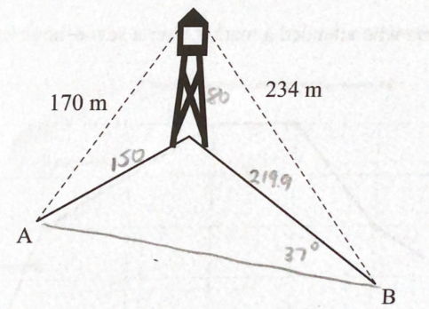Question 10

Students needed to firstly use Pythagoras’ theorem to determine the distances from the base of the tower to Landmark A and Landmark B.

Respectively these distances are  and 

Angle B in the triangle shown is 

Angle A can be found using the sine rule . This solves to give 

The third angle in the triangle is 

Using the cosine rule, distance AB is 

Module 4 – Graphs and relations

|  |  |  |  |  |  |
| --- | --- | --- | --- | --- | --- |
| Question | % A | % B | % C | % D | % E |
| 1 | 8 | 3 | 87 | 2 | 0 |
| 2 | 1 | 2 | 1 | 95 | 2 |
| 3 | 0 | 4 | 3 | 3 | 91 |
| 4 | 15 | 65 | 11 | 5 | 3 |
| 5 | 23 | 55 | 5 | 9 | 7 |
| 6 | 74 | 9 | 12 | 2 | 3 |
| 7 | 4 | 30 | 38 | 5 | 23 |
| 8 | 43 | 22 | 23 | 4 | 7 |
| 9 | 3 | 12 | 72 | 10 | 2 |
| 10 | 20 | 13 | 11 | 24 | 31 |

Students did not score as highly on questions that required a higher level of analysis of the graphs and relations presented (Questions 7, 8 and 10).

Question 7

The charge for the energy used is 

Total number of megajoules used in June is 

The average number of megajoules used per day is 

Question 8

Consider firstly a ratio of 2 units of meat to 5 units of dry food.

 and ‘no more than’ is represented by 

An inequality could be 

Therefore, , which is equivalent to 

Question 10

The gradient of the line including points B and C is 

The objective function has gradient of 

The maximum will occur at C only if the objective function has the steeper of the two gradients.

Solving  gives 