2021 VCE Further Mathematics 1 external assessment report

General comments

Students generally found questions accessible in the Further Mathematics 1 examination in 2021. They found some questions involving the application of the key skills and key knowledge from the study design challenging, such as Questions 12, 23 and 24 from the Core section; Question 8 from Module 1, Matrices; Questions 3, 5 and 7 from Module 2, Networks and decision mathematics; Questions 3, 7 and 8 from Module 3, Geometry and measurement; and Questions 7 and 8 from Module 4, Graphs and relations.

Specific information

The tables below indicate the percentage of students who chose each option.

The statistics in this report may be subject to rounding resulting in a total more or less than 100 per cent.

Section A – Core

In 2021, the Core section comprised two components: Data analysis (Questions 1–16) and Recursion and financial modelling (Questions 17–24).

|  |  |  |  |  |  |  |
| --- | --- | --- | --- | --- | --- | --- |
| Question | Correct answer | % A | % B | % C | % D | %E |
| 1 | A | 70 | 3 | 21 | 4 | 2 |
| 2 | D | 1 | 5 | 2 | 82 | 10 |
| 3 | A | 50 | 13 | 28 | 1 | 8 |
| 4 | B | 4 | 60 | 10 | 11 | 15 |
| 5 | E | 20 | 4 | 5 | 8 | 63 |
| 6 | C | 28 | 13 | 51 | 3 | 4 |
| 7 | D | 2 | 32 | 9 | 54 | 3 |
| 8 | C | 3 | 12 | 67 | 3 | 15 |
| 9 | C | 8 | 10 | 71 | 7 | 4 |
| 10 | B | 7 | 71 | 13 | 5 | 4 |
| 11 | D | 14 | 29 | 11 | 40 | 5 |
| 12 | D | 4 | 8 | 13 | 34 | 41 |
| 13 | C | 4 | 8 | 53 | 24 | 11 |
| 14 | B | 8 | 48 | 15 | 25 | 3 |
| 15 | C | 10 | 8 | 59 | 15 | 6 |
| 16 | E | 7 | 4 | 29 | 7 | 52 |
| 17 | A | 83 | 5 | 4 | 6 | 2 |
| 18 | C | 1 | 3 | 93 | 3 | 1 |
| 19 | B | 24 | 44 | 10 | 15 | 6 |
| 20 | C | 3 | 40 | 44 | 9 | 4 |
| 21 | D | 22 | 12 | 13 | 40 | 12 |
| 22 | B | 5 | 56 | 10 | 23 | 5 |
| 23 | A | 31 | 15 | 11 | 33 | 9 |
| 24 | B | 9 | 33 | 25 | 15 | 16 |

Data analysis

Students generally answered the questions in the Data analysis section very well, particularly questions that required definitions or standard, routine calculations (Questions 1, 2, 9 and 10). Students did not answer well questions that required the use or analysis of graphical or tabular information (Questions 3, 11 and 14).

Question 3

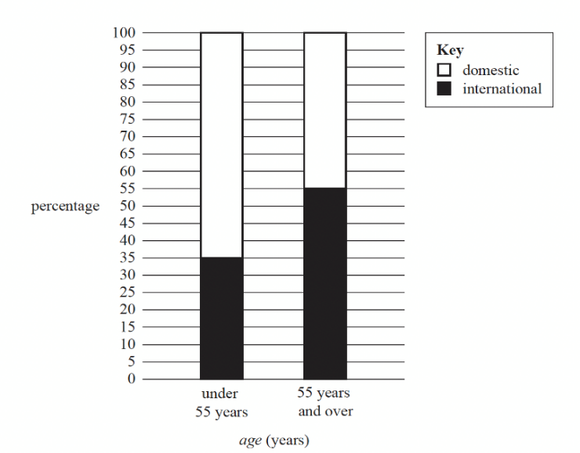

From the segmented bar chart:

under 55 years:

35% international

65% domestic

55 years and over:

55% international

45% domestic

The results could also be summarised in a two-way frequency table.

|  |  |  |
| --- | --- | --- |
| Preferred travel destination | Under 55 years | 55 years and over |
| domestic | 91 $÷$ 140 = 65% | 90 $÷$ 200 = 45% |
| international | 49 $÷$ 140 = 35% | 110 $÷$ 200 = 55% |
| total | 140 $÷$ 140 = 100% | 200 $÷$ 200 = 100% |

Question 11

Inspection of the scatter plot with the regression line shows that the predicted values (represented by the regression line) are above the actual values six times.

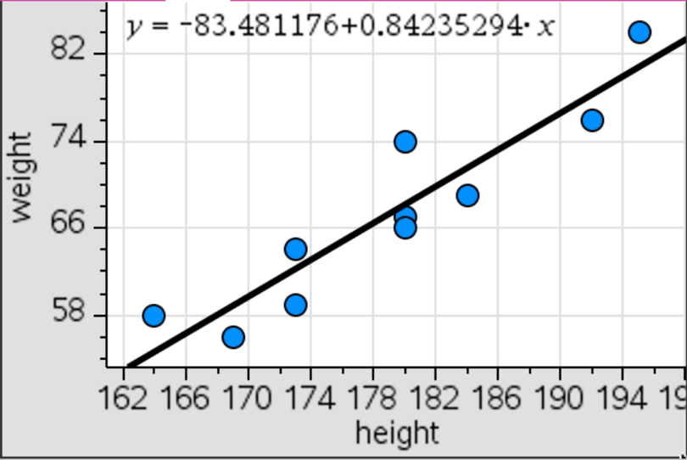

Question 12

The times series plot shows a decreasing trend with irregular fluctuations. To indicate the presence of seasonality we would expect to see regular fluctuations in the plot as well.

Question 14

|  |  |  |  |  |  |  |  |
| --- | --- | --- | --- | --- | --- | --- | --- |
| Day | Monday | Tuesday | Wednesday | Thursday | Friday | Saturday | Sunday |
| Quantity (m3) | 234 | 186 | a | b | c | 346 | 346 |

The five-mean smoothed quantity of garden soil sold on Thursday is 206 m3.

, giving *.*

The three-mean smoothed quantity of garden soil sold on Thursday, in cubic metres, is 498 ÷ 3 = 166.

Recursion and financial modelling

Students did not answer well the questions involving the use of the finance solver or questions involving a change in condition part way through the problem (Questions 19, 20, 21, 23 and 24).

Question 19

Two steps are required.

Step 1: Determine the annual interest rate using the amortisation table.



Step 2: Use Finance Solver to find the number of payments.

N = 15.0000

I% = 4

PV = –500 000

PMT = 44970.55

FV = 0

P/Y = 1

C/Y = 1

Question 20

First year: 720 000 × 10% = 72 000

Second year: (720 000 $-$ 72 000) × 10% = 64 800

Third year: (648 000 $-$ 64 800) × 10% = 58 320

Question 21

Two steps are required.

Step 1: Determine the annual interest rate.

Use Finance Solver

N = 4 $×12$

I%= 5.4499976569879

PV = –3000

PMT = 0

FV = 3728.20

P/Y = 12

C/Y = 12

Step 2: Determine the effective annual interest rate using the formula $r_{effective}={\left(1+\frac{r}{n}\right)}^{n}-1$

**

Question 23

Two steps are required.

Step 1: Determine the annual interest rate.

Use Finance Solver

N = 20 × 12

I% = 3.599

PV = 450 000

PMT = –2633

FV = 0

P/Y = 12

C/Y = 12

Step 2: Calculate R



Question 24

Two steps are required.

Step 1: Determine the scheduled monthly repayment.

Use Finance Solver

N = 20 × 12

I% = 3.14

PV = 400 000

PMT = –2246.5283

FV = 0

P/Y = 12

C/Y = 12

Step 2: Determine the new interest rate.

Use Finance Solver

N = 18 × 12

I% = 2.2116

PV = 400 000

PMT = –2246.53

FV = 0

P/Y = 12

C/Y = 12

Section B – Modules

Module 1 – Matrices

|  |  |  |  |  |  |  |
| --- | --- | --- | --- | --- | --- | --- |
| Question | Correct answer | % A | % B | % C | % D | %E |
| 1 | D | 2 | 10 | 2 | 82 | 4 |
| 2 | D | 2 | 7 | 5 | 73 | 13 |
| 3 | A | 56 | 13 | 16 | 5 | 7 |
| 4 | E | 4 | 8 | 8 | 7 | 73 |
| 5 | E | 9 | 15 | 13 | 17 | 45 |
| 6 | B | 17 | 66 | 7 | 5 | 4 |
| 7 | A | 40 | 12 | 27 | 14 | 6 |
| 8 | D | 13 | 17 | 27 | 29 | 11 |

Students did not answer well questions involving the use of a matrix recurrence relation (Questions 7 and 8).

Question 5

BT is the transpose of matrix B. BT is a 7 × 10 matrix, therefore A(BT) is defined.

Question 7

Two steps are required.

Step 1: Determine matrix C using 

Matrix



Step 2: Determine matrix S2.

Matrix 

Question 8

Two steps are required.

Step 1: Determine the state matrix for Tuesday.



Step 2: Determine the percentage not expected to change.



Module 2 – Networks and decision mathematics

|  |  |  |  |  |  |  |
| --- | --- | --- | --- | --- | --- | --- |
| Question | Correct answer | % A | % B | % C | % D | %E |
| 1 | E | 1 | 1 | 1 | 5 | 91 |
| 2 | C | 1 | 2 | 95 | 1 | 1 |
| 3 | C | 1 | 2 | 34 | 61 | 1 |
| 4 | A | 62 | 8 | 3 | 7 | 20 |
| 5 | D | 8 | 31 | 42 | 17 | 1 |
| 6 | B | 7 | 46 | 6 | 8 | 31 |
| 7 | C | 9 | 10 | 33 | 23 | 24 |
| 8 | B | 16 | 48 | 13 | 16 | 6 |

Students did not answer well the questions that included the definitions of different types of graphs (Question 3, 5 and 7) and questions finding unknown edge weights (Questions 6 and 8).

Question 3

When the graph is redrawn as planar there are only four faces. It would appear that many students did not redraw the graph in its planar form before counting the faces.

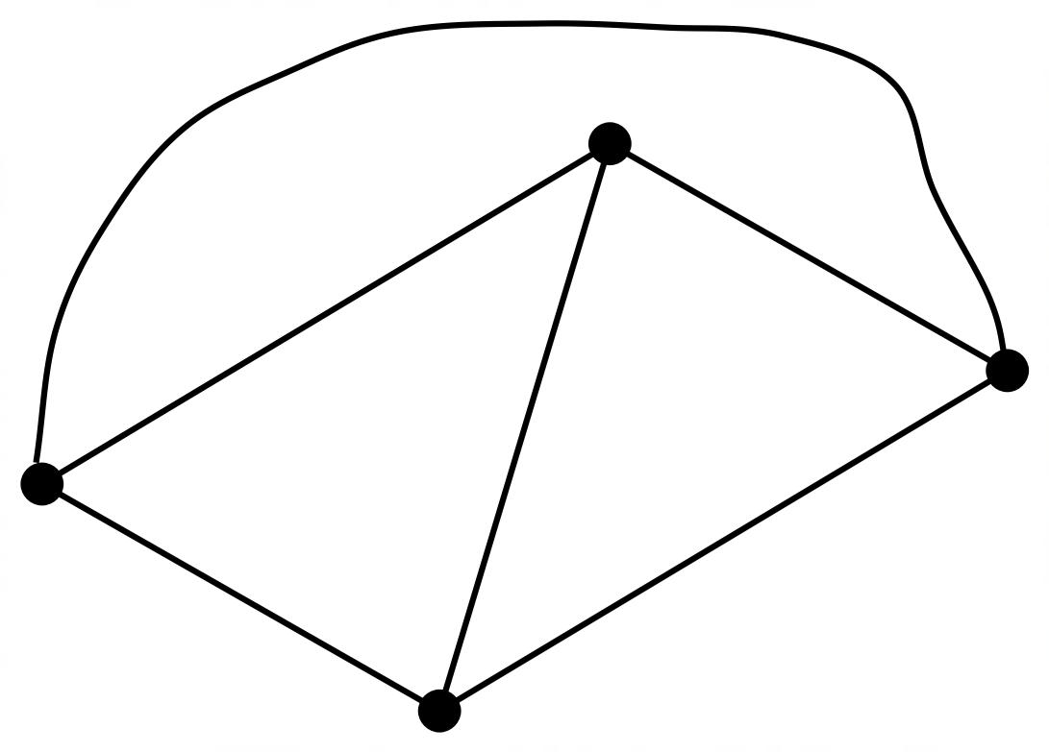

Question 5

Consider labelling the vertices of the given graph.

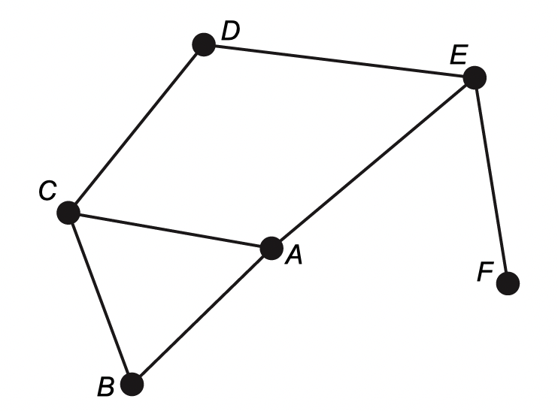

The graph shown is planar.

It contains a cycle (one example is ABC).

It contains a bridge (EF).

It also contains a Hamiltonian path (one example is ABCDEF) but no Eulerian trail.

Therefore, the correct answer is D, four statements are correct.

Question 6

Two possible critical paths that include activity E need to be considered.

BEJ: if the minimum completion time is 18, the maximum value of x is 6.

CGFEJ: if the minimum completion time is 18, the maximum value of x is 3.

Question 7

A zero in an adjacency matrix designates no direct connection. By inspection of the network:

* J does not connect directly to M or itself
* K does not connect directly to N
* L does not connect directly to itself
* M does not connect directly to J, N or itself
* N does not connect directly to K, M or itself

Therefore, the adjacency matrix would contain 10 zeros.

Question 8

If x = 50 and y = 55, the minimum total length of road would be 356 km.

If x = 50 and y = 60, the minimum total length of road would be 361 km.

If x = 55 and y = 55, the minimum total length of road would be 358 km.

If x = 55 and y = 60, the minimum total length of road would be 363 km.

If x = 55 and y = 65, the minimum total length of road would be 363 km.

Module 3 – Geometry and measurement

|  |  |  |  |  |  |  |
| --- | --- | --- | --- | --- | --- | --- |
| Question | Correct answer | % A | % B | % C | % D | %E |
| 1 | D | 7 | 8 | 11 | 65 | 9 |
| 2 | C | 3 | 5 | 86 | 4 | 1 |
| 3 | D | 3 | 4 | 7 | 38 | 46 |
| 4 | C | 8 | 9 | 68 | 8 | 7 |
| 5 | A | 46 | 15 | 12 | 13 | 11 |
| 6 | B | 10 | 45 | 25 | 15 | 4 |
| 7 | D | 13 | 27 | 13 | 32 | 14 |
| 8 | B | 10 | 30 | 18 | 27 | 12 |

Questions involving elementary application of the key skills from this module were answered correctly by the majority of students. Students did not answer well the questions that included the use of a scale factor (Question 3) and the application involving bearings without a supporting diagram (Question 10).

Question 3

If the area scale factor is 9, then the linear scale factor is .

The original length = 12, therefore, the enlarged length = 12 × 3 = 36.

Question 5

The volume of a cylinder is three times the volume of a cone with the same radius.

 and 





The height of the cylinder = 4 cm.

Question 6

The area shaded equals the area of the rectangle (6 × 21) minus the area of circles 

Question 7

Angle bº lies on the straight line with angle 



Question 8

A diagram may be useful to solve this question.

Use the cosine rule to obtain SL − either 495 m (or 2136 m).

Use the cosine rule to obtain CL − 1212 m.

Lucia walked a total of 1400 + 950 + 495 = 2845 m

Rod walked a total of 1400 + 1212 + 700 = 3312 m

Therefore, Rod walks 467 m further than Lucia.

20º

950 m

1400 m

*P*

30º

700 m

*L*

*S*

*C*

495 m

1212 m

Module 4 – Graphs and relations

|  |  |  |  |  |  |  |
| --- | --- | --- | --- | --- | --- | --- |
| Question | Correct answer | % A | % B | % C | % D | %E |
| 1 | B | 2 | 92 | 3 | 1 | 1 |
| 2 | A | 57 | 6 | 8 | 19 | 8 |
| 3 | D | 7 | 8 | 14 | 62 | 6 |
| 4 | C | 3 | 6 | 44 | 31 | 15 |
| 5 | E | 4 | 8 | 12 | 16 | 58 |
| 6 | D | 7 | 16 | 27 | 42 | 6 |
| 7 | B | 19 | 39 | 19 | 11 | 11 |
| 8 | E | 10 | 21 | 16 | 22 | 29 |

Students did not answer well the questions on linear programming questions (Questions 7 and 8).

Question 4

Lani should park in Eastpark on Wednesday: fee = $14.

Lani should park in Northpark on Thursday: fee = $2.30 × 4 = $9.20.

Total fees = $23.20.

Question 6

The gradient of the straight line is .

Substituting this into the linear relation rule: .

Question 7

An objective function with a gradient between  and  will have its maximum at point K.

 has a gradient of .

Question 8

The gradient of the line including point (20, 40) is .

The objective function has gradient of .

Given that a = 15, b = 30.

Maximum profit = .