2021 VCE Specialist Mathematics 1 (NHT) examination report

Specific information

This report provides sample answers or an indication of what answers may have included. Unless otherwise stated, these are not intended to be exemplary or complete responses.

Question 1a.





, $n∈Z$

Question 1b.

 therefore, there are no points of inflection

Question 2a.

A diagram is useful but not required.

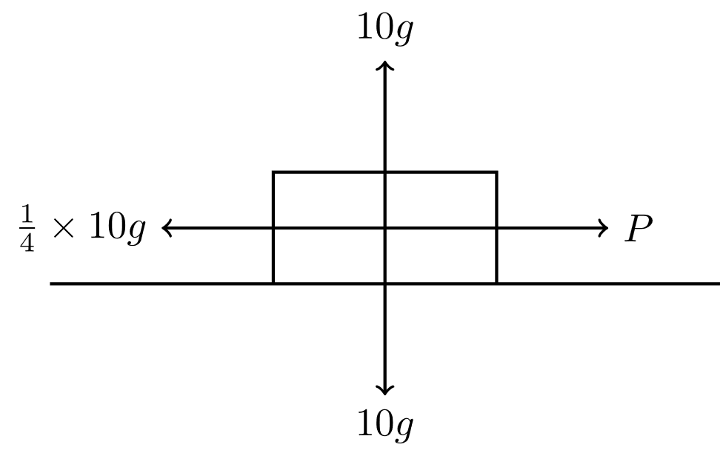



Question 2b.

A diagram is useful but not required.

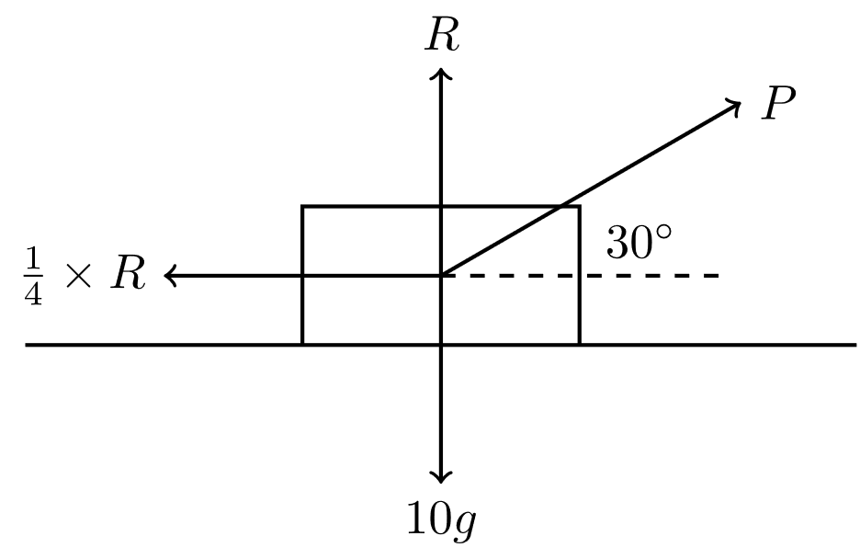



Therefore



Question 3a.



Question 3b.



Question 4a.



Question 4b.



Question 4c.



Question 5a.



When ,  and so . Therefore



Question 5b.



Question 6

Differentiate implicitly to obtain



The gradient of the line  is . When , , :



The curve passes through :



, 

Question 7

Use either  or  to obtain



When $x=0$, $v=4$. Therefore $c=8$ and $v^{2}=10x+6x^{2}+16$

When $x=2$, $v^{2}=20+24+16=60$ and since $v>0$, $v=\sqrt{60}=2\sqrt{15}$

Question 8



Use partial fractions to obtain



Question 9a.



Question 9b.



Question 9c.

Note that



The length of the curve is



Question 10

Squaring both sides gives:



Therefore



and so $a=0$ or $a=3$.

Since $a=0$ does not satisfy the original equation, $a=3$.