2021 VCE Specialist Mathematics 2 (NHT) examination report

Specific information

This report provides sample answers or an indication of what answers may have included. Unless otherwise stated, these are not intended to be exemplary or complete responses.

Section A – Multiple-choice questions

| **Question** | **Answer** |
| --- | --- |
| 1 | A |
| 2 | C |
| 3 | C |
| 4 | D |
| 5 | C |
| 6 | B |
| 7 | A |
| 8 | E |
| 9 | A |
| 10 | D |
| 11 | B |
| 12 | E |
| 13 | D |
| 14 | B |
| 15 | E |
| 16 | D |
| 17 | C |
| 18 | E |
| 19 | C |
| 20 | B |

Section B

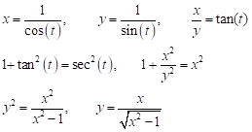Question 1a.

Appropriate working required to verify the given result.

There are a variety of suitable approaches.

Question 1b.

$$x∈\left(1,∞\right), y∈\left(1,∞\right)$$

Question 1c.

$$\frac{dy}{dx}=\frac{-1}{{\left(x^{2}-1\right)}^{3/2}}\text{ is }\frac{\text{negative}}{\text{positive}}$$

Gradient is always negative.

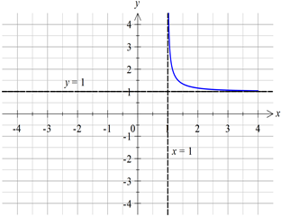Question 1d.

Question 1ei.

Question 1e.ii.



Question 2ai.

Question 2bi.

Question 2bii.

Question 2c.

Students were required to show convincing working that led to the following result.

Question 2d.

Question 3ai.

Question 3aii.

Students were required to show convincing working that led to this result.

Question 3aiii.

Inflection points are:

**Question 3bi.

Question 3bii.

For both points, which does not depend on *k*.

Question 4a.

Students were required to show convincing working that led to this result.

Question 4b.

Question 4c.

Question 4d.

Question 4e.

Question 4f.

Question 5a.

Alternatively, a calculus approach would be suitable.

Question 5b.



Question 5c.

Question 5d.

Question 5e.

Question 6a.



Question 6b.

Question 6c.

Question 6d.

Question 6e.

So, there is strong evidence to support the agent’s belief.