2020 VCE Product Design and Technology examination report

General comments
In 2020 the Victorian Curriculum and Assessment Authority produced an examination based on the VCE Product Design and Technology Adjusted Study Design for 2020 only. Students who scored highly had a strong grasp of the terminology, could interpret the context of questions and were able to respond to the design brief creatively. Most students made good use of the photographs and information given in the exam in their responses to questions in Section A. However, many students did not score highly on questions where they were not clear on the terminology. This includes stages and steps of the product design process and the product design factors and their parameters.
In 2020, many students rewrote questions in their responses, which was not required and often took up half of the allocated space.
Students are reminded that for the design brief question, information needs to come directly from the scenario provided in the insert. Students need to bring suitable colouring media into the exam to complete the design drawing in Section B.
Teachers and students are reminded to refer to the current VCE Product Design and Technology Study Design 2018–2023 as the reference for all terminology.
Areas of strength were:
- using the information provided when analysing products
- understanding the needs of two- to five-year-olds with knowledge of suitable materials/designs
- clarity shown in visualisations and the design option drawings
- knowledge of anthropometric data and its uses
- instructions for safe use, maintenance and/or care for the designed product.
Areas for improvement were:
- clarity about the different types of research, their purpose and how they are conducted
- knowledge of benefits of mass production
- knowledge of product design factors and their associated parameters, both in relation to product analysis and in constructing a design brief
- writing the context, end-user and requirements for a design brief drawn from the given scenario
- drawing and creating viable, creative designs in response to the brief
- describing characteristics and/or properties of materials
- understanding the difference between materials and products
- recognising ‘feature’ as something specific about a product.

Specific information
Student responses reproduced in this report have not been corrected for grammar or spelling.
This report provides sample answers or an indication of what answers may have included. Unless otherwise stated, these are not intended to be exemplary or complete responses.
The statistics in this report may be subject to rounding resulting in a total more or less than 100 per cent.

Section A

Question 1
Marks | 0 | 1 | 2 | 3 | Average
% | 16 | 17 | 27 | 40 | 1.9
Many students were unable to name the steps correctly as they appear on page 10 of the study design, which was required to gain full marks. The number of the step was not required, yet a handful of students wrote the number only and therefore could not receive any marks.

Question 2a.
Marks | 0 | 1 | Average
% | 3 | 97 | 1.0
Most students were able to name a typical end-user such as babies, toddlers, carers, parents or kindergartens.

Question 2b.
Marks | 0 | 1 | 2 | Average
% | 7 | 26 | 67 | 1.6
Most students were able to explain why the material selection was important for the Gyro Buddy Bowl by mentioning it needed to be food-safe, non-toxic for chewing, soft for possible knocks and tough for resisting dropping.
However, many students took almost two lines to rewrite the question as part of their answer, when it would have been sufficient to start with ‘This is important because …’
The following is an example of a high-scoring response.
Material selection is important for the primary function of the buddy bowl as the materials must be safe if congested by the toddler and will be durable during rough play.

Question 2c.
Marks | 0 | 1 | Average
% | 19 | 81 | 0.8
Some students were unclear about the meaning of ‘outline the context’ and interpreted it as asking for a purpose or reason why the bowl would be used. Responses such as ‘for eating/feeding’ or ‘when having a meal’ could not be awarded a mark.
Many students gave the example of toddlers eating in the car, which could be seen in the image provided and was a suitable response. Many mentioned carers/mothers being busy and not having to worry about washing the bowl by hand, which was also accepted. Others outlined a situation in which it would save on spills.
The following is an example of a high-scoring response.
The Gyro Buddy Bowl could be used when feeding babies and toddlers at home so that a spillage isn't caused, designed to stay upright.

Question 2d.
Marks | 0 | 1 | 2 | Average
% | 13 | 33 | 53 | 1.4
Many students were able to choose relevant factors that were important to the secondary function of the Gyro Buddy Bowl. However, many did not write the full name of the factor, which was required for one of the two possible marks. If a good description of its importance was given, students were able to earn one mark.
The following are examples of high-scoring responses.
One product design factor is Materials used. If the material is not flexible enough it cannot move and form into different pieces.
Innovation and creativity is crucial to the secondary functions as the element giving this bowl its market edge is that it is unique and not just a traditional bowl.
User centred design as the easy grip handles, suitable for many sizes, assist with the child not dropping the bowl.

Question 2e.
Marks | 0 | 1 | 2 | 3 | Average
% | 15 | 27 | 33 | 25 | 1.7
Many students did not state a stage from the product design process but instead identified a step or referred to a manufacturing stage. Many students mentioned an area of risk but did not describe it as instructed by the question.
Many students identified a risk for manufacturing but described a risk inherent in using the product. Most students chose to describe a risk with use of the bowl, such as the potential risk of fingers being jammed between bowl and handles.
Overall, many students were not clear on what a risk is and were unable to describe it clearly.
The following is an example of a high-scoring response.
Planning and production is a stage where risks must be assessed. One possible risk during this stage for the Gyro Buddy Bowl would be dealing with the plastic, as cutting and melting plastic can have major effects on an individual's breathing.

Question 2f.
Marks | 0 | 1 | 2 | Average
% | 23 | 31 | 46 | 1.2
Students generally scored highly when outlining an approach to manage the risk identified in Question 2e. Many students offered an instruction to the user of the bowl, which could not receive full marks.
The following are examples of high-scoring responses.
One approach in managing the risk is to research different materials that are safe for kids to use such as non-toxic plastic. Also researching materials that would not break from impact.
An approach to managing the risk above is to ensure that all workers wear correct PPE to protect themselves as well as having signage to remind individuals of the precautions to take before using a machine, such as securing the material.
To manage the risk of injury the products design must be approached with the end-users in mind, designing the product to be free of sharp edges and corners.

Question 3a.
Marks | 0 | 1 | 2 | Average
% | 2 | 3 | 95 | 1.9
Most students were able to explain how a feature would be appealing. However, some students only listed a feature without any explanation. Many responses were possible here as long as they related to the information provided in the examination about the Gyro Buddy Bowl.

Question 3b.
Marks | 0 | 1 | 2 | Average
% | 28 | 26 | 46 | 1.2
To gain full marks, students’ responses needed to demonstrate an understanding of qualitative research, the information it seeks and how it could be conducted. This could include user trials, interviews or focus groups with open-ended questions or with the reviewer making observations.
The following is an example of a high-scoring response.
Qualitative research could be conducted through interviews, surveys and other forms of open-ended responses to gather information on the Gyro Buddy Bowl and how it compares to its competitors.

Question 3ci.
Marks | 0 | 1 | 2 | Average
% | 43 | 31 | 26 | 0.8
To score two marks, students needed to describe any market research method that gathers quantitative data (that is, that allows for responses to be compiled numerically). Many confused the context of the quantitative data with product specifications, which is often published for consumers in a numerical form but does not constitute market research for feedback. Many students wrote about anthropometric data, which is not a method of market research. Others suggested asking users about the number of spills or daily uses, which were not suitable questions for feedback on the bowl.
The following is an example of a high-scoring response.
One method of market research could be a survey asking each person to rank the effectiveness of innovation and creativity, user-centered design and materials from 1 to 10.

Question 3cii.
Marks | 0 | 1 | 2 | 3 | Average
% | 34 | 32 | 25 | 10 | 1.1
To gain full marks, students’ responses needed to demonstrate an understanding of quantitative data gained from market research – namely that it is numerical and useful for collecting a large amount of responses that are easily interpreted – and how this information could be used.
Most students understood how this data could be used for feedback on the design or marketing of the bowl.
The following is an example of a high-scoring response.
Quantitative data is numerical information generally sourced from a wide range of people. It is needed for comparison and modification of products and it could be used to identify whether users are satisfied with the specifications of the Gyro Buddy Bowl.

Question 4
Marks | 0 | 1 | 2 | 3 | 4 | 5 | 6 | Average
% | 7 | 1 | 4 | 29 | 19 | 19 | 20 | 3.9
Examples of suitable responses:
Feature | Possible related parameters
Open virtually anything in the kitchen | - Social and physical needs  - Accessibility  - Secondary functions  - Improves quality of life
Has six different built-in cutting, gripping, twisting tools | - Secondary functions  - Operation  - Performance  - Innovative  - Improves quality of life
Can open any jar, tin, etc. | - Innovative  - Improves quality of life
No sharp blades | - Safety  - Improves quality of life
Smooth turning handle | - Ergonomics  - Operation  - Comfort  - Improves quality of life
Ergonomically designed handle | - Ergonomics or anthropometric data  - Comfort  - Improves quality of life
Does not leave sharp edges | - Safety  - Improves quality of life
Holds onto the lid | - Secondary function  - Innovation  - Improves quality of life
Safe, comfortable and easy to use | - Comfort  - Safety  - Improves quality of life
While most students could easily identify a product feature from the photograph and information provided on the Multi-function Kitchen Tool, fewer were able to identify and link a parameter to the feature. A parameter in response to this question must be written as it appears in the right-hand column on page 11 of the study design. Many students named a product design factor instead of a parameter, which could not be awarded marks.

Question 5a.
Marks | 0 | 1 | Average
% | 48 | 52 | 0.5
Acceptable responses outlined a method of market research. However, many students did not read the question carefully and described an end-user rather than a way to identify them.
The following are examples of high-scoring responses.
Surveys out the front of shops asking have you ever had difficulties opening jars.
By looking at statistics of people who purchase canned products and products with bottle tops.

Question 5b.
Marks | 0 | 1 | 2 | 3 | Average
% | 20 | 21 | 36 | 23 | 1.6
High-scoring responses for this question mentioned various features of the Multi-function Kitchen Tool, such as the handles, shape of the grip area, location of trigger/button/safety-catch and overall size for leverage, that would be designed with reference to anthropometric data and that it was important for comfort and ease of use for a wide range of end-users.
Common misunderstandings were that the data would be used to create different sizes, which is unlikely for this product. A lot of students also repeated the information given in the question as their response, which could not be awarded any marks.
The following is an example of a high-scoring response.
Anthropometric data on hand size could give the designers insight into the diameter of the handle in order to make it comfortable to hold. As well as determining where they placed buttons for easy reaching.

Question 6
Marks | 0 | 1 | 2 | Average
% | 3 | 7 | 90 | 1.9
Examples of expectations are that it will be comfortable to use, will open all sizes of kitchen products, will suit those with arthritic hands, will not leave sharp edges, is safe for children as it has no sharp blades, etc.
Most students were able to list two expectations for end-users of the Multi-function Kitchen Tool and many correctly drew from the information provided in the examination.

Question 7
Marks | 0 | 1 | 2 | 3 | 4 | Average
% | 22 | 8 | 29 | 8 | 33 | 2.2
This question required a new technology as listed on page 23 of the study design. Computer-aided design (CAD) and Rapid 3D prototyping were the most common acceptable responses, as long as the explanation related to the design and development stage. Laser and computer numerical control (CNC) were acceptable if the student explained their use during the design and development stage. However, many chose computer-aided manufacture (CAM), a technology that is only used in manufacturing, and therefore could not be awarded any marks. It appears many students did not read the information explaining the context of the question and named any technologies with an explanation of what they were, rather than how they could help develop a different feature. To gain full marks students needed to relate the description to developing a different product feature or to developing the final design of the tool.
The following are examples of high-scoring responses.
CAD programs such as Fusion 360 may have been used to design 3D models with the 8 functions to see visually how they looked together.
Rapid 3D prototyping to build two scale models to assess whether the handle is comfortable.
Rapid 3D prototyping. Used in conjunction with CAD computer aided design to create prototypes of many components of the tool to ensure they work as intended before adding to the final design.
CAD computer aided design. Used to create a 3D virtual representation of the product to correct and modify components, such as the overall streamlined shape to ensure it is correct size to suit anthropometric data collected.

Question 8
Marks | 0 | 1 | 2 | 3 | Average
% | 74 | 2 | 8 | 16 | 0.7
Students needed to identify one of the four sustainability strategies from page 23 of the study design: Life Cycle Assessment (Analysis), Cradle to Cradle, Design for Disassembly or Extended Producer Responsibility.
Many students identified lean manufacturing as a strategy to make the product more sustainable, but this is not always the case.
Many students did not identify that the question was asking for a sustainability strategy and wrote various methods to make a product more sustainable, which could not score any marks.
The following are examples of high-scoring responses.
Life cycle analysis. The designer could have thought of its life cycle from its raw materials to its end-of-life. Making sure in every stage that it is sustainable as the strategy focuses on every aspect, such as the manufacturing, distribution and disposal, i.e. reuse or recycling of the product.
Extended producer responsibility (EPR) may be implemented as this would see a program setup where consumers take the product to a specific drop off site at the end of its life so that the producer can recycle the product correctly. This would influence the design as then sustainable recyclable materials would be used so that they can be reused. This would impact production as it would result in more sustainable environmentally conscious products being used and therefore polluting the environment less.

Question 9
Marks | 0 | 1 | 2 | 3 | Average
% | 9 | 16 | 37 | 38 | 2.0
Acceptable responses included:
- economies of scale
- speed of production
- consistency of product
- eliminates errors
- creates profits and employment
- eliminates danger for workers if robotics are used.
This response needed to outline three benefits for mass production in relation to the Multi-function Kitchen Tool. Many students gave one benefit as being environmentally beneficial, but mass production is often considered as having a negative environmental impact regardless of ‘economies’ made. Other students gave brief descriptions of mass production instead of benefits. Most students were able to outline two benefits, but few could name a third. Others made unjustified claims, such as will be sold overseas, distributed around the world, will meet international standards, is easily replaced, will be available everywhere or creates less waste. None of these responses were able to be awarded marks.

Section B

Question 1
Marks | 0 | 1 | 2 | 3 | 4 | 5 | 6 | 7 | 8 | 9 | 10 | Average
% | 4 | 16 | 9 | 8 | 8 | 10 | 7 | 8 | 7 | 11 | 12 | 5.1
Responses for Question 1 needed to extract the necessary information from the design scenario to create a design brief. Students who drew their information directly from the scenario scored highly. The Associated Parameters column needed to express product requirements from the scenario and product list and match each of them with a related product design factor.

Outline of context
To score one mark, responses needed to include mention of a mobile toy library. They could also mention that it travelled around country Victoria. Some students wrote that it was for remote Victorian children but omitted any mention of a mobile toy library. Many students wrote the name of the product or end-user in the space provided for the context, which was not required as it was already ticked in the box above the question.

End-user
This year all products had the same end-user: children aged two to five years and/or their parents or carers.

Product design factors and associated parameters
Marks were awarded for each correctly named factor only if there was an attempt at extracting a reasonable parameter from the scenario. Marks were not awarded for correct factors if the Associated parameters column was left blank. Students who used the exact language of the parameters as expressed on page 11 of the study design could not score a mark (that is, creative and critical, primary and secondary functions, design elements and principles). The parameter column needed to express a requirement from the scenario that was specific to the product that the student had chosen to design. It should also have been expressed as a phrase, not a single word. A small number of students wrote what the product will do, which was not acceptable.
Many students did not know the product design factors sufficiently to write them correctly in the left column. Some students wrote their answers in the wrong columns and could not score any marks. A proportion of students included the product design factors of Sustainability, Economics and/or Technologies when there were no requirements in the scenario related to those factors.
A large number of students scored only one mark for Question 1 as they were only able to identify the end-user.
The following is an example of a high-scoring response for the activity table.
Outline of context | End-user
A mobile library as part of a regional project to increase educational opportunities for young children is looking for a product to enhance fine motor skills. | children aged 2 to 5 years old

Product design factor | Associated parameters
User centred design | must be suitable for children aged 2 to 5
Materials | must incorporate two or more materials
Innovation and creativity | must be creative and innovative
Purpose function and context | must have a reversible tabletop

Question 2
Marks | 0 | 1 | Average
% | 9 | 91 | 0.9
While this question was mostly answered well, some students gave a general answer such as ‘creativity’ or named one of the factors instead of outlining a feature of the product. A feature needs to be something concrete or specific about that particular product.
The following is an example of a high-scoring response.
Being colourful, creative and innovative would be most appealing to a 2 to 5 year old as they are drawn to bright colours and products that look interesting.

Question 3
Marks | 0 | 1 | 2 | Average
% | 9 | 14 | 77 | 1.7
Most students were able to choose a constraint from the design scenario and write it as an evaluation question. Many students were able to include a detail from the scenario but were unable to do this in their design brief for Question 1, suggesting confusion between the terms design scenario, design brief, requirements, design specifications and associated parameters.
A small number of students phrased evaluation questions that cannot be answered or do not allow for evaluation, such as ‘Will there be folding legs?’, ‘What materials is the product made of?’ or ‘What can I use for attachments?’, which are all incorrect phrasing for evaluation.
The most common acceptable responses were:
Constraint | Evaluation question
Must incorporate two or more materials | Does the (product) incorporate at least two or more materials?
Must be suitable for 2- to 5-year-olds | Is the product suitable/safe/engaging for 2- to 5-year-olds?

Question 4
Marks | 0 | 1 | 2 | 3 | 4 | Average
% | 18 | 13 | 24 | 23 | 22 | 2.2
While most students easily identified an area of research for their constraint in Question 3, others wrote ‘Research and Development’, ‘Market Research’, ‘Quantitative or Qualitative research’ or ‘Primary/secondary Research’ and did not relate the question to being Step 4 in the product design process. It is possible many were confusing ‘research of what is on the market’ with ‘Market Research’. Many students interpreted ‘area of research’ as the ‘type of research’ when this was not expected. While most could justify how the research was relevant to the design scenario and their evaluation question, others neglected/omitted this part of the question.
The following is an example of a high-scoring response.
An area of research could be conducting primary research by going into a daycare and looking at the toys used by children that fall in the 2-5 age group. Along with this you could conduct secondary research around the size, colour, texture and shape of toys for the 2 to 5 age group to ensure the product isn't too big, has no sharp materials and is an appealing colour.

Question 5
Marks | 0 | 1 | 2 | Average
% | 16 | 33 | 51 | 1.4
Most students could identify a specific material, but many listed a broad category such as timber, plastic or metal. While it was acceptable to name a broad category, students should have knowledge of the correct name of specific materials.
Many students wrote about the reasons why the material was selected without mentioning any characteristics or properties. Others wrote descriptors that are not applicable as characteristics/properties of materials but are more suited to the structure of a product, such as sturdy or safe for children. Others wrote phrases such as ‘comes in different colours’ instead of referring to the property of ‘absorbs colours’ or ‘retains dye’.
To score full marks students needed to include two characteristics and/or properties relevant to the material named, such as hardness, density, softness, rigidity, strength, flexibility, durability, tactility, washability, workability, straight grained, colour (of timber), non-toxic and easily coloured.

Question 6 – Visualisations
Marks | 0 | 1 | 2 | 3 | 4 | Average
% | 3 | 4 | 17 | 14 | 63 | 3.3
Overall, the visualisation drawings were good, but the two boxes provided should show something different or a different approach to solving the design problem. Many students repeated the same drawing without any discernible difference. Students do not need to render or colour these drawings.
Examples of high-scoring responses are on pages 12–14.

Question 7 – Design option
Marks | 0 | 1 | 2 | 3 | 4 | 5 | 6 | 7 | 8 | 9 | 10 | 11 | 12 | Average
% | 4 | 1 | 2 | 4 | 7 | 10 | 12 | 14 | 12 | 14 | 11 | 6 | 2 | 6.9
The design option drawing should demonstrate command of the visual, tactile and aesthetic parameters, be suitable for the purpose and have enough detail to communicate this clearly. It should be developed from the visualisations.
Many students were unable to create a drawing of a viable solution to the brief that included enough detail about how the product could be constructed or how it would function/work or fit together. Examples of this were how folding legs could move past drawers that looked to be fixed to the leg, how the play mat turned into a backpack with wheels when none were obvious, or how handles attached to outer edges of the play mat allowed it to fold up into a backpack.
Others coloured in parts, but this did not always enhance the quality of communication from the drawing or help to indicate textures or materials. Annotations needed to be legible and reflect requirements from the design scenario. Annotations that indicated a feature that was not in any way discernible to the viewer could not score a mark. Students could not score more than four marks for annotations, but many wrote a lot more.
To score highly students needed to create a design that:
- was realistic and filled the space provided
- solved the functional requirements of the brief
- was rendered to represent materials or textures
- demonstrated some creativity or innovation in how it looked or functioned
- had enough detail to communicate how it could ‘work’ or be constructed.
Examples of high-scoring responses on pages 12–14.

For the activity table

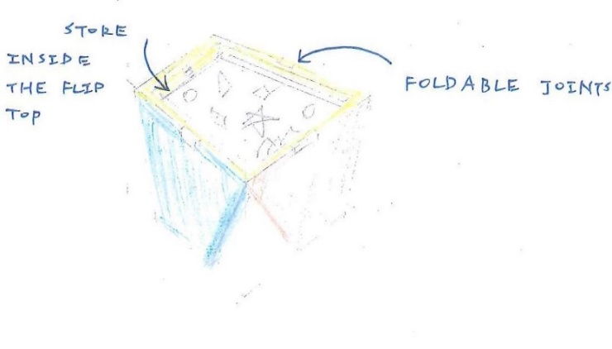
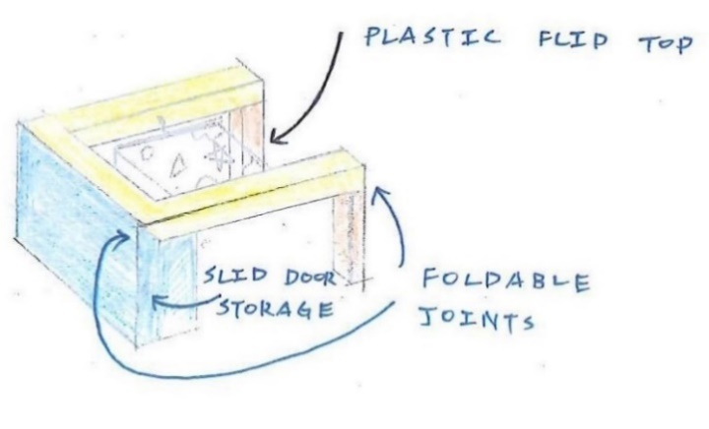
Question 6 – Visualisations

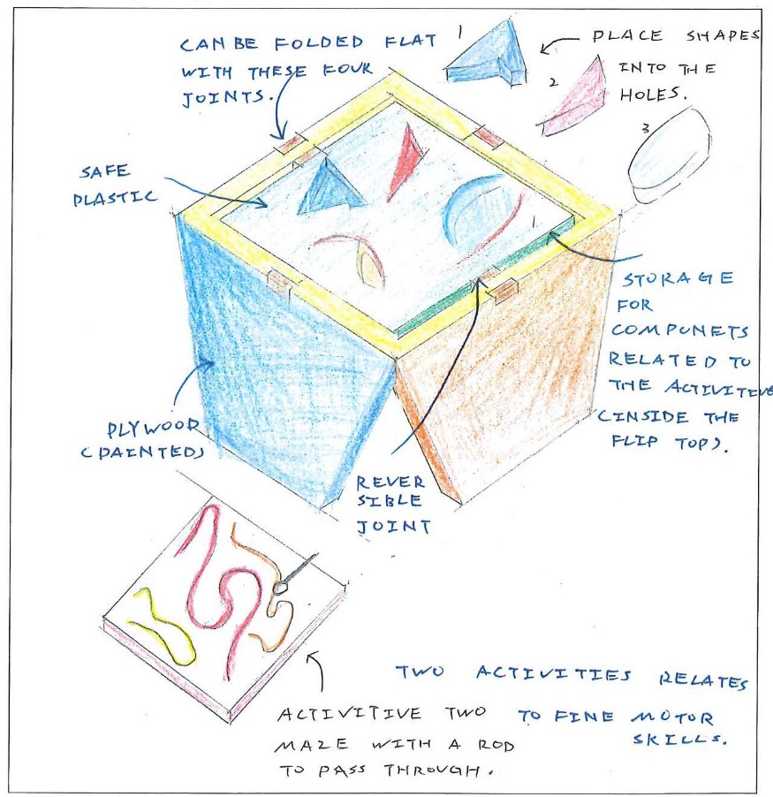
Question 7 – Design option

For the outdoor play tools

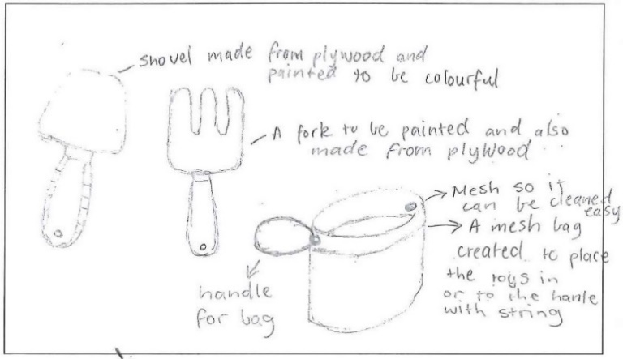
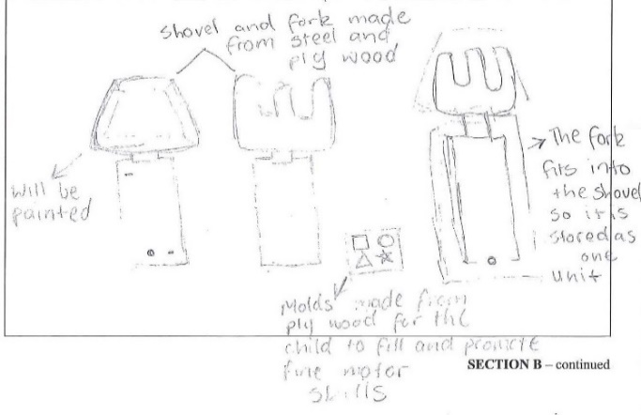
Question 6 – Visualisations

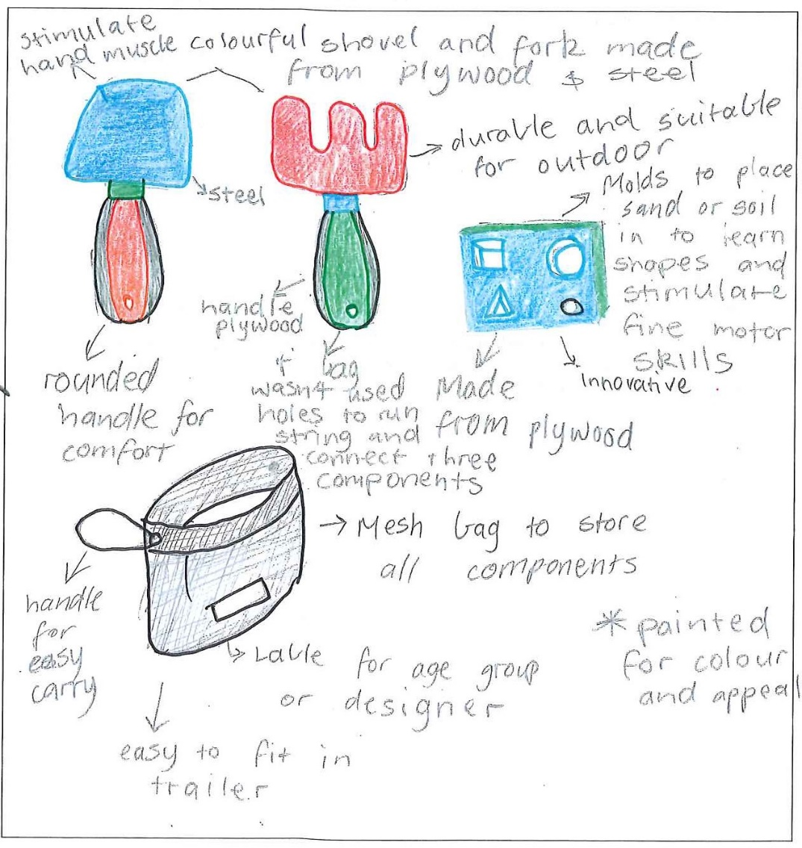
Question 7 – Design option

For the play mat

Question 6 – Visualisations
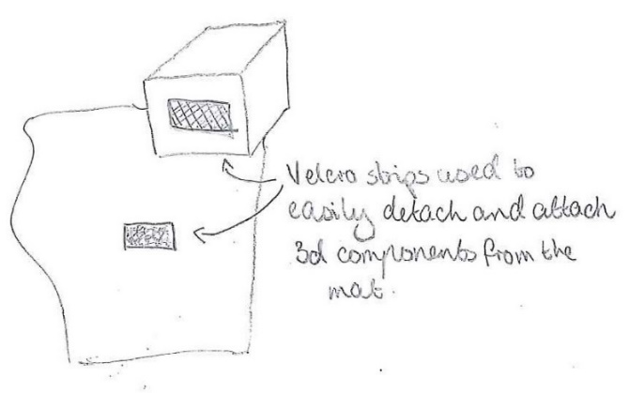
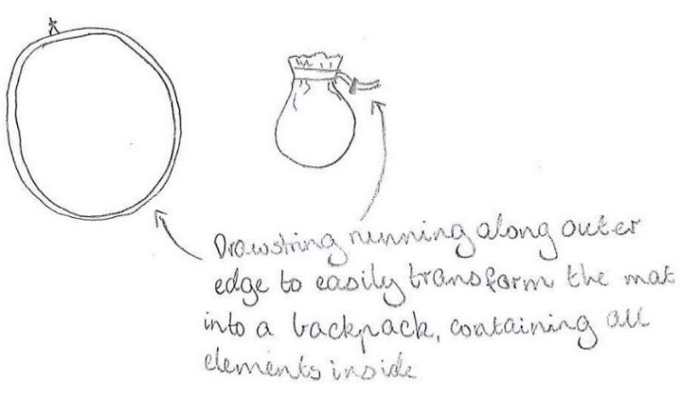

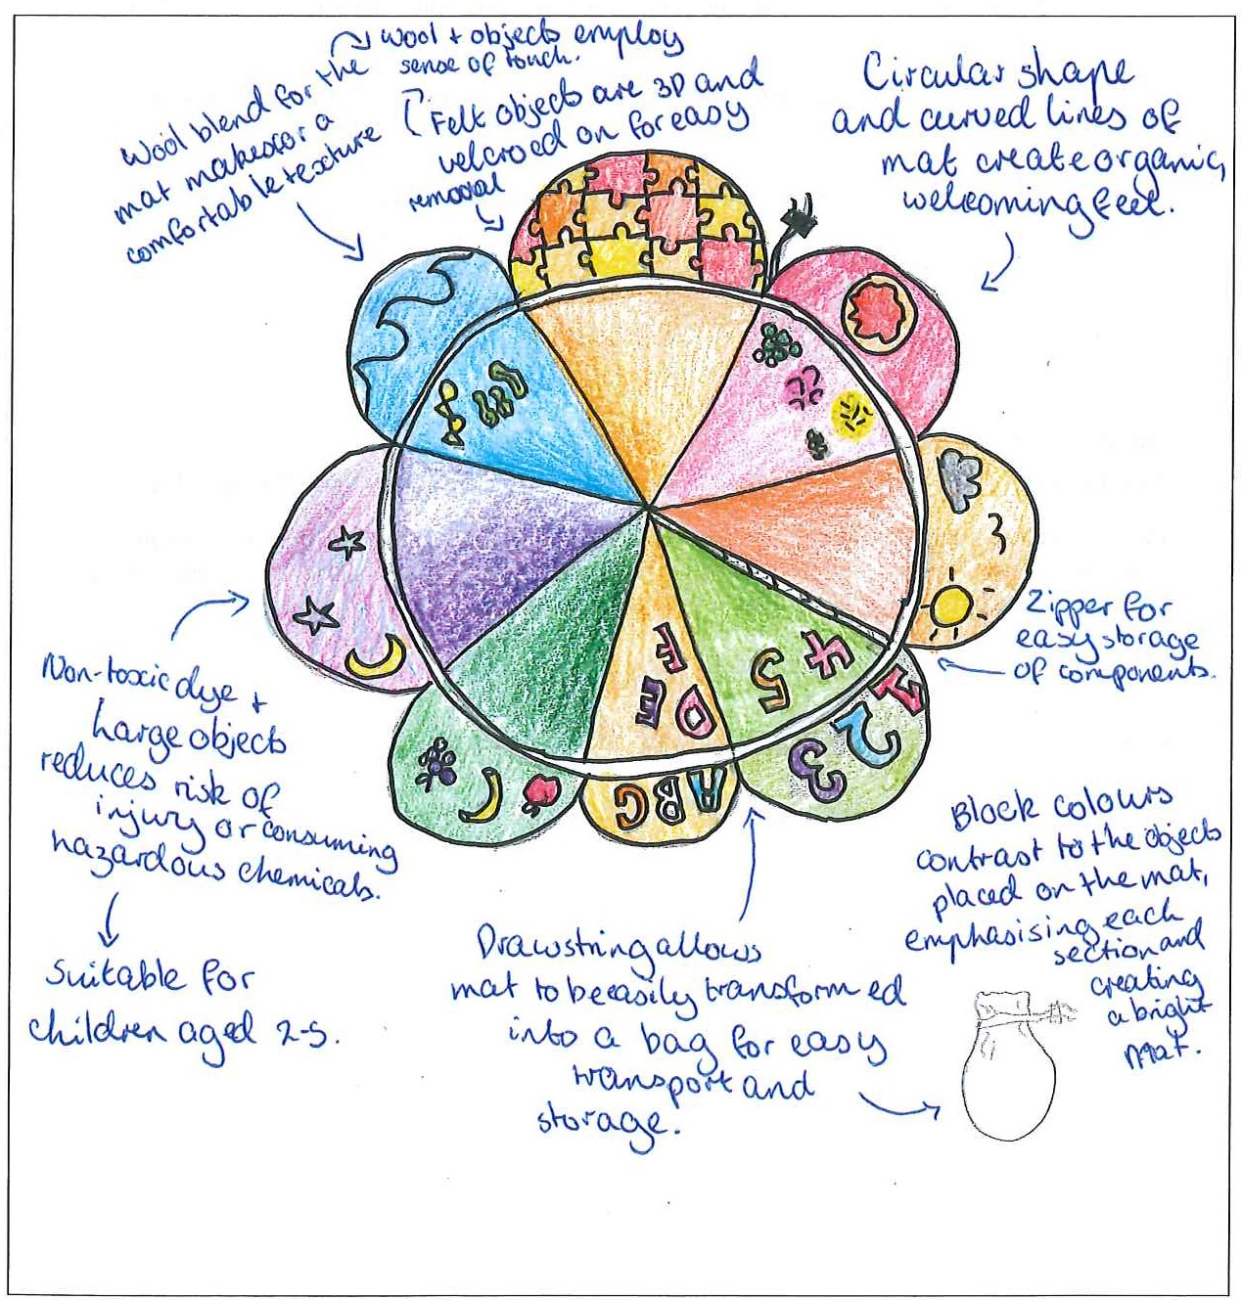
Question 7 – Design option

Question 8a.
Marks | 0 | 1 | 2 | 3 | Average
% | 18 | 17 | 36 | 29 | 1.8
Many students were able to discuss a safety issue for their product; however, the majority did not make it clear how it would apply to the design, instead giving a solution to the construction of the product or a modification to the finished product. A small number gave instructions to the users, which was not related to the question.
The following are examples of high-scoring responses.
- The texture of the plywood is a safety issue as it could cause splinters, could be addressed in design by changing material or allocating time to smoothly sand product within production, and try different materials sanded.
- One safety issue is the plastic being toxic, this could be addressed by designing the product with non-toxic plastic so that if kids chew on it they won't get sick.
- A possible safety issue with the product is the stability of the table. The table can be designed to hold a large amount of weight to stop it from collapsing.

Question 8b.
Marks | 0 | 1 | 2 | 3 | Average
% | 9 | 4 | 17 | 70 | 2.5
Overall, students were able to write three instructions for safe use, maintenance and/or care of their product. However, many wrote instructions that would be specific to the children, who would most likely not be reading them, when they should have been directed to the adult in charge.
The following is an example of a high-scoring response for the outdoor play tools.
1. Clean product with damp cloth after use.
2. Keep all components together in bag to avoid damage in the trailer.
3. Repaint if scratches occur with a thin coat of paint.

Question 9
Marks | 0 | 1 | 2 | 3 | 4 | Average
% | 52 | 11 | 14 | 13 | 11 | 1.2
Many students were unable to identify a construction process used to assemble their product, describe why it was suitable for packaging and transportation and include equipment. Many described a functional aspect, such as ‘folding of the product’, which is not a construction process. Others gave instructions for folding the legs, which was also not what was being asked. Many interpreted the construction process as ‘setting up’ the product.
Some students identified processes that were not suitable for use in the assembly phase of construction, such as cutting materials or finishing techniques. A large number of students neglected to include mention of any equipment.
For full marks the response needed to name and describe a construction process that was suitable to the product being frequently used, set-up, packed and unpacked by a lot by different people (that is, that made it strong/durable or prevented fraying of fabric).
The following are examples of high-scoring responses.
Welding: The steel frame of the table will be welded together for optimal strength. This process will require a MIG welder gas appropriate PPE such as a mask, gloves and jacket as well as a grinder to clean up the welds. By welding the frame together it will be ensured that the joints will be to the highest quality and will be able to withstand the stress of transportation.
Sewing a seam: Sewing a seam allows for a flexible join between two pattern pieces, which means the product is durable and will not fall apart but can also easily be folded down into the required space and doesn't require any assembly for the end-user. This process uses a sewing machine and thread.

