2022 VCE Systems Engineering external assessment report

General comments
Students attempted the majority of questions on the exam. Questions 7, 11 and 15 required students to read the stem of the question carefully and those students who did were rewarded.
When doing multipart calculations, students need to keep their answers exact and only round for the final answer.
Both decimal and fractions were accepted. Gear ratios should be in lowest factor form and students should be aware that a gear ratio of 1:3 is not the same as 0.3:1 or 3:1.
The term ‘discuss’ means more than just list. It requires the presentation of a clear, considered and balanced argument or prose that identifies issues and shows the strengths and weaknesses of, or points for and against, one or more arguments, concepts, factors and/or opinions.

Specific information
Student responses reproduced in this report have not been corrected for grammar, spelling or factual information.
This report provides sample answers or an indication of what answers may have included. Unless otherwise stated, these are not intended to be exemplary or complete responses.
The statistics in this report may be subject to rounding, resulting in a total of more or less than 100 per cent.

Section A – Multiple-choice questions
Shading indicates the correct answer.
Question | Correct answer | % A | % B | % C | % D | Comments
1 | B | 31 | 60 | 5 | 3 | The inclined plane is twice the length (40 m) as the height (20 m) so the mechanical advantage is 2.
2 | A | 30 | 53 | 5 | 11
3 | B | 0 | 97 | 2 | 1 | solar
4 | B | 13 | 45 | 31 | 10 | 20 N as at a constant velocity, all forces sum to zero.
5 | D | 9 | 31 | 11 | 48 | Power = energy/time, so power is 800 J/50 s = 16 W. Efficiency of system is output energy/input energy × 100% = 16/20 × 100 = 80%
6 | D | 4 | 2 | 3 | 90
7 | B | 9 | 71 | 18 | 1 | The question states that the pulley is not ideal. This means there is some movement in both pulleys. 200/125 = 1.6
8 | D | 40 | 3 | 8 | 49
9 | B | 1 | 90 | 9 | 1 | Given the energy in a wire is electrical, the answer must be B.
10 | D | 10 | 18 | 8 | 64 | Work done = force × distance.  Force = mg = 100 × 10 = 1000 N  Work done = 1000 × 2.5 = 2500 J
11 | D | 3 | 3 | 7 | 86
12 | C | 2 | 27 | 70 | 1
13 | B | 4 | 58 | 31 | 7
14 | C | 17 | 22 | 54 | 6 | Brown (1) Red (2) Yellow (0000) Gold (5%) gives 120 000 ± 6000.  This gives the interval 114 000 Ω to 126 000 Ω.  115 000 Ω is within these limits.
15 | A | 68 | 3 | 19 | 10
16 | A | 69 | 11 | 19 | 1
17 | C | 10 | 5 | 71 | 15
18 | D | 12 | 27 | 7 | 52 | The signal is 10 VAC and would overload a 5 V Voltmeter.
19 | B | 40 | 21 | 23 | 16 | Four cords from the moving mass so the force is 100 × 4 = 400 N.  The mass is raised 0.5 m so the increase in energy is 400 × 0.5 = 200 J.  Power = energy/time so power is 200/25 = 8 W.
20 | A | 38 | 41 | 17 | 4 | Period is 40 mS or 0.04 s, so the frequency is 1/0.04 = 25 Hz.

Section B

Question 1
Mark | 0 | 1 | 2 | 3 | 4 | Average
% | 3 | 0.8 | 29 | 0.2 | 67 | 3.3
- process
- input
- output
- transducer

Question 2a.
Mark | 0 | 1 | 2 | 3 | 4 | Average
% | 62 | 19 | 2 | 1 | 17 | 0.95
There were two groups of students who answered this question; those who got full marks and those who got the series and parallel resistors mixed up. The parallel branch with the two 20 Ω resistors should have been calculated first. The parallel sum of that branch of 10 Ω should have then been added to the 50 Ω resistor.

Question 2b.
Mark | 0 | 1 | 2 | 3 | Average
% | 50 | 37 | 6 | 7 | 0.7
The answer to 2a. was needed to calculate the total current I₃, using V/R to give 1 amp. If the answer to 2a. was incorrect, students could still gain marks if they’d used the correct formula.

Question 3
Mark | 0 | 1 | 2 | 3 | Average
% | 28 | 31 | 27 | 13 | 1.3
PNP transistor
Resistor
Variable capacitor
Thermistor
AC power supply
Motor

Question 4a.
Mark | 0 | 1 | Average
% | 60 | 40 | 0.4
I_{total} = I₃ = 200 mA

Question 4b.
Mark | 0 | 1 | 2 | Average
% | 37 | 28 | 35 | 1
Power = Voltage × current so P = 60 × 200mA = 12W

Question 4c.
Marks | 0 | 1 | Average
% | 72 | 28 | 0.3
Resistor 1 was faulty giving an open circuit. Other alternatives such as a crack in the circuit board were accepted.

Question 4d.
Marks | 0 | 1 | 2 | Average
% | 64 | 30 | 6 | 0.5
The two voltmeters are in parallel so have the same reading. V=IR so V=0.2 x 200 =40 V. Most students overlooked the fact that one of the resistors was open circuit.

Question 5a.
Mark | 0 | 1 | 2 | 3 | 4 | Average
% | 35 | 20 | 17 | 7 | 21 | 1.6
The four aspects of this question were:
- the calculation of the area
- converting the 60 kg to a force
- the use of P = F/A
- the correct calculation and unit.
The main errors were in calculating the correct area.

Question 5b.
Mark | 0 | 1 | Average
% | 77 | 23 | 0.3
The lid will stop moving down when the pressure inside the cylinder is equal to the pressure produced by the 60 kg object.

Question 6a.
Mark | 0 | 1 | 2 | 3 | 4 | Average
% | 22 | 7 | 21 | 20 | 31 | 2.3
Ratio 1 is driven/driver = 60/30 = 2:1
Ratio 2 is driven/driver = 120/15 = 8:1
Total gear ratio = ratio 1 × ratio 2 = 2:1 × 8:1 = 16:1

Question 6b.
Mark | 0 | 1 | Average
% | 59 | 41 | 0.4
The mechanical advantage is 16.

Question 6c.
Mark | 0 | 1 | Average
% | 29 | 71 | 0.7
The gear system increased the torque.

Question 7a.
Mark | 0 | 1 | 2 | Average
% | 14 | 37 | 49 | 1.35
Any two of the following:
- area of high rainfall
- high elevation
- space for the body of water
- space for the hydroelectric generators.
A response that gained full marks is given below.
‘It must have a source of flowing water nearby or in the build site. Needs to have a high flow rate meaning that it needs to be up higher on its source for example a mountain.’

Question 7b.
Mark | 0 | 1 | 2 | 3 | 4 | Average
% | 7 | 8 | 32 | 22 | 32 | 2.7
The stem of the question asked students to ‘discuss’, so just writing a list of advantages and/or disadvantages did not get full marks. Reasons for the advantage/disadvantage needed to be given. For example, hydro-electric power is renewable as it uses rainwater stored in a dam as its energy source. The following student response gained full marks.
‘Hydroelectricity is a clean renewable energy that involves no carbon when in operation, It also can provide jobs for workers and creates an industry. However, hydro also has a very large initial cost to build and set up and can only be put in areas that meet certain features such as where the water flows at high rates.’

Question 8
Mark | 0 | 1 | 2 | 3 | 4 | Average
% | 91 | 8 | 0.6 | 0.1 | 0 | 0.1
- The functioning of the circuit: the voltage across the diode will become 0.7 volts. This means the voltage across the 150 Ω resistor is 19.3 volts (20 - 0.7). The current through the 150 Ω resistor will increase, so the power will increase to greater than 2 W and the resistor will expire.
- The voltage across the resistor R_{L}: The voltage across the load will be close to 0 volts as the diode and pn junction both have a voltage drop of around 0.7 volts.

Question 9a.
Mark | 0 | 1 | 2 | 3 | Average
% | 21 | 33 | 42 | 4 | 1.3
Heat (thermal)
Solar (light)
Chemical

Question 9b.
Mark | 0 | 1 | 2 | Average
% | 53 | 20 | 27 | 0.8
The process of photosynthesis splits CO₂ into carbon, which is absorbed by the tree, and oxygen, which is released. Some students gave the chemical equation for photosynthesis, going beyond what was required.

Question 10
Mark | 0 | 1 | 2 | Average
% | 6 | 4 | 90 | 1.9
One possible hazard is shards of metal entering your eyes.
The control needed to be appropriate to the hazard; in this case, it is making sure that the user is wearing safety glasses.

Question 11a.
Mark | 0 | 1 | 2 | Average
% | 21 | 43 | 36 | 1.2
Any two of the following:
- The context, and the constraints and considerations that apply to the problem, need, opportunity or situation, are articulated in a design brief.
- Criteria are developed to evaluate how well the system satisfies the design brief.
- Factors that influence the creation and use of a system are described.
The following answer gained full marks.
‘The clients scope and constraints i.e. what is being required of the project, the specifications of the problem and the success criteria.’

Question 11b.
Mark | 0 | 1 | 2 | Average
% | 22 | 41 | 37 | 1.2
Provides features/characteristics of the ‘evaluate and report on the system produced and processes used’ stage that relate to the ‘identify and document the problem, need, opportunity or situation’ stage of the systems engineering process.
The following answer gained full marks.
‘The evaluation looks at how well the solution actually met the initial requirements by looking at the evaluation criteria created and the solution constraints and scope, and how well the solution addressed them.’

Question 12
Mark | 0 | 1 | 2 | 3 | 4 | 5 | Average
% | 53 | 10 | 8 | 9 | 9 | 11 | 1.5
The complete circuit board is given below.

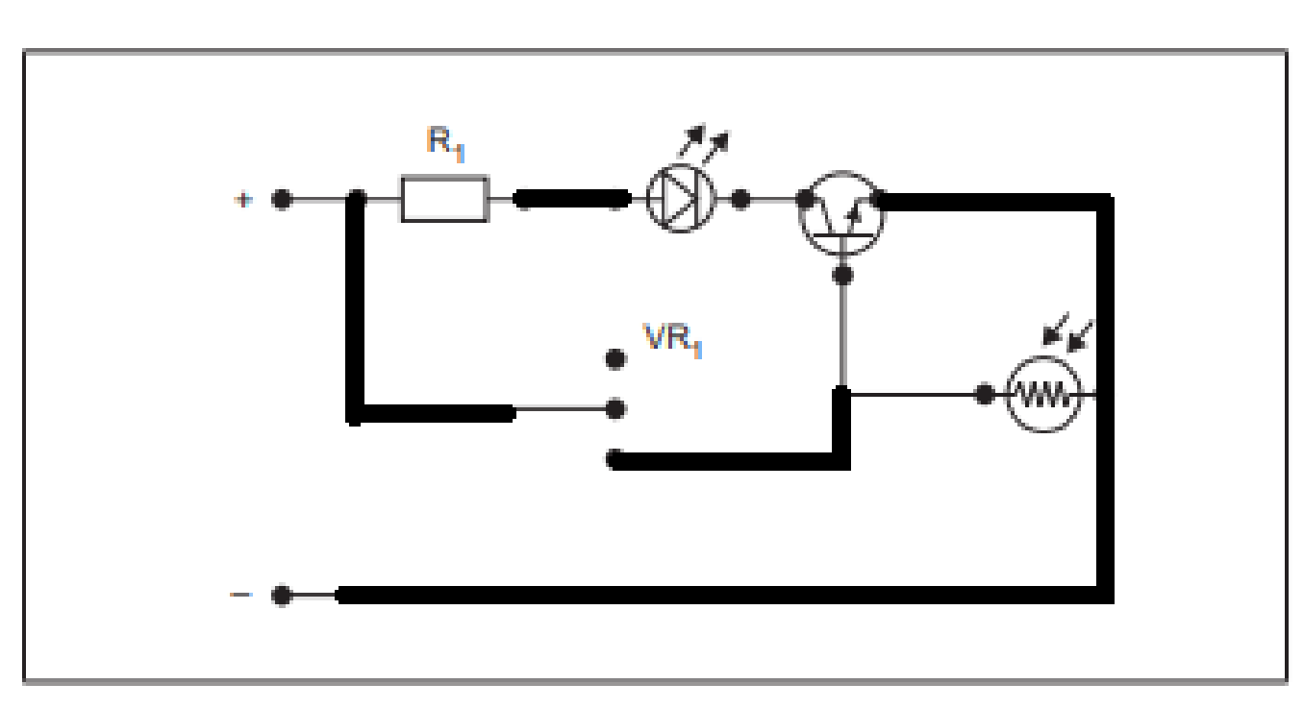

Question 13a.
Mark | 0 | 1 | 2 | 3 | 4 | Average
% | 61 | 9 | 1 | 0.7 | 28 | 1.3
The power to the secondary circuit is 410 W.
Resistance is 640 Ω, so using a combination of P = VI and V = IR (or P = I²R) you get
I² = P/R = 410/640 = 0.64
I = SQR 0.64 = 0.8A

Question 13b.
Mark | 0 | 1 | 2 | Average
% | 62 | 12 | 26 | 0.7
Using V = IR, V = 0.8 × 640 = 512 V

Question 13c.
Mark | 0 | 1 | 2 | Average
% | 72 | 5 | 23 | 0.5
Using the transformer formula $\frac{V_{p}}{V_{s}}=\frac{N_{p}}{N_{s}}$ , $\frac{128}{512}=\frac{N_{p}}{400}$
N_{p} = 100

Question 14
Students needed to identify the technology, explain how the energy is stored and then released for each section of this question.

Question 14a.
Mark | 0 | 1 | 2 | 3 | Average
% | 58 | 5 | 12 | 26 | 1.1
Mechanical energy can be stored in a spring or in a flywheel in the form of rotational energy. A detailed account of how energy is released using gears or how the flywheel can be used to drive a generator is required.
Many students did not attempt this question.
The following response gained full marks.
‘A spring can be used to store mechanical energy. The energy is stored by compressing the spring and is released by releasing the spring. This can be used in watches to store energy to keep the watch working.’

Question 14b.
Mark | 0 | 1 | 2 | 3 | Average
% | 18 | 17 | 33 | 32 | 1.8
Electrical energy can be stored in a battery in the form of chemical energy. A detailed account of how energy is released when the battery is connected to a circuit is required.
Electrical energy could also be stored in a super capacitor in the form of electrostatic charge.

Question 14c.
Mark | 0 | 1 | 2 | 3 | Average
% | 63 | 9 | 11 | 16 | 0.8
Thermal energy can be stored in an insulated water tank,, or similar device, as water has a high specific heat capacity. A detailed account of how the hot water can then be used for domestic use, such as heating, is required.
The following answer gained full marks.
‘A heat bag can be used to store thermal energy as the beans inside are dense and hold heat well. The bag will release heat into the air to be used.’

Question 15
Mark | 0 | 1 | 2 | 3 | 4 | 5 | 6 | Average
% | 34 | 3 | 5 | 7 | 9 | 11 | 30 | 3.1
These types of modelling were given in the stem of the question:
- prototyping
- virtual modelling
- simulation
- calculations
- scale modelling.
Students were required to include the characteristics/features of the benefit of each of these in the context of the subsystems given. The examples below gained full marks.
For the electrotechnological aspect of the controlled system
‘calculations can be used to model the voltage and current flow through the system.’
For the mechanical
‘3-D modelling allows a clear picture of the design and predicts specific size of parts and components.’

