2020 VCE VET Furnishing written examination report

General comments
The 2020 examination contained a variety of questions on content from the following four units of competency:
- MSFFP2001 Undertake a basic furniture making project
- MSFFM2002 Assemble furnishing components
- MSFFM2001 Use furniture making sector hand and power tools
- MSFGN2001 Make measurements and calculations.
The three sections of the examination were:
- Section A – Multiple-choice: Questions from all four units of competency
- Section B – Short answer: Questions drawn from all four units. Students were required to read a number of simple drawings and answer questions. Simple sketching was needed to answer some questions.
- Section C – Case study: The case study provided production drawings and specifications for a Hallway Cabinet. The students were asked to answer questions related to the Hallway Cabinet and the process of planning and making the item including, tools, safety, calculations, and materials.
Students were able to identify a range of common hand and power tools correctly.
Where students were asked to describe the application/use of tools, most were able to show some knowledge of the range of tools examined.
Questions about safety consideration when using power tools were an area of strength for most students.
Questions about construction methods and the application to furniture items were generally well answered.
Students were able to effectively interpret simple drawings.
Questions involving more complex drawings were generally not answered well.
Students were unable to completely develop production information from the drawings and specifications. Interpretation of drawings and the development of accurate cutting lists presented a challenge to many students.
Areas of strength included:
- identification of common hand and power tools
- uses for common hand and power tools
- safety
- construction methods for simple furniture items.
Areas for improvement include:
- reading complex drawings
- costing rough sawn timber
- understanding and applying construction methods
- types and uses of adhesives.

Specific information

Section A
Questions | % A | % B | % C | % D | Comment
1 | 33 | 24 | 30 | 12 | Headless pins should be used for fastening moulding of this size.
2 | 13 | 9 | 73 | 5
3 | 54 | 32 | 9 | 6 | This is the safest method of commencing the task.
4 | 23 | 1 | 12 | 62 | Low speed (RPM) is critical with large diameter drilling tools.
5 | 12 | 66 | 17 | 5 | 6mm is the standard size of the trimmer router chuck.
6 | 11 | 5 | 28 | 56 | The smaller tool is the correct option.
7 | 65 | 7 | 6 | 22
8 | 29 | 12 | 46 | 12
9 | 21 | 7 | 56 | 16 | Many students did not differentiate between general bench work and cabinet assembly work.
10 | 66 | 0 | 7 | 26 | Repair of major defects is not an effective use of time or materials. Re-use for other smaller parts is the correct option.
11 | 76 | 11 | 9 | 5
12 | 27 | 9 | 23 | 40
13 | 93 | 0 | 5 | 1
14 | 15 | 44 | 20 | 18 | Single dovetails are commonly used for carcase rail joints.
15 | 0 | 76 | 0 | 24
16 | 1 | 0 | 90 | 9
17 | 7 | 10 | 68 | 15
18 | 4 | 5 | 11 | 80
19 | 5 | 91 | 2 | 1
20 | 27 | 38 | 32 | 4

Section B

Question 1
Marks | 0 | 1 | 2 | 3 | 4 | Average
% | 63 | 1 | 15 | 1 | 20 | 1.2
The short point for the miters is found by subtracting the width of the rebate in the bottom of the crown mounding (20 mm) from the length or width of the cabinet.
Many students did not understand the drawing or the question and provided incorrect lengths without providing any working out.
Front Piece (A) 1800 – (20 + 20) = 1760mm
Side piece (B) 600 – 20 = 580mm

Question 2
Marks | 0 | 1 | 2 | Average
% | 14 | 4 | 82 | 1.7
Correct answer:
15 kitchens x 20 drawers = 300 drawers
300 drawers / 12 per day = 25 days

Question 3
Marks | 0 | 1 | 2 | 3 | 4 | 5 | 6 | Average
% | 14 | 16 | 10 | 17 | 21 | 11 | 10 | 2.9
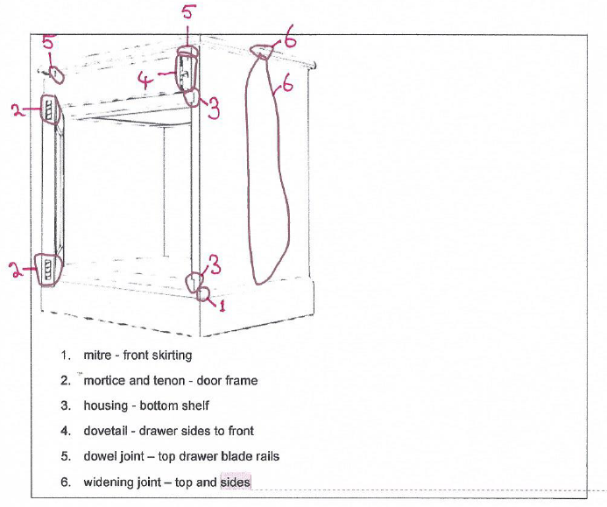

Question 4
Marks | 0 | 1 | 2 | 3 | Average
% | 87 | 4 | 2 | 7 | 0.3
Epoxy-based glue or polyurethane based.
Must be waterproof for outdoor table.
Marks were not awarded if students listed interior adhesives.

Question 5a.
Marks | 0 | 1 | 2 | Average
% | 56 | 12 | 33 | 0.75
The correct answer: Broad butt hinge, piano hinge or dovetail hinge; provide adequate strength and correct geometry. Many students listed hinges that were inappropriate for the task.

Question 5b.
Marks | 0 | 1 | 2 | 3 | 4 | Average
% | 87 | 4 | 2 | 4 | 2 | 0.3
This question required student to read and understand the drawing of the table. They were then asked to sketch the sub-frame rail.
Many students did not sketch the correct part or provide details of the parts required.
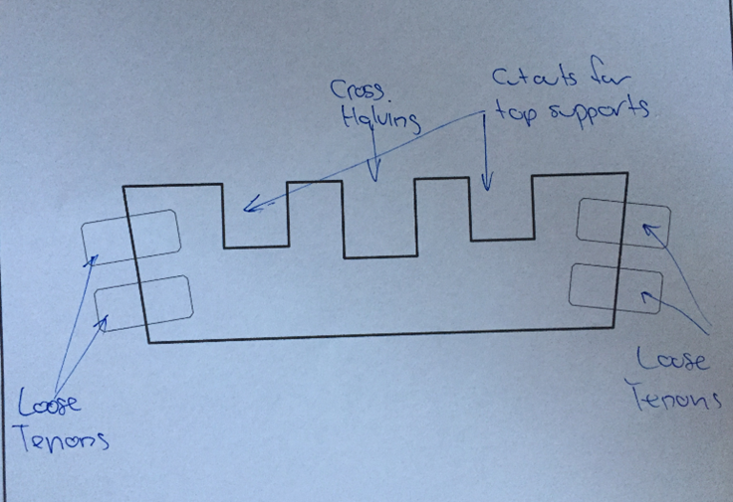

Question 5c.
Marks | 0 | 1 | 2 | Average
% | 28 | 39 | 34 | 1.05
Safety Data Sheet (SDS); an SDS must be provided by the person who sold the product.
At each stage in the distribution of the product the SDS is provided to the buyer, for example, manufacturer to wholesaler, wholesaler to retailer, retailer to furniture maker.

Question 6a.
Marks | 0 | 1 | 2 | Average
% | 20 | 5 | 75 | 1.55
Correct answer: 45 º + 74 º = 119 º, 180 º – 119 º = 61 º

Question 6b.
Marks | 0 | 1 | Average
% | 36 | 64 | 0.65
Correct answer: Cut test and check on job/set out OR measure angle with a protractor.

Question 7
Marks | 0 | 1 | 2 | 3 | 4 | 5 | 6 | 7 | 8 | Average
% | 1 | 10 | 13 | 5 | 24 | 32 | 14 | 1 | 0 | 3.95
Many students were able to identify the hinges but fewer were able to correctly apply the hinges to the correct application.
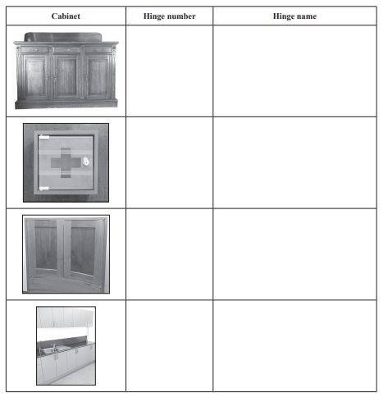
Glass hinge
Pivot hinge
Concealed hinge
Butt hinge
1
2
4
3

Question 8
Marks | 0 | 1 | 2 | 3 | 4 | Average
% | 17 | 19 | 18 | 10 | 36 | 2.3
Many students were able to read some of the scales correctly; 1:20 and 1:500 were less well read.
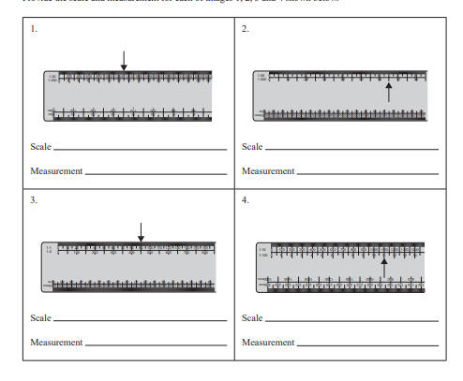
1:500
65
1:100
11
1:1
90
1:20
1300

Question 9
Marks | 0 | 1 | 2 | Average
% | 40 | 1 | 58 | 1.2
The correct answer: 2 x 600mm x 3.14 = 3768mm
The answer was required in millimetres. If an allowance for waste was shown in the working, this was accepted as correct.

Section C

Question 1
Marks | 0 | 1 | 2 | 3 | 4 | 5 | 6 | 7 | 8 | 9 | 10 | 11 | 12 | 13 | 14 | 15 | 16 | Average
% | 12 | 0 | 1 | 3 | 1 | 4 | 5 | 7 | 12 | 14 | 12 | 9 | 11 | 4 | 5 | 0 | 2 | 8.2
Most students were able to correctly complete some of the Job Plan.
Section | Step | Tools/equipment required | Personal protective equipment (PPE) for task
preparation | 10 | 1 | hearing and eye protection, dust control
 | Glue upside panels and back board to top and carcass top. | 11
 | 14 | router, spindle moulder | hearing and eye protection, dust control
 | Send timber to CNC for shaping of moulding, corbels and shelf supports. | 13
construction | Mark out carcass components. | pencil, 300mm steel rule, combination square, tape measure
 | Cut carcass components. | table saw, mitre saw | hearing and eye protection dust control
 | Assemble carcass including facing, corbels and skirting. | drill, cordless screwdriver, tape measure, glue, rags
 | Mark outdoor rails and stiles. | pencil, 300mm steel rule, combination square,
 | Cut doors rails and make door joints. | 8 | hearing and eye protection, dust control
 | Assemble doors. | cramps, glue, rags,
 | 5 | 6
 | Mark out top and shelf length. | pencil, 300mm rule, combination square marking gauge
 | 9 | table saw, hand saw, power saw, hand plane, sander
 | 4 | shaper, router | 7
 | Mark and cut backing board to top. | pencil, 300mm steel rule, combination square, pattern, jigsaw, bandsaw
 | 2 | 15
 | Assemble backboard and shelf components, fix top to backboard. | drill, cordless screwdriver, tape measure, glue, rags | hearing and eye protection
finishing | Sand all parts ready for finishing. | sanding block and abrasive paper, sander | hearing and eye protection, dust control

Question 2
Marks | 0 | 1 | 2 | Average
% | 50 | 29 | 20 | 0.7
Lapped dovetails are used in drawer construction to provide strength and to give uninterrupted appearance for the solid timber front.
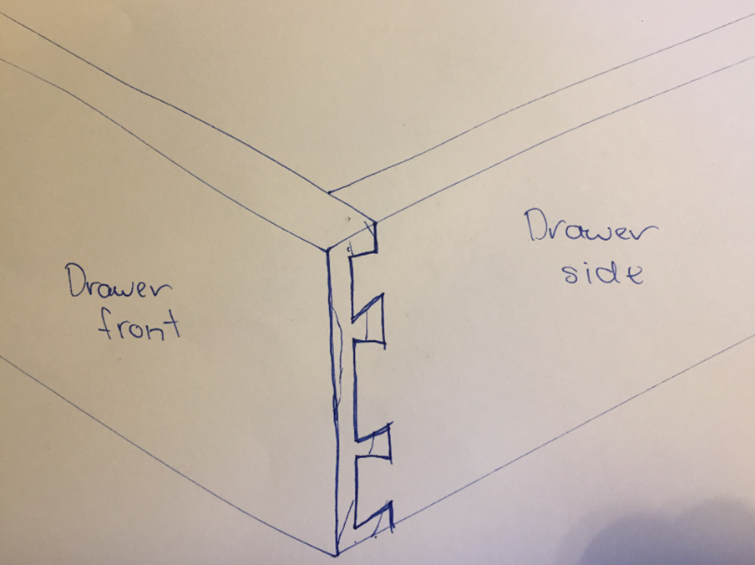

Question 3
Marks | 0 | 1 | Average
% | 50 | 50 | 0.5
This question required students to review the drawing provided and add up the shown dimensions.
10 + 2 + 6 + 50 + 9 + 136 + 8 + 10 = 231mm

Question 4
Marks | 0 | 1 | Average
% | 36 | 64 | 0.65
This question required students to review the drawing provided and add up the shown dimensions:
20 + 1070 + 20 = 1110mm

Question 5
Marks | 0 | 1 | Average
% | 90 | 10 | 0.1
The length of the top is 1110mm and the width is 435mm. The tops must be made from 150mm x 25mm RS timber. Three lengths of greater than 1.11m are required. An allowance for waste can be included.
1.11m x 3 pieces = 3.33m + an allowance for waste. Round up to nearest 300mm increment = 3.6m.
Many students were unfamiliar with purchasing timber and the standard lengths available.

Question 6
Marks | 0 | 1 | 2 | Average
% | 81 | 14 | 6 | 0.25
Corbels are the decorative timber pieces fixed to the front pilasters under the top.
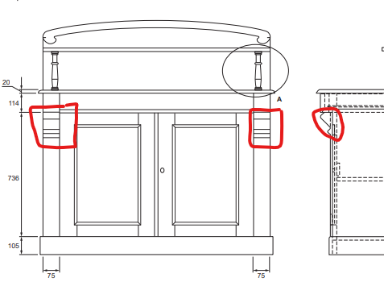

Question 7
Marks | 0 | 1 | Average
% | 53 | 47 | 0.45
The correct answer was router and 20mm round over bit.

Question 8
Marks | 0 | 1 | 2 | Average
% | 52 | 42 | 6 | 0.55
The correct answer was poorly prepared timber, uneven clamping supports, poorly made joints.

Question 9
Marks | 0 | 1 | Average
% | 42 | 58 | 0.55
Do not use the tool; get the tool re-tested using normal workplace procedures.

Question 10
Marks | 0 | 1 | 2 | Average
% | 40 | 17 | 44 | 1.05
The router bit is missing the guide bearing and needs cleaning/sharpening.
Replace the guide bearing and get the bit sharpened by a professional sharpening service.

Question 11
Marks | 0 | 1 | Average
% | 74 | 26 | 0.25
The correct answer was 732 mm.
Drawing indicates overall door height of 736mm. Question asks to allow for 2mm gap allowance. Gap necessary at top and bottom of door. 736mm – 2mm – 2mm = 732mm.

Question 12
Marks | 0 | 1 | 2 | Average
% | 58 | 27 | 15 | 0.6
View and discuss the drawings/specifications. Ensure both the maker and the client sign or initial and date each sheet of the drawings.

Question 13
Marks | 0 | 1 | 2 | 3 | 4 | 5 | 6 | 7 | 8 | Average
% | 16 | 6 | 9 | 6 | 12 | 13 | 14 | 19 | 6 | 4.15

Item no. | Part of  product | No. of  pieces | Length | Width | Thickness | Notes | Total lineal metres | Cost per  lineal metre ($) | Total | Remarks
1 | plinth | 1 | 2100 | 105 | 20 |  | 2.1 | 10.13 | 21.27
2 | sides | 2 | 955 | 345 | 20 | 4 @ 955 × 172.5 × 20 | 3.82 | 13.50 | 51.57
3 | front pelmet | 2 | 955 | 75 | 20 |  | 1.91 | 6.75 | 12.89
4 | corbels | 2 | 265 | 75 | 55 | 4 @ 265 × 75 × 27.5 | 1.06 | 10.26 | 10.88
5 | bottom  shelf | 1 | 1030 | 345 | 20 | 2 @ 1030 × 172.5 × 20 | 2.06 | 13.50 | 27.81 | notch out for sides
6 | middle  shelf | 1 | 1030 | 325 | 20 | 2 @ 1030 × 162.5 × 20 | 2.06 | 13.50 | 27.81
7 | top | 1 | 1110 | 435 | 20 | 3 @ 1110 × 145 × 20 | 3.33 | 10.13 | 33.73 | bullnose on front and edges
8 | backboard | 1 | 1070 | 430 | 20 | 3 @ 1070 × 143.5 × 20 | 3.21 | 10.13 | 32.52 | shape curve on top
9 | top curved decoration | 1 | 1070 | 140 | 15 |  | 1.07 | 10.13 | 10.84 | cut and shape
10 | top shelf | 1 | 1070 | 130 | 20 |  | 1.07 | 10.13 | 10.84
11 | top spindles | 2 | 251 | 30 | 30 | 1 @ 251 × 70 × 30 | 0.251 | 10.26 | 2.58 | turned on lathe
12 | back panels | 1 | 955 | 1030 | 20 | 5 @ 955 × 206 × 20 | 4.775 | 13.50 | 64.46 | panels butted together and into sides
13 | drawer rail | 1 | 1030 | 145 | 20 |  | 1.03 | 10.13 | 10.43 | notch out for sides
14 | drawer runner | 2 | 200 | 80 | 20 |  | 0.4 | 6.75 | 2.70
15 | drawer guide | 2 | 325 | 55 | 20 |  | 0.65 | 6.75 | 4.39
16 | drawer front | 1 | 916 | 98 | 20 |  | 0.916 | 6.75 | 6.18 | rebate for bottom
17 | drawer moulding | 1 | 916 | 30 | 14 |  | 0.916 | 3.38 | 3.10 | 7mm radius
18 | drawer stops | 2 | 75 | 16 | 20 |  | 0.15 | 3.38 | 0.51
19 | drawer sides | 2 | 349 | 92 | 14 |  | 0.67 | 6.75 | 4.52 | rebate for bottom
20 | drawer back | 1 | 888 | 76 | 14 |  | 0.888 | 6.75 | 5.99
21 | drawer bottom | 2 | 420 | 341 | 6 | 6 @ 420 ×  113.5 × 6 | 2.52 | 10.13 | 25.53
22 | drawer muntin | 1 | 335 | 100 | 16 |  | 0.335 | 6.75 | 2.26 | rebate on two sides
23 | door top and bottom rail | 4 | 289 | 84 | 20 |  | 1.156 | 6.75 | 7.80
24 | door stiles | 4 | 732 | 84 | 20 |  | 2.936 | 6.75 | 19.82
25 | door panel | 2 | 594 | 317 | 6 | 6 @ 594 ×  105.5 × 6 | 3.564 | 10.13 | 36.10
26 | door panel moulding | 2 | 1822 | 14 | 8 | 1 @ 1900  × 40 × 8 | 1.9 | 3.38 | 6.42
27 | door front moulding | 1 | 732 | 14 | 10 |  | 0.732 | 3.38 | 2.47 | 7 mm radius
s

