Insight Assessment Platform
Catholic School Administrator User Guide

Authorised and published by the Victorian Curriculum and Assessment Authority
Level 7, 2 Lonsdale Street
Melbourne VIC 3000
ISBN: 978-1-925867-38-1
© Victorian Curriculum and Assessment Authority 2023

No part of this publication may be reproduced except as specified under the Copyright Act 1968 or by permission from the VCAA. Excepting third-party elements, schools may use this resource in accordance with the VCAA educational allowance. For more information go to https://www.vcaa.vic.edu.au/Footer/Pages/Copyright.aspx.
The VCAA provides the only official, up-to-date versions of VCAA publications. Details of updates can be found on the VCAA website at www.vcaa.vic.edu.au.
This publication may contain copyright material belonging to a third party. Every effort has been made to contact all copyright owners. If you believe that material in this publication is an infringement of your copyright, please email the Copyright Officer vcaa.copyright@education.vic.gov.au
Copyright in materials appearing at any sites linked to this document rests with the copyright owner/s of those materials, subject to the Copyright Act. The VCAA recommends you refer to copyright statements at linked sites before using such materials.
The VCAA logo is a registered trademark of the Victorian Curriculum and Assessment Authority.

Contact us if you need this information in an accessible format - for example, large print or audio.
Telephone (03) 9032 1635 or email vcaa.media.publications@education.vic.gov.au

Contents
Introduction 2
About the Insight Assessment Platform 2
About this user guide 2
Additional user guides 2
Section 1: Setting up your school 3
Section 2: Log in 3
Section 3: Managing Staff and Classes 4
Creating ad hoc classes and co-teachers 5
For Principal only (Manage Staff) 8
Managing students 10
Managing classes 12
Section 4: Assessment delivery 13
Section 5: System support 13
Appendix A: Upload specification and validation rules 14

Introduction

About the Insight Assessment Platform
The Insight Assessment Platform (Insight) is an online assessment platform. It assists teachers to assess student progress and apply more targeted teaching practices through its powerful data analytics and reporting capabilities. Teachers can review student assessment data for diagnostic, formative and summative purposes.
Insight has seven assessment instruments, with more under development, as follows:
- English Online Interview (EOI), targeting Years F–2
- Mathematics Online Interview (MOI), targeting Years F–2
- Fractions and Decimals Online Interview (FDOI), targeting Years 5–10
- Transition Learning and Development Statement (TLDS), targeting Kindergarten–Year F
- Reading and Vocabulary Assessment for English as an Additional Language students (RVEAL)
- Diagnostic Assessment Tools in English (DATE), targeting Years F–4
- Intercultural Capabilities, targeting Years F–10.
For more information about these instruments, see the Assessment Tools section of the Insight webpage.

About this user guide
This guide provides Insight School Administrators and Principals in Catholic schools with information and support to use Insight, including:
- Maintaining staff, class and student data.
- Adding non-homeroom classes (known on Insight as ad hoc classes) and co-teachers.

Additional user guides
The following additional user guides are available for Government schools to learn more about using Insight:
- Technical Support Staff User Guide.
- Teacher – Assessment Delivery User Guide.
- Insight Platform Reporting Guide.
For more information see the Non-Government section of the Insight webpage.

Section 1: Setting up your school
Before you are able to log in and use Insight, your school must be registered, the staff, students and classes set up.

If your school uses the Integrated Catholic Online Network (ICON), you will need to register your interest in using Insight before using it for the first time. To register, please contact servicedesk@macs.vic.edu.au. Once registered, ICON will automatically update your staff, students, and classes on Insight. The accuracy of data on Insight will be determined by the accuracy of the data entered into ICON.

Catholic schools that do not use the Integrated Catholic Online Network (ICON), you must contact insight@education.vic.gov.au and request your school to be registered. You will then receive instructions and electronic files to set up your staff, students and classes for using Insight. You must populate and send electronic files to insight@education.vic.gov.au, which reflect the staff, students and classes at your school. This is because the uploading of these files to Insight is currently managed by the VCAA. For a successful upload to occur, these file specifications and field definitions must be strictly adhered to. Appendix A outlines the specifications of these files, as well as the validation rules. An annual set-up will be required in order to effectively set up staff, student and class data for that year.

Section 2: Log in
Chrome or Firefox are the recommended internet browsers to access Insight.
To log in:
- Open your internet browser.
- Copy and paste https://www.vcaa.vic.edu.au/assessment/f-10assessment/insight/Pages/login.aspx or click here. The Insight Log In screen will appear.
- Select the Catholic Schools button. The CECV Log In screen will appear (see Figure 2.0).
- Enter your current CNumber/CVEN credentials login and password. The Insight Home screen will appear (see Figure 2.1).
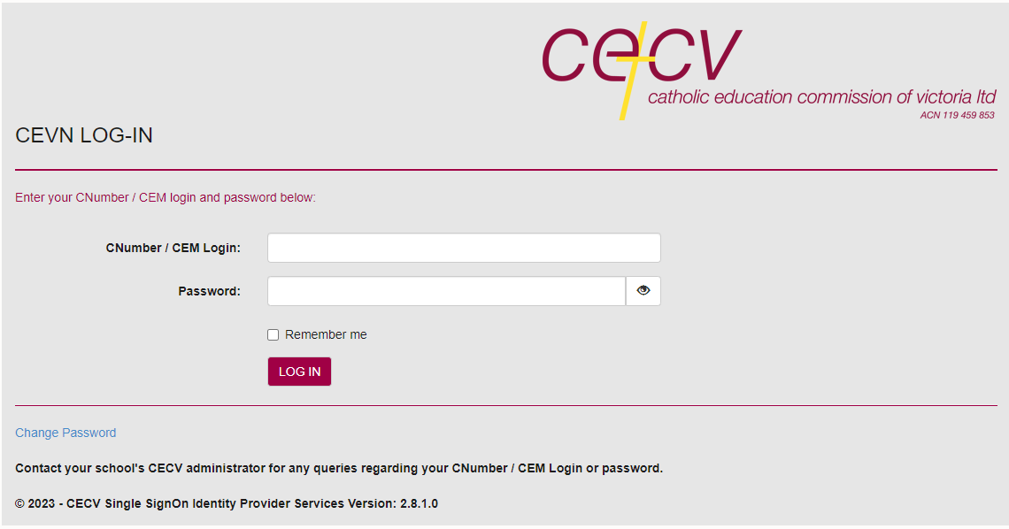
Figure 2.0: CECV Log In screen
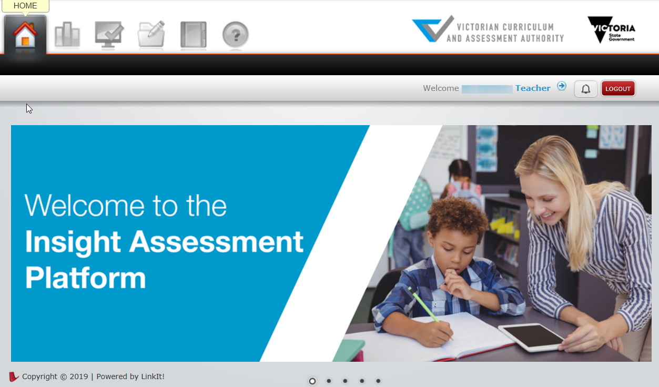
Figure 2.1: Insight Home screen
Once you have logged into Insight, your name will appear on the top right corner of the Insight Home screen. If this is not the case, contact insight@education.vic.gov.au or your Insight School Administrator.

Section 3: Managing Staff and Classes
Principals and Insight School Administrators have the ability to perform a range of functions, including managing staff, class and student information on Insight.

Creating ad hoc classes and co-teachers
Adding a co-teacher to a class is required when an assessment is being delivered by a teacher who is not the homeroom teacher or when there is a team-teaching environment. Ad hoc classes can be created when a class that has students from different homerooms is required.
To create an ad hoc class:
- On the Insight Home screen, select the Data Admin icon. The Data Admin options will appear.
- Select Manage Classes. The Manage Classes screen will appear (see Figure 3.0).

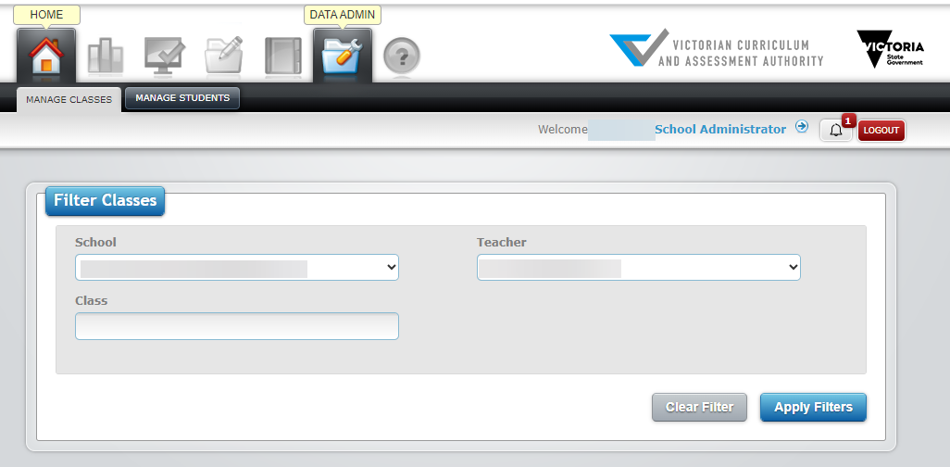
Figure 3.0 Manage Classes screen
- Select the required teacher from the Teacher drop-down box and click on the Apply Filters button. The Teachers class details will appear in the Classes window (see Figure 3.1)
- Click on the Add New Class button in the Classes window. The Add Class screen will appear.
- Type in the name of the class in the Group/Course Name text box.
- Select the required teacher from the Teacher drop-down box.
- Select the class type from the Class Type drop-down box.
- Click on the Submit button. The class will be created.
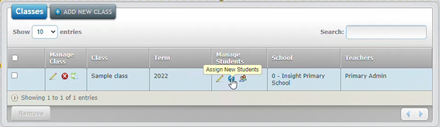
Figure 3.1 Classes window
To add students to an ad-hoc class:
- On the Insight Home screen, select the Data Admin icon. The Data Admin options will appear.
- Select Manage Classes. The Manage Classes screen will appear (see Figure 3.0).
- Select the year level from the Setting drop-down box.
- Select the teacher from the Teacher drop-down box.
- Click on the Apply Filters button. The class lists will appear in the Classes window below.
- Select the class you would like to add students to by clicking on the Assign New Students icon (see Figure 3.1). The Assign New Students screen will appear (see Figure 3.2).
- Using the grey check boxes in the far left select the students you wish to add to the class.
- Once the relevant students have been selected, click on the Add Student(s) to Class button (see Figure 3.2). The updated students will be stored.
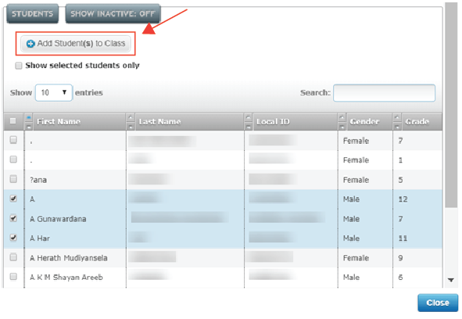
Figure 3.2 Assign New Students screen
To remove students from an ad hoc class:
- Follow the above steps 1–5.
- Under the class list, select Manage Current Students (see Figure 3.3).

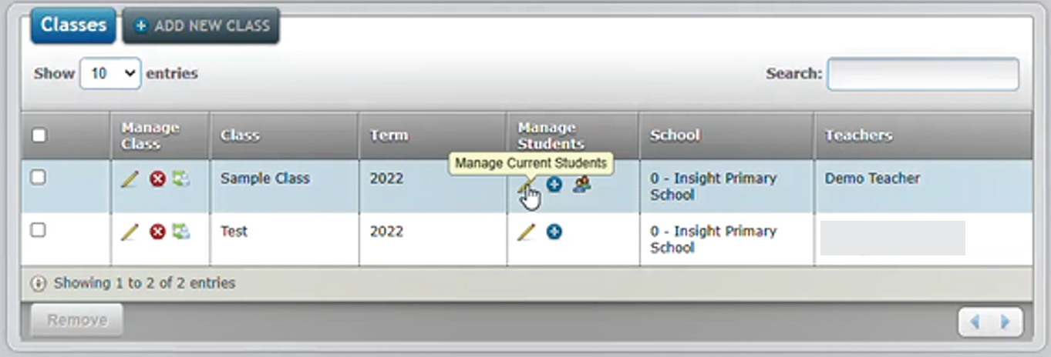
Figure 3.3 Manage Classes screen

- Click on the Remove button on the far left next to the students name you wish to remove from the class (see Figure 3.4). Confirm by clicking ok or cancel to finalise your response. The updated class list will be stored.

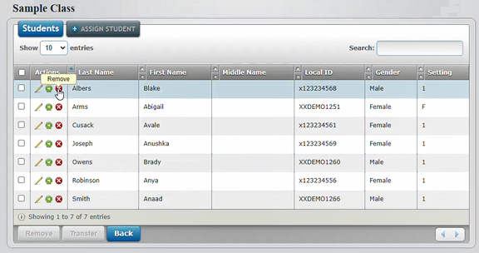
Figure 3.4 Manage Classes screen

To delete an ad-hoc class:
- You must email insight@education.vic.gov.au and indicate that you wish to delete an ad-hoc class from Insight.
- You will receive an email from the Insight team when the class has been deleted.

As many co-teachers as required can be added to a class.
To add a co-teacher:
- On the Insight Home screen, select the Data Admin icon. The Data Admin options will appear.
- Select Manage Classes. The Manage Classes screen will appear (see Figure 3.0).
- Click on the Apply Filters button. The class details will appear in the Classes window (see Figure 3.1).
- Click on the Assign Teacher icon under the Manage Classes column (see Figure 3.1). The Assign Teacher screen will appear (see Figure 3.5).
- Select the Teacher from the Teacher drop-down box.
- Select Co-teachers from the Level of Engagement drop-down box.
- Click on the Submit button. The co-teacher will be added to the class. As many co-teachers as required can be added to a class.
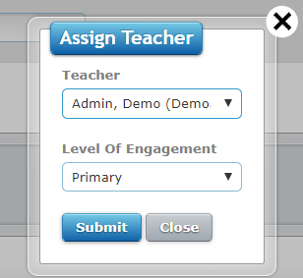
Figure 3.5 Assign Teacher screen

To remove a co-teacher:
- Click on the Edit icon (the pencil) under the Manage Classes column (see Figure 3.2). The Edit Class screen will appear.
- Click on the Remove from Class icon (the red circle with a white cross). A prompt will appear asking if you are sure you want to remove this teacher. Click on the OK button.
- Select Co-teachers from the Level of Engagement drop-down box.
- Click on the Submit button. The co-teacher will be removed from the class.

For Principal only (Manage Staff)
Principals and Insight School Administrators are responsible for ensuring that staff details are accurate, and that accounts are deactivated when a staff member exits the school.
Principals are the only users with rights to edit existing teacher details.
To change a user role:
- On the Insight Home screen, select the Data Admin icon. The Data Admin options will appear.
- Select Manage Users. The Manage Users screen will appear (see Figure 3.6).

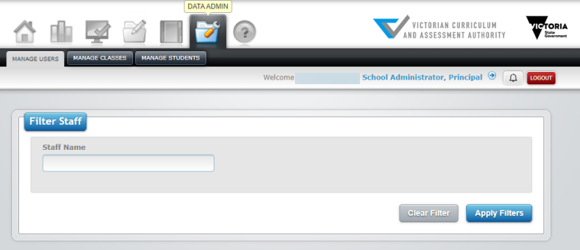
Figure 3.6 Manage Users screen
- Click on the Apply Filters button. The staff list will appear in the Manage Staff window below.
- Select the staff member you would like to edit by clicking on the Edit icon (see Figure 3.7). The Edit Staff screen will appear (see Figure 3.8).
- Select the role you would like to assign from the Role drop-down list.
- Once the relevant changes have been made, click on the Submit button. The updated details will be stored.
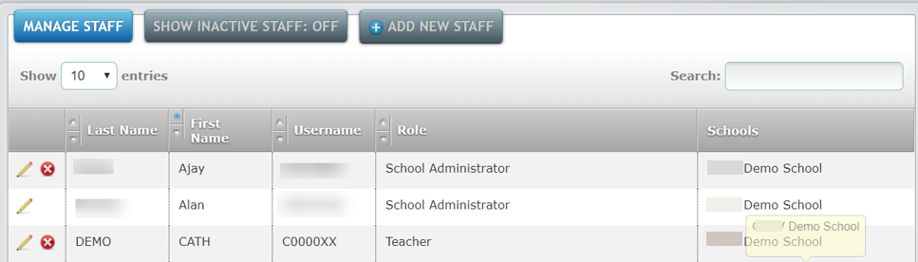
Figure 3.7 Manage Staff window

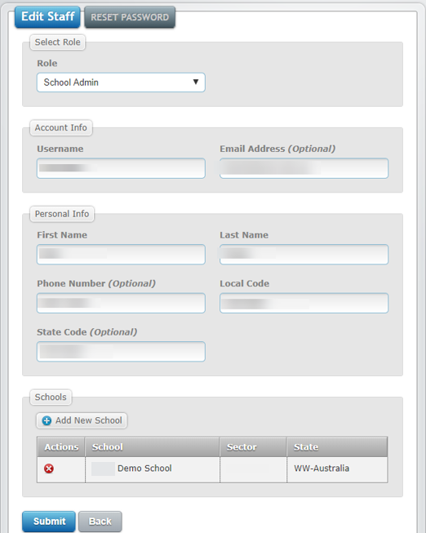
Figure 3.8 Edit Staff screen
To edit a staff members details:
1. Follow the above steps 1–4.
2. Once the relevant changes have been made, click on the Submit button. The updated teacher details will be stored.
To deactivate a user:
1. follow the above steps 1–3.
2. Click on the Deactivate icon (see Figure 3.6). A pop-up screen will appear asking if you are sure you want to deactivate this user. Click on the OK button. The user will now be deactivated.

Managing students
To add new students or add a student into a new class:
- You must email insight@education.vic.gov.au to indicate that you wish to add new students or a new class to Insight. Any advice required to create the required electronic file will be provided.
- You must send the electronic file to insight@education.vic.gov.au. It must reflect the updated students and/or class, at your school.
- You will receive an email from the Insight team when the upload has occurred.

To edit a student’s details:
- On the Insight Home screen, select the Data Admin icon. The Data Admin options will appear.
- Select Manage Students. The Manage Students screen will appear (see Figure 3.9).
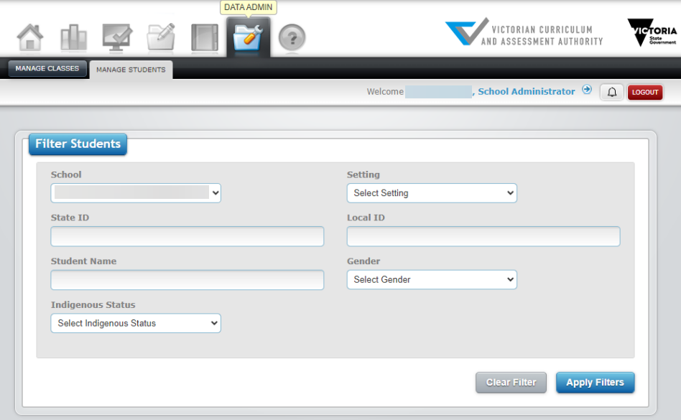
Figure 3.9 Manage Students screen
- Select the year level from the Setting drop-down box.
- Click on the Apply Filters button. The student list will appear in the Students window below (see Figure 3.10).
- Select the student you would like to edit by clicking on the Edit icon (see Figure 3.11). The Edit Student screen will appear.
- Make the relevant changes and click on the Submit button. The updated student details will be stored.
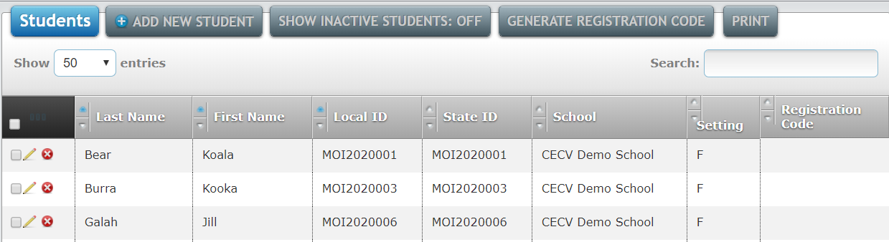
Figure 3.10 Students window
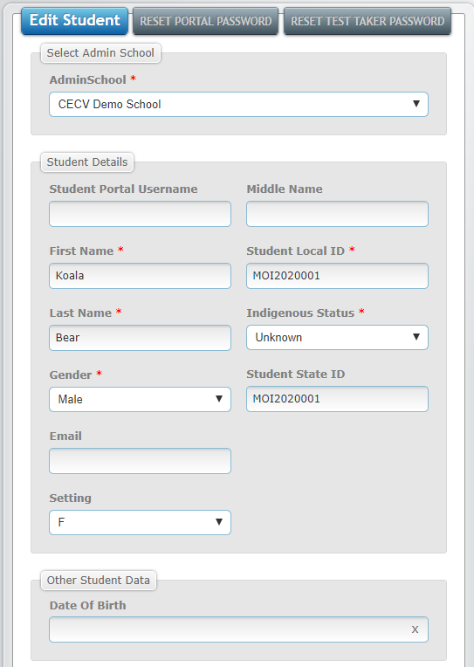
Figure 3.11 Edit Students screen

To delete a class from a student’s profile:
- You must email insight@education.vic.gov.au and indicate that you wish to delete a class from Insight.
- You will receive an email from the Insight team when the class has been deleted.

Managing classes
To change the ‘primary’ teacher:
- You must email insight@education.vic.gov.au to indicate that you wish to change the ‘primary’ teacher of a class on Insight. Any advice required to create the required electronic file will be provided.
- You must send electronic file to insight@education.vic.gov.au. It must reflect the updated teacher’s details, at your school.
- You will receive an email from the Insight team when the upload has occurred.
To add a class teacher:
- On the Insight Home screen, select the Data Admin icon. The Data Admin options will appear.
- Select Manage Classes. The Manage Classes screen will appear (see Figure 3.0).
- Select the ‘primary’ teacher from the Teacher drop-down box.
- Click on the Apply Filters button. The class list(s) for that teacher will appear in the Class window below.
- Select the class you would like to edit by clicking on the Edit icon under Manage Classes (see Figure 3.1). The Edit Class screen will appear (see Figure 3.12).
- If adding another teacher, click on the Assign Teacher icon in the Teachers tab. The Assign Teacher screen will appear.
- Select the teacher you would like to add from the Teacher drop-down list.
- Select the relevant role for the teacher from the Level of Engagement drop-down list.
- Once the relevant changes have been made, click on the Submit button. The updated teacher details will be stored.
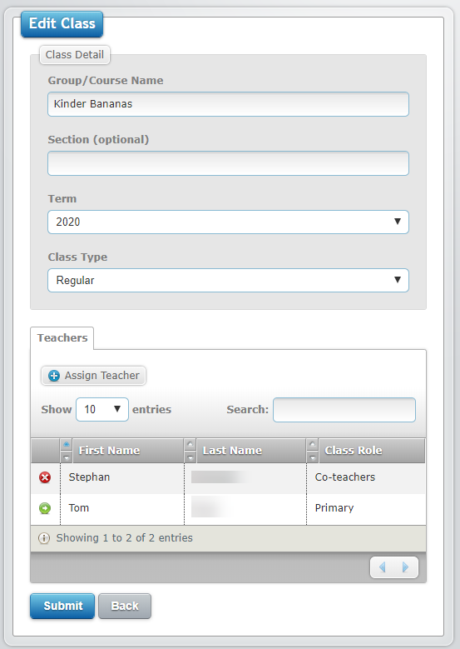
Figure 3.12 Edit Class screen

Section 4: Assessment delivery
For instructions on how to set up assessments for delivery to students and conducting assessments please see the Independent School Assessment Delivery and Reporting User Guide.
For instructions on how to access reporting options:
- Assessment Tools – Insight Platform Reporting Guide
- Transition Learning and Development Statements (TLDS) - School User Guide

Section 5: System support
It is possible to get on-screen help for Insight. This help consists of being directed to the Insight Assessment Platform webpage, where information about Insight and the assessments it houses can be accessed.
To access Insight support:
- On the Insight Home screen, select the Help icon. The Help Resources tab will appear.
- Click on the Help Resources tab. The Insight Assessment Platform Web page will appear.
For further support, contact insight@education.vic.gov.au.

Appendix A: Upload specification and validation rules
Insight Student Detail Upload
Field (Column) | Maximum characters | Status | Type | Details
School Name (A) | 100 | Mandatory | Alphanumeric | School name (suburb), e.g. Holy Name School (RESERVOIR)
School Enumber (B) | 20 | Mandatory | Alphanumeric | School ‘E’ number, e.g. Ennnn, where n is a digit
User name (C) | 50 | Mandatory | Alphanumeric | Staff ‘C’ number, e.g Cnnnnnnn, where n is a digit
User code (D) | 50 | Mandatory | Alphanumeric | Staff ‘C’ number, e.g Cnnnnnnn, where n is a digit
Current Year (E) | 50 | Mandatory | Alphanumeric | Must be current year
Class Name (F) |  | Mandatory | Alphanumeric
Subject (G) |  | Optional | Alphanumeric
Course Number (H) | 200 | Optional | Alphanumeric | Leave blank
Student Last Name (I) | 100 | Mandatory | Alphanumeric
Student First Name (J) | 100 | Mandatory | Alphanumeric
Student Middle Name (K) | 100 | Optional | Alphanumeric
Student ID (L) | 50 | Mandatory | Alphanumeric | Student VSN number
School specific student code (M) | 50 | Optional | Alphanumeric | Must be unique across sector. Concatenating your school code to the front of your school based school identifier will make it unique. E.g.  If your school code is "E1003"  and your student code is "00321" then this code could be  "E1003-00321"
Student Gender (N) | 1 | Mandatory | Alphanumeric | M = Male  F = Female  U = Unknown  X = Gender X
Student ATSI Status (O) | 2 | Optional | Alphanumeric | K = Aboriginal  T = Torres Strait Islander  N = None  B = Both Aboriginal and Torres Strait Islander  NA = Not Applicable/Unknown
Student Year Level (P) | 50 | Mandatory | Alphanumeric | Any value from F-12 or UG for Ungraded
Student Date of Birth (Q) |  | Mandatory | Alphanumeric | DD/MM/YYYY format
Field (Column) | Maximum no. of characters | Status | Type | Details
Role (A) | 50 | Mandatory | Alphanumeric | Insight User Role
School Name (B) | 100 | Mandatory | Alphanumeric | School name (suburb), e.g. Holy Name School (RESERVOIR)
School Code (C) | 20 | Mandatory | Alphanumeric | School ‘E’ number, e.g. Ennnn, where n is a digit
Surname (D) | 50 | Mandatory | Alphanumeric
First Name (E) | 50 | Mandatory | Alphanumeric
User code (F) | 50 | Mandatory | Alphanumeric | Staff ‘C’ number, e.g Cnnnnnnn, where n is a digit
User code(G) | 50 | Mandatory | Alphanumeric | Staff ‘C’ number, e.g Cnnnnnnn, where n is a digit
Blank | 100 |  | Alphanumeric | Leave blank
Phone number (I) | 50 | Optional | Alphanumeric
Email (J) | 100 | Mandatory | Alphanumeric | Must be valid email address

