Instructions on completing the Unit 3 Audit Questionnaires

**Please read these instructions before you commence the audit questionnaire.

If there is more than one person teaching Units 3 and 4 of this study, please make sure this audit is a combined response. Only one response will be considered from each school.

The audit is conducted early to allow for early intervention (if required). The VCAA therefore understands that not all information provided will be final. Please answer each question based on the best current information.

We strongly recommend using Google Chrome or Mozilla Firefox web browsers to complete the audit. .

Time required to complete:

It may take between one and three hours to complete the online study-specific audit questionnaire.

The collection of information in preparation to complete the online study-specific audit questionnaire may take between three and six hours.

Resources:

We recommend reviewing the Advice for teachers documentation on the relevant VCE study webpages for explanation and definition of terms used within the questionnaires.

Before commencing the audit questionnaire, schools are encouraged to refer to the School-based Assessment Audit: Information and advice for schools.

PDF available:

This audit must be completed online. A PDF document of the questionnaire is available for reference purposes through VASS downloads – search the keyword ‘AUDIT’. You may need to ask your VASS Administrator to download the questionnaire. If you and your VASS administrator are unable to access the PDF version of the questionnaire, please email school.assessment.vcaa@education.vic.gov.au.

The PDF should be printed out and used to assist in preparing the answers to this audit. Please note that the PDF shows every question contained in the questionnaire. However, the online version of the questionnaire contains in-built logic, which means that based on your selections, some questions will not appear.

It is recommended that answers are prepared in advance using a text editor such as Microsoft Word. Answers can then be copied and pasted into the online questionnaire from the text document. Please note that only text, bullet points and numbered lists can be pasted into input boxes. Tables and images cannot be pasted into input boxes.

Navigation:
To move forward or backward through the online audit questionnaire, use the [PREVIOUS PAGE] and [SAVE AND CONTINUE] buttons displayed in the bottom corners of each page.
Do not use the arrows in your web browser as this can exit you out of the audit without saving.

Uploading files:

Please note that for some questions, only one file can be attached. Where this is the case and you have multiple documents to upload, please combine them into one document or a zip file before uploading.

Please ensure the document has completed uploading before clicking [SAVE AND CONTINUE]. If the wrong document is uploaded, simply upload the correct document over the top of the existing one.
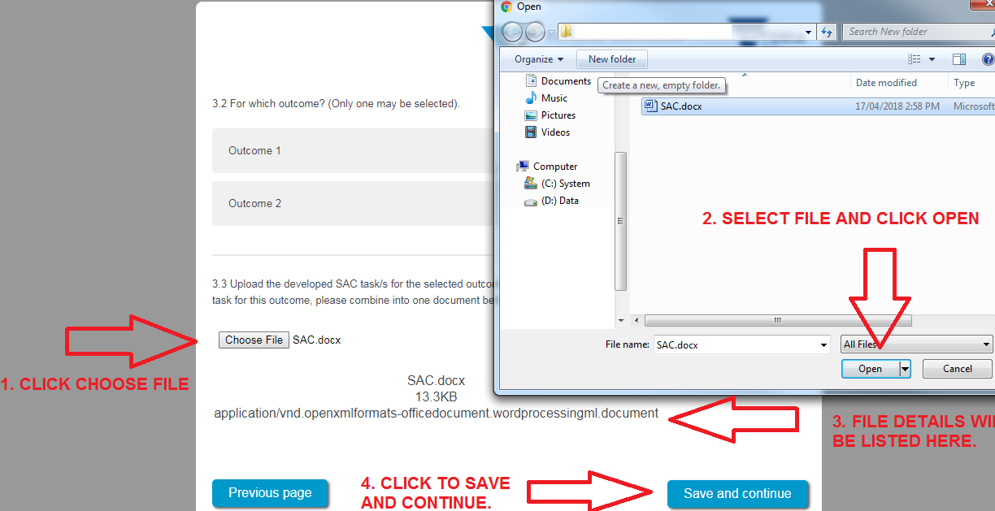

Connectivity:
To avoid losing information if your internet connection drops out, we recommend that answers are prepared prior to commencing the online audit.
The audit can be completed at a later stage once commenced.
To recommence the audit please ensure you:
- use the [SAVE AND CONTINUE] button located in the bottom right-hand corner to save entered information
- use the same computer and web browser on which the audit was commenced, as a copy of your responses will have been saved.
In the event there are any technical issues, please contact the School-based Assessment Audit team for assistance on (03) 9059 5166 or via email at school.assessment.vcaa@education.vic.gov.au. Generally, 'lost' responses are retrievable.

Input boxes:
For most input boxes, the size of the box can be extended by dragging the handle in the bottom right-hand corner of the input box. The handle looks like two diagonal lines.
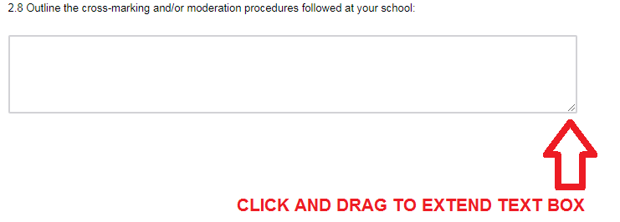

Copy of response:
- Once the [PREVIEW RESPONSE] button is pressed at the conclusion of the online audit, a full preview of the responses you have provided will be shown. A PDF of this can be downloaded. Once you have viewed the PDF, you can go back to edit any of the responses provided by using the [PREVIOUS PAGE] button.
- If a document is uploaded to the audit, it can no longer be viewed in the response review. Please check the document prior to uploading. If the wrong document is uploaded, simply upload the correct document over the top of the existing one.

