VCE Physical Education
Units 3 and 4, 2018–2024

Clarification of content:
Biomechanical principles

Introduction
This supplementary material has been developed to guide teachers in their approach to biomechanical principles as part of VCE Physical Education (2018–2024).
The information provided specifically relates to VCE Physical Education, Unit 3, Area of Study 1: How are movement skills improved?. This area of study includes key knowledge of:
- biomechanical principles for analysis of human movement including:
- angular and linear kinetic concepts of human movement: Newton’s three laws of motion, inertia, mass, force, momentum and impulse
- angular and linear kinematic concepts of human movement: distance, displacement, speed, velocity, acceleration and projectile motion (height, angle and speed of release)
- equilibrium and human movement: levers (force, axis, resistance and the mechanical advantage of anatomical levers), stability and balance (centre of gravity, base of support and line of gravity).

Important considerations in the approach to biomechanical principles
The following information should be considered when delivering the key knowledge and key skills related to biomechanical principles.
- In relation to biomechanics, the VCE Physical Education study design requires students to undertake qualitative analysis of movement skills. Students need to understand the biomechanical principles listed in the study design and apply these to a range of movement contexts. They are required to understand the relationship between variables and apply this understanding in a range of movement contexts. Students may collect numerical data (such as distances or times) to compare or identify patterns or trends; however, quantitative analysis, including calculations, is not required. Students are not permitted to take a calculator into the end-of-year examination.
- The assessment task for Unit 3, Area of Study 1, Outcome 1 that assesses biomechanical and skill acquisition principles requires the collection of primary data. Students are encouraged to explore biomechanical principles through movement as much as possible and collect primary data during these experiences.

The following information contains recommended points of emphasis for teachers when delivering these concepts from the key knowledge related to biomechanical principles.

Impulse
- Impulse is the change in momentum of an object and is the product of force (F) and the time (t) during which the force acts. (impulse = F × t)
- The greater the impulse, the greater the change in momentum. Momentum (p) is the product of mass (m) and velocity (v). (p = m × v)
- Impulse can be applied to an object to either increase or decrease the momentum of the object.
Using impulse to generate momentum of a stationary object:
In many throwing or striking sports, an individual will attempt to cause a large change in the velocity of an object (and therefore a large change in momentum) by applying a large impulse to the object. This is done by maximising the force applied and/or the time over which it is applied.
For example, hockey players use impulse to generate momentum when using two different techniques (a push pass and a strike) to move a hockey ball:
- In the push pass, the performance goal for a hockey player is accuracy. The player keeps their stick in contact with the ball for a longer period of time, which increases the time over which the force is applied, increasing the impulse to the ball. For a longer pass, the player can increase the force applied through the stick (that is, through the application of the biomechanical principle of summation of momentum), which will further increase the impulse.
- In a strike, the performance goal is speed. While the contact time between the ball and the stick is short, the player will likely apply a much greater level of force (than for the push pass), which will increase the impulse applied to the ball.
Using impulse to decrease momentum of a moving object (manipulating the variables of impulse):
Students are expected to describe how the variables of impulse (force and time) can be manipulated to decrease the momentum of an object. Examples could include an airborne individual landing safely or someone catching an object effectively and safely.
When asked to compare different techniques to stop the same object (which has the same mass and is travelling with the same velocity and therefore possesses the same momentum), it is important to remember that the same impulse will be required to change the momentum of the object and bring it to a stop. Different techniques will manipulate the force and time variables of the impulse equation differently, but they will still generate the same impulse.
Figure 1 is a graphical representation of the landing forces created by the same airborne individual who lands from the same height, either with a ‘stiff’ knee landing or a ‘bent’ knee landing.
When using a ‘stiff’ landing, the individual will receive a large impact force through the body, as this force is being absorbed in a short period of time (illustrated by a sharp increase in force over a short period of time) hence this technique can cause injury.
When the same individual, landing from the same height (possessing the same momentum), lands ‘softly’, by bending their knees and absorbing the impact force over a longer period of time, they will still come to rest but with less risk of injury because of the smaller impact force. This is illustrated by a smaller increase in force but extended over a longer period of time.
In both examples described above, the impulse applied is the same. Given both techniques will return the airborne individual to a stationary position, the change in momentum is the same. However, the way in which the impulse equation is manipulated is different. This is shown in Figure 1: the two different graphs represent the different techniques used to manipulate the impulse equation, but the area under each graph, representing the impulse of each technique, is the same.
Figure 1: Using two landing techniques to manipulate force and time, for the same change in momentum (impulse)
= impulse
force
time
‘stiff’ knee landing
‘bent’ knee landing
Source: Adapted from SP Flanagan 2014, Biomechanics: A case-based approach, 1st edn, Jones & Bartlett.

Projectile motion (height, angle and speed of release)
- Projectile motion refers to the motion that any object or body possesses when released into the air. A projectile is influenced by air resistance and gravity.
- Air resistance is a force working against the horizontal motion of a projectile, while gravity is a force working against vertical motion.
- Three factors affect the flight path (trajectory) of a projectile: speed of release, angle of release and height of release. These factors can be manipulated to achieve a particular performance outcome, such as maximising distance, maximising height, or maximising or minimising flight time.
Students are only required to consider factors that contribute to the release of a projectile. Concepts such as drag forces and lift forces are not covered in the VCE Physical Education study design.
VCE Physical Education students are encouraged to learn about the effect the three factors have on the flight path of a projectile through movement-based activities. This can include simple activities within the classroom such as playing noughts-and-crosses using beanbags.

Speed of release
The distance a projectile travels is a product of horizontal velocity and flight time (flight time is influenced by the height of release and vertical velocity at release).

Angle of release
A projectile is usually released at an angle between 0° and 90°. However, there are examples where an individual aims to minimise flight time (see the cricket example on page 5) and they release a projectile below horizontal (that is, an angle less than 0°).
The angle of release is measured through the centre of gravity of the object.
Provided the height of release is approximately equal to the landing height (see the soccer example on page 5), an angle of release of approximately 45° will maximise horizontal distance.
To decrease the maximum height of the trajectory and flight time of a projectile, a smaller angle of release is required.
To increase the maximum height of the trajectory and flight time of a projectile, a larger angle of release is required.

Height of release
If the speed and angle of release are kept constant, changing the height of release will affect the horizontal distance the projectile travels.
If the height that the projectile is being released from is higher than the landing position (positive height of release), the projectile will naturally travel further horizontally (assuming speed and angle of release are kept the same). Therefore, it might be appropriate to reduce the angle of release if the intended landing position remains the same (see the cricket example on the following page).
If the height that the projectile is being released from is lower than the landing position (negative height of release), the projectile will naturally travel less distance horizontally (assuming speed and angle of release are kept the same). Therefore, it might be appropriate to increase the angle of release if the intended landing position remains the same (see the netball example below).

Applied examples

Shooting a netball goal:

Performance outcome required is to shoot the ball over the defender to reach the ring.
Projectile is the ball being shot by the goal attack.
Height of release of the ball is below the relevant finishing point (the ring).
As the goal attack appears to be quite close to the ring, the horizontal speed of release does not need to be as great as the vertical speed of release that is needed to clear the defender and reach the ring.
A larger angle of release is needed to clear the defender.

Kicking a soccer ball for distance:
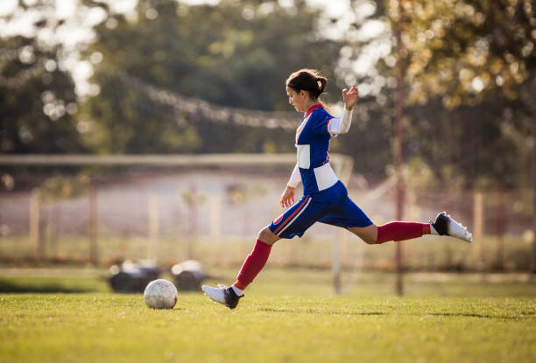

Performance outcome required is to kick the ball for maximal horizontal distance.
Projectile is the ball being kicked by the player.
Height of release of the ball is similar to the landing point.
Given the aim is to achieve maximal horizontal distance, the horizontal and vertical speed of release needs to be similar (achieving a parabolic flight path).
The angle of release required is approximately 45°.

Bowling a cricket ball:
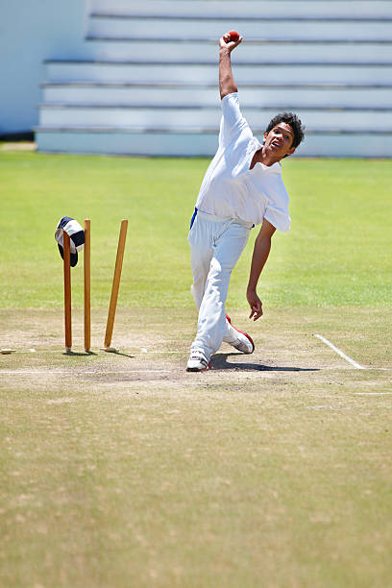

Performance outcome required is to land the ball on a particular spot on the pitch, just before it reaches the batter.
Projectile is the ball being bowled by the player.
Height of release of the ball is above the landing point.
If the spot aimed for is close to the batter, there will be a greater horizontal speed of release. If the bowler wishes to achieve greater bounce, the vertical speed of release would be increased.
A small angle of release is required. The angle of release is likely below horizontal (that is, less than 0°).
The performance advantage of a taller bowler is an increased height of release. If bowling with the same speed of release as a shorter bowler, the taller bowler can reduce the angle of release to hit the same spot on the pitch. This will increase the bounce the ball has after hitting the pitch

Levers
- A lever is a simple machine that consists of a rigid beam (for example, an arm or leg bone in the body) that rotates around a fixed point (an axis or fulcrum).
- A lever rotates around an axis when force (or effort) is applied, causing the lever to move against a resistance (or load).
- There are three classes of lever: first, second and third.
- A lever system can be used to either multiply force and move a heavy resistance more easily or to produce range of motion and multiply speed.
- A lever in the body is made up of:
- the axis or fulcrum: the fixed joint/axis in the body that the lever moves around
- the force (effort): the muscles that contract to generate the force to move the lever
- the resistance: the bone of the body and whatever is being held or moved by the bone.
- The measurement of whether a lever system is designed to multiply force or multiply speed is its mechanical advantage.
- The mechanical advantage equation is:
$$\frac{force arm}{resistance arm}$$

(where force arm is the distance from the axis to the force and resistance arm is the distance from the axis to the resistance)
- An increased mechanical advantage (that is, greater than 1) will improve the ability to move a heavy resistance more easily. A decreased mechanical advantage (that is, less than 1) can be referred to as a mechanical disadvantage in the ability of the lever to move heavy resistance; however, a decreased mechanical advantage will increase the range of motion and speed the lever can produce, provided that enough force can be applied to overcome the inertia of the lever.

- Third class levers are the most common types of lever in the human body. These levers have a longer resistance arm than force arm and therefore have a mechanical disadvantage, but the lever has the ability to produce greater speed.
It is expected that students should be able to identify first, second and third class levers. In addition, students should be able to describe the potential performance advantage of third class levers and apply this to a range of human movement or sporting examples.

Three classes of lever
A = axis F = force R = resistance
First class lever:

R
F
A

Second class lever:

R
F
A

Third class lever:

R
F
A

Applied example – third class lever
A = axis (shoulder joint) F = force (applied through the hands gripping the bat)
R = resistance (bat being swung)
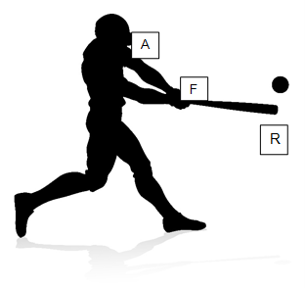
- The baseball bat is a third class lever, as the force is in between the axis and the resistance.
- The mechanical advantage is less than 1 (or a mechanical disadvantage) as the resistance arm is larger than the force arm.
- The longer the resistance arm, the greater the inertia that needs to be overcome. Hence, the level of force that can be applied to get the bat moving needs to be considered when deciding on the length of the bat. This is particularly important when considering bat length and mass for children.
- A longer lever (and resistance arm) can multiply the speed of the lever due to its larger range of motion. If the same angular velocity is applied to a longer bat, the end of the bat will travel further in an arc than the handle, in the same period of time. The bat will possess a greater linear velocity that can be transferred to the ball. This is due to the equation:
linear velocity = angular velocity × radius
(where radius is length of the lever)

Acknowledgements
The information in this supplement was researched and written by Chris Clark. The information was reviewed by Physical Education and Sport Science academics and a number of VCE Physical Education teachers.
Picture acknowledgements: p. 4 top iStock.com/VasjaKoman, bottom iStock.com/skynesher; p. 5 iStock.com/PeopleImages; p. 7 iStock.com/ChrisGorgio.

References
Blazevich AJ 2010, Sports biomechanics – the basics: optimising human performance, 3rd edn, Bloomsbury.
Flanagan SP 2014, Biomechanics: A case-based approach, 1st edn, Jones & Bartlett.
Grimshaw P, Fowler N, Lees A and Burden A 2006, BIOS instant notes in sport and exercise biomechanics, Taylor & Francis.
McGinnis PM 2013, Biomechanics of sport and exercise, 3rd edn, Human Kinetics.
Nunome H, Hennig E and Smith N (eds) 2017, Football biomechanics, Routledge, https://doi.org/10.4324/9781315638553.
Szymanski DJ, Szymanski JM, Schade RL, Bradford TJ, McIntyre JS, DeRenne C and Madsen NH 2010, ‘The relation between anthropometric and physiological variables and bat velocity of high-school baseball players before and after 12 weeks of training’, Journal of Strength and Conditioning Research, 24(11):2933–2943, https://doi.org/10.1519/JSC.0b013e3181f0a76a.
Thatcher J 2009, Sport and exercise science, Learning Matters.
Watkins J 2014, Fundamental biomechanics of sport and exercise, Taylor & Francis.

