Moderating student work samples – moving from Levels A–D into the
F–10 curriculum, English
Annotated student work samples

Authorised and published by the Victorian Curriculum and Assessment Authority
Level 7, 2 Lonsdale Street
Melbourne VIC 3000
© Victorian Curriculum and Assessment Authority 2022

No part of this publication may be reproduced except as specified under the Copyright Act 1968 or by permission from the VCAA. Excepting third-party elements, schools may use this resource in accordance with the VCAA educational allowance. For more information go to https://www.vcaa.vic.edu.au/Footer/Pages/Copyright.aspx.
The VCAA provides the only official, up-to-date versions of VCAA publications. Details of updates can be found on the VCAA website at www.vcaa.vic.edu.au.
This publication may contain copyright material belonging to a third party. Every effort has been made to contact all copyright owners. If you believe that material in this publication is an infringement of your copyright, please email the Copyright Officer vcaa.copyright@edumail.vic.gov.au
Copyright in materials appearing at any sites linked to this document rests with the copyright owner/s of those materials, subject to the Copyright Act. The VCAA recommends you refer to copyright statements at linked sites before using such materials.
The VCAA logo is a registered trademark of the Victorian Curriculum and Assessment Authority.

Contact us if you need this information in an accessible format - for example, large print or audio.
Telephone (03) 9032 1635 or email vcaa.media.publications@edumail.vic.gov.au

Contents
Introduction 1
Context 1
Key principles 1
Framework 2
The student work samples 3
Sample 1 4
Sample 2 6
Sample 3 8
Sample 4 10
Sample 5 12
Sample 6 14

Introduction

Context
The Victorian Curriculum and Assessment Authority (VCAA) partnered with Concord School, a specialist school, and Dr Anna Bortoli, a special education consultant, in a project to moderate written work samples produced by students with disabilities and additional learning needs.
In this document, six work samples from students with disabilities and additional learning needs (provided by Concord School) have been moderated using the Victorian Curriculum F–10, English. The following case study documents the processes used by the group to moderate, including some discussions and reflections.
These work samples, and the process of moderating each one, illustrate how students can demonstrate a wide range of knowledge and skills. While many of the students whose work is represented here are not yet able to completely demonstrate consistent foundation literacy skills (such as use of punctuation, capitalisation and spelling), many of them can demonstrate some complexity in shaping their experiences and ideas, the ability to edit and self-correct, and the capacity to appropriately use and change tensing. It is important to assess student work holistically, highlighting what is being demonstrated, rather than identifying only the gaps.
Students attending Concord School are funded through the Program for Students with Disabilities under the criteria of Intellectual Disability.
A note from the VCAA:
The content descriptions and the achievement standards in the Victorian Curriculum represent the mandated curriculum schools implement and assess. Implementation and pedagogy are school-based decisions. Teachers and schools are empowered to enact the curriculum in their classrooms in ways that best meet their cohort, context and community.
The content descriptions and the achievement standards indicate proficiency in knowledge and skills at each level. It is important for teachers and schools to continue to provide students with new knowledge and skills as they achieve proficiency, as well as explore any objectives in terms of quality in the context of their own classrooms.

Key principles
Key principles were agreed on by the group:
- Attitudes around learning for students with disabilities have moved to a strength-based model.
- Students with disabilities learn in many ways; it is critical that diversity is acknowledged, and assessment of learning is individualised.
- Collaborative moderation is very important.
- A framework is important for collaborative moderation to provide for objectivity, fairness and consistency.

Framework
The following table was the framework used by the group for this moderation.
Student name: | Year level:
Learning area and relevant achievement standard:
1. Initial thoughts on the student’s learning as shown by the work sample. (Circle one.)
Working at the achievement standard
Working towards the achievement standard
2. What is the learning demonstrated by the student as shown in the work sample? (Be specific.)
3. What are the gaps in the student’s learning as indicated by the work sample? (Be specific.)
How might the teacher address these gaps in this learning area?
4. What are the highlights in the student’s learning as shown in the work sample? (Be specific.)
How might the teacher extend the student in this learning area?

The student work samples
The group moderated student work samples provided by Concord School.
These samples were all generated from the same activity: students engaging with and describing their experiences in a garden. The task involved students using a picture to engage with their earlier experiences in the garden. They were asked to label the picture, and to recount, in order, what they did in the garden. Students were offered several supports, including a word wall that included visuals and words from which they could select (or copy) words to label the picture and to recount their experiences or the events. The use of visual supports such as this word wall, also known as an Assisted Language Display (ALD), capitalises on the student’s strengths in visual processing.
This activity offered an authentic experience for students and connected across different environments – both school and home.
The group selected six samples to moderate, discussing the activity, the individual student, the evidence in the work sample (highlights and gaps), and opportunities for extension in teaching and learning.
Note, the word wall that could be used as assistance in these work samples was co-created by the students and their teachers. After their experiences in the garden, the students and teachers shared their thoughts, brainstormed language and created the word wall. Those words were then made available to students on the wall of the classroom as they worked on their recounts. Some students had the words transferred onto paper that they could have them beside them on their desk. Other students had the words aligned to images, to use as a reference.

Sample 1
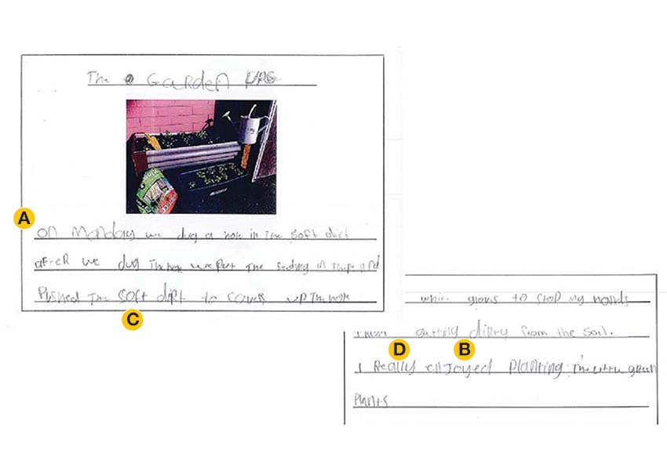

Assistance provided to the student
- Word wall
- Some prompting (‘Can you do more?’)
- Largely independent work

Highlights
- Strong sequencing (‘On Monday’, ‘after’) (see ‘A’ on the sample)
- Good use of tenses (see ‘B’ on the sample)
- One full stop
- Use of adjectives and describing words, used appropriately (see ‘C’ on the sample)
- Use of adverbs, used appropriately (see ‘D’ on the sample)
- Sentence structures are appropriate

Gaps
- Lacks punctuation
- Lacks appropriate use of capital letters
- Lacks a full knowledge of upper- and lower-case letters

Opportunities
- Occupational therapy (OT) support for handwriting
- Support for punctuation and capitalisation
- Demonstrate and support the use of pronouns
- Extend vocabulary
- Support self-initiation
- Move into creative or narrative writing and exposure to other genres

Mapped to the Victorian Curriculum F–10, English
This work sample provides evidence of the student working towards the standard for Level 1.
Relevant extracts from the Level 1 achievement standard include:
- provide details about ideas or events, and details about the participants in those events
- accurately spell words with regular spelling patterns and use their knowledge of blending and segmenting, and many simple and high-frequency words to write predictable words
- use capital letters and full stops appropriately.

Discussion
This student has a strong sense of the task, offering an emotional and engaged recount and moving into other aspects of writing, including opinion (‘I really enjoyed …’). There are some elements of foundational literacy not yet established (the consistent use of punctuation and the consistent use of capital letters); however, approaching the English F–10 curriculum holistically, this student is demonstrating skills and knowledge clearly within Level 1 (see the achievement standard extracts above). It is possible that the cognitive load required for this student to demonstrate the skills at Level 1 has had implications for the foundational literacy skills. There is no doubt that while the student does require assistance with some of the foundational skills (see above in Opportunities), extending them in terms of writing for purpose and context is also appropriate (see below in Planning the next stage of student learning).

Planning the next stage of student learning
When planning the next stage of the teaching and learning program to progress this student’s learning, focus on the following skills and knowledge in Level 1.
Level 1 content descriptions:
- Recognise that different types of punctuation, including full stops, question marks and exclamation marks, signal sentences that make statements, ask questions, express emotion or give commands (VCELA190)
- Recreate texts imaginatively using drawing, writing, performance and digital forms of communication (VCELT192)

Sample 2
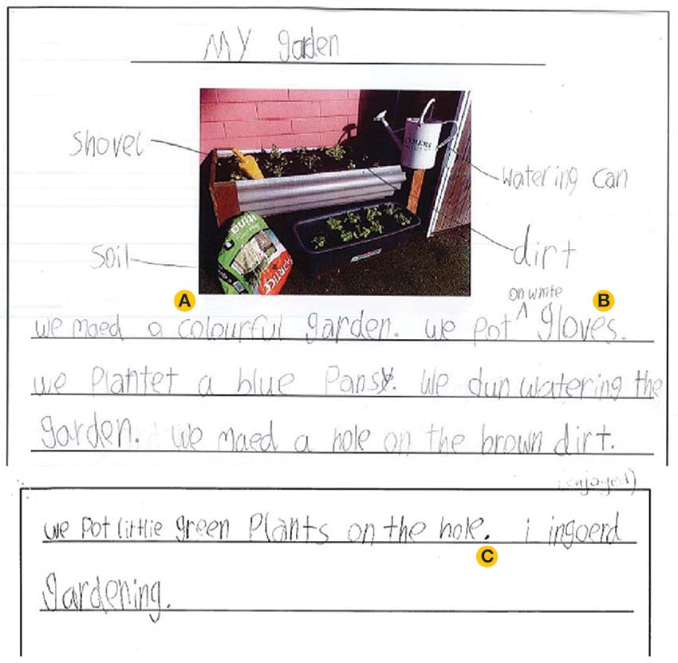

Assistance provided to the student
- Use of instructions
- Word wall
- Some prompting (‘Reread your work’)
- Largely independent

Highlights
- Strong use of adjectives (see ‘A’ on the sample)
- Evidence of editing and corrected spelling (see ‘B’ on the sample)
- Some sequencing
- Uses punctuation – consistent use of the full stop (see ‘C’ on the sample)
- Lovely opening sentence: an overview sentence
- Opinion sentence at the end
- Clear understanding of the task

Gaps
- Use of phonetic spelling and approximation of spelling
- Inconsistent use of capitalisation
- Appears to struggle with vowels and some consonants (lacks some sound–letter knowledge)
- Sequencing lacks a logical order (though the recount may have reflected the student’s experience in the garden)
- Inconsistent use of prepositions (‘on’ rather than ‘in’)

Opportunities
- Support decoding and correct spelling
- Support to develop an understanding of capitalisation
- Introduce conjunctions to develop cohesion
- Further support tensing and the use of prepositions

Mapped to the Victorian Curriculum F–10, English
This work sample provides evidence of the student working towards standard for Foundation Level.
Relevant extracts from the Foundation Level achievement standard include:
- use familiar words and phrases and images to convey ideas
- shows evidence of letter and sound knowledge, beginning writing behaviours and experimentation with capital letters and full stops
- correctly form all upper- and lower-case letters.

Discussion
Sample 2 demonstrates a gap between foundational literacy skills and higher order skills. This sample indicates gaps in sound–letter knowledge (through the use of phonetic spelling) but also shows the capacity to reread work and to edit. This skill appears at Level 2 in the curriculum (‘Reread and edit text for spelling, sentence-boundary punctuation and text structure’ VCELY231). As for Sample 1, it is important to see the curriculum holistically, acknowledging all the skills demonstrated by the student and taking further steps and opportunities to engage with both the skills that are missing and the skill sets that are evident, to foster and extend these skills.

Planning the next stage of student learning
When planning the next stage of the teaching and learning program to progress this student’s learning, focus on the following skills and knowledge in Foundation Level.
Foundation Level content descriptions:
- Understand that punctuation is a feature of written text different from letters and recognise how capital letters are used for names, and that capital letters and full stops signal the beginning and end of sentences (VCELA156)
- Understand that spoken sounds and words can be written and know how to write some high-frequency words and other familiar words including their name (VCELA157)
- Understand that sounds in English are represented by upper- and lower-case letters that can be written using learned letter formation patterns for each case (VCELY162)

Sample 3

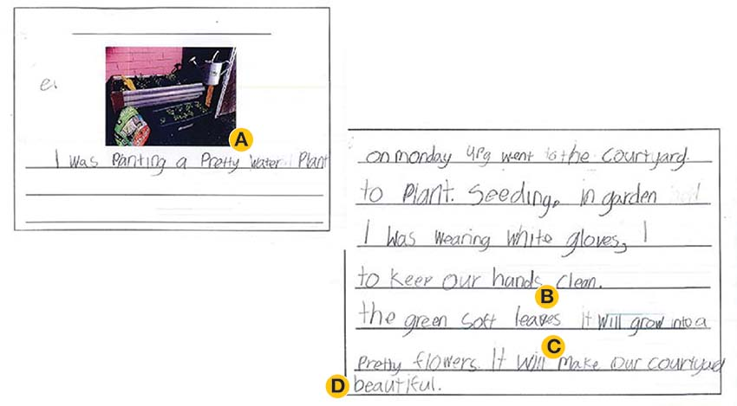

Assistance provided to the student
- Instructions
- Word wall
- Independent work

Highlights
- Well-formed and quite complex ideas
- Clear understanding of and connection with the task
- Use of adjectives (see ‘A’ on the sample)
- Use of plurals (see ‘B’ on the sample)
- Extended vocabulary
- Sequencing through tensing (moves from ‘was wearing’ to ‘will make’) (see ‘C’ on the sample)
- Clear handwriting
- Demonstrates opinion (see ‘D’ on the sample)

Gaps
- Lacks consistent use of appropriate punctuation
- Requires more support to develop sentence structures
- Lacks a clear flow of events

Opportunities
- Model sentence structures
- Model the elements of a recount
- Explore purpose in more detail – writing to inform and entertain
- Extend the use of tenses

Mapped to the Victorian Curriculum F–10, English
This work sample provides evidence of the student working towards standard for Level 1.
Relevant extracts from the Level 1 achievement standard include:
- provide details about ideas or events, and details about the participants in those events
- accurately spell words with regular spelling patterns and use their knowledge of blending and segmenting, and many simple and high-frequency words to write predictable words
- use capital letters and full stops appropriately.

Discussion
As with Samples 1 and 2, this student demonstrated complex understandings. Instead of sequencing through prepositions or temporal phrasing, this student has signalled sequence through tensing. This skill appears at Level 3 – ‘Understand that verbs represent different processes (doing, thinking, saying, and relating) and that these processes are anchored in time through tense’ VCELA262. This student is also able to demonstrate a sensitivity to the experience, and to invest emotion in the recount (‘the soft green leaves it will grow into a pretty flowers It will make our courtyard beautiful.’) However, again like Samples 1 and 2, this student has not yet consolidated some of the foundational literacy skills, such as word sequence (‘I was wearing white gloves, I to keep our hands clean.’), spelling (‘seeding’), punctuation (missing full stops) and capitalisation. While developing these skills is important, so too is the need to extend the skills that have been demonstrated, like the use of tensing at Level 3.

Planning the next stage of student learning
When planning the next stage of the teaching and learning program to progress this student’s learning, focus on the following skills and knowledge in Level 1.
Level 1 content descriptions:
- Create short imaginative and informative texts that show emerging use of appropriate text structure, sentence-level grammar, word choice, spelling, punctuation and appropriate multimodal elements (VCELY194)
- Recognise that different types of punctuation, including full stops, question marks and exclamation marks, signal sentences that make statements, ask questions, express emotion or give commands (VCELA190)
- Understand how to use visual memory to write high-frequency words, and that some high-frequency words have regular and irregular spelling components (VCELA184)

Sample 4
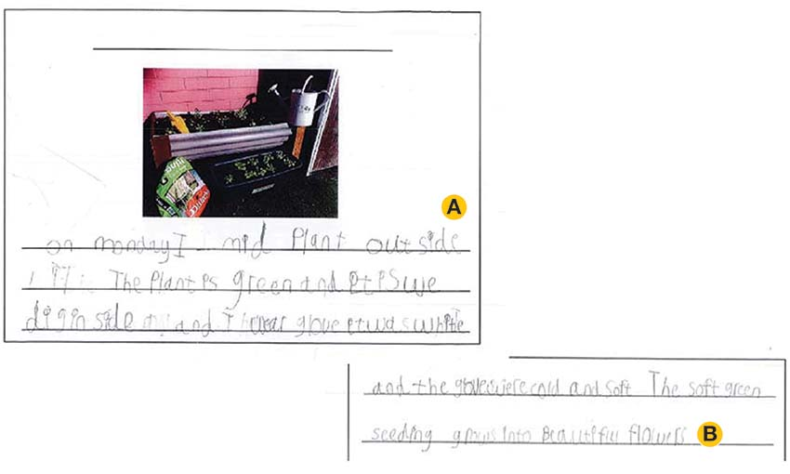

Assistance provided to the student
- Instructions
- Word wall
- Largely independent

Highlights
- Can select appropriate words and copy accurately (see ‘A’ on the sample)
- Includes common words
- Good sound–letter knowledge
- Demonstrates an understanding of the purpose of the task
- Demonstrates an ability to invest emotion into the recount (see ‘B’ on the sample)

Gaps
- In places, the handwriting is difficult to read
- Lacks sequencing, which can compromise a reader understanding what is being conveyed
- Stream of consciousness rather than a clear, sequential recount
- Lacks linking and cohesion
- Uneven sentence structures – begins well but tapers off
- Spacing between the words makes it difficult to read
- Lacks punctuation

Opportunities
- Model consistent spacing between words
- Provide more assistance with forming letters
- Provide assistance with sentence structures, possibly using colourful semantics
- Model punctuation
- Continue to foster the use of emotion in writing and recounting

Mapped to the Victorian Curriculum F–10, English
This work sample provides evidence of the student working towards standard for Foundation Level.
Relevant extracts from the Foundation Level achievement standard include:
- use familiar words and phrases and images to convey ideas
- shows evidence of letter and sound knowledge, beginning writing behaviours and experimentation with capital letters and full stops
- correctly form all upper- and lower-case letters.

Planning the next stage of student learning
When planning the next stage of the teaching and learning program to progress this student’s learning, focus on the following skills and knowledge in Foundation Level.
Foundation Level content descriptions:
- Create short texts to explore, record and report ideas and events using familiar words and beginning writing knowledge (VCELY160)
- Participate in shared editing of students’ own texts for meaning, spelling, capital letters and full stops (VCELY161)
- Understand that punctuation is a feature of written text different from letters and recognise how capital letters are used for names, and that capital letters and full stops signal the beginning and end of sentences (VCELA156)

Sample 5
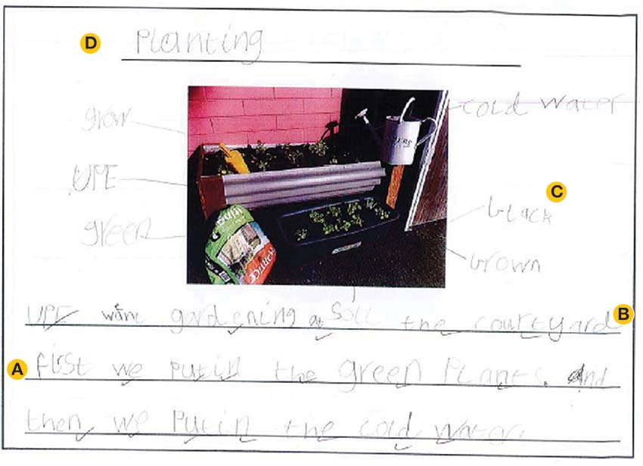
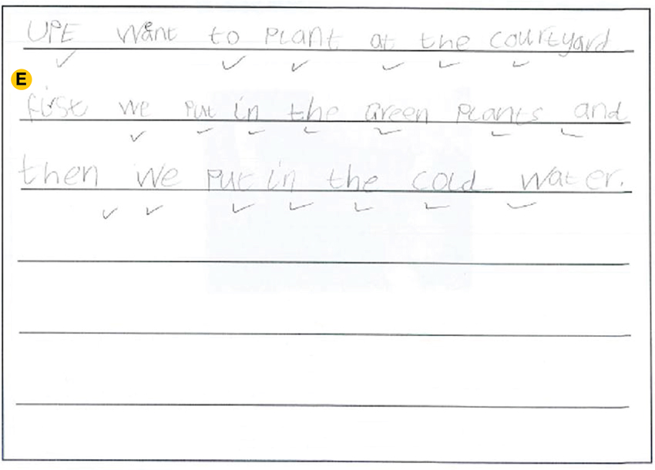

Assistance provided to student
- Instructions
- Word wall
- Largely independent

Highlights
- Clear sequence (‘first we’, ‘then we’) (see ‘A’ on the sample)
- Some use of connections and conjunctions (see ‘B’ on the sample)
- Use of adjectives
- Use of punctuation
- A more complex process of labelling demonstrates planning – though some of those adjectives do not appear in the writing (see ‘C’ on the sample)
- Use of a heading (see ‘D’ on the sample)
- Neat writing
- Good spacing between words
- Use of editing (second page is a clean copy of the first page) (see ‘E’ on the sample)

Gaps
- Mixture of upper- and lower-case letters that do not conform to grammatical rules
- Lacks appropriate use of prepositions (‘at the courtyard’)

Opportunities
- Model compound and complex sentences
- Assist student to use the words they identified in labelling
- Model appropriate use of prepositions

Mapped to the Victorian Curriculum F–10, English
This work sample provides evidence of the student working towards standard for Level 1.
Relevant extracts from the Level 1 achievement standard include:
- provide details about ideas or events, and details about the participants in those events
- accurately spell words with regular spelling patterns and use their knowledge of blending and segmenting, and many simple and high-frequency words to write predictable words
- use capital letters and full stops appropriately.

Discussion
This student might benefit from some assisted technology; however, the use of keyboards – designed on a QWERTY model – has created additional stress for this student, who prefers the alphabet presented in order.

Planning the next stage of student learning
When planning the next stage of the teaching and learning program to progress this student’s learning, focus on the following skills and knowledge in Level 1.
Level 1 content descriptions:
- Create short imaginative and informative texts that show emerging use of appropriate text structure, sentence-level grammar, word choice, spelling, punctuation and appropriate multimodal elements (VCELY194)
- Reread student's own texts and discuss possible changes to improve meaning, spelling and punctuation (VCELY195)

Sample 6
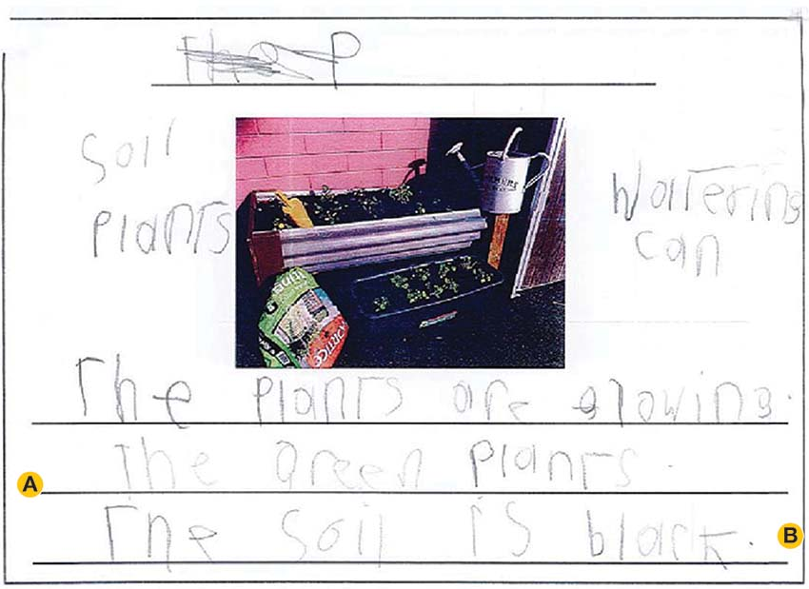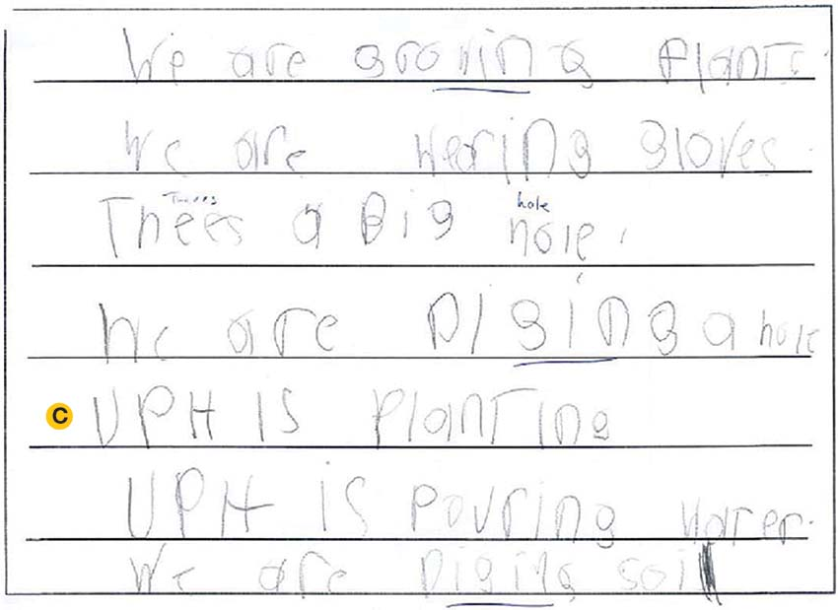

Assistance provided to the student
- Instructions
- Word wall
- Largely independent

Highlights
- Lists (using the word wall) the activities they completed in the garden (see ‘A’ on the sample)
- Good sentences
- Understands punctuation (see ‘B’ on the sample)
- Understands capitalisation
- Correct labelling of the class (‘UPH’) (see ‘C’ on the sample)

Gaps
- No heading
- Lacks a purpose – to inform or entertain
- Lacks a coherent sequence
- Pressure changes on the paper (suggesting a large cognitive load)

Opportunities
- Template to structure writing for purpose (possibly using a graphic organiser)
- Explore the purpose of writing
- Introduce and model conjunctives
- Assistance with handwriting
- Continue to model the purpose of upper- and lower-case letters
- Explore the use of lines when writing

Mapped to the Victorian Curriculum F–10, English
This work sample provides evidence of the student working at standard for Foundation Level.
Relevant extracts from the Foundation Level achievement standard include:
- use familiar words and phrases and images to convey ideas
- shows evidence of letter and sound knowledge, beginning writing behaviours and experimentation with capital letters and full stops
- correctly form all upper- and lower-case letters.

Planning the next stage of student learning
When planning the next stage of the teaching and learning program to progress this student’s learning, focus on the following skills and knowledge in Level 1.
Level 1 content descriptions:
- Understand that the purposes texts serve shape their structure in predictable ways (VCELA176)
- Understand patterns of repetition and contrast in simple texts (VCELA189)
- Recognise that different types of punctuation, including full stops, question marks and exclamation marks, signal sentences that make statements, ask questions, express emotion or give commands (VCELA190)

