Intercultural Capability: Unit plan, Levels 3 and 4

Exploring cultural practices

Authorised and published by the Victorian Curriculum and Assessment Authority
Level 7, 2 Lonsdale Street
Melbourne VIC 3000
© Victorian Curriculum and Assessment Authority 2019

No part of this publication may be reproduced except as specified under the Copyright Act 1968 or by permission from the VCAA. Excepting third-party elements, schools may use this resource in accordance with the VCAA educational allowance. More copyright information.
The VCAA provides the only official, up-to-date versions of VCAA publications. Details of updates can be found on the VCAA website.
This publication may contain copyright material belonging to a third party. Every effort has been made to contact all copyright owners. If you believe that material in this publication is an infringement of your copyright, please email the Copyright Officer: vcaa.copyright@edumail.vic.gov.au.
Copyright in materials appearing at any sites linked to this document rests with the copyright owner/s of those materials, subject to the Copyright Act. The VCAA recommends you refer to copyright statements at linked sites before using such materials. URLs were correct at the time of publication.

The VCAA logo is a registered trademark of the Victorian Curriculum and Assessment Authority.

Contents
The Intercultural Capability project 4
Safety and wellbeing 4
About this unit 5
Context 5
Overview 5
Formative assessment rubric 6
Unit lesson plans 7
Appendix 1 12
Appendix 2 13
Appendix 3 14
Appendix 4 15
Appendix 5 16
Work samples 18
Sample 1 a) 18
Sample 1 b) 19
Sample 2 a) 21
Sample 2 b) 22
Sample 3 a) 24
Sample 3 b) 25
Teacher reflections 27

The Intercultural Capability project
This unit is based on material developed with schools participating in the 2018 Intercultural Capability project. The project was conducted by the Victorian Curriculum and Assessment Authority in partnership with the International Education Division at the Department of Education and Training. The units of work target the explicit teaching of the Victorian Curriculum: F-10 Intercultural Capability. They include formative assessment rubrics that the teachers designed to describe progression of student learning in Intercultural Capability and to provide guidance to students on how to make progress in their learning. This unit provides one example of how a school might plan for the explicit teaching of Intercultural Capability. It is not published as an exemplar.

Safety and wellbeing
Teachers must exercise their duty of care in ensuring that the safety and wellbeing of students is maintained during the study of this Intercultural Capability unit. In addition to the usual pastoral care and health needs of students, teachers should bear in mind cultural sensitivities and the potential for disagreement or conflict over cultural/racial issues. Students should be given the opportunity to provide depersonalised responses or exempt themselves from activities of a potentially sensitive nature and should not be asked to speak on behalf of others. Harmful language or behaviour towards others on the basis of culture or race should not be tolerated. Where appropriate students should be counselled and/or debriefed. For further advice on navigating race and culture issues in the classroom, see the VCAA’s Teacher Guide.

About this unit
Unit title: Exploring cultural practices
Band: Levels 3 and 4
Teaching time: 4 x 45 minutes

Context
- This unit was developed in a metropolitan, culturally diverse primary school.
- Students were familiar with celebrations but not with the celebrations of other cultures.
- The teacher used resources from the Immigration Museum website and school library to create a sequence of lessons.

Overview
The learning intention of the unit is for students to gain a deeper understanding of other cultures and develop greater empathy and connectedness to help reduce or prevent racism.
The unit was created in association with a formative assessment rubric (see below) which was used to plan teaching and learning activities to facilitate progress in student learning. The lessons address the following actions in the rubric:
- Explores their own cultural practices
- Explores cultural practices of others
- Explores how cultural practices and intercultural experiences can influence behaviour.
In the sequence of four lessons, students define and describe their own and other cultures and explore similarities and differences between their experiences and the intercultural experiences of a refugee child.
The unit and the accompanying rubric target the following part of the Victorian Curriculum: F–10 Intercultural Capability curriculum:
Band: Levels 3 and 4
Strand: Cultural Practices
Content descriptions: Compare their own and others cultural practices, showing how these may influence the ways people relate to each other (VCICCB005)
Describe what they have learnt about themselves and others from intercultural experiences including a critical perspective on and respect for their own and others cultures (VCICCB006)
Achievement Standard: By the end of Level 4, students are able to compare a range of cultural practices and explain their influence on people’s relationships. They explain what they have learnt about themselves and others from intercultural experiences. Students explain the role of cultural traditions in the development of various identities. They develop critical perspective on and respect for their own and others’ cultures.

Formative assessment rubric
The formative assessment rubric below was used to help identify the steps in learning, to collect evidence of learning and as a basis for providing feedback. The lesson plans that follow specify which part of the rubric was targeted in each lesson.
The rubric was developed using the relevant Intercultural Capability achievement standard/s and the Guide to Formative Assessment Rubrics. More information about the terminology and structure of the rubric can be found in the Guide.
 |  |  | Intercultural Capability, Levels 3 and 4
 |  |  | Phase 1 | Phase 2 | Phase 3
 |  |  | Students in this phase can define ‘culture’ (including its practices and characteristics) and identify the relevance of culture to individuals | Students in this phase can explore different cultural practices and compare and contrast cultures | Students in this phase demonstrate can understanding of the significance of cultural practices and how intercultural experiences influence behaviour
Organising Element/s | Action |  | Quality Criteria
Cultural Practices strand | 1. Explores their own cultural practices | Insufficient evidence | 1.1 Identifies their own cultural characteristics (e.g. group membership, cultural celebrations, customs, traditions, language/s) | 1.2 Explains nature of their own cultural characteristics | 1.3 Gives reasons why cultural characteristics are significant within their own culture
 | 2. Explores cultural practices of others | Insufficient evidence | 2.1 Identifies cultural characteristics of others | 2.2 Explains nature of cultural characteristics of others, including through comparison with another culture | 2.3 Explains the influence of cultural practices on people’s relationships
 | 3. Explores how cultural practices and intercultural experiences can influence behaviour | Insufficient evidence | 3.1 Identifies how their own cultural practices can influence behaviour | 3.2 Identifies how other people’s cultural practices influence their behaviour | 3.3 Explains how an intercultural experience can influence behaviour

Unit lesson plans
The following lessons were created to facilitate progress in student learning. Each lesson is linked to a particular action/s in the formative assessment rubric above and the associated quality criteria. Teachers should give students ongoing feedback on the next steps in their learning and provide opportunities for them to make progress in their understanding of the targeted area of the curriculum.

Lesson 1 – Introducing culture

Rubric area targeted:
- 1.1 Identifies their own cultural characteristics (e.g. group membership, cultural celebrations, customs, traditions, language/s)

Assessing prior knowledge:
- Find out what students already know about the term ‘culture’. Either on a real wall or a Padlet ‘wall’, ask students to place sticky notes indicating their understanding of the term ‘culture’. (Preferably, preview sticky notes before displaying them, to check for appropriateness and to ensure students write responses in their own words.)

Sharing:
- Display the sticky notes on the wall and share/discuss with the whole class.
- As part of the discussion, share with the class the meanings of ‘culture’ and ‘cultural practice’, for example:
Culture is made up of ‘cultural practices’ that relate to the ways a group of people live. Some cultural practices involve material objects such as clothing or musical instruments but also non-material things such as language, customs and social roles.
Different cultural groups can have different cultural practices, such as the food they eat and how it is made, the language they speak, the clothes they wear, the music and arts they create and the religious tradition they observe.
Cultural practices become traditional when they are regularly passed down to different members of the family and community through experiences and stories.
(Note: the definition above is based on the Victorian Curriculum: F–10 Intercultural Capability Glossary.)
Use a range of digital images and/or other objects to support discussion of the meanings of culture and cultural practices.

Mindmap activity:
- Students use the Mindmap template to independently demonstrate their understanding of the concept of culture.
- Students write a main word that relates to the characteristics of their own and other cultures on the dotted lines of the template (e.g. food, music, celebrations, clothing, sport). They then add 3 descriptions or examples branching out from each main word.

Resources:
Sticky notes or iPads (Padlet app)
Mindmap template (see Appendix 1)
Digital images and/or objects representing different characteristics of culture

Lesson 2 – Cultural practices

Rubric areas targeted:
- 1.2 Explains nature of their own cultural characteristics
- 2.1 Identifies cultural characteristics of others
- 2.2 Explains nature of cultural characteristics of others including through comparison with another culture

Tuning in:
- Ask students to recall cultural characteristics/practices of their own culture from last lesson. Provide feedback on their progress on understanding the concepts of culture and cultural practices.
1–2–4 activity:
- Introduce students to the categories drawn from the Cultural Characteristics table (see Appendix 3): country, food, celebrations, dress, sport and other (note: headings are examples only and can be adapted to suit student needs).
- Individually, students choose a country and find 5 cultural characteristics of the culture most strongly associated with that country, using the categories from the Cultural Characteristics table. (See examples of URLs in Resources.) Ensure that students do not all choose the same country. Students then write the name of the country and what they know about each category in dot-points on a sticky note.
- Ask students to share their knowledge with a partner.
- They then share their knowledge in a group of 4, identifying similarities and differences in their findings.
- In the group of 4, students add their sticky notes to the mini-poster on ‘Other cultures’ (Appendix 2).
Sharing:
Distribute a Cultural Characteristics table to each group and assist students to use the table to compile a list of the different cultures their group has written about.
Resources:
Starting points for research into cultural practices:
- Italy
- India
- Germany
- China
Sticky notes
Mini-poster template (‘Other cultures’) (see Appendix 2)
A4 sheet of paper for each group of 4
Cultural Characteristics table (see Appendix 3)

Lessons 3 and 4 – Cultural practices and intercultural experiences

Rubric areas targeted:
- 1.3 Gives reasons why cultural characteristics are significant within their own culture
- 2.2 Explains nature of cultural characteristics of others, including through comparison with another culture
- 2.3 Explains the influence of cultural practices on people’s relationships
- 3.1 Identifies how their own cultural practices can influence behaviour
- 3.2 Explains how other people’s cultural practices influence their behaviour
- 3.3 Explains how an intercultural experience can influence behaviour

Tuning in:
- Explain that the class will be reading The Little Refugee about the experience of a Vietnamese boy coming to Australia and that knowing about some Vietnamese cultural practices will help in reading and responding to the text. Introduce Vietnamese cultural practices to the class and ask students to compare these with another culture such as their own or a culture researched in the previous lesson.
- Read The Little Refugee as a class.

Compare and contrast activity:
Students compare the little refugee’s experiences and cultural practices with their own experiences and another culture. They:
- Complete The Little Refugee sheet in Appendix 4 and discuss their responses with a partner. (For differentiation, consider varying the number of responses students need to give.)
- Discuss with a partner how the little refugee’s intercultural experiences (after arriving in a new country) influenced his behaviour.
Review the Cultural Characteristics table from the previous lesson. Use students’ compilations and student analysis of The Little Refugee as a stimulus for the whole class to discuss how cultural practices and intercultural experiences might influence behaviour. Record students’ observations on the board, and provide explicit feedback to facilitate progress in their learning.
Reflection and conclusion:
Ask students to complete the worksheet ‘How Cultural Characteristics Influence Behaviour’ (Appendix 5) individually. Students could draw on research done in previous lessons to complete the last question on the worksheet. Then discuss responses as a class.
Resources:
Examples of Vietnamese cultural practices
The Little Refugee by Anh Do
Compare and Contrast – The Little Refugee (see Appendix 4)
Cultural Characteristics table from last lesson
How Cultural Characteristics and Intercultural Experiences Influence Behaviour worksheet (see Appendix 5)

Appendix 1

Mindmap template

………..………………… …………………………………

Culture

………………………………. ………………………………

……………………………………….

Appendix 2
Mini-poster

Other
Cultures

Appendix 3
Cultural Characteristics
Fill in the table for each country chosen
 | Country name | Food | Celebrations | Dress | Sport | Other
1 | e.g. Italy | Pizza | Easter | Long skirt | Soccer | Tarantella (folk dance)
2
3
4
5

Appendix 4
Compare and Contrast – The Little Refugee

The little refugee’s experiences: Your experiences: (Identify how your experiences
have been similar or different to those of the little refugee)

When he was a baby in Vietnam, Anh (the little refugee) _____________________________________________________________
lived in a house with up to 14 family members.
In Vietnam, lots of people crowded onto one motorbike. _____________________________________________________________
Anh’s family had to flee their own country. _____________________________________________________________
Anh had a dangerous journey to Australia. _____________________________________________________________
Anh’s parents ran their own business and were very busy. _____________________________________________________________
Anh couldn’t speak English when he started school. _____________________________________________________________
Anh had different food from the other kids at school. _____________________________________________________________
Anh made new friends at school. _____________________________________________________________
The school assembly made Anh feel welcome. _____________________________________________________________

Appendix 5
How Cultural Characteristics and Intercultural Experiences Influence Behaviour

Describe a celebration, event or practice that is important in your culture.
_____________________________________________________________________________________________________________________________________________________________________________________________________________________________________________________________________________________________________________________________________

Explain why the cultural celebration/event/practice is important to you or your cultural group.
_____________________________________________________________________________________________________________________________________________________________________________________________________________________________________________________________________________________________________________________________________

Describe how the cultural celebration/event/practice influences your behaviour.
_____________________________________________________________________________________________________________________________________________________________________________________________________________________________________________________________________________________________________________________________________

Imagine you moved to a country with different cultural practices from Australia. Identify one way in which your behaviour would need to change so that you could fit in with the new culture. Then identify one behaviour that would probably stay the same.
______________________________________________________________________________________________________________________________________________________________________________________________________________________________________________________________________________________________________________________________________________________________________________________________________

Work samples
Samples have not been corrected for expression or accuracy.

Sample 1 a)
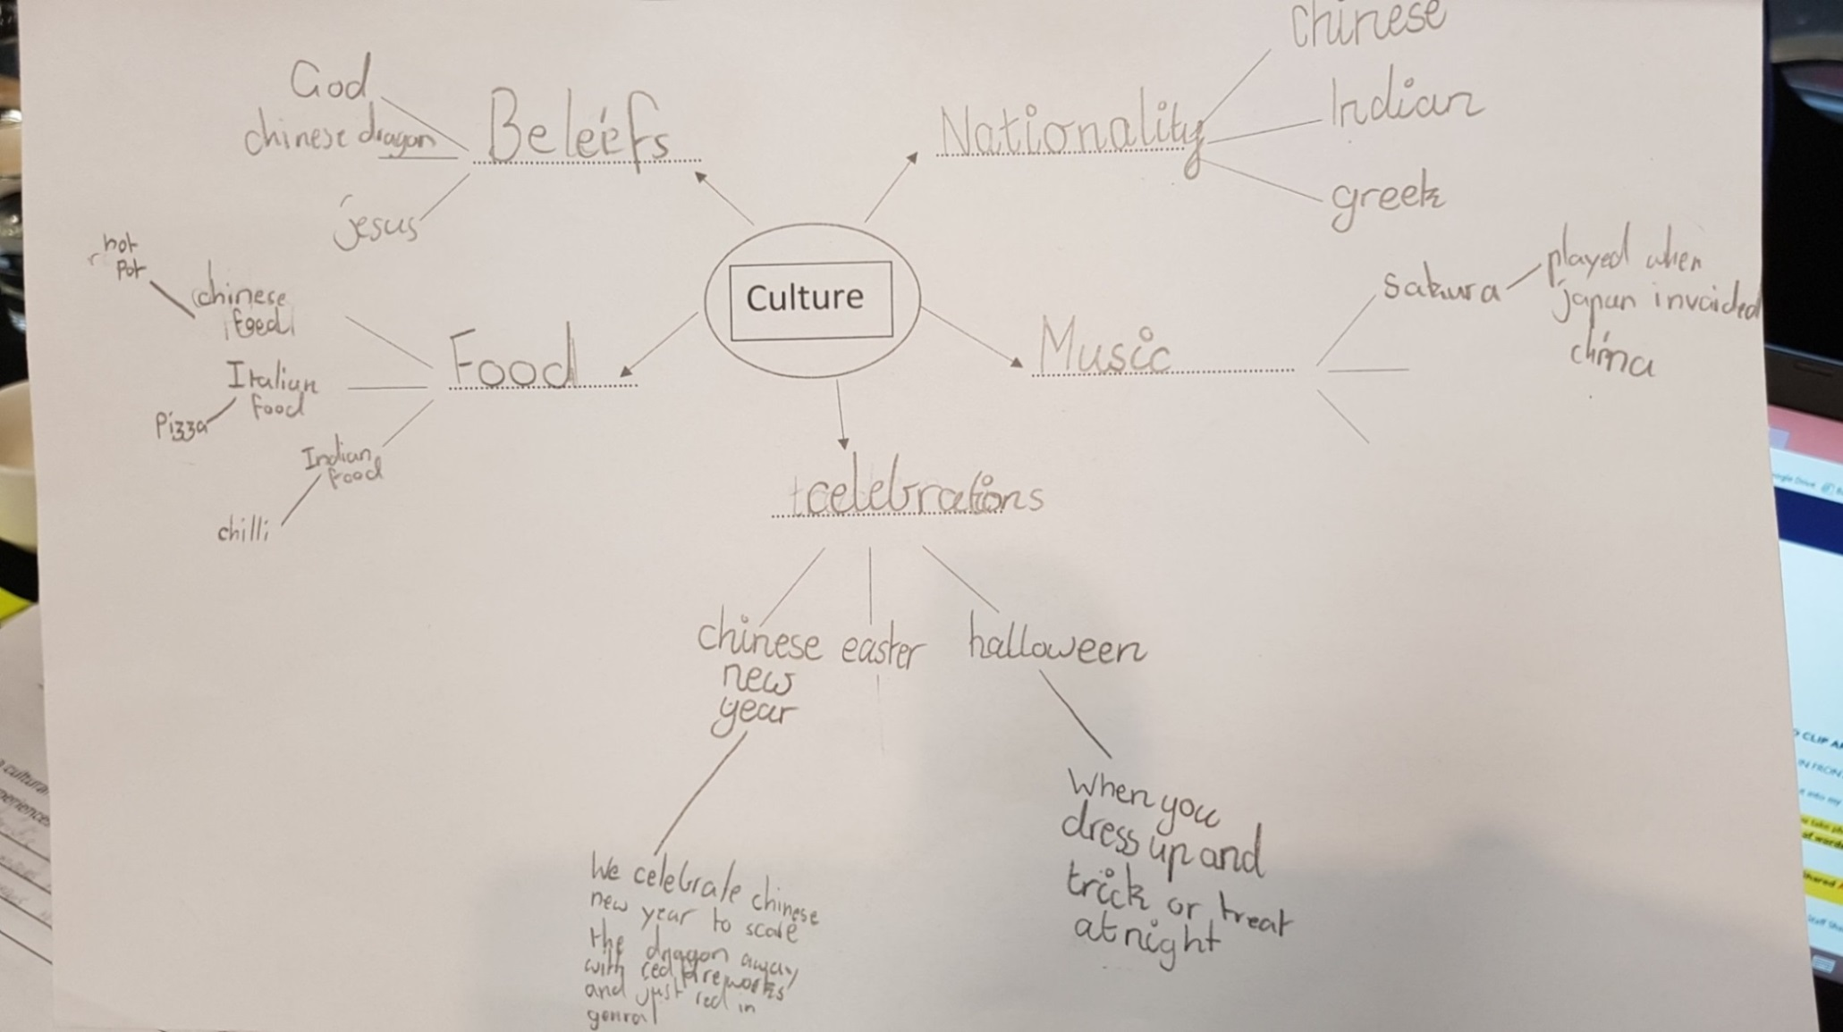
This sample demonstrates the following actions in the rubric:
1.1 Identifies their own cultural characteristics (student identified own culture as Chinese and stated a number of characteristics)
Progress towards 1.2 Explains nature of their own cultural characteristics
Progress towards 2.1 Identifies cultural characteristics of others
Progression: The next step for the student would be to give more explanation of cultural practices.

Sample 1 b)
Describe a celebration, event or practice that is important in your culture.
Chinese New Year is what my culture celebrates.

Explain why the cultural celebration/event/practice is important to you or your cultural group.
We celebrate Chinese New Year because Chinese people believe the dragon will destroy China so they wear red and set off red fireworks.

Describe how the cultural celebration/event/practice influences your behaviour.
I think it influences my behaviour to respect my family.
This sample demonstrates the following actions in the rubric:
Progress towards 1.1 Identifies their own cultural characteristics
Progress towards 1.3 Gives reasons why cultural characteristics are significant within their own culture
Progress towards 3.1 Identifies how their own cultural practices can influence behaviour

Progression: The next step for the student would be to give more than one example of a cultural characteristic and to explain more precisely the connection between cultural practices and behaviour/relationships, e.g. why observing Chinese New Year is a sign of respect to her family.

 |  | Sample 1 | Intercultural Capability, Levels 3 and 4
 |  |  | Phase 1 | Phase 2 | Phase 3
 |  |  | Students in this phase can define ‘culture’ (including its practices and characteristics) and identify the relevance of culture to individuals | Students in this phase can explore different cultural practices and compare and contrast cultures | Students in this phase demonstrate can understanding of the significance of cultural practices and how intercultural experiences influence behaviour
Organising Element/s | Action |  | Quality Criteria
Cultural Practices strand | 1. Explores their own cultural practices | Insufficient evidence | 1.1 Identifies their own cultural characteristics (e.g. group membership, cultural celebrations, customs, traditions, language/s) | 1.2 Explains nature of their own cultural characteristics | 1.3 Gives reasons why cultural characteristics are significant within their own culture
 | 2. Explores cultural practices of others | Insufficient evidence | 2.1 Identifies cultural characteristics of others | 2.2 Explains nature of cultural characteristics of others, including through comparison with another culture | 2.3 Explains the influence of cultural practices on people’s relationships
 | 3. Explores how cultural practices and intercultural experiences can influence behaviour | Insufficient evidence | 3.1 Identifies how their own cultural practices can influence behaviour | 3.2 Identifies how other people’s cultural practices influence their behaviour | 3.3 Explains how an intercultural experience can influence behaviour

Sample 2 a)
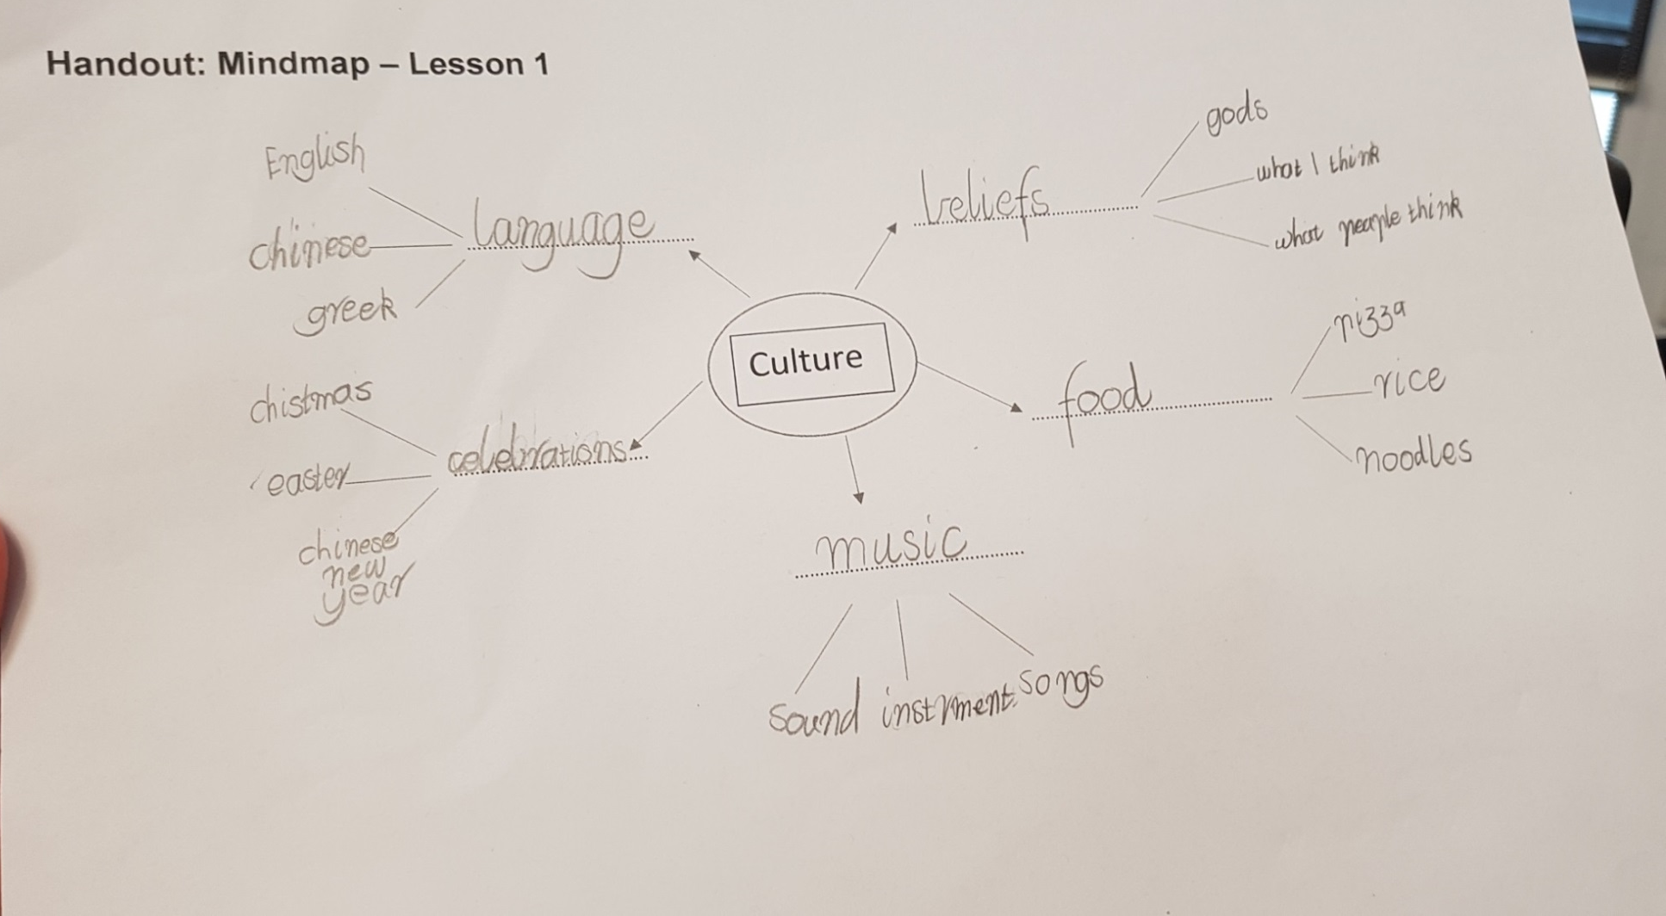
This sample demonstrates the following actions in the rubric:

Progress towards 1.1 Identifies their own cultural characteristics (student identified own culture as Australian and gave Christmas and Easter as examples of cultural characteristics)
Progress towards 1.2 Explains nature of their own cultural characteristics
Progress towards 2.1 Identifies cultural characteristics of others

Progression: The next step for the student would be to be more specific about the nature of their cultural characteristics, e.g. ‘gods’ and ‘beliefs’.

Sample 2 b)
Describe a celebration, event or practice that is important in your culture.
Christmas.

Explain why the cultural celebration/event/practice is important to you or your cultural group.
Christmas is important in my culture because I can be with my family more.

Describe how the cultural celebration/event/practice influences your behaviour.
I celebrate Christmas to get together not just to get something.

This sample demonstrates the following actions in the rubric:
Progress towards 1.1 Identifies their own cultural characteristics
Progress towards 1.3 Gives reasons why cultural characteristics are significant within their own culture
Progress towards 3.1 Identifies how their own cultural practices can influence behaviour (student hints that some people are materialistic about Christmas, just wanting to ‘get something’)

Progression: The next step for the student would be to identify the broader meaning of cultural practices, e.g. what Christmas means apart from than providing an opportunity to spend time with family.

 |  | Sample 2 | Intercultural Capability, Levels 3 and 4
 |  |  | Phase 1 | Phase 2 | Phase 3
 |  |  | Students in this phase can define ‘culture’ (including its practices and characteristics) and identify the relevance of culture to individuals | Students in this phase can explore different cultural practices and compare and contrast cultures | Students in this phase demonstrate can understanding of the significance of cultural practices and how intercultural experiences influence behaviour
Organising Element/s | Action |  | Quality Criteria
Cultural Practices strand | 1. Explores their own cultural practices | Insufficient evidence | 1.1 Identifies their own cultural characteristics (e.g. group membership, cultural celebrations, customs, traditions, language/s) | 1.2 Explains nature of their own cultural characteristics |  | 1.3 Gives reasons why cultural characteristics are significant within their own culture
 | 2. Explores cultural practices of others | Insufficient evidence | 2.1 Identifies cultural characteristics of others | 2.2 Explains nature of cultural characteristics of others, including through comparison with another culture |  | 2.3 Explains the influence of cultural practices on people’s relationships
 | 3. Explores how cultural practices and intercultural experiences can influence behaviour | Insufficient evidence | 3.1 Identifies how their own cultural practices can influence behaviour | 3.2 Identifies how other people’s cultural practices influence their behaviour |  | 3.3 Explains how an intercultural experience can influence behaviour

Sample 3 a)
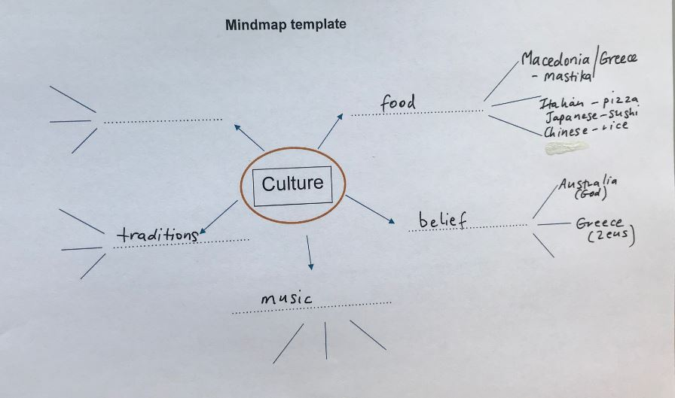

This sample demonstrates the following actions in the rubric:

Progress towards 1.1 Identifies their own cultural characteristics (student identified own culture as Macedonian/Greek and referred to a drink and a Greek god as cultural characteristics)
Progress towards 2.1 Identifies cultural characteristics of others

Progression: The next step for the student would be to give more examples of cultural characteristics and explain their nature.

Sample 3 b)
Describe a celebration, event or practice that is important in your culture.
I celebrate Greek Easter.

Explain why the cultural celebration/event/practice is important to you or your cultural group.
I celebrate Greek Easter because I am Greek and it’s fun for my family.

Describe how the cultural celebration/event/practice influences your behaviour.
I spend more time with my family and have a stronger bond.

This sample demonstrates the following actions in the rubric:
Progress towards 1.1 Identifies their own cultural characteristics
Progress towards 1.3 Gives reasons why cultural characteristics are significant within their own culture
3.1 Identifies how their own cultural practices can influence behaviour

Progression: The next step for the student would be to identify more than one cultural characteristic and to identify the deeper significance of cultural practices, e.g. the religious origins of Easter.

 |  | Sample 3 | Intercultural Capability, Levels 3 and 4
 |  |  | Phase 1 | Phase 2 | Phase 3
 |  |  | Students in this phase can define ‘culture’ (including its practices and characteristics) and identify the relevance of culture to individuals | Students in this phase can explore different cultural practices and compare and contrast cultures | Students in this phase demonstrate can understanding of the significance of cultural practices and how intercultural experiences influence behaviour
Organising Element/s | Action |  | Quality Criteria
Cultural Practices strand | 1. Explores their own cultural practices | Insufficient evidence | 1.1 Identifies their own cultural characteristics (e.g. group membership, cultural celebrations, customs, traditions, language/s) | 1.2 Explains nature of their own cultural characteristics | 1.3 Gives reasons why cultural characteristics are significant within their own culture
 | 2. Explores cultural practices of others | Insufficient evidence | 2.1 Identifies cultural characteristics of others | 2.2 Explains nature of cultural characteristics of others, including through comparison with another culture | 2.3 Explains the influence of cultural practices on people’s relationships
 | 3. Explores how cultural practices and intercultural experiences can influence behaviour | Insufficient evidence | 3.1 Identifies how their own cultural practices can influence behaviour | 3.2 Identifies how other people’s cultural practices influence their behaviour | 3.3 Explains how an intercultural experience can influence behaviour

Teacher reflections
Teachers involved in the Intercultural Capability Project were invited to reflect on their curriculum planning and teaching experience.
The teachers of this unit stated:
Students were very engaged and interested in learning about other cultures, particularly those of their peers. Students gained greater intercultural awareness. In future we would extend lessons to allow more time for discussion and to allow all students to complete the tasks in the time given.

