2022 VCE Specialist Mathematics 1 (NHT) external assessment report

Specific information

This report provides sample answers or an indication of what answers may have included. Unless otherwise stated, these are not intended to be exemplary or complete responses.

Question 1





 and 



Question 2

 and 

 and 



An algebraic approach using the rectangular form for complex numbers could also have been used.



Question 3

Note that 

The axis intercepts are at  and . The equation of the straight line joining the axis intercepts is .

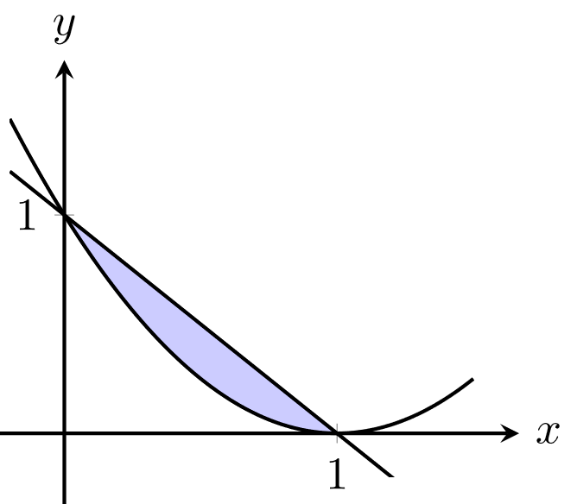

The volume is:



Question 4a.

Marking the forces on the diagram is recommended.

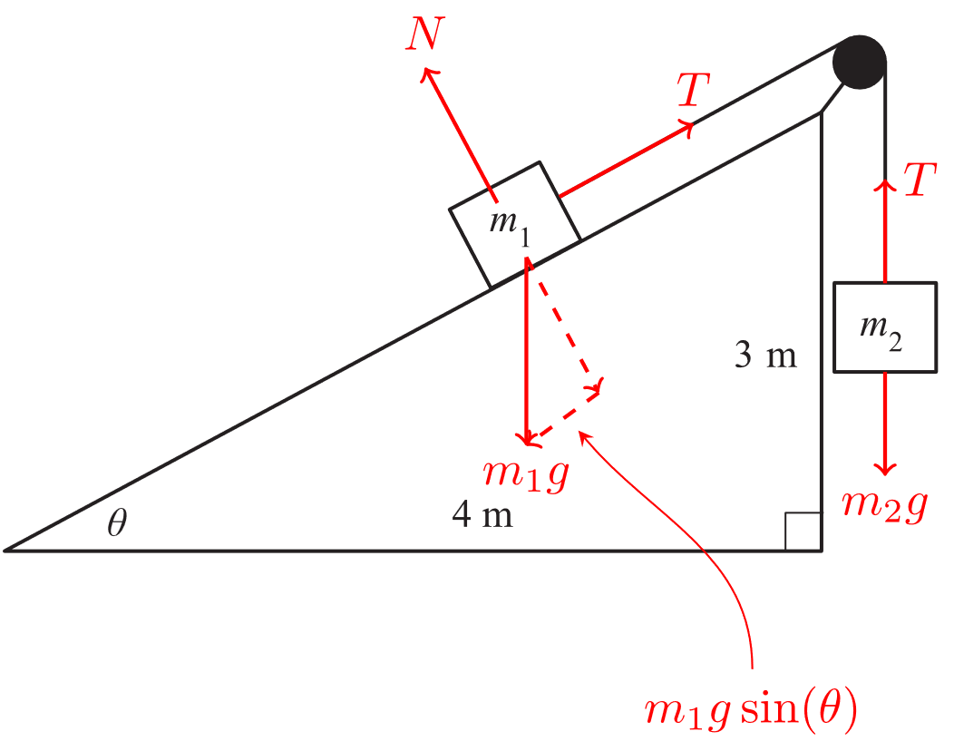

As the system is in equilibrium:



Therefore, .

As , it follows that:



Question 4b.

Using  gives:



Using the constant acceleration formula :



Alternatively, an integral form for acceleration may be used:



When , . Therefore, . When , .

Question 5

Let .



Square both sides and complete the square to obtain:



The centre is at  and the radius is .

Question 6



Then:



The magnitude of the force is .

Question 7a.

, 

As ,



Question 7b.







Question 8a.

Let and  represent the distribution of print runs of standard and deluxe cartridges respectively.



and



Therefore, .

Question 8b.





Therefore, .

Note that , as  is a normally distributed random variable.

Question 8c.



 and 



Question 9a.

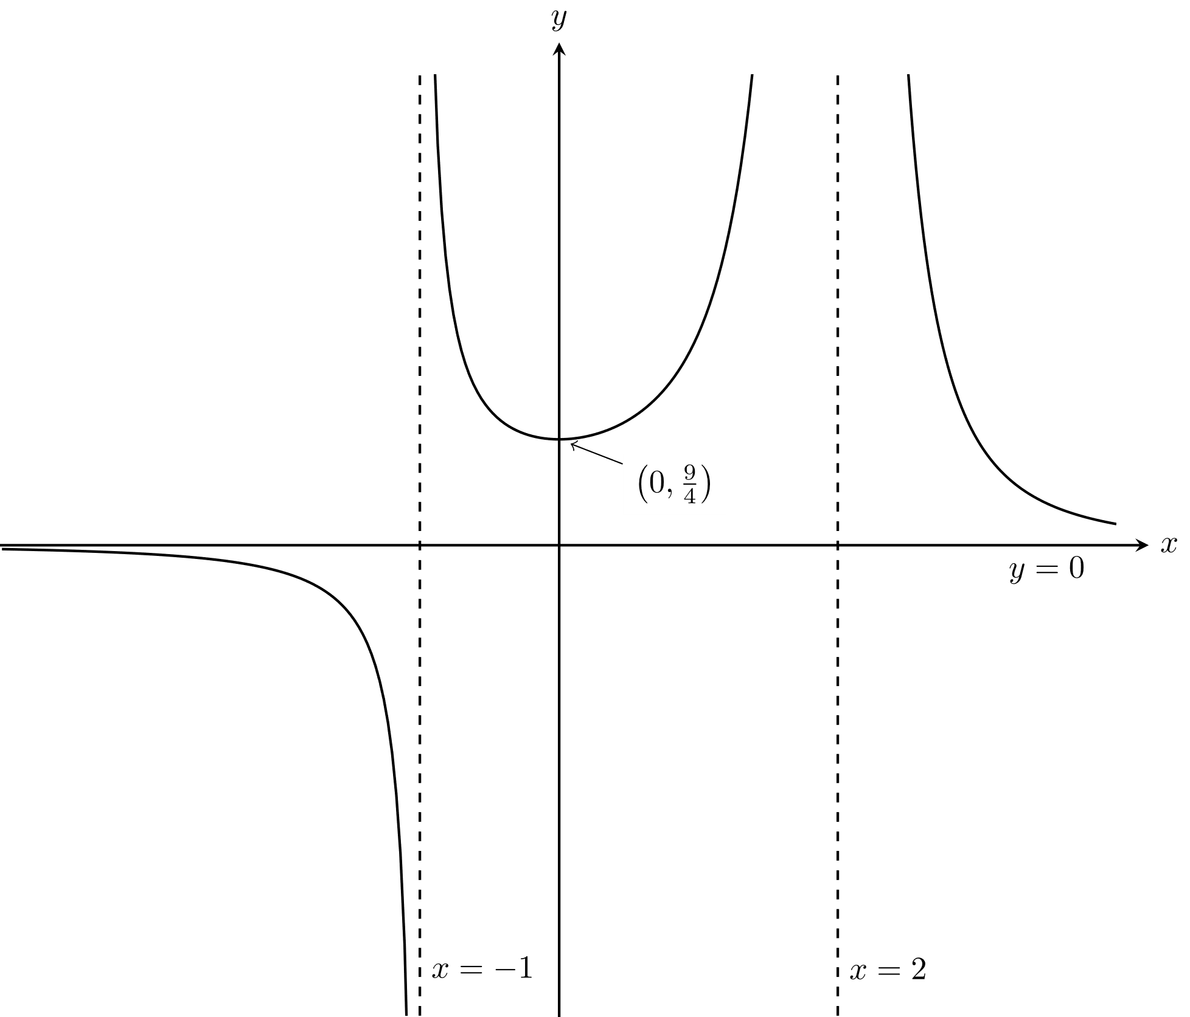

Asymptotes ,  and .

Minimum turning point and –intercept at .

Question 9b.



, , 

Then:



Question 10a.



Question 10b.

