2023 VCE Mathematical Methods 1 (NHT) external assessment report

Specific information
This report provides sample answers or an indication of what answers may have included. Unless otherwise stated, these are not intended to be exemplary or complete responses.

Question 1a.
This question involved using the product rule for differentiation.
$$\frac{dy}{dx}=\sin\left(x\right)+x cos(x)$$

Question 1b.
$\int_{0}^{\frac{π}{2}}{\left(x+\cos\left(x\right)\right)}dx={\left[\frac{x^{2}}{2}+\sin\left(x\right)\right]}_{0}^{\frac{π}{2}}$
$$=\left(\left(\frac{π^{2}}{8}+1\right)-\left(0-0\right)\right)$$
$$=1+\frac{π^{2}}{8}$$

Question 2
While most students correctly included a constant of integration, some did not subsequently calculate the value correctly.
$f^{'}\left(x\right)={\left(3-x\right)}^{3}$  $f\left(x\right)=\int{{\left(3-x\right)}^{3}}dx$  $f\left(x\right)=\int{\left(-x^{3}+9x^{2}-27x+27\right)}dx$  $f\left(x\right)=-\frac{1}{4}x^{4}+3x^{3}-\frac{27}{2}x^{2}+27x+c$  $f\left(4\right)=\frac{5}{4}=-\frac{1}{4}{\left(4\right)}^{4}+3{\left(4\right)}^{3}-\frac{27}{2}{\left(4\right)}^{2}+27\left(4\right)+c$  $f\left(4\right)=\frac{5}{4}=-64+192-216+108+c$  $∴c=\frac{-75}{4}$  $f\left(x\right)=-\frac{1}{4}x^{4}+3x^{3}-\frac{27}{2}x^{2}+27x-\frac{75}{4}$ | Or alternatively,  $$f^{'}\left(x\right)={\left(3-x\right)}^{3}$$  $f\left(x\right)=\int{{\left(3-x\right)}^{3}}dx$  The formula sheet gives the rule  $$\int{{\left(ax+b\right)}^{n} dx= }\frac{1}{a\left(n+1\right)}{\left(ax+b\right)}^{n+1}+c, n≠-1$$  $$∴f\left(x\right)=\frac{1}{\left(-1\right)\left(3+1\right)}{\left(3-x\right)}^{3+1}+c$$  $∴f\left(x\right)=\frac{-1}{4}{\left(3-x\right)}^{4}+c$  $f\left(4\right)=\frac{5}{4}=\frac{-1}{4}{\left(3-(4)\right)}^{4}+c$  $\frac{5}{4}=\frac{-1}{4}+c$  $∴c=\frac{6}{4}=\frac{3}{2}$  $f\left(x\right)=\frac{-1}{4}{\left(3-x\right)}^{4}+\frac{3}{2}$

Question 3a.
$$\frac{27}{125}$$

Question 3b.
The formula for variance is on the formula sheet
$$\sqrt{3×\frac{3}{5}×\frac{2}{5}}=\frac{\sqrt{18}}{5}=\frac{3\sqrt{2}}{5}$$

Question 3c.
Some students found the arithmetic of the fraction calculations challenging
$$Pr\left(R=3|R≥2\right)=\frac{Pr\left(R=3\right)}{Pr\left(R≥2\right)}$$
$$=\frac{Pr\left(R=3\right)}{Pr\left(R=2\right)+Pr⁡(R=3)}$$
$$=\frac{\frac{27}{125}}{3{\left(\frac{3}{5}\right)}^{2}\left(\frac{2}{5}\right)+\frac{27}{125}}$$
$$=\frac{\frac{27}{125}}{\frac{54}{125}+\frac{27}{125}}$$
$$=\frac{27}{125}×\frac{125}{81}$$
$$=\frac{1}{3}$$

Question 4a.
$$g\left(\log_{2}{(3)}\right)=2^{2\log_{2}{(3)}}-9×2^{\log_{2}{(3)}}+20$$
$$=2^{\log_{2}{(9)}}-9×2^{\log_{2}{(3)}}+20$$
$$=9-(9×3)+20$$
$$=2$$

Question 4b.
$$2^{2x}-9×2^{x}+20=0$$
Let $A=2^{x}$
$∴A^{2}-9A+20=0$
$\left(A-5\right)\left(A-4\right)=0$ or $\left(2^{x}-5\right)\left(2^{x}-4\right)=0$
$$∴A=5 or A=4$$
$$∴2^{x}=5 or 2^{x}=4$$
$$∴x=\log_{2}{(5)} or x=2$$

Question 5a.
$\int_{-∞}^{∞}{f\left(x\right)dx=1}$
$\int_{-d}^{d}{\left(\frac{x+c}{2}\right)dx=1}$
${\left[\frac{x^{2}}{4}+\frac{cx}{2} \right]}_{-d}^{d}=1$ or ${\frac{1}{2}\left[\frac{x^{2}}{2}+cx \right]}_{-d}^{d}=1$
$\left(\left(\frac{d^{2}}{4}+\frac{cd}{2}\right)-\left(\frac{d^{2}}{4}-\frac{cd}{2}\right)\right)=1$ $\left(\frac{d^{2}}{2}+cd\right)-\left(\frac{d^{2}}{2}-cd\right)=2$
$cd=1$ $2cd= 2$

$d=\frac{1}{c}$

Question 5b.
$\int_{-d}^{d}{\left(\frac{x^{2}}{2}+\frac{cx}{2}\right)dx}=\frac{1}{24}$
${\left[\frac{x^{3}}{6}+\frac{cx^{2}}{4}\right]}_{-d}^{d}=\frac{1}{24}$
$\left(\left(\frac{d^{3}}{6}+\frac{cd^{2}}{4}\right)-\left(-\frac{d^{3}}{6}+\frac{cd^{2}}{4}\right)\right)=\frac{1}{24}$
$\frac{d^{3}}{3}=\frac{1}{24}$ or $\frac{1}{3c^{3}}=\frac{1}{24}$
$d^{3}=\frac{1}{8}$ or $c^{3}=8$
$∴d=\frac{1}{2} and c=2$

Question 6a.
To exclude a value from an interval, the notation needs to be a backslash $\backslash$.
$$R\backslash \left\{1\right\}$$

Question 6b.
Asymptotes should be marked in as dashed lines and labelled with their equation. Graph lines should be smooth, single stroke constructions and display appropriate asymptotic behaviour.
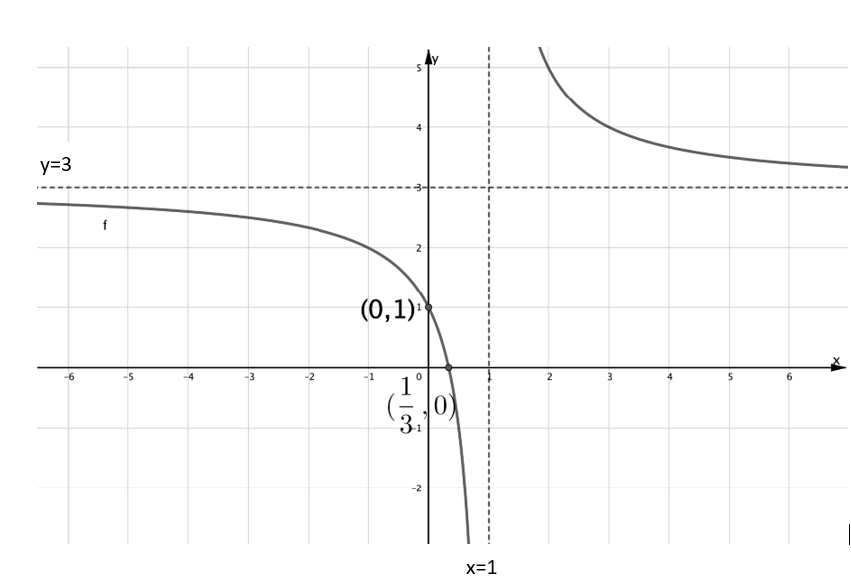

Question 6c.
$f\left(x\right)=3+\frac{2}{x-1}$
$f\left(x\right)=3+2∙g(x-1)$
$∴h\left(x\right)=3+2x$
Alternatively,
$g\left(x-1\right)=\frac{1}{x-1}$
$h\left(g\left(x-1\right)\right)=3+2∙\left(\frac{1}{x-1}\right)$
$∴h\left(x\right)=3+2x$

Question 7a.
$3+2x-x^{2}>0$
$x^{2}-2x-3<0$
$\left(x-3\right)\left(x+1\right)<0$
$∴x<3$and $x>-1$
$∴\left(-1,3\right)$
Alternatively, a graph of the parabolic inequality $3+2x-x^{2}>0$
could be considered.

Question 7b.
$$x=1$$

Question 7c.
$\log_{e}\left(3+2x-x^{2}\right)=0$
$1=3+2x-x^{2}$
$x^{2}-2x-2=0$
${\left(x-1\right)}^{2}-3=0$
$\left(x-1-\sqrt{3}\right)\left(x-1+\sqrt{3}\right)=0$
$∴x=1-\sqrt{3}$ and $x=1+\sqrt{3}$

Question 8a.
There were many correct ways this question could be answered and one correct specific and clear reason needed to be given. Potential correct answers included:
Turning points of $f(x)$ don’t match x-intercepts of $g\left(x\right)$.
or
When $g\left(x\right)=0$ at x=0, it is clear that $f(x)$ is increasing.

Question 8b.
$g\left(x\right)=\int{\left(\frac{1}{3}x^{2}+\sin\left(πx\right)\right)dx}$
$$=\frac{1}{9}x^{3}-\frac{1}{π}\cos\left(πx\right)+ c$$
At the origin
$$0=\frac{1}{9}{\left(0\right)}^{3}-\frac{1}{π}\cos\left(0\right)+c$$
$$∴c=\frac{1}{π}$$
$∴g\left(x\right)=\frac{1}{9}x^{3}-\frac{1}{π}\cos\left(πx\right)+\frac{1}{π}$

Question 8c.
This question was a ‘show that’ question. As such each line of working needed to demonstrate a clear, logical and explicit progression. Working needs to flow from one side, $k\left(x\right)$, and lead to the other, $k\left(-x\right)$, and must only consider the general case, not a specific function.
Let $k(x)=m(x)+n(x)$
$k\left(-x\right)=m\left(-x\right)+n(-x)$
$=m\left(x\right)+n(x)$
$=k(x)$
$∴k(x)$ has the property.

Question 8d.
$\frac{1}{3}x^{2}$ is an even function for all $x$.
then
The graph of $y=sin\left(πx-c\right)$ has the property (is a reflection in the y-axis) when the vertical intercept is one of the turning points.
or
recognise $sin\left(θ+\frac{π}{2}\right)=sin⁡(-θ+\frac{π}{2}$)
or
graphs of $y=sin\left(πx-c\right)$ and $y=-sin\left(πx+c\right)$ have period of 2, so when graphs are moved left $\frac{1}{2}$ a unit and right $\frac{1}{2}$ a unit respectively, they are identical, so $c=\frac{π}{2}$
then
$∴c=\frac{π}{2}+kπ, k∈Z$ or $c=(2k+1)\frac{π}{2}$, $k∈Z$ or equivalent.
Alternatively,
$$h\left(x\right)=h\left(-x\right)$$
$$\frac{1}{3}x^{2} +\sin\left(πx-c\right)= \frac{1}{3}{(-x)}^{2}+sin(-πx-c)$$
$$\sin\left(πx-c\right)=\sin\left(-πx-c\right)$$
$$\sin\left(πx-c\right)=-sin⁡(πx+c)$$
$$πx+c-\left(πx-c\right)=(2k+1)π, k∈Z$$
$$2c=(2k+1)π$$
$c=\frac{π}{2}(2k+1)$ or $c=-\frac{π}{2}(2k+1) , k∈Z$

