2021 VCE Music Performance written external assessment report

General comments
In 2021 the Victorian Curriculum and Assessment Authority produced an examination based on the VCE Music Study Design Units 1–4: 2017–2022. The examination comprised three sections: Sections A, B and C.
Section A – Listening and interpretation required listening to previously unheard works and analysing the ways performers used elements of music to achieve expressive outcomes. In order to discuss the interpretative decisions made by performers and/or conductors, students must ensure that they develop sound knowledge of music terminology and language. A thorough understanding of the elements of music is also required. When addressing the questions, students were required to discuss the treatment of elements of music and the expressive outcomes that were evident as a result. Although it is imperative that students outline what the expressive outcome is, they should avoid spending most of the writing time describing the expressive outcome with little reference to what the performers did to achieve it. Students also need to ensure that the link between the expressive outcome and the element of music is logical. For example, a high-pitched flute passage is not necessarily eerie. There could be other factors that contribute to this expressive outcome. It is vital that students understand what the elements of music mean. While dynamics and tone colour were handled reasonably well, improvisation/embellishment/ornamentation, articulation and blend of instrumental voices proved more challenging for students. In order to develop these understandings, it can be very useful to listen to works and analyse and discuss the treatment of every element of music.
Given the time constraints, students do not need to repeat the question as an opening paragraph. Especially where students are required to write about the treatment of different elements of music, subheadings may be useful. The final paragraph does not need to repeat the points made in the body of the essay. Students need to ensure that their handwriting is clear and legible.
Conventions of music notation proved problematic for some students in Sections B and C. When notating pitch, it is vital that students make it clear as to whether the note sits in a space or on a line on the staff. Inaccuracy made it very difficult to discern the intended response. Accidentals need to be written level with and before the note to which they apply. Where accidentals may collide on the staff, it is customary to move the note or accidental over to avoid writing an accidental on top of another accidental. For quavers, separate tails are always written facing the right side of the note. The writing of the bass clef proved problematic for some students. Many students were not aware of the two dots that are required and their correct positioning on the staff. Students are advised to look at the rest of the paper if they need to check how a clef is written.
Regular practice of the aural and written tasks is required for students to develop the skills necessary to complete Sections B and C successfully. While Section C – Music language (written) was completed quite well, Section B – Music language (aural) proved challenging for some students as it required students to complete aural comprehension tasks under the time constraints of the CD, which stipulated when to move on to the next question. Regular practice of all the Section B topics is required for students to develop the ability, for example, to discern the differences between chords quickly and accurately. A thorough understanding of the theoretical basis of chords is also required. Regular practice using aural training software, if available, is highly recommended.

Specific information
Note: This report provides sample answers, or an indication of what answers may have included. Unless otherwise stated, these are not intended to be exemplary or complete responses.
The statistics in this report may be subject to rounding resulting in a total more or less than 100 per cent.

Section A – Listening and interpretation

Question 1a.
Marks | 0 | 1 | 2 | 3 | 4 | 5 | 6 | Average
% | 0.5 | 5 | 18 | 30 | 28 | 16 | 3 | 3.4
This question required students to describe how the performers used articulation, improvisation/ embellishment/ornamentation and dynamics to contribute to the expressive outcomes. Responses that scored highly were able to identify the expressive response and draw a link between the treatment of the elements of music. All three elements of music were required in the response. While most students were able to write about the treatment of dynamics in general terms, articulation and improvisation/ embellishment/ornamentation proved more challenging. ‘Trills’ were often used as a blanket term for embellishment/improvisation/ornamentation. Trills are, strictly speaking, a very fast alternation of two notes. Students would be better served to learn some of the terminology for vocal and instrumental embellishment, such as scoop, slide or fall off, to more accurately describe the techniques used. Detail about what the performers do to create their own interpretation is required. While lyrics are not listed in the study design, the examination of lyrics can allude to the character of the piece.
The following are examples of possible relevant points. The singer uses:
- humming / ooh sound in the introduction – very connected, legato singing creates a relaxed, serene effect. At the repeat of the introduction phrase, vibrato is used on the upper note of the phrase to add a little more intensity
- upward slide onset on some lyrics
- small decorative figures at ends of phrases – at times creates effect of a sigh
- repetition of a phrase – slightly more intensity is created by decoration
- vibrato to increase intensity. For example, the vibrato on the final syllable of the chorus added intensity. However, the vocalists’ accompanying ‘oohs’ continued the soothing character through the very legato singing
- clear articulation of lyrics. Some soft, low notes sounded almost spoken and created a feeling of wistful sadness. In contrast, improvisation on higher notes created intensity when moving towards the chorus.

Question 1b.
Marks | 0 | 1 | 2 | 3 | 4 | Average
% | 1 | 14 | 39 | 37 | 9 | 2.4
This question was broad, requiring students to describe how the accompaniment contributed to the expressive outcomes. Students could refer to both the instrumental accompaniment and backing vocals.
Responses that scored highly were able to refer to elements such as the a cappella backing chorus that followed the soloist rhythmically, followed by the gentle and soft guitar strumming. In spite of the growing intensity of the soloist from the verse to the chorus, the ‘ooh’ vocal accompaniment continued the soothing character. The drums (brushes) gave forward momentum, giving the chorus a double-time, busy feel. There was also a ‘marching’ feel to the drumming as the lyrics became stronger. The accompaniment mirrored the growing intensity of the vocal line in forward motion and textural dynamic level.

Question 2
Marks | 0 | 1 | 2 | 3 | 4 | 5 | 6 | 7 | 8 | Average
% | 0.5 | 2 | 7 | 14 | 25 | 20 | 21 | 9 | 3 | 4.7
This was a broad question that enabled students to focus on one or more of the elements of music. Most students referred to tone colour; however, consideration of other elements allowed for more sophisticated responses. For some students the question presented the opportunity to list the tone colour events in chronological order. Responses that scored highly were able to draw the link between the treatment of elements of music and the character.
To prepare for this type of question, students need to have experience listening to works of all genres, including orchestral works. Most students were able to identify the dark, foreboding character of the opening. Changes of character may occur in excerpts and students should be listening for even subtle changes.
Responses that scored highly may have included, but were not limited to, the following points:
- character: dark, foreboding, mysterious, driving, purposeful, busy, urban sound
- sustained strings moving to sharply accented lines have a dry, piercing quality
- flowing/sustained melody of the strings in the middle was warm and soothing
- percussion feature as a team, setting up a polyrhythmic ostinato, which sits on top of the orchestral sound
- dramatic use of crescendo on rolling drums and cymbals at the opening
- use of sudden forte or piano for dramatic effect
- as the volume increased, so did the excitement.

Question 3
Marks | 0 | 1 | 2 | 3 | 4 | 5 | 6 | 7 | 8 | 9 | 10 | 11 | 12 | Average
% | 0.5 | 1 | 2 | 5 | 8 | 10 | 17 | 15 | 15 | 12 | 9 | 4 | 2 | 6.9
In their responses to this question, students had to compare the ways in which the two interpretations created different characters and expressive outcomes through tone colour, balance of musical lines, improvisation/embellishment/ornamentation, articulation and phrasing.
High level comparison and discussion was lacking in the responses this year. Most frequently, responses consisted of chronological descriptions of each interpretation rather then focused comparisons of the two interpretations and how their different characters and expressive outcomes were created were evident.
The most successful responses were able to list the points concisely, drawing links to the characters and comparing the treatment of the element with the second interpretation.
Responses presented comparisons in a range of formats. Some listed points evident in each interpretation. Others used a two-column format, aligning the descriptions of the specific features of each interpretation. The highest-scoring responses made a clear comparison between the two interpretations, linking the treatment of the three elements of music to the expressive outcomes.
The following are examples of possible relevant points.

Tone Colour
Interpretation A:
- Strings are warm, and together with guitar and bass give a very full and rich harmonic support to the vocalist.
- Rich orchestral backing and fills assists in creating the longing, sad character.
- Male voice sounds rough in high register which gives intensity, but mellow in the lower register adding to the yearning character.
- Warmth of the tone colour of the backing vocals in the chorus adds to the yearning character.
Interpretation B:
- The raspy, vocal production of the singer creates a demanding, grand gesture of pain.
- The heaviness of the accompaniment from the start is big and bold adding to the intensity. The resultant tone colour is harsh.
- Overall, the tone colour is big and bold, with competing forces.

Articulation
Interpretation A:
- Smoother articulation is used in longer phrases.
- The vocalist uses a small amount of vibrato.
- The high belt of the singer is strained, which adds to the feeling of longing.
- The bass guitar’s clear articulation contributes to the rhythmic drive without overpowering the other parts.
- Legato phrases of the backing vocals in the chorus adds to the longing character.
- Legato articulation of the strings adds to the yearning character.
Interpretation B
- The vocalist’s accented calling out, as if yelling, creates a demanding effect.
- The band’s heavy articulation of the semiquavers anticipating the chorus dominates the texture, adding to the demanding character.
- In the verses the shorter articulation is used to emphasise the pain of the words.

Phrasing
Interpretation A
- Elongated phrases with melisma add to the longing character while the shorter phrases add to the intensity of the words.
- Strings have smooth melodic fills.
- Short silence before the words ‘to love somebody’ adds to the poignancy.

Interpretation B
- The vocalist sings in clear eight-bar phrases.
- Verses are clipped in speech like pattern, like calling out, which together with the harsh tone colour, contributes to the demanding character.
- The phrases are elongated in the chorus, which assists in creating more intensity.

Ornamentation/embellishment/improvisation
Interpretation A
- The vocalist moves further away from the melody as the excerpt progresses. The higher level of improvisation creates the yearning character.
- The backing vocals hold the melody line in the chorus while the soloist improvises against it.
- Much use of vocal melisma is made, which adds more intensity in the higher tessitura.
Interpretation B
- The vocalist uses small vocal flicks to decorate the melody in a small way.
- In the chorus, the singer elongates ‘to love somebody’ adding to the intensity.
- The vocalist sings with passionate intensity, moving between gentle and epic belt.
- The line of the main melody is changed to an upward phrase shape, adding to the intensity.

Balance of musical lines
Interpretation A
- The orchestral sounds do not dominate the voice but allow the fullness of sound to support the voice. The string counter melody never dominates the texture, creating a wash of sound, adding to the yearning quality.
- The backing group of female voices is allowed to shine in the chorus, when the vocal soloist improvises against it.
- The drumkit increases its presence in the final chorus to assist in the build of intensity, but it still remains a supporting instrument.
Interpretation B
- In the verses the singer is heard clearly, for the story telling of the lyrics, despite a substantial backing.
- In the chorus the singer is blended back in the overall mix. The sound is full, with the accompaniment competing with the singer. The lyrics are not as clear. The overall effect of the build-up of power is assisted enormously by the prominence of the instrumental parts.
- Strings have a dominant role in anticipating the chorus with heavily bowed chordal semiquavers. This adds to the intensity.
- In the chorus at the words ‘to love somebody’ the accompaniment drops back significantly, allowing the singer to emphasise the words. The drumkit continues to play, maintaining the intensity.

Section B – Music language (aural)

Question 4
Marks | 0 | 1 | 2 | 3 | 4 | Average
% | 6 | 15 | 35 | 29 | 16 | 2.3
- The first interval was a perfect 4th.
- The second interval was a minor 2nd.
- The third interval was a minor 7th.
- The fourth interval was a minor 6th.
The majority of the intervals were presented melodically. Harmonic presentation of the third interval proved problematic for many students. To prepare for this type of question, students must practise recognising intervals melodically and harmonically. Intervals may be presented ascending or descending. The descending minor 6th interval was difficult for some students. For example, G descending to B is a minor 6th as intervals are always named from the bottom note (i.e. B up to G is a minor 6th), regardless of which note is played first. If students feel uncomfortable with the top note of the interval being played before the lower note, they should practise reversing the two notes.
To obtain full marks, both quality and quantity needed to be correct. Students must avoid using ‘M’ or ‘m’ to indicate the quality of intervals, as this is unclear. If the interval was not clearly identified, it was deemed incorrect.

Question 5
Marks | 0 | 1 | 2 | 3 | 4 | Average
% | 4 | 10 | 21 | 24 | 40 | 2.8
- The first was a Dorian mode.
- The second was a blues scale.
- The third was a harmonic minor scale.
- The fourth was a minor pentatonic scale.
Many students were able to identify the blues scale. Some students confused the Dorian mode with the natural minor scale. There is only one note difference between a Dorian mode and the natural minor scale. In a Dorian mode, the sixth degree of the scale is a major 6th from the bottom note, whereas in a natural minor scale the sixth of the scale is a minor 6th. Practising writing and singing scales is required for students to be able to identify relatively subtle differences between the scales and modes. Memorising the scale and then replaying it silently in the working time enables closer analysis of the scales/modes. Many students identified the harmonic minor scale correctly, while the minor pentatonic scale was often listed as a major pentatonic scale. The minor 3rd between the first and second notes of the scale was a key indicator of the minor pentatonic scale.

Question 6a.
Marks | 0 | 1 | 2 | 3 | Average
% | 22 | 28 | 22 | 28 | 1.5
- The first interval was a perfect octave.
- The second interval was a major 6th.
- The third interval was a major 2nd.
Many students were able to identify the opening ascending interval as a perfect octave or eighth. All intervals require identification of quality as well as the number, so ‘octave’ on its own was insufficient to identify this interval. The middle interval was challenging for many students. Memorisation of the melody so that students can replay the melody silently at a comfortable speed during the working allows students to stop at the notes required for the second interval. Use of ‘M’ or ‘m’ was insufficient to identify major or minor intervals.

Question 6b.
Marks | 0 | 1 | Average
% | 75 | 25 | 0.3
The melody was based on the major pentatonic scale. Many responses incorrectly identified the scale as the major scale, but the omission of the fourth and seventh degree of the scale was an indicator of the major pentatonic scale, as well as the absence of any semitones from one note to another. Singing and performing pentatonic melodies can assist in students’ understanding and recognition of pentatonic scales.

Question 7
Marks | 0 | 1 | 2 | 3 | 4 | Average
% | 13 | 24 | 23 | 21 | 19 | 2.0
- The quality of the first triad/chord was major 7th.
- The quality of the second triad/chord was augmented.
- The quality of the third triad/chord was minor.
- The quality of the fourth triad/chord was full diminished 7th.
Many students were able to identify the first chord as a major 7th chord. The minor chord presented harmonically proved difficult for some students. Students need to practise recognising the quality of chords that are presented melodically as well as harmonically. Practising singing the individual notes when hearing a chord played harmonically enables students to break the chord down into its individual notes and analyse the intervals that are involved in each chord.
Some students confused the full diminished 7th chord with the half diminished 7th chord. The half diminished 7th chord has a minor 7th above the root, whereas the full diminished 7th chord has a diminished 7th above the root.
Writing of chords followed by singing of chords when learning them, and focusing on the differences, should assist.
Again, ‘M’ or ‘m’ was not accepted as an identification of major or minor.

Question 8
Marks | 0 | 1 | 2 | 3 | 4 | Average
% | 4 | 6 | 44 | 16 | 30 | 2.6

Bass note | D | A
Quality | minor | minor
Many students were able to identify the final chord (chord 7) as an A minor chord, which was also heard in chords 1, 3 and 5. The bass line ascended from the A in chord 5 up a fourth to a D chord for chord 6.

Question 9
Marks | 0 | 1 | 2 | 3 | 4 | 5 | 6 | 7 | 8 | Average
% | 4 | 9 | 14 | 17 | 12 | 10 | 10 | 8 | 17 | 4.1

Bass note | G | E | A | D
Quality | major 7th | minor | minor | major
Although this progression proved to be quite difficult for some students, many students were able to identify the first chord correctly, hearing the bass line returning to the opening note, G, and hearing the additional 7th with consequent identification of the chord as a G major 7th chord.
Many students identified chord 6 with the D bass line as it descended by step to the given bass line of C for chord 7. Unfortunately, some students identified the quality of this chord as dominant. The chord was a major chord based on V. Dominant does not identify the quality of this chord and it was not a 7th chord. Students who were not awarded full marks for this question often wrote incorrect bass notes. Many students were able to correctly identify the quality of the chords.

Question 10
Marks | 0 | 1 | 2 | 3 | 4 | 5 | 6 | 7 | 8 | Average
% | 13 | 7 | 6 | 9 | 10 | 6 | 9 | 13 | 28 | 4.7
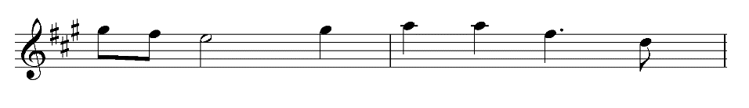
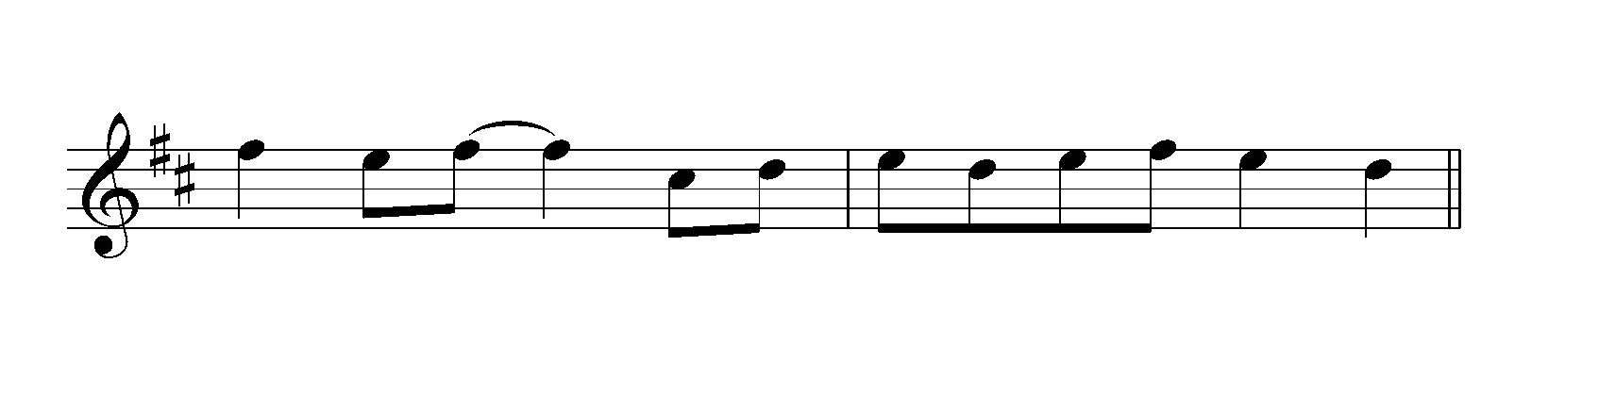The first three notes of the melodic transcription were handled well by many students, who noted that it moved down by step from the tonic of A major at the end of bar with G#, F# and E. The leap in bar 5 from E up to G# proved difficult for some students. When confronted by leaps in melodic transcriptions it can be very useful to look at the accompanying parts to identify the chords used. There is a high probability that the note may be a note that belongs to the accompanying chord. In this case it was a dominant 7th chord (E, G#, B and D), so G# was a likely note to use. The melody then progressed to the upper tonic of A major at the beginning of bar 6. Memorisation of the melody can assist students to break down the melody into segments when working out more challenging parts of the transcription. The F# and D in the second half of bar 6 outlined the D major chord. Many students were able to identify the last note required as D, noting that it ascended by step to the given note E in bar 7. Regular sight singing and practising of melodic transcription is required throughout the year.

Question 11
Marks | 0 | 1 | 2 | 3 | 4 | 5 | 6 | Average
% | 11 | 15 | 13 | 11 | 11 | 13 | 26 | 3.2
Bars 4 and 5
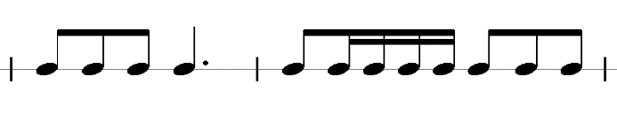
Bar 7
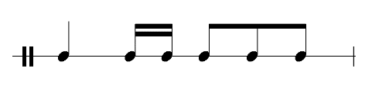
The time signature of 6/8 proved problematic for many students and errors indicated a lack of familiarity with this time signature. More work on compound time signatures needs to be undertaken through the year, so that students can become more accustomed to working with compound duple, triple and quadruple time signatures. Writing rhythms and undertaking sight reading and transcription exercises in these more unfamiliar time signatures is highly recommended.
Although 6/8 is compound duple time, with two dotted crotchet beats per bar, it can be useful to count six quaver pulses per bar, particularly when semiquavers are used. Most students were able to hear the first three quavers of bar 4. In bar 7 a number of students heard two semiquavers but were not able to identify where in the beat they occurred. In 6/8 time the value of the beat is a dotted crotchet, so it is advisable to beam the quavers and semiquavers to reflect the dotted crotchet beat. Some students beamed the notes as if the rhythm was in 3/4 time. Even if the correct order of notes was written, incorrect grouping of notes made it impossible to award full marks.

Question 12
Marks | 0 | 1 | 2 | 3 | 4 | 5 | 6 | 7 | 8 | Average
% | 6 | 10 | 11 | 9 | 7 | 6 | 7 | 7 | 39 | 4.9
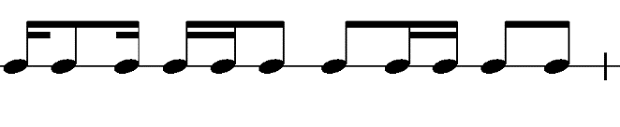
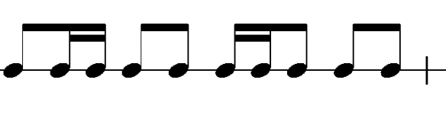
Bar 3
Bar 6
This transcription in 4/4 time was handled reasonably well by students. Responses that scored highly demonstrated the ability to identify which rhythmic pattern occurred on which beat of the bar correctly. To be awarded full marks for this question, correct grouping of notes was required. When completing this question, students are strongly advised to look at the patterns that are in the music that is already provided. Some students noted that the syncopated rhythm of semiquaver, quaver, semiquaver occurred at the beginning of bar 2 and at the beginning of the first bar of the required transcription, bar 3. The two semiquavers followed by a quaver pattern proved to be difficult for some students. Even though 4/4 time technically consists of four crotchet beats per bar, it can be useful to subdivide the beat and count quavers to be able to notate the semiquavers in the correct position.
Students should write rhythms that include different groupings of quavers and semiquavers and then perform the rhythms. When fluency is achieved, rhythmic transcription exercises should be devised ranging from short to more extended rhythms, including different forms of syncopation.

Section C – Music language (written)

Question 13
Marks | 0 | 1 | 2 | Average
% | 5 | 21 | 74 | 1.7
- The first interval was a major 2nd.
- The second interval was a perfect 4th.
When identifying written intervals, students should count the number of the interval first. In the first interval D# to E# is a 2nd. Then students should work out the quality of the interval. It is advisable to think of the key of the bottom note and work out if the next note belongs to the major scale of that note. The D# can be a difficult key to conceptualise, so students are advised to transpose both notes down into a more comfortable key to work out the quality: shifting it down a semitone results in D to E, which is a major 2nd. The second interval, C# to F#, was a perfect 4th. F# belongs to the scale of C# major, so it is called a perfect 4th. Naming the interval as a major 4th was marked as incorrect as intervals of 1, 4, 5 and 8, where the top note belongs to the bottom note major scale, are identified as perfect not major.

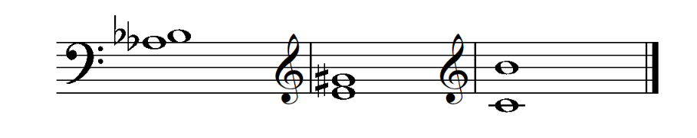
Question 14
Marks | 0 | 1 | 2 | 3 | Average
% | 12 | 10 | 23 | 55 | 2.2
Students need to read the instructions carefully. The question required students to write the intervals using semibreves. Some students chose to fill in the notes, thus making their answer incorrect. There was also some confusion of clefs. Before writing notes on the staff, students should always check whether it is using a treble or bass clef. Students need to take more care with notation and, more specifically, writing of accidentals. Accidentals should be level with the note to which they apply and they should be written before the note. If two notes require accidentals and they are very close to each other on the staff, it can be useful to spread them out, allowing space for the relevant accidentals.
This question required students to write notes on the staff indicated by the clef. The first interval, a major 2nd below Bb, proved difficult for many students. When writing intervals, students should write the given note first, then write the other note above or below as per the instructions. For the first interval, a few students wrote the Bb correctly and the A below it, but did not check whether A to Bb was, in fact, a major 2nd. It was not, so Ab was required to make it a major 2nd. Intervals are always worked from the bottom note up. Most students were able to write the major 7th above C correctly, but the major 3rd above E was incorrect for those who omitted the sharp in front of the G.

Question 15a.
Marks | 0 | 1 | 2 | 3 | Average
% | 15 | 20 | 6 | 59 | 2.1
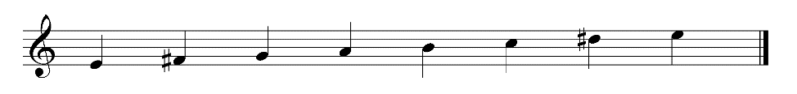
Or
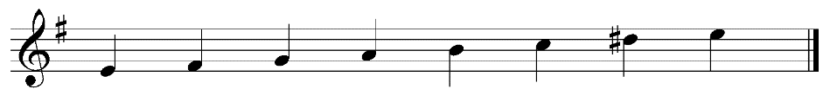
Most students used accidentals for the writing of scales although they were given the option of using a key signature. The harmonic minor was handled reasonably well, but for some, incorrect stems made it impossible to award full marks. Adherence to conventions of musical notation is required, so stems that are written below the note must be on the left side of the note.

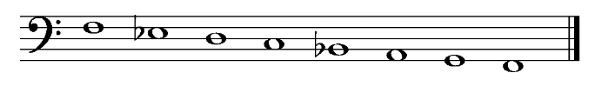
Question 15b.
Marks | 0 | 1 | 2 | 3 | Average
% | 23 | 18 | 12 | 48 | 1.8
Many students were able to insert the correct accidentals to make the example a mixolydian mode, taking note of the bass clef that was required to make it start on F. The writing of the bass clef proved difficult for many students. On the same page there was an example of the bass clef in Question 14. Students should check that their writing of a clef matches the conventions of musical notation that are used in the other examples. The bass clef requires two dots in a specific position on the staff. Many students were unable to place them in the correct position, which made the clef incorrect and hence only two marks were awarded for the correct accidentals.

Question 16
Marks | 0 | 1 | 2 | Average
% | 31 | 24 | 45 | 1.1
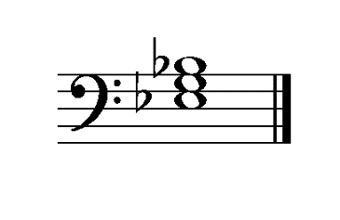
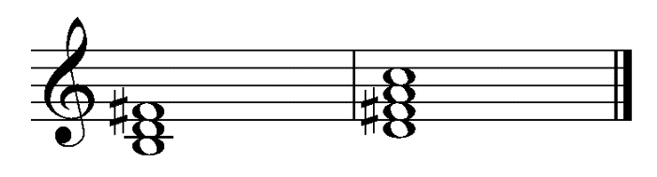
Students were required to write chords in given keys. This means that only accidentals that occur in the
key can be used. D major contains F# and C#. Students were required to work out which note is vi of D major, in this case B, and then build a chord on B (B, D, F), then add the required accidentals. In this case, F# was required. The V7 of G major proved problematic for students who wrote out the notes, D, F, A and C, but then proceeded to put in C#. G major does not contain C#, but it does contain F#, so the correct chord was D, F#, A and C. A sound knowledge of scales and the chords that are built on each degree of the scale within the key is required. To gain full marks for this question, all notes of the chord
had to be correct. Very few students used key signatures, which meant that they did not need to add any accidentals to the chords in a major key.

Question 17
Marks | 0 | 1 | 2 | 3 | 4 | Average
% | 13 | 7 | 9 | 15 | 56 | 2.9

Diatonic function | Submediant (or VI or 6) | Dominant (or V or 5)
Quality | minor 7th | major
Students were required to identify the diatonic function of two chords in the key of A major and the quality of each chord, including whether it was a triad or a 7th chord.
The example of the question for chords 1 and 4 used Roman numerals and technical names to identify the chords. When identifying diatonic function, students do not have to use both ways of identifying the chords. Some students identified the number of the chord correctly, but then wrote the incorrect technical name. If students choose to use the technical name (e.g. submediant), they must know the meanings of the technical names thoroughly. For example, VI is submediant, not subdominant. Subdominant is IV.
Students should also check the key signature to see if the sharps or flats apply to any of the notes in the chords.
Many students were able to identify the diatonic function correctly; however, many were not able to identify the quality of the chords correctly. Students needed to write out the names of the notes of each chord and use this to analyse the quality of each chord. The first chord contained the notes F#, A, C# and E. Many students did not identify that it was a minor 7th chord, writing simply ‘minor’. Knowledge that a minor 7th chord contains a minor triad with an additional minor 7th assisted students to identify it correctly. The second chord (E, G#, B and E) was a major chord, since the G# is a major 3rd above E and the B is a perfect 5th. Theoretical understanding of how chords are built will enable students to identify the quality of chords accurately. Dominant is not a quality of a chord, but is traditionally used as a dominant 7th chord, which contains a major chord and a minor 7th from the root of the chord. The second chord did not contain a 7th.

Question 18a.
Marks | 0 | 1 | Average
% | 67 | 33 | 0.3
Very few students were able to identify the time signature as 3/2, opting to count six crotchets in each bar and assuming that this meant 6/4 time. 6/4 time is a compound time signature that groups notes into two dotted minim beats per bar. The musical example grouped the notes in minim beats. The trombone part showed this clearly. Three minim beats per bar is an example of 3/2 time.

Question 18b.
Marks | 0 | 1 | Average
% | 44 | 56 | 0.6
Students who were able to identify the interval between notes C to Eb marked on the score as minor third were able to take into consideration the effect of the key signature that contained Eb. This meant the interval was C to Eb, not C to E, and hence a minor 3rd.

Question 18c.
Marks | 0 | 1 | Average
% | 32 | 68 | 0.7
The students who identified the notes of the chord in bar 4 as Bb, D, F and A were able to identify the chord as a major triad with a major 7th from the Bb root of the chord. Thus, it was named as a Bb major 7th chord. More thorough understanding of how chords are built is required to correctly identify the qualities of chords. Practising writing chords is highly recommended.

