2021 VCE VET Furnishing external assessment report

General comments
Student responses to the exam were generally strong, with work health and safety (WHS), identification of tools/equipment and manufacturing process items being areas of particular strength for many students.
A number of questions appeared to be answered poorly due to students not reading the question carefully.
The 2021 examination covered key knowledge and skills from the four units of competency:
- MSFFM2001 Use furniture making sector hand and power tools
- Questions relating to this unit were well answered. Students’ responses indicated that they were familiar with only a limited range of tools. Within the limited range identification of tools and knowledge of the application and safe use of tools were strongly answered. Knowledge of both hand and power tools was similar.
- MSFFM2002 Assemble furnishing components
- Student responses showed familiarity with only a narrow range of furniture assembly methods and hardware. Knock down fittings and assembly process questions were very challenging for students.
- MSFFP2001 Undertake a basic furniture making project
- This unit addressed a wide range of skills and knowledge necessary to successfully plan and manufacture a basic furniture project. Students demonstrated good knowledge of the manufacturing of furniture projects but were challenged by questions relating to the planning stages.
- MSFGN2001 Make measurements and calculations
- Questions relating to this unit were generally well answered with many students successfully applying their knowledge to the scenarios provided as stimulus material.
Planning items challenged many students. Production planning, modifying products, completing cutting lists, optimisation plans and setting out were all skills that could benefit from additional learning focus.

Specific information
Note: This report provides sample answers or an indication of what answers may have included. Unless otherwise stated, these are not intended to be exemplary or complete responses.
The statistics in this report may be subject to rounding resulting in a total more or less than 100 per cent.

Section A – Multiple-choice questions

Question | Correct answer | % A | % B | % C | % D | Comments
1 | C | 18 | 7 | 45 | 30 | Only dowels can be used to join rails and stiles successfully.
2 | C | 1 | 0 | 48 | 51
3 | B | 4 | 79 | 16 | 0
4 | D | 6 | 36 | 15 | 43 | Pythagoras’ theorem can be used to check if right angle exists, thus checking for square.
5 | B | 27 | 42 | 27 | 4 | Tenons should be approximately 1/3 of the total width of the timber.
6 | D | 18 | 9 | 34 | 39 | Quarter sawn timber shows an even lined figure, back sawn timber has whorls and arches.
7 | C | 25 | 22 | 46 | 6 | Honing is always undertaken at a greater angle than grinding. 25 degrees is the correct grinding angle.
8 | B | 15 | 82 | 1 | 1
9 | B | 4 | 45 | 46 | 4 | Drawer fitting must be sufficiently accurate to ensure smooth operation but large enough to prevent sticking in high humidity conditions.
10 | A | 69 | 4 | 13 | 13
11 | D | 12 | 25 | 36 | 27 | Clearance holes must be slightly larger than the diameter of the screws to allow free movement of the timber being attached.
12 | C | 4 | 4 | 87 | 4
13 | A | 49 | 37 | 1 | 12 | Flush cutters have the bearing and cutter of the same diameter. The bearing follows a pattern or template.
14 | D | 13 | 7 | 9 | 70
15 | A | 52 | 39 | 3 | 6
16 | A | 54 | 12 | 15 | 19
17 | D | 31 | 6 | 34 | 28 | The hammer should match the size of the nail and the tasks being undertaken. The cross pein of a Warrington hammer is necessary to prevent mashing fingers when driving short nails.
18 | D | 0 | 9 | 13 | 78
19 | B | 6 | 25 | 67 | 1 | Measuring the height of the leg will not reveal any twist in the table base. A sighting must be taken to see the twist.
20 | B | 30 | 60 | 7 | 3 | Students must be able to comprehend an optimised cutting plan. Calculating the total area will not provide the correct answer.

Section B – Short-answer questions

Question 1
Marks | 0 | 1 | 2 | Average
% | 16 | 9 | 75 | 1.6
Most students were able to sketch the correct position of the two dowels.

Question 2
Marks | 0 | 1 | 2 | Average
% | 30 | 23 | 47 | 1.2
Industry standard face and edge markings were required for two marks.

Question 3
Marks | 0 | 1 | 2 | Average
% | 20 | 47 | 34 | 1.2
A jig will promote accuracy and save time.

Question 4
Marks | 0 | 1 | 2 | Average
% | 16 | 68 | 16 | 1.0
The centre point of a dowel drill provides accurate positioning. The spurs cut the timber prior to removing the bulk, preventing cross-grain tear out.

Question 5
Marks | 0 | 1 | 2 | 3 | 4 | 5 | Average
% | 6 | 11 | 20 | 26 | 22 | 16 | 3.0
- Coping saw is used to make small curved cuts.
- Rasp is used for rough shaping.
- Spoke shave is used for shaping curved components.
- Try square is used for marking lines at right angles or checking for square.
- Marking gauge is used to make lines parallel to the edge of a piece of timber.

Question 6
Marks | 0 | 1 | 2 | Average
% | 39 | 53 | 8 | 0.7
Water is used when honing to help remove steel particles, lubricate the stone or create a slurry.
Many students answered this question for grinding a plane iron.

Question 7
Marks | 0 | 1 | 2 | 3 | Average
% | 0 | 17 | 50 | 32 | 2.2
Name: Belt sander. Task: sanding large areas.
Name: Circular Saw. Task: ripping or crosscutting timber.
Name: Biscuit joiner: Task: cutting biscuit slots.
This question was generally well answered. The belt sander was the most challenging item.

Question 8a.
Marks | 0 | 1 | Average
% | 68 | 32 | 0.4
The grain of a corner block should be diagonally across the joint.

Question 8b.
Marks | 0 | 1 | Average
% | 83 | 17 | 0.2
The grain must run diagonally to prevent the corner block timber splitting along the grain.

Question 8c.
Marks | 0 | 1 | Average
% | 26 | 74 | 0.8
Corner blocks provide additional strength to the joints and are used to support/attach the seat.

Question 9a.
Marks | 0 | 1 | Average
% | 67 | 33 | 0.4
The screw should be between 30 and 32 mm long.

Question 9b.
Marks | 0 | 1 | Average
% | 74 | 26 | 0.3
11–13 mm, approximately 2/3 of the thickness of the top. Many students selected a depth that was insufficient.

Question 10a.
Marks | 0 | 1 | 2 | Average
% | 62 | 12 | 26 | 0.7
The total lineal metres required is the length of the four legs plus 10% waste. The answer must be expressed in lineal metres (lm).
490 mm – 20 mm = 470 mm
470 mm x 4 = 1880 mm
1800 mm + 10% = 2068 mm
2068 mm = 2.068 lm

Question 10b.
Marks | 0 | 1 | 2 | Average
% | 5 | 40 | 56 | 1.5
Only three joints are shown in the diagram. Many students listed joints they were familiar with but were not shown in the diagram.
- Dovetail joint
- Dowel joint
- Butt joint

Question 11
Marks | 0 | 1 | 2 | 3 | 4 | Average
% | 64 | 14 | 7 | 5 | 11 | 0.9
The four stages of assembly are:
- glue up back legs and rails for the back frame
- glue up front legs and rail for the front frame
- glue up the back and front frames with the side rails
- attach the seat slats to the chair.
Listing four stages to prepare the chair components for assembly was not required.

Question 12a.
Marks | 0 | 1 | Average
% | 84 | 16 | 0.2
A cross halving joint is used to join the top rail together.

Question 12b.
Marks | 0 | 1 | 2 | Average
% | 11 | 42 | 47 | 1.4
Leg and rail joint were accepted.
- Dowel
- Mortice and tenon
- Loose tenon

Question 13
Marks | 0 | 1 | 2 | Average
% | 77 | 18 | 5 | 0.3
Few students were able to identify the knock down fittings shown.
- Cam and pin/dowel
- Benchtop connector

Question 14
Marks | 0 | 1 | 2 | Average
% | 23 | 19 | 59 | 1.4
This question was well answered by most students.
Total hours: 9.5 + 3 = 12.5
Tradesperson: 12.5 x $27.50 = $343.75
Apprentice 1: 12.5 x ($27.50/2) = $171.88
Apprentice 2: 12.5 x ($27.50/2) = $171.88
Total: $687.50

Question 15
Marks | 0 | 1 | 2 | Average
% | 46 | 17 | 37 | 0.9
A labeled sketch showing a horizontal beam or a vertical division supporting the shelf was required.

Section C – Case study
The case study provided students with a specification and drawings for a coffee table with two drawers and an inserted glass top. Questions followed the process of planning, manufacturing and shipping the coffee table.
Responses scored highly when the questions addressed the manufacturing stage, with WHS, tool identification and use and assembly being particular strengths.
Accurate completion of the cutting list and the optimised cutting plan are two areas for improvement.

Question 1
Marks | 0 | 1 | 2 | 3 | 4 | 5 | 6 | Average
% | 11 | 48 | 31 | 7 | 3 | 0 | 0 | 1.4
The cutting list is completed with the following details:
- Row 2 length = 900 mm
- Row 6 width = 42 mm
- Row 9 width = 468 mm – the length is always with the grain of the timber
- Row 12 width = 118 mm
- Row 16 length = 349 mm
- Material is hoop pine plywood.
Many students struggled to identify the required information from the specification and drawings.

Question 2
Marks | 0 | 1 | 2 | 3 | 4 | Average
% | 11 | 9 | 13 | 3 | 65 | 3.1
The correct order of numbered responses: 2, 1, 3 and 4.

Question 3
Marks | 0 | 1 | 2 | 3 | 4 | 5 | Average
% | 68 | 18 | 9 | 5 | 0 | 0 | 0.5
The optimised cutting plan awarded marks for:
- showing all VPB parts on the cutting plan
- listing the correct sizes marked on the cutting plan
- aligning each part with the correct grain direction
- showing saw cuts with no dead ends or impossible cutting sequences
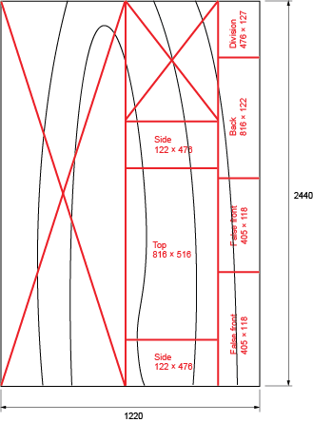
- showing the side-top-side together to enable grain matching.

Question 4
Marks | 0 | 1 | 2 | Average
% | 61 | 29 | 10 | 0.5
Full size set outs are used for:
- confirming sizes and measurements
- planning construction details and methods
- communicating with other tradespeople.

Question 5a.
Marks | 0 | 1 | 2 | Average
% | 78 | 5 | 17 | 0.4
Corners are squared out using a chisel and mallet. The corner is marked with a pencil and rule/square and cut to the line with a chisel and mallet, taking care not to chisel over the lines.

Question 5b.
Marks | 0 | 1 | 2 | Average
% | 27 | 39 | 34 | 1.1
The width and depth of the rebate. The depth of the rebate is equal to the thickness of the glass top.

Question 5c.
Marks | 0 | 1 | Average
% | 78 | 22 | 0.2
A rebate cutter is shown here.
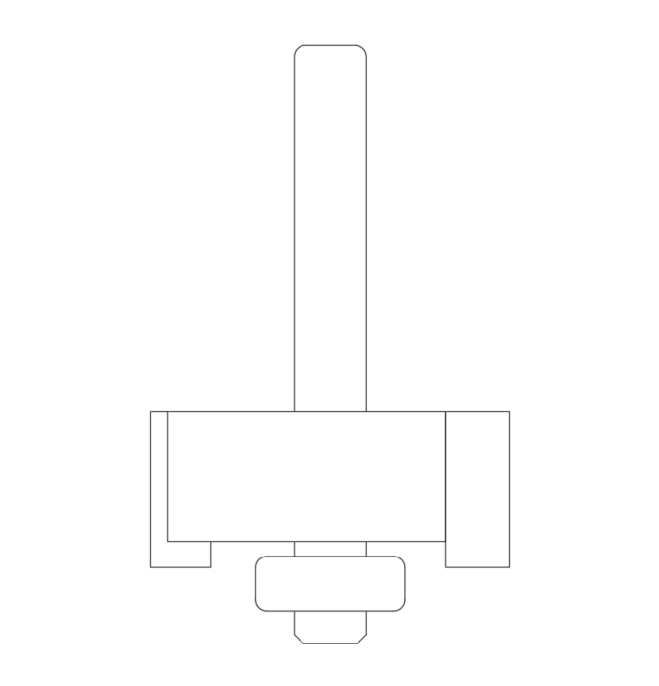

Question 6
Marks | 0 | 1 | 2 | 3 | 4 | 5 | 6 | Average
% | 3 | 2 | 8 | 17 | 9 | 23 | 39 | 4.5
Most students demonstrated good knowledge of WHS in this question.
 | Method 1 | Method 2
 | Vacuum or portable extractor | Dust mask or PPE
Advantage | - Dust removed at source  - Work area kept clean | - Low cost  - Simple to use  - Barrier to dust
Disadvantage | - Some dust not captured  - Cumbersome  - Cost | - Workshop still dusty  - Reduces visibility/Fogs up glasses  - Uncomfortable

Question 7
Marks | 0 | 1 | 2 | Average
% | 43 | 5 | 53 | 1.1
Joining method: loose tenon, dowel, mortice and tenon
Reason: not visible when complete, strength.

Question 8a.
Marks | 0 | 1 | 2 | 3 | Average
% | 10 | 11 | 57 | 23 | 1.9
- Check for square
- Check for twist
- Check for gaps
- Check for excess glue
Most students were able to identify two or three checks.

Question 8b.
Marks | 0 | 1 | Average
% | 56 | 44 | 0.5
Apply corrective pressure by adjusting the angle or position of the sash clamps.

Question 9
Marks | 0 | 1 | 2 | 3 | 4 | Average
% | 11 | 5 | 27 | 34 | 23 | 2.6
A selection of grades from coarse (80–120) through to fine (240–320) accounted for three marks, with an explanation of the reason for using several grades required for full marks.
- 120
- 180
- 240
- 320
Lower numbered (coarse) abrasive paper is needed to remove defects quickly.
Higher number (fine) abrasive paper is needed to remove the scratches left by the coarse abrasive paper.

Question 10a.
Marks | 0 | 1 | Average
% | 47 | 53 | 0.6
Total shipping dimensions are 920 mm x 570 mm x 390 mm

Question 10b.
Marks | 0 | 1 | Average
% | 78 | 22 | 0.2
Convert sizes to metres and find the volume in m3.
.92 x .57 x .39 = .204516 m3
Multiply the volume by the rate.
.204516 x $626 = $128.03

