2020 VCE VET Integrated Technologies examination report

General comments

The 2020 VET Integrated Technologies examination consisted of two sections: Section A, which comprised 20 multiple-choice questions; and Section B, which comprised 10 questions that required students to provide a combination of written explanations and show working, and state the correct units of measurements for the given problems. Completing the artwork drawing of printed circuit boards, identifying advantages and disadvantages of particular types of technology and an understanding of the technologies used in the nbnTM were required in some questions.

Students were required to use correct engineering prefixes. It was apparent that many students needed to prepare for the examination by practising the application of Ohm’s Law and how to consistently apply engineering prefixes.

In applying Ohm’s Law calculations, students should follow the standard procedure. For example, in Question 2c., to determine the circuit current IT and show the answer in mA (milliamps), the procedure is:

Select the formula required for the desired outcome: I = V / R  
Substitute the given values using base units: I = 10 / (10+560)  
Calculate the answer in base units: I = 0.01754A  
Express the answer, using the preferred notation (mA): I = 17.54mA

The limited number of students who followed this methodology or a similar approach to this, gained full marks for this question and also would have gained full marks when this methodology was applied correctly in similar questions. It is highly recommended that students familiarise themselves with the standard table of electronic symbols as used in these examinations and published online by the VCAA.

Refer to: <https://www.vcaa.vic.edu.au/documents/vce/symbolstablew.pdf>

Specific information

This report provides answers or an indication of what answers may have included. Unless specifically stated these are not intended to be exemplary or the complete list of possible responses.

The statistics in this report may be subject to rounding resulting in a total more or less than 100 per cent.

Section A – Multiple-choice questions

The table below indicates the percentage of students who chose each option. The correct answer is indicated by shading.

|  |  |  |  |  |  |
| --- | --- | --- | --- | --- | --- |
| Question | % A | % B | % C | % D | Comments |
| 1 | 72 | 10 | 3 | 14 |  |
| 2 | 17 | 17 | 66 | 0 | Applying the resistor colour codes supplied in the Examination Formula Sheet insert. |
| 3 | 3 | 7 | 3 | 86 |  |
| 4 | 38 | 24 | 34 | 3 |  |
| 5 | 3 | 31 | 3 | 62 |  |
| 6 | 0 | 10 | 0 | 90 |  |
| 7 | 7 | 3 | 0 | 90 | Cloud storage is not location-specific and allows access to files from a range of different locations. |
| 8 | 72 | 17 | 10 | 0 | In a voltage divider circuit, the highest voltage drop will occur over the highest resistance. Therefore V1 = 4V and V2 = 8V is the only viable option. |
| 9 | 79 | 3 | 10 | 7 |  |
| 10 | 3 | 93 | 0 | 3 |  |
| 11 | 90 | 7 | 3 | 0 |  |
| 12 | 24 | 69 | 7 | 0 | LDR (Light Dependent Resistor) is a standard resistor symbol with additional angled arrows indicating a light source. |
| 13 | 48 | 3 | 28 | 21 | 50µF, 100 V When two capacitors are wired in series, the overall capacitance of each cap is halved and the voltage rating is added. |
| 14 | 17 | 10 | 17 | 55 | The ceramic disc capacitor values are given in pF (picoFarad). 104 = 10 and (4 x ‘0’) = 100,000pF = 100nF or 0.1µF |
| 15 | 28 | 7 | 45 | 21 | The masonry drill bit is identified as having a tungsten tip. |
| 16 | 3 | 41 | 34 | 21 |  |
| 17 | 3 | 66 | 10 | 21 | 3 x 30Ω resistors in connected parallel = 10Ω.  Plus another 30Ω in series = 40Ω (30//30//30 = 10, 10+30 = 40) |
| 18 | 14 | 17 | 41 | 28 | 3 x 120Ω resistors in connected parallel = 40Ω (120//120//120 =40). The closest value to 40Ω in the E12 resistor series is 39Ω. |
| 19 | 7 | 76 | 14 | 3 |  |
| 20 | 59 | 7 | 3 | 31 | In soldering, brazing or welding, flux is used as a chemical cleaner to remove oxidation and as a flowing agent. |

Section B

Many students showed limited capability in applying and completing Ohm’s Law problems and in applying engineering notation.

In this report every attempt has been made to provide the preferred solutions and answers. Some students solved questions using different mathematical methods and were awarded full marks if correctly solved. The list of possible answers provided for any given question is not inclusive of all possible solutions, and students who provided a correct but different response were awarded marks.

Question 1a.

|  |  |  |  |
| --- | --- | --- | --- |
| Marks | 0 | 1 | Average |
| % | 72 | 28 | 0.3 |

In the term ‘e-waste’, the first ‘e’ refers to electronic. It was expected that more students would have known the widely used term ‘e’ is a common abbreviation of the word ‘electronic’ as used in EFT or email.

Question 1b.

|  |  |  |  |  |  |
| --- | --- | --- | --- | --- | --- |
| Marks | 0 | 1 | 2 | 3 | Average |
| % | 7 | 4 | 35 | 54 | 2.4 |

Any one of the following devices for each category:

|  |  |
| --- | --- |
| Category of e-waste | Device |
| Plug | old lamps, LEDs, leads, wires |
| Battery | toys, mobile phones, remote control devices, clocks, watches, smoke alarms |
| power cord | power tools, kitchen and laundry machines |

A common answer for battery category was a ‘phone’ for the device. While this was accepted, as landline phones often contain a battery, students are encouraged to provide more detail in their responses.

The devices listed with power cord usually have a mains power cord; however, items that utilise a lower voltage DC power cord were also accepted.

While it may be possible for any single e-waste item to fall into all three categories, students who listed the same item in all three categories were not awarded full marks.

Question 2a.

|  |  |  |  |
| --- | --- | --- | --- |
| Marks | 0 | 1 | Average |
| % | 61 | 39 | 0.4 |

Component F is a fuse.

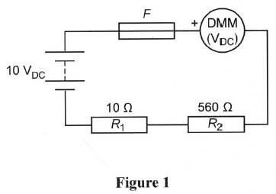

Question 2b.

|  |  |  |  |  |
| --- | --- | --- | --- | --- |
| Marks | 0 | 1 | 2 | Average |
| % | 11 | 56 | 33 | 1.2 |

The response to this question was in two parts.

* The DMM (Voltmeter) is wired incorrectly in series in this circuit. As the internal resistance of the DMM is very high (+ 20MΩ), the nominal supply voltage of 10V would be displayed on the DMM.
* The 9.98V (nominally 10V) displayed is an accurate reading, and therefore the meter is not faulty.

Question 2c.

|  |  |  |  |  |  |
| --- | --- | --- | --- | --- | --- |
| Marks | 0 | 1 | 2 | 3 | Average |
| % | 22 | 22 | 22 | 33 | 1.7 |

The correct calculation was as follows.

RT = R1 + R2 =10Ω + 560Ω = 570Ω

IT = V / R = 10V / 570Ω = 0.01754A

= 17.54mA (an answer in the range of 17 to 18mA was accepted.)

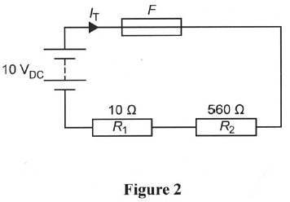

In this question three steps were required to find the total current drawn IT: (1) finding RT, (2) applying Ohm’s Law, and (3) expressing the answer in milliamps (mA). Many students appeared to be unfamiliar with using engineering notation, converting the base unit of Volts (V) to millivolts (mV) or in other questions the base unit of Amps (A) to milliamps (mA).

Question 2d.

|  |  |  |  |  |
| --- | --- | --- | --- | --- |
| Marks | 0 | 1 | 2 | Average |
| % | 46 | 13 | 41 | 0.9 |

V = I R = 0.0174A x 10 = 0.1754V

= 175.4mV

Question 2e.

|  |  |  |  |
| --- | --- | --- | --- |
| Marks | 0 | 1 | Average |
| % | 41 | 59 | 0.6 |

The DMM (VDC) meter needed to be connected across R1 and the correct polarity shown.

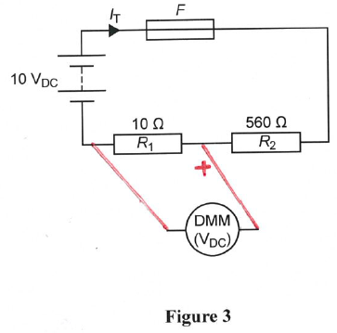

Question 2f.

|  |  |  |  |
| --- | --- | --- | --- |
| Marks | 0 | 1 | Average |
| % | 69 | 31 | 0.3 |

To obtain the most accurate reading of 175.4mV, the DMM dial would be set to 200m on the V (Volts) range setting.

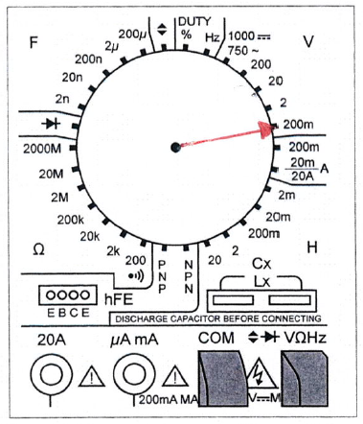

Question 2g.

|  |  |  |  |
| --- | --- | --- | --- |
| Marks | 0 | 1 | Average |
| % | 50 | 50 | 0.5 |

The reading is just displayed with a minus (–), in addition to the measured value.

Question 2h.

|  |  |  |  |  |  |
| --- | --- | --- | --- | --- | --- |
| Marks | 0 | 1 | 2 | 3 | Average |
| % | 43 | 7 | 26 | 24 | 1.3 |

Students needed to provide a comprehensive answer for full marks to be awarded.

* The term ‘auto ranging display’ only requires the user to switch to the overall desired unit of measurement: for example, volts.
* The meter display would automatically range through the voltage measurements by moving the decimal point to provide the greatest accuracy to be read.
* The diagnostic benefit is that the user can efficiently and safely roam about the circuit board with the test leads, testing different areas without being required to adjust the voltage range setting at any point during the fault diagnosis. For example, 0.173 volts would nominally be automatically displayed as 172.25mV.

Question 3a.

|  |  |  |  |  |
| --- | --- | --- | --- | --- |
| Marks | 0 | 1 | 2 | Average |
| % | 25 | 16 | 60 | 1.4 |

Any two of the following:

* superior power to weight ratio
* comparatively light weight motors
* reduced electrical sparking
* less wear and tear (brushes don’t need to be replaced)
* improved speed control
* comparatively greater torque
* comparatively greater efficiency.

Question 3b.

|  |  |  |  |  |  |  |
| --- | --- | --- | --- | --- | --- | --- |
| Marks | 0 | 1 | 2 | 3 | 4 | Average |
| % | 4 | 18 | 37 | 35 | 7 | 2.2 |

|  |  |  |
| --- | --- | --- |
| Information or symbol | Full name | Technical description |
| Li-ion | Lithium-ion battery | Lithium-ion is a rechargeable battery technology as used in cordless power tools. |
|  | 18 volts DC | The battery supplies 18V DC (Direct Current). |
| 5.0 Ah | 5 Amp hour battery capacity | When fully charged, this battery has the nominal capacity to supply 5 Amps at 18 volts continuously for 1 hour. It can equally mean that the battery pack could potentially supply 10 Amps for 30 minutes. |
|  | This battery is recyclable. | This symbol indicates that the materials and components that make up the battery can be individually or collectively recycled at the end of the battery’s life. |
|  | Do not dispose of the battery in the regular (landfill) waste bin. | The battery must not be disposed of in the regular landfill waste bin. The battery is recyclable and should be disposed into e-waste only. |

Responses that missed or misinterpreted specific critical information from the cordless tool battery pack specifications were not awarded marks. Common errors included:

* Voltage symbol: many students did not include that the battery supplies direct current (DC), which is indicated in the symbol by the solid line with three dashes below.
* Battery capacity symbol: some students referred to the battery pack as a device that was consuming or drawing electric power, rather than being the device providing the power to operate the cordless tool. Students should be familiar with the storage capacity and supply capabilities of battery packs as given by the manufacturer’s data sheet or website.
* Recycling symbol: a number of students incorrectly interpreted that this symbol indicated that the battery pack was manufactured using recycled materials only rather than that the battery could be recycled at the end of its life.

Question 3c.

|  |  |  |  |
| --- | --- | --- | --- |
| Marks | 0 | 1 | Average |
| % | 74 | 26 | 0.3 |

Any one of the following:

* Ni-cad (nickel cadmium)
* Ni-MH (nickel metal hydroxide)
* Li-polymer (lithium polymer)
* SLA (sealed lead acid).

Many students identified batteries, which are non-rechargeable. Common incorrect answers included standard alkaline and zinc carbon batteries.

Question 3d.

|  |  |  |  |  |
| --- | --- | --- | --- | --- |
| Marks | 0 | 1 | 2 | Average |
| % | 49 | 23 | 28 | 0.8 |

Lithium-ion batteries have minimal memory effect. Battery memory effect is a process where batteries gradually lose their maximum energy capacity if they are repeatedly recharged after being only partially discharged. In effect, the battery appears to ‘remember’ the smaller charging capacity.

Question 3e.

|  |  |  |  |  |
| --- | --- | --- | --- | --- |
| Marks | 0 | 1 | 2 | Average |
| % | 35 | 46 | 19 | 0.8 |

Any two of the following:

* the recharge rate of supercapacitors is very fast
* they weigh less
* they’re less prone to (battery) memory effect
* potentially environmentally better for disposal as Li-ion batteries need special management for disposal
* potentially cheaper with mass production.

Question 4a.

|  |  |  |  |
| --- | --- | --- | --- |
| Marks | 0 | 1 | Average |
| % | 19 | 81 | 0.8 |

The switch S1 is ‘closed’ or ‘on’.

Question 4b.

|  |  |  |  |  |  |
| --- | --- | --- | --- | --- | --- |
| Marks | 0 | 1 | 2 | 3 | Average |
| % | 35 | 9 | 0 | 56 | 1.8 |

To find RT, three circuits have to be determined. The circuit has two parallel resistor circuits in series with each other. The total resistance (RT) has to be expressed in Ω.

3 x 60Ω resistors in parallel (60//60//60 = 20Ω)

2 x 120 Ω resistors in parallel (120//120 = 60Ω)

Parallel networks in series: 20 + 60 = 80Ω

Question 4c.

|  |  |  |  |  |  |
| --- | --- | --- | --- | --- | --- |
| Marks | 0 | 1 | 2 | 3 | Average |
| % | 33 | 9 | 23 | 35 | 1.6 |

To calculate the current displayed on meter, the students had to select the correct Ohm’s Law formula, substitute the correct values and express the answer in mA (milliamps).

I = V / R

= 24V / 80Ω

= 0 3A = 300mA

Question 4d.

|  |  |  |  |  |  |
| --- | --- | --- | --- | --- | --- |
| Marks | 0 | 1 | 2 | 3 | Average |
| % | 46 | 9 | 7 | 39 | 1.4 |

To calculate the voltage, students needed to select the correct Ohm’s Law formula, substitute the correct values and express the answer in V (volts).

V = I x R

= 0.3A x 60Ω

= 18 V

Question 4e.

|  |  |  |  |  |
| --- | --- | --- | --- | --- |
| Marks | 0 | 1 | 2 | Average |
| % | 44 | 5 | 51 | 1.1 |

To find the power dissipated by the circuit, students needed to select the correct formula for power calculations, substitute the correct values and express the answer in W (watts) or mW (milliwatts).

P = V x I

= 24V x 0.3A

= 7.2W or 7200mW

Question 4f.

|  |  |  |  |  |
| --- | --- | --- | --- | --- |
| Marks | 0 | 1 | 2 | Average |
| % | 75 | 5 | 19 | 0.4 |

* Typically, a 500mA fuse or up to a 1000mA fuse was accepted.
* If a 300mA rated fuse is used, it will blow immediately when switched on.

Fuses and circuit breakers require a significant margin of electrical current rating above the nominal current drawn by a circuit. Students who answered ‘300mA fuse rating’ were not awarded marks.

Question 5a.

|  |  |  |  |  |  |  |  |
| --- | --- | --- | --- | --- | --- | --- | --- |
| Marks | 0 | 1 | 2 | 3 | 4 | 5 | Average |
| % | 29 | 7 | 2 | 11 | 14 | 38 | 2.9 |

The partially completed circuit board layout design needs to have the five missing tracks drawn in without any short circuits being created.

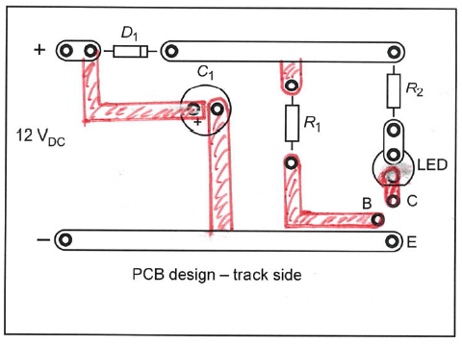The majority of students roughly drew single lines between the pads to be connected. They were awarded marks if the lines were drawn in the correct positions. Generally, much greater accuracy and care needs to be taken when answering PCB design questions.

Question 5b.

|  |  |  |  |  |
| --- | --- | --- | --- | --- |
| Marks | 0 | 1 | 2 | Average |
| % | 18 | 32 | 50 | 1.3 |

* The function of resistor R2 in the circuit is to operate as a current limiting resistor or to provide an appropriate voltage drop for the LED.
* If the drop resistor was not included in the circuit, the LED would potentially have its maximum current exceeded and burn out.

Question 5c.

|  |  |  |  |  |
| --- | --- | --- | --- | --- |
| Marks | 0 | 1 | 2 | Average |
| % | 82 | 11 | 7 | 0.3 |

* The function of capacitor C1 in the circuit is to provide any smoothing from the 12 V DC power supply.
* The inclusion of the capacitor, while not totally essential, provides stability to the DC power supply.

Question 6a.

|  |  |  |  |  |
| --- | --- | --- | --- | --- |
| Marks | 0 | 1 | 2 | Average |
| % | 14 | 38 | 48 | 1.3 |

* The main purpose of prototyping is to use a quick method to build a circuit and test it for correct functioning.
* Possible developmental changes and modification of the circuit would also be undertaken during this stage of an integrated technology project.

Question 6b.

|  |  |  |  |  |  |  |
| --- | --- | --- | --- | --- | --- | --- |
| Marks | 0 | 1 | 2 | 3 | 4 | Average |
| % | 23 | 23 | 16 | 18 | 20 | 1.9 |

Possible answers included:

|  |  |  |
| --- | --- | --- |
| Prototyping technique | Advantage | Disadvantage |
| Breadboard | * Quick and easy to set up * Easy to change, swap and modify components | * Relatively large and spread out components * May not be suitable for some circuits (e.g. RF) * Prone to faulty wiring connections * Not suitable for a final circuit use, as highly prone to faults over time |
| Veroboard | * The circuit can be built tight and compact * The soldered connections are generally very reliable * It is quick to fabricate, and it may be possible to use it for the final circuit | * Not as neat as a custom designed PCB * Removal or changing components can be difficult, often resulting in damage or lifted tracks and pads |

Question 6c.

|  |  |  |  |  |  |
| --- | --- | --- | --- | --- | --- |
| Marks | 0 | 1 | 2 | 3 | Average |
| % | 71 | 16 | 5 | 7 | 0.5 |

Students needed to demonstrate an understand of the step-by-step design and construction terms that are involved in the process of circuit design and development through to the fully completed PCB.

|  |  |
| --- | --- |
| Process | Step Number |
| Design the PCB layout on a computer. | **4** |
| Simulate the circuit on a computer. | **1** |
| Output the final circuit PCB design to a CNC router. | **5** |
| Mock up the circuit on a breadboard. | **2** |
| Mock up and fabricate the circuit on Veroboard. | **3** |
| Solder the components into the fully designed PCB. | **7** |
| Propagate the components into the fully designed PCB. | **6** |

Question 7a.

|  |  |  |  |
| --- | --- | --- | --- |
| Marks | 0 | 1 | Average |
| % | 82 | 18 | 0.2 |

FTTN stands for ‘fibre to the node’.

Question 7b.

|  |  |  |  |  |
| --- | --- | --- | --- | --- |
| Marks | 0 | 1 | 2 | Average |
| % | 52 | 41 | 7 | 0.6 |

* 4G stands for 4th Generation.
* 4G is a mobile phone and data network, which is currently and extensively used across Australia.

Question 7c.

|  |  |  |  |  |  |
| --- | --- | --- | --- | --- | --- |
| Marks | 0 | 1 | 2 | 3 | Average |
| % | 57 | 16 | 16 | 11 | 0.8 |

The level of understanding shown and response provided by the students determined the allocated marks.

Some reasonable responses given are detailed below.

* As the nbnTM is being rolled out across Australia utilising a multi-technology mix, the complex network is subject to faults and service interruptions. The 4G network provides a reduced speed, short-term backup.
* Having an inbuilt 4G mobile data network backup means that in the event of an internet drop-out, the gateway device will automatically switch over the available 4G nbnTM data network to maintain nbnTM connection.
* The 4G network is suitable for short-term service backup; however, the data speed is usually significantly slower than the regular NBN service delivery.

Question 7d.

|  |  |  |  |  |  |
| --- | --- | --- | --- | --- | --- |
| Marks | 0 | 1 | 2 | 3 | Average |
| % | 29 | 16 | 0 | 55 | 1.8 |

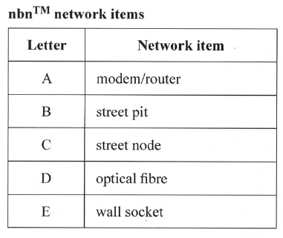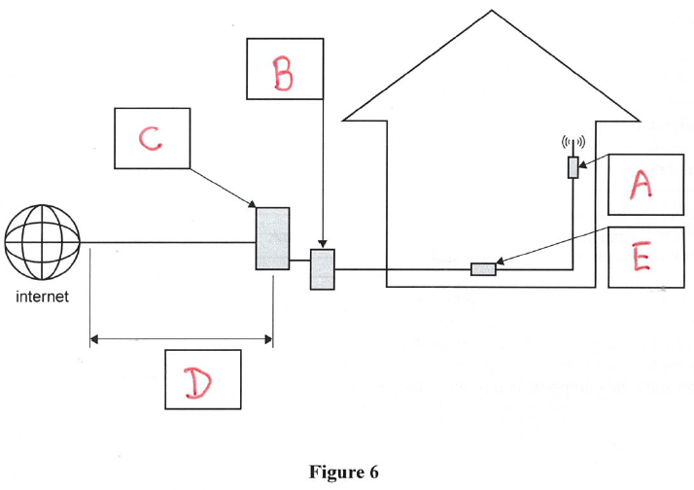

Question 7e

|  |  |  |  |
| --- | --- | --- | --- |
| Marks | 0 | 1 | Average |
| % | 77 | 23 | 0.2 |

Coaxial cable is the type of cable shown.

Question 7f.

|  |  |  |  |  |
| --- | --- | --- | --- | --- |
| Marks | 0 | 1 | 2 | Average |
| % | 80 | 20 | 0 | 0.2 |

This question was poorly answered or not responded to.

Correct answers identified the following.

* The nbnTM network commonly called a ‘home network modem’ should not be referred to as a ‘modem’ as the word is derived from the collective abbreviation of ‘modulator/demodulator’. It is an obsolete term for the computer connection device that in the past was originally connected to the analog audio phone line and used to send audio modulations over the line to the server computer and in turn demodulated the returning audio signals.
* As the nbnTM is a purely digital network, what is commonly now referred to as a ‘modem’ is neither a modulator nor a demodulator, rather it operates only as a digital router nbnTM gateway device.

Question 8.

|  |  |  |  |  |
| --- | --- | --- | --- | --- |
| Marks | 0 | 1 | 2 | Average |
| % | 39 | 12 | 49 | 1.1 |

Any one of each of the following:

* User hazard: eye strain, risk of RSI, risk of back injury, risk of wrist injury
* Control measure: changing seating position to avoid excessive daylight on the screen, getting an appropriate height table, using an adjustable chair with back support



Students needed to identify hazards that were visible in the photo and not, for example, assume a power lead was a trip hazard. Marks were awarded to students who identified a realistic hazard and provided a related and effective measure to control the risk.

Question 9a.

|  |  |  |  |
| --- | --- | --- | --- |
| Marks | 0 | 1 | Average |
| % | 82 | 18 | 0.2 |

The ‘view A-A’ drawing is identified as a ‘cross-sectional view’ or sometimes a ‘cut-away view’.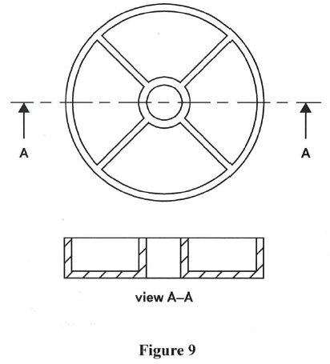

Question 9b.

|  |  |  |  |
| --- | --- | --- | --- |
| Marks | 0 | 1 | Average |
| % | 93 | 7 | 0.1 |

An identifying feature of the cross-sectional view are the diagonal hashed lines.

Question 10a.

|  |  |  |  |  |
| --- | --- | --- | --- | --- |
| Marks | 0 | 1 | 2 | Average |
| % | 46 | 11 | 44 | 1.0 |

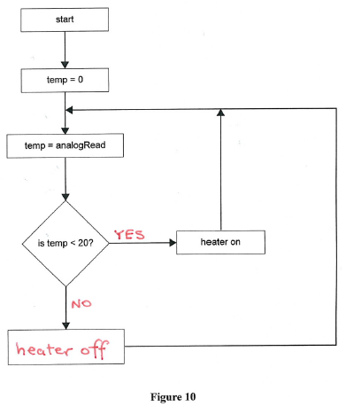

Question 10b.

|  |  |  |  |
| --- | --- | --- | --- |
| Marks | 0 | 1 | Average |
| % | 49 | 51 | 0.5 |

The function ‘heater off’ should be written into the last function box.