Running Internet Explorer in MS Edge

Background
The VCAA is aware that Internet Explorer will no longer be supported by Microsoft as of 15th June 2022. The On Demand application still has a dependency on Internet Explorer for the administration portal which will cease to work after this date.
Microsoft Edge will continue to support Internet Explorer Mode for the foreseeable future and so some configuration changes will need to be made to PCs that need to access the On Demand administration portal.
Note that the test player used by students does not require Internet Explorer and so no changes need to be made to student facing devices.

Options
The first option is to enable Internet Explorer Mode in MS Edge on a local PC and add the required On Demand URLs to the IE Mode site list. Sites added to IE Mode in this way will expire after 30 days and need to be re-added. Instructions on how to do this are available from the On Demand Helpdesk.
The second option is for a school technician / systems administrator to configure Group Policy to automatically enable IE Mode in Edge and define a list of sites to be opened in this mode. Documentation on this process is available from Microsoft. We will provide links to MS articles as well as an extract from those articles on how suggested approach to this.
Please note that VCAA and the On Demand Helpdesk cannot provide troubleshooting support for the configuration of Group Policy.

Links
How to configure IE Mode and Enterprise Site List via policy: https://docs.microsoft.com/en-us/deployedge/edge-ie-mode-policies
Enterprise Mode Site List Manager: https://go.microsoft.com/fwlink/p/?LinkId=716853
This is a useful tool for generating XML Enterprise Site Lists instead of creating them manually.

Option 1

Steps
- Open Microsoft Edge browser
- Click the options button on the top right-hand corner
- Select settings
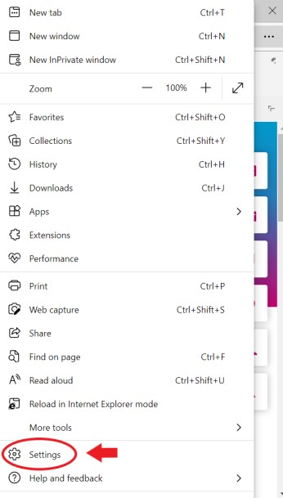
- Click on the Default browser on the left
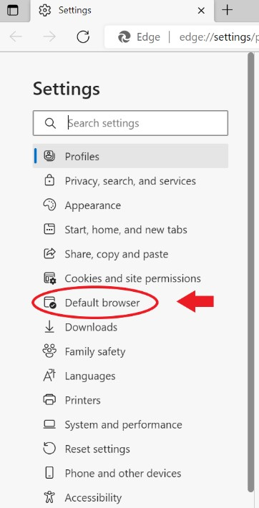

- Click on the dropdown menu for Allow sites to be reloaded in Internet Explorer mode and select Allow
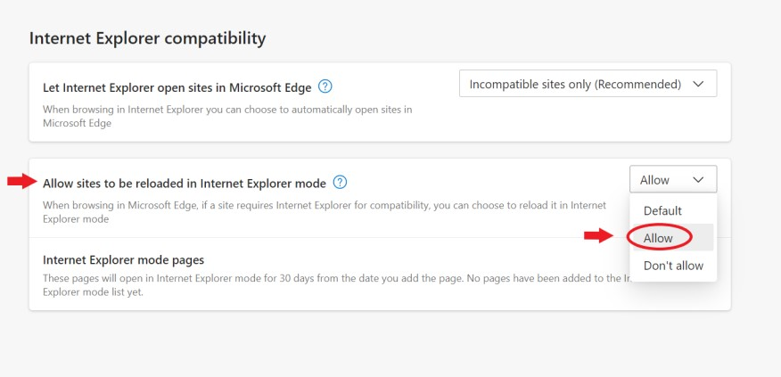

Adding the central server URL to Internet Explorer mode pages
- Click the Add button for Internet Explorer mode pages
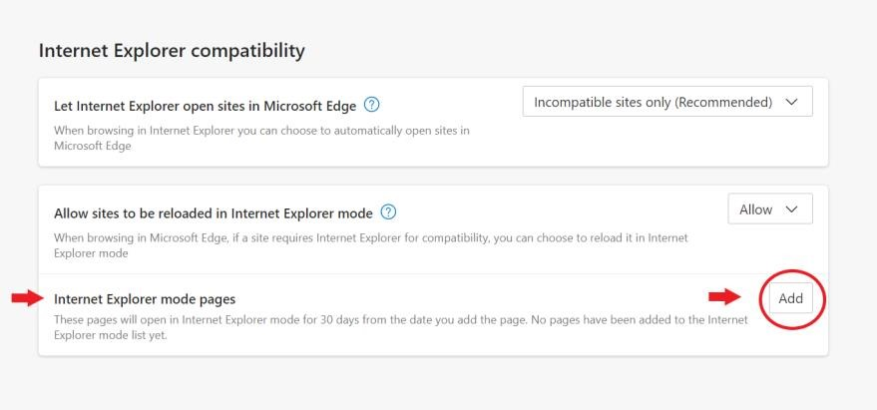
- In the Add a page window type in the URL for the Central Server https://www.aimonline.vic.edu.au/client_controller.asp and click Add
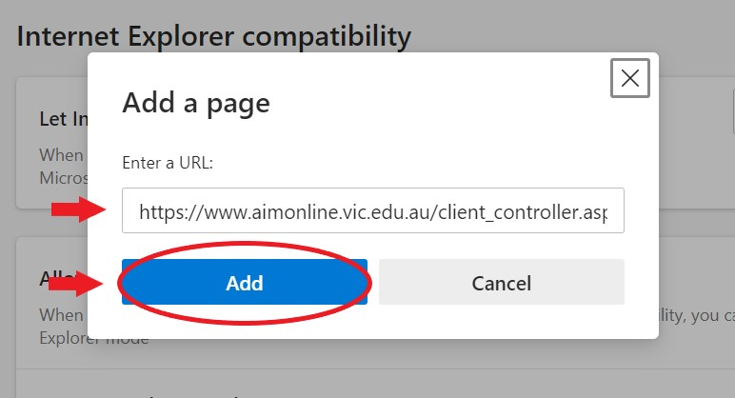
- Repeat steps 6 & 7 to add the School Server URL
- Close Microsoft Edge browser and re-open

Option 2 Steps
- Create an Enterprise Site List XML file
- Create or edit a Group Policy object in your domain that targets the required PCs
- Configure required settings for IE Mode and Site List.
These steps are taken from the MS article linked earlier, specifically the sections titled “Enable
Internet Explorer integration using Group Policy” and “Configure using the Configure the Enterprise Mode Site List policy”
This is only a suggested configuration, there are many configuration options available and the options should be evaluated in the context of your systems.

Step 1
Before configuring the group policy you’ll need an XML Enterprise Site List that defines which URLs will open in IE Mode when using Edge. This can be done using the tool linked earlier or manually using the following example format:
<site-list version="1">
<site url="www.aimonline.vic.edu.au">
<compat-mode>Default</compat-mode>
<open-in>IE11</open-in>
</site>
</site-list>

Your site list will need to include www.aimonline.vic.edu.au for access to our central server for test downloading and the URL of your local school server.
This site list will need to be hosted somewhere that is accessible to the target PCs. Possibly on a file share or web server. Note the path to this hosted XML file for use later.
Note: This same issue also applies to VASS, if your school is a VASS user then you may have already performed these steps and only need to add On Demand to the site list. You can contact the VASS Helpdesk for further information.

Step 2
Create a Group Policy object in your domain that will have Computer Configuration items in it and will target PCs used by teaching staff who administer On Demand. This step will vary greatly depending on your specific system setup.

Step 3
Edit the Group Policy Object created in the previous step and navigate to Computer Configuration > Administrative Templates > Microsoft Edge
Edit the setting named “Configure Internet Explorer Integration” and set it to Enabled and option “ Internet Explorer Mode”
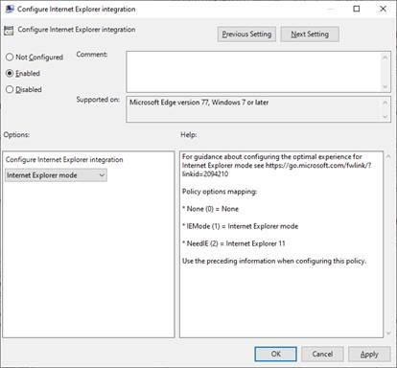
Edit the setting named “Configure the Enterprise Mode Site List”, set it to Enabled, and enter the XML location noted earlier in the Options section.
