Event registration guidelines
The Trumba event registration system is used for participants to register online for VCAA professional development. Click on the link you have been given to register for your preferred session as per the following instructions. You must register for only one session. You will be unable to register for a session that is flagged as full. Confirmation of registration will be sent to your email address through Trumba. Note: The examples shown refer to the VASS New Users PD.
Online Trumba registration
- Click on the link to the Trumba calendar for VCAA professional development.
- Change the month on the calendar to the correct one if needed. For this training period, go to February or March (see Figure 1).

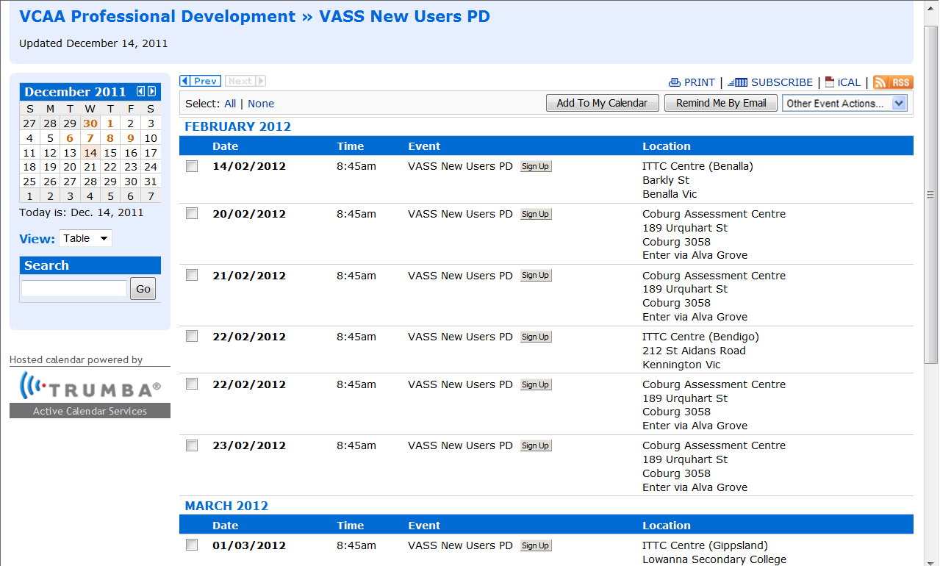
Figure 1: VASS New Users PD calendar

- By clicking on the event name you can see additional information or click on the Sign Up icon to go directly to the registration form (see Figure 2).

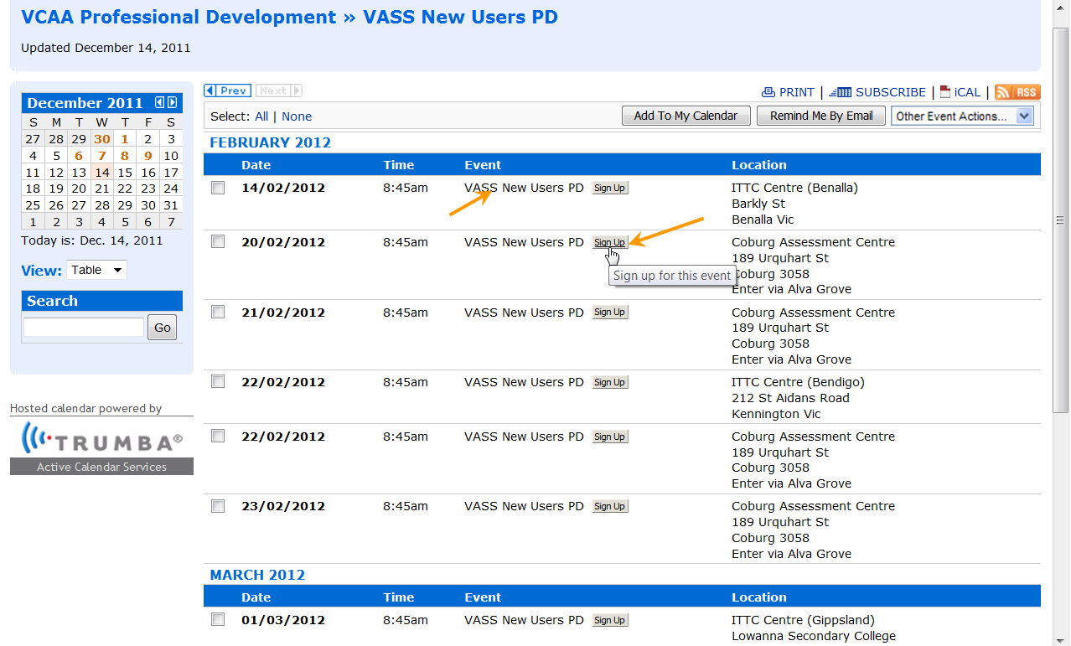
Figure 2: February & March 2012 training dates and venues
- Training information is included in the next screen. To sign up for this session, click on the Sign Up icon (see Figure 3).
- There is a map attached for most sessions. This is important for the Coburg Assessment Centre because there are two parts to Urquhart Street. You will need the map to find the centre.

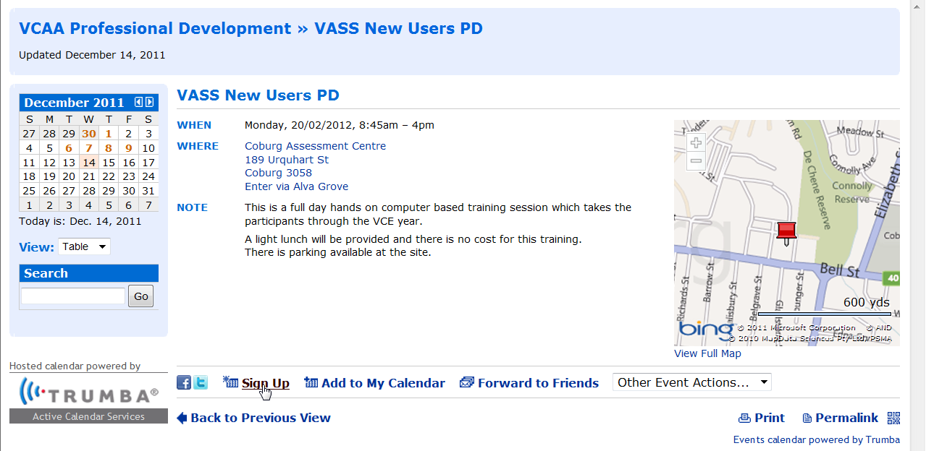
Figure 3: February 2012 specific date and venue information
- Enter details in all relevant fields of the Registration Form (see Figure 4). Note: Mandatory fields have an asterisk next to them.
- Place a tick in the box beside ‘Add to my Calendar’ and follow the instructions after clicking the OK button. Leave the tick in the box next to ‘Notify me’.
- Note: If you wish to be sent a reminder email, place a tick in the box next to ‘Email me a reminder’ and select an appropriate time (e.g. 24 hours).
- On the next page, you will be asked to select the option you want the confirmation email to be directed to. Select which one you use: for example, choose Outlook and you will be ‘invited’ to a meeting (see Figure 5). This is just a reminder. Please accept the meeting invitation when it is sent. This will ensure you are reminded of the time and date of your training session.

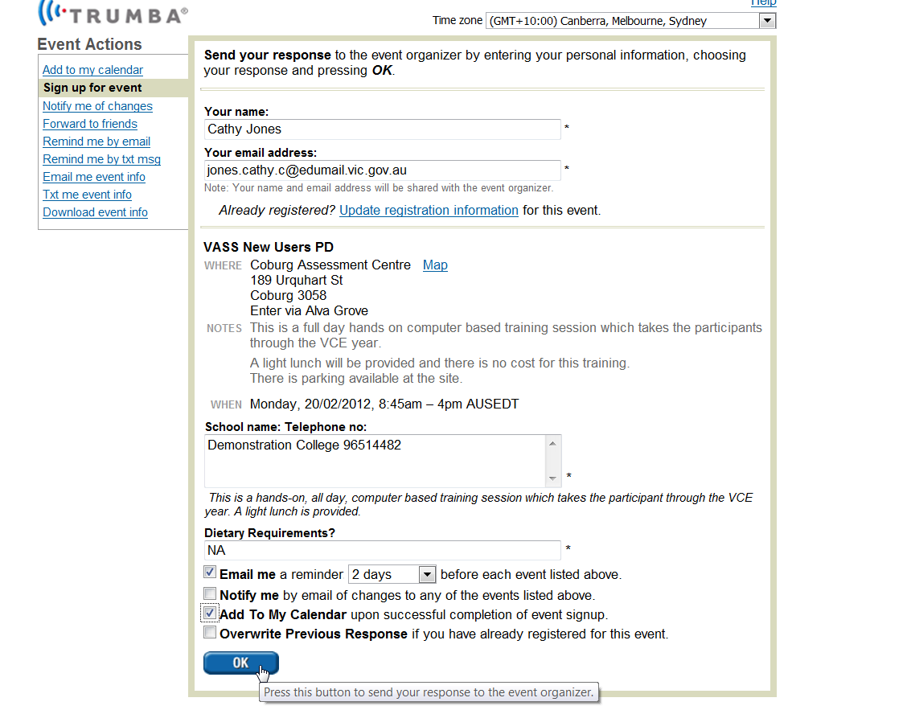
Figure 4: Registration form/template

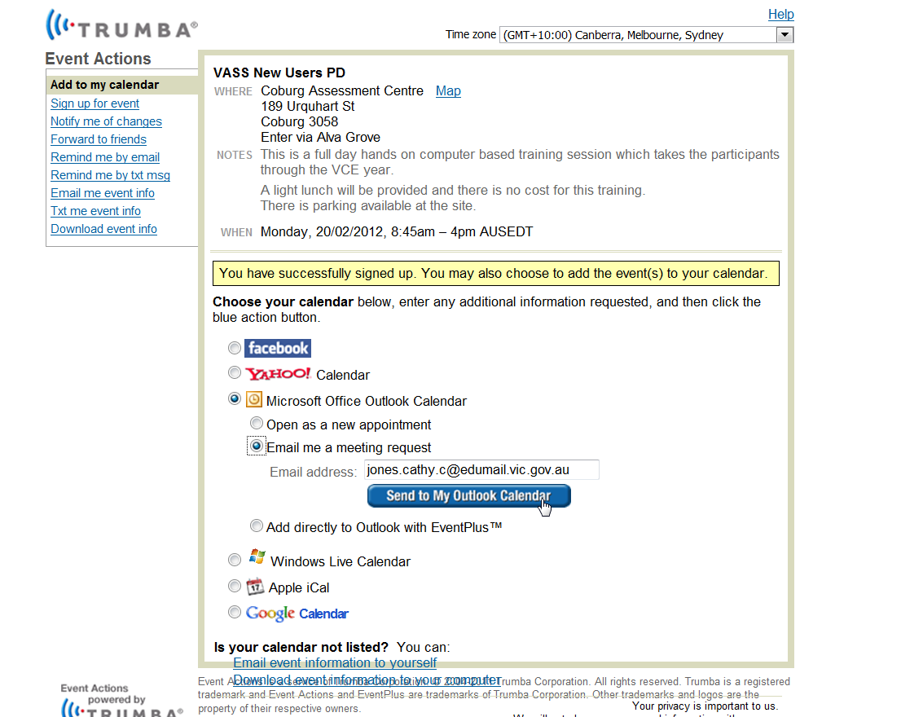
Figure 5: Email to Outlook Calendar

