Navigation instructions

Navigation:
- To move forward or backward through the online audit questionnaire, use the [PREVIOUS PAGE] and [SAVE AND CONTINUE] buttons displayed in the bottom corners of each page.
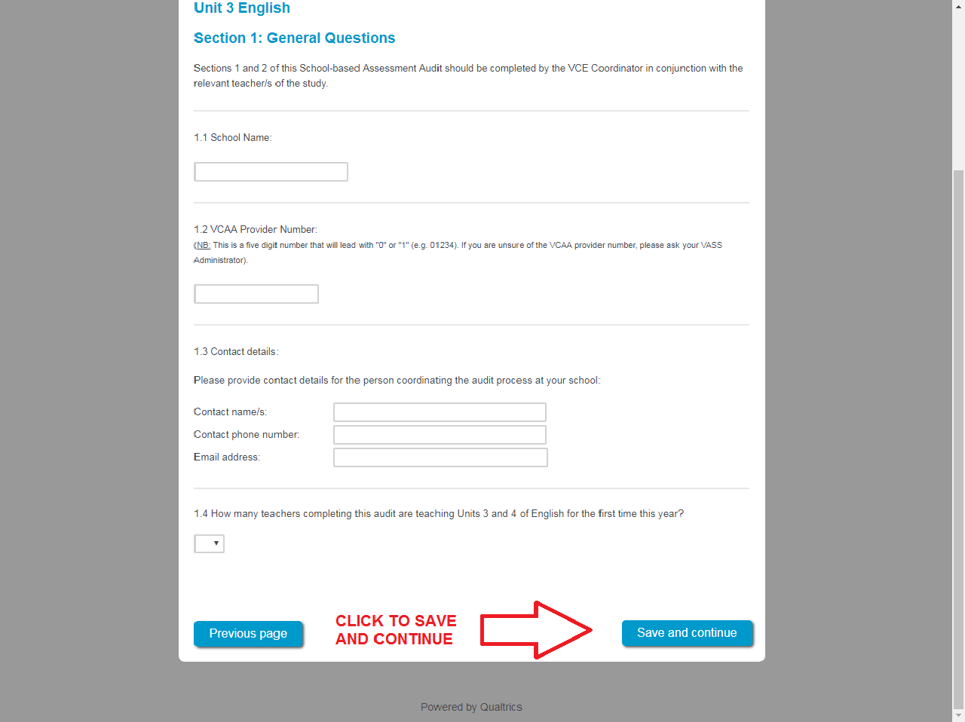
- Do not use the arrows in your web browser as this can exit you out of the audit without saving.

Uploading files:
Please note that for some questions, only one file can be attached. Where this is the case and you have multiple documents to upload, please combine them into one document or a zip file before uploading.
Please ensure the document has completed uploading before clicking [SAVE AND CONTINUE].
If the wrong document is uploaded, simply upload the correct document over the top of the existing one.
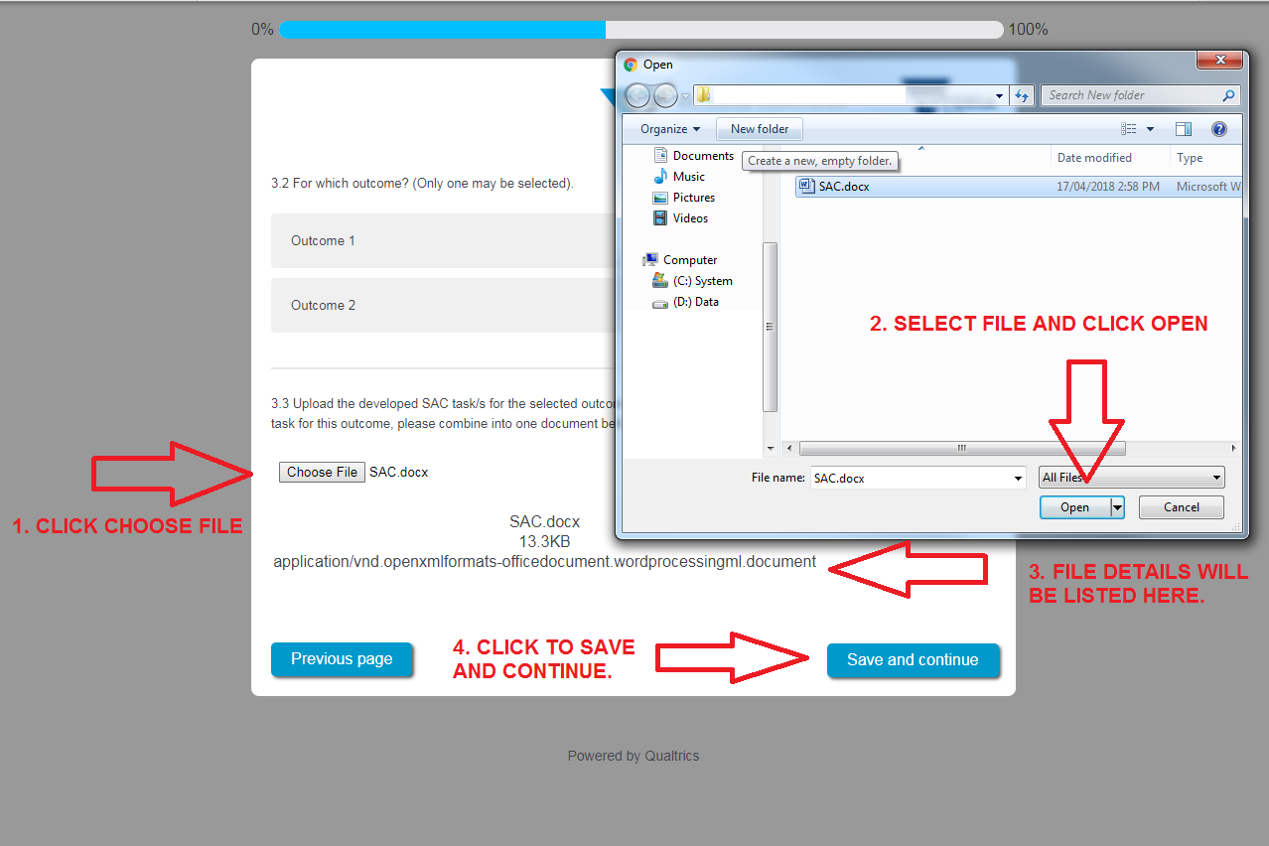

Connectivity:
To avoid losing information if your internet connection drops out, we recommend that answers are prepared prior to commencing the online audit.
The audit can be completed at a later stage once commenced.
To recommence the audit please ensure you:
- use the [SAVE AND CONTINUE] button located in the bottom right-hand corner to save entered information
- use the same computer and web browser on which the audit was commenced, as a copy of your responses will have been saved.
In the event there are any technical issues, please contact the School-based Assessment Audit team for assistance on (03) 9059 5166 or via email school.assessment.vcaa@education.vic.gov.au. Generally, 'lost' responses are retrievable.

Input boxes:
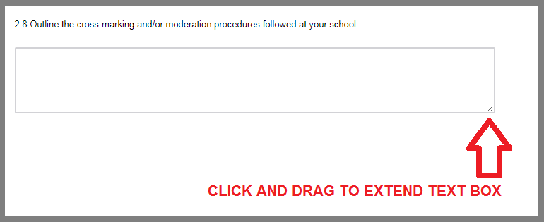
For most input boxes, the size of the box can be extended by dragging the handle in the bottom right-hand corner of the input box. The handle looks like two diagonal lines.

Copy of response:
- Once the [PREVIEW RESPONSE] button is pressed at the conclusion of the online audit, a full preview of the responses you have provided will be shown. A PDF of this can be downloaded.
- Once you have viewed the PDF, you can go back to edit any of the responses provided by using the [PREVIOUS PAGE] button.
- If a document is uploaded to the audit, it won't be able to be viewed in the response review. Please check the document prior to uploading. If the wrong document is uploaded, simply upload the correct document over the top of the existing one.
