VCE Legal Studies 2018–2023

Appendix 7 – Defamation Jigsaw Research Activity

Unit 1 Area of Study 3

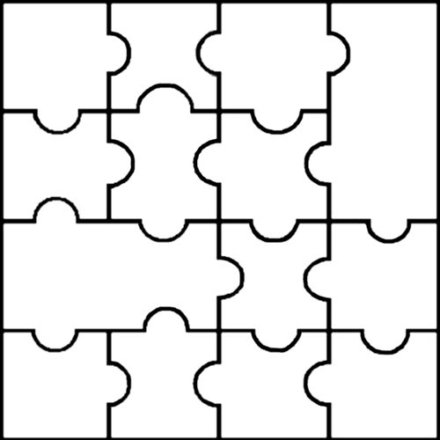
Research the defence to defamation of triviality
Defamation Jigsaw Activity
Research the defence to defamation of honest opinion
Find a recent example of a defamation case.
Identify the elements a Plaintiff must prove in defamation
Research the defence to defamation of publication of Public Documents
Research the defence to defamation of contextual Truth.
Research the ways of resolving a defamation Cases
Research the defence to defamation of qualified privilege
Research the defence to defamation of absolute privilege
Instructions
Students to pair up

Cut up the jigsaw pieces and hand them out to students at random

Provide time and assistance to research the piece each pair was provided

Present or combine all pieces together
Research the defence to defamation of consent
Define the term defamation, and what law covers this civil area in Victoria.
Research the defence to defamation of fair report of proceedings of public concern

