VCE Product Design and Technology 2018–2022
Example of a commercial product comparison template
The following table represents an example of a commercial product comparison activity. The teacher would have to provide some technical information about each product too, as this task cannot be completed using the pictures alone.

Product design factor | 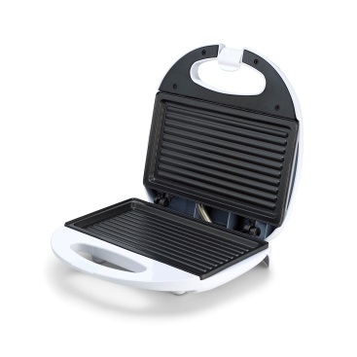 | 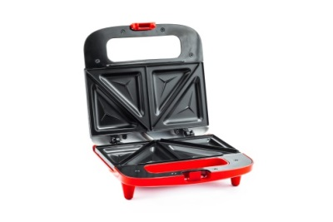 | 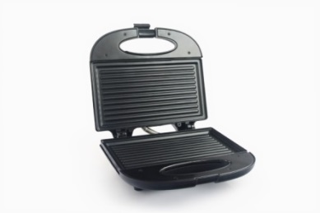
 | Product 1 | Product 2 | Product 3
 | List attributes | List attributes | List attributes
Purpose, function and context
User- centered Design
Innovation and creativity
Visual, tactile and aesthetic
Sustainability
Economics
Legal responsibilities
Materials
Technologies

