VCE Product Design and Technology 2018–2022

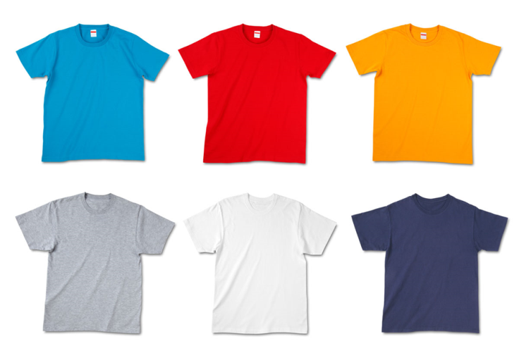**DryDye Technology** DryDye Technology


Dry dyeing is a new technology which uses compressed carbon dioxide to force dye into fibres like cotton.

Dry dyeing eliminates dye-filled run off which heavily pollutes waterways such as rivers.

Dry dyeing also reduces the negative impact on people's health of using chemical dyes.

Uses no water compared to normal t-shirt dyeing which uses 25 litres of water per t-shirt.