Modelling contagious diseases using Wolfram

Overview
This resource package consists of a disease/vaccination modelling simulation, links to appropriate scientific websites, articles and videos and other graphing and modelling activities related to vaccines and society. This is specifically designed for VCE Biology Unit 3, however, it could be adapted for students in lower secondary levels. The resource may be used by teachers as a demonstration or by students, in groups or individually, to investigate the spread of disease, the effectiveness of vaccines and herd immunity.
The resource uses Wolfram Mathematica®. The Department of Education and Training (DET) has obtained Wolfram Mathematica® software licenses for all staff and students at Government, Catholic and Independent schools in Victoria to be able to access this resource.

How the resource could be used in the classroom
The resource is structured into three parts, which may be completed individually or together. Part 1 is directly related to VCE Biology Unit 3, Area of Study 2 – Immunity. Parts 2 and 3 of the resource include extension activities that cover the issues related to vaccines and society in more detail and from different perspectives supported by relevant scientific and medical journal articles.
- Part 1 – Modelling the effectiveness of vaccination and herd immunity
Students investigate and model the rate of spread of infectious disease under different conditions, vaccination programs and their role in maintaining herd immunity for a particular disease in the human population.
- Part 2 – Vaccination and society
Using Australian data, students investigate the effectiveness of vaccination programs, social issues and how the media present information concern infectious diseases and vaccines.
- Part 3 – The science of vaccines
Students study the purpose of vaccines, vaccine safety and vaccine components. This is split into two parts – 3a: The science of vaccines and 3b: Graphing the spread of disease.
The simulation included allows students to investigate and model the rate of spread of infectious diseases under different conditions, including number of initial carriers, population size, infection rate and vaccination rate. The simulation uses real data obtained from official medical and government websites including the World Health Organisation, Australian Infectious Diseases Research Centre and the United States Centres for Disease Control and Prevention (CDC).
To allow for further investigations, the simulation could be used to model other infectious diseases by changing the variables to suit the disease’s virulence, contagious period, and so on. Teachers could also create their own data (or use data from other sources) for students to simulate and investigate factors such as infection rates and effectiveness of vaccination.

The resource could also be used at lower secondary levels by excluding some questions or by running the simulation in Part 1 as a demonstration. Part 3a has a large scientific literacy component and Part 3b has a large numeracy component which teachers should also take into consideration when determining the suitability of the resource for other year levels.
Teachers may choose to demonstrate the resource to the whole class or students can individually or in groups run the simulations on their own computers and fill in the answer boxes in the program as they work through the resource. It is not a requirement of the resource to directly answer the questions in the program; teachers may choose to ask students to write their responses in their workbook, or use Pages or another word processing program. If recording their answers in the program, students should be encouraged to regularly save their program since all their simulations and responses may be lost if the school experiences online connection issues.
Students submitting their copy of the resource for feedback or assessment will need to rename the program file name (for example, “modelling contagious diseases.” becomes “Jane Smith modelling contagious diseases.”).

Resource Requirements
The resource uses Wolfram Mathematica®. Mathematica® can be used as a downloadable program or online (Mathematica® Online). The Department of Education and Training has software licenses for all staff and students at Government, Catholic and Independent schools in Victoria.
Step 1: Obtaining a Wolfram ID
Teachers must first obtain a Wolfram ID to download Mathematica® or to access Mathematica® Online. To do this,
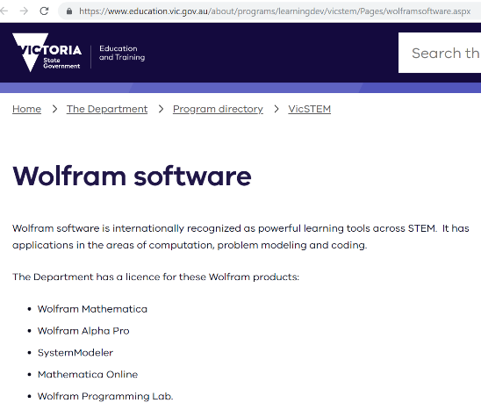
- go to the Wolfram software page at the Department of Education and Training website, as shown below:

- Scroll down to ‘Register for a Wolfram ID’ section, as shown below.
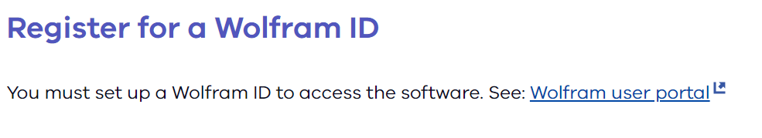
- Click on the ‘Wolfram user portal’ hyperlink to be taken to the Wolfram account page.
- Register for a Wolfram ID here by clicking on the ‘Create one’ hyperlink. Make sure you use your school email address.
Students can also use Mathematica® or Mathematica® Online and the resource package for free. Instructions for student access are also included on the DET Wolfram software page.

Step 2: Downloading Mathematica®
Once a Wolfram ID has been obtained, go back to the DET Wolfram software page and follow the instructions and hyperlinks under either the ‘Access for government schools’ or ‘Access for Catholic and independent schools’ headings to download Wolfram Mathematica®.
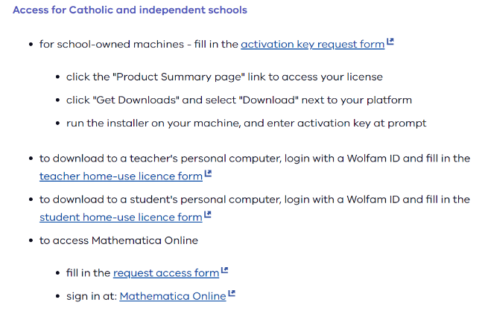
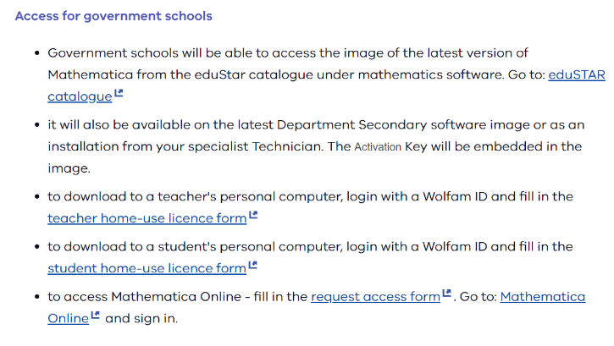
As shown below:

Alternatively: Accessing Mathematica® Online
This version of Mathematica® is for computers and tablets (especially iPads) that are unable to run the downloadable version. You require a Wolfram ID to access Mathematica® Online. Once you have a Wolfram ID, go to Mathematica® Online, click on the Mathematica® Online icon and sign in.
Step 3: Downloading “Modelling Contagious Diseases”
Once you have downloaded and installed the Wolfram Software you will be able to download and use the “Modelling Contagious Diseases” file.
To download the simulation, click on the “Modelling Contagious Diseases” file available on the VCAA VCE Biology webpage. Download the file onto your computer and save in a suitable folder.

Suggested additional Wolfram software downloads
- Wolfram | Alpha Pro
This is a powerful search engine that does not lead to other websites, however, provides answers from it’s own database. It is able to perform calculations and provide statistics and analysis of data. For access, follow the instructions on the DET Wolfram software page to access it.
- Wolfram SystemModeler
Wolfram SystemModeler (WSM) is a complete physical modelling and simulation tool which uses drag and drop functionality to create sophisticated systems. This is the software that built the simulation.

Modelling Contagious Diseases Curriculum Mapping
Title | Wolfram Tool | VCE Biology  Study Design 2016-2021 | Level 9-10  Science Understanding | Level 9-10  Scientific Inquiry Skills
Part 1: Modelling the effectiveness of vaccination and herd immunity | Uses prebuilt SIR Disease Epidemic Wolfram System Modeler to create an activity that explores vaccination programs and their role in maintaining herd immunity for a particular disease in the human population. | Key Knowledge  Unit 3, Outcome 2  - The difference between natural and artificial immunity, and active and passive strategies for acquiring immunity  - Vaccination programs and their role in maintaining herd immunity for particular diseases in the human population  Key Science Skills  - Analyse and evaluate data, methods and scientific models.  - Conduct investigations to collect and record data.  - Critically evaluate various types of information related to biology from journal articles, mass media and opinions presented in the public domain.  - Analyse and evaluate data, methods and scientific models. | - Multicellular organisms rely on coordinated and interdependent internal systems to respond to changes to their environment (VCSSU117)  - Scientific understanding, including models and theories, are contestable and are refined over time through a process of review by the scientific community (VCSSU114)  - Advances in scientific understanding often rely on developments in technology and technological advances are often linked to scientific discoveries (VCSSU115)  - The values and needs of contemporary society can influence the focus of scientific research (VCSSU116) | - Analyse patterns and trends in data, including describing relationships between variables, identifying inconsistencies in data and sources of uncertainty, and drawing conclusions that are consistent with evidence (VCSIS138)  - Use knowledge of scientific concepts to evaluate investigation conclusions, including assessing the approaches used to solve problems, critically analysing the validity of information obtained from primary and secondary sources, suggesting possible alternative explanations and describing specific ways to improve the quality of data (VCSIS139)
Part 2: Vaccination and society | Uses Mathematica notebook to write background information alongside the analysis of the model, making it easier to work through the activity
Part 3: The science of vaccines | Uses Mathematica notebook and Wolfram System Modeler to generate and analyse meta data on immunisation rates of Australian children activity.

