VCE Karen Units 1 and 2: 2024–2028; Units 3 and 4: 2025–2028

VCE Karen Planning Tool – SAMPLE

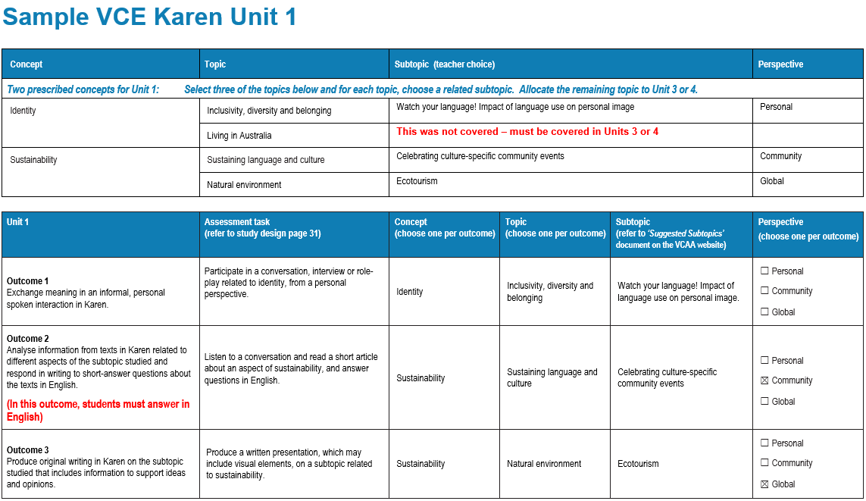
This sample illustrates one way of developing a program for VCE Karen. Please refer to the study design for further information.
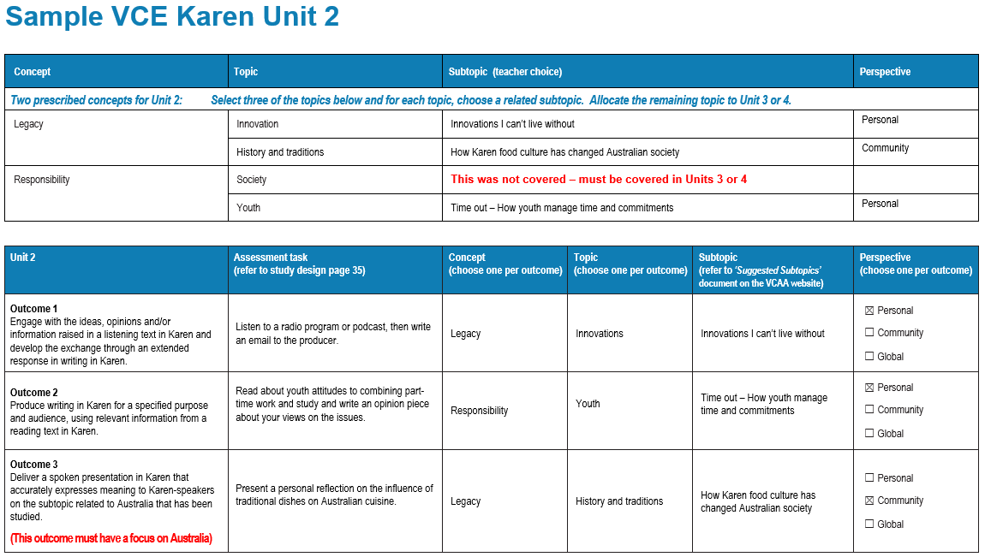
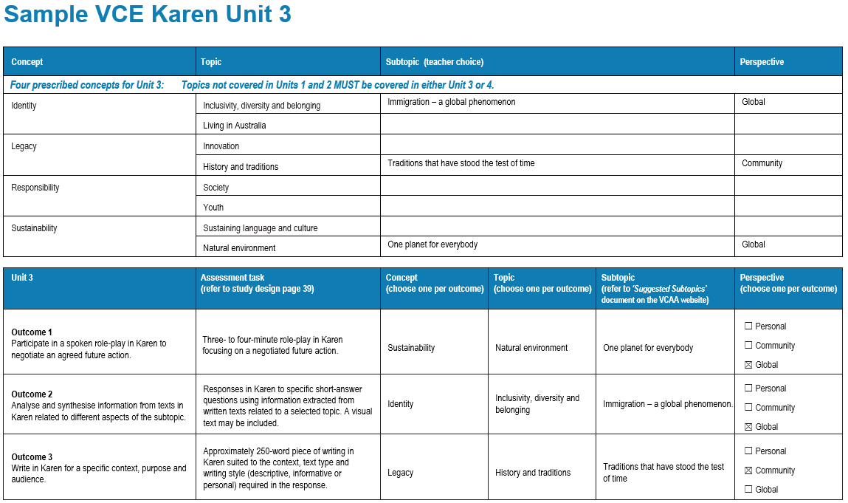
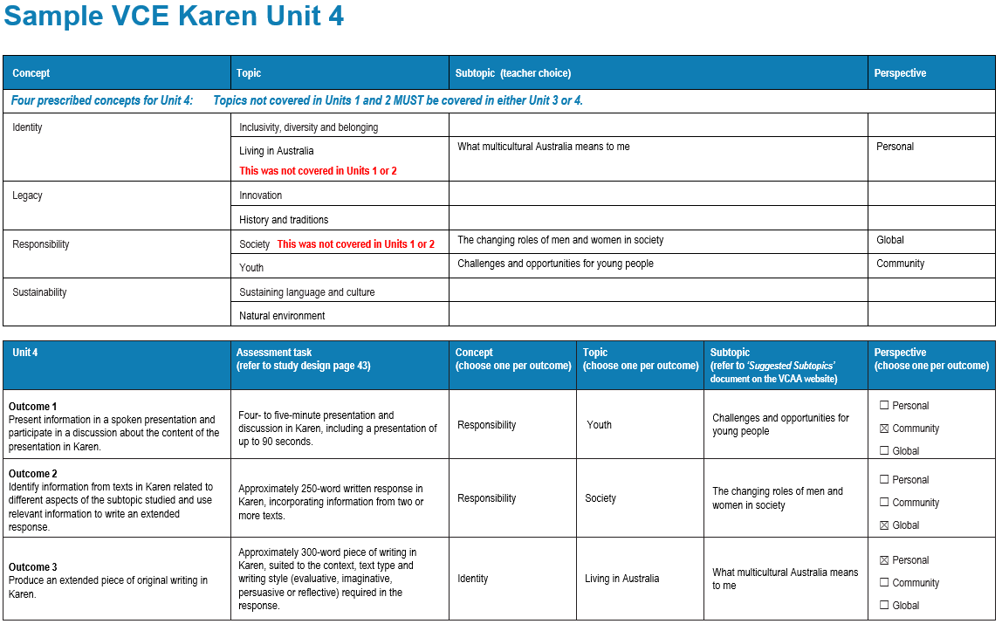
For further support, please refer to the VCE Karen study page on the VCAA website

VCE Karen Unit 1 VCE Karen Units 1 and 2: 2024–2028; Units 3 and 4: 2025–2028
Concepts and topics not covered in Units 1 and 2 must be covered in Units 3 or 4. Each of the concepts and topics must be covered at least once by the end of Unit 4.
All perspectives must be addressed over the two years of the study.
Concept | Topic | Subtopic (Suggested subtopics on the study design page) | Perspective
Two prescribed concepts for Unit 1: Select three of the topics below and for each topic, choose a related subtopic. Allocate the remaining topic to Unit 3 or 4.
Identity | Inclusivity, diversity and belonging
 | Living in Australia
Sustainability | Sustaining language and culture
 | Natural environment

Unit 1 | Assessment task  (refer to study design page 31) | Concept  (choose one per outcome) | Topic  (choose one per outcome) | Subtopic  (refer to ‘Suggested Subtopics’ document on the VCAA website) | Perspective  (choose one per outcome)
Outcome 1  Exchange meaning in an informal, personal spoken interaction in Karen. |  |  |  |  | - Personal  - Community  - Global
Outcome 2  Analyse information from texts in Karen related to different aspects of the subtopic studied and respond in writing to short-answer questions about the texts in English. |  |  |  |  | - Personal  - Community  - Global
Outcome 3  Produce original writing in Karen on the subtopic studied that includes information to support ideas and opinions. |  |  |  |  | - Personal  - Community  - Global

VCE Karen Unit 2 VCE Karen Units 1 and 2: 2024–2028; Units 3 and 4: 2025–2028
Concepts and topics not covered in Units 1 and 2 must be covered in Units 3 or 4. Each of the concepts and topics must be covered at least once by the end of Unit 4.
All perspectives must be addressed over the two years of the study.
Concept | Topic | Subtopic (Suggested subtopics on the study design page) | Perspective
Two prescribed concepts for Unit 2: Select three of the topics below and for each topic, choose a related subtopic. Allocate the remaining topic to Unit 3 or 4.
Legacy | Innovation
 | History and traditions
Responsibility | Society
 | Youth

Unit 2 | Assessment task  (refer to study design page 35) | Concept  (choose one per outcome) | Topic  (choose one per outcome) | Subtopic  (refer to ‘Suggested Subtopics’ document on the VCAA website) | Perspective  (choose one per outcome)
Outcome 1  Engage with the ideas, opinions and/or information raised in a listening text in Karen and develop the exchange through an extended response in writing in Karen. |  |  |  |  | - Personal  - Community  - Global
Outcome 2  Produce writing in Karen for a specified purpose and audience, using relevant information from a reading text in Karen. |  |  |  |  | - Personal  - Community  - Global
Outcome 3  Deliver a spoken presentation in Karen that accurately expresses meaning to Karen-speakers on the subtopic related to Australia that has been studied. |  |  |  |  | - Personal  - Community  - Global

VCE Karen Unit 3 VCE Karen Units 1 and 2: 2024–2028; Units 3 and 4: 2025–2028
Concepts and topics not covered in Units 1 and 2 must be covered in Units 3 or 4. Each of the concepts and topics must be covered at least once by the end of Unit 4.
All perspectives must be addressed over the two years of the study.
Concept | Topic | Subtopic (Suggested subtopics on the study design page) | Perspective
Four prescribed concepts for Unit 3: Topics not covered in Units 1 and 2 MUST be covered in either Unit 3 or 4.
Identity | Inclusivity, diversity and belonging
 | Living in Australia
Legacy | Innovation
 | History and traditions
Responsibility | Society
 | Youth
Sustainability | Sustaining language and culture
 | Natural environment

Unit 3 | Assessment task  (refer to study design page 39) | Concept  (choose one per outcome) | Topic  (choose one per outcome) | Subtopic  (refer to ‘Suggested Subtopics’ document on the VCAA website) | Perspective
Outcome 1  Participate in a spoken role-play in Karen to negotiate an agreed future action. | Three- to four-minute role-play in Karen focusing on a negotiated future action. |  |  |  | - Personal  - Community  - Global
Outcome 2  Analyse and synthesise information from texts in Karen related to different aspects of the subtopic. | Responses in Karen to specific short-answer questions using information extracted from written texts related to a selected topic. A visual text may be included. |  |  |  | - Personal  - Community  - Global
Outcome 3  Write in Karen for a specific context, purpose and audience. | Approximately 250-word piece of writing in Karen suited to the context, text type and writing style (descriptive, informative or personal) required in the response. |  |  |  | - Personal  - Community  - Global

VCE Karen Unit 4 VCE Karen Units 1 and 2: 2024–2028; Units 3 and 4: 2025–2028
Concepts and topics not covered in Units 1 and 2 must be covered in Units 3 or 4. Each of the concepts and topics must be covered at least once by the end of Unit 4.
All perspectives must be addressed over the two years of the study.
Concept | Topic | Subtopic (Suggested subtopics on the study design page) | Perspective
Four prescribed concepts for Unit 4: Topics not covered in Units 1 and 2 MUST be covered in either Unit 3 or 4.
Identity | Inclusivity, diversity and belonging
 | Living in Australia
Legacy | Innovation
 | History and traditions
Responsibility | Society
 | Youth
Sustainability | Sustaining language and culture
 | Natural environment

Unit 4 | Assessment task  (refer to study design page 43) | Concept  (choose one per outcome) | Topic  (choose one per outcome) | Subtopic  (refer to ‘Suggested Subtopics’ document on the VCAA website) | Perspective  (choose one per outcome)
Outcome 1  Present information in a spoken presentation and participate in a discussion about the content of the presentation in Karen. | Four- to five-minute presentation and discussion in Karen, including a presentation of up to 90 seconds. |  |  |  | - Personal  - Community  - Global
Outcome 2  Identify information from texts in Karen related to different aspects of the subtopic studied and use relevant information to write an extended response. | Approximately 250-word written response in Karen, incorporating information from two or more texts. |  |  |  | - Personal  - Community  - Global
Outcome 3  Produce an extended piece of original writing in Karen. | Approximately 300-word piece of writing in Karen, suited to the context, text type and writing style (evaluative, imaginative, persuasive or reflective) required in the response. |  |  |  | - Personal  - Community  - Global

VCE Karen Planning Tool - Checklist

Concepts and topics not covered in Units 1 and 2 must be covered in Units 3 or 4. Each of the concepts and topics must be covered at least once by the end of Unit 4.
All perspectives must be addressed over the two years of the study.

Unit 1 | Concept | Topic | Perspective |  | Unit 3 | Concept | Topic | Perspective
 | ☐ Identity | ☐ Inclusivity, diversity and belonging | ☐ Personal  ☐ Community  ☐ Global |  |  | ☐ Identity | ☐ Inclusivity, diversity and belonging | ☐ Personal  ☐ Community  ☐ Global
 |  |  |  |  |  |  | ☐ Living in Australia
 |  | ☐ Living in Australia | ☐ Personal  ☐ Community  ☐ Global |  |  | ☐ Legacy | ☐ Innovation | ☐ Personal  ☐ Community  ☐ Global
 |  |  |  |  |  |  | ☐ History and traditions
 | ☐ Sustainability | ☐ Sustaining language and culture | ☐ Personal  ☐ Community  ☐ Global |  |  | ☐ Responsibility | ☐ Society | ☐ Personal  ☐ Community  ☐ Global
 |  |  |  |  |  |  | ☐ Youth
 |  | ☐ Natural environment | ☐ Personal  ☐ Community  ☐ Global |  |  | ☐ Sustainability | ☐ Sustaining language and culture | ☐ Personal  ☐ Community  ☐ Global
 |  |  |  |  |  |  | ☐ Natural environment
Unit 2 | Concept | Topic | Perspective |  | Unit 4 | Concept | Topic | Perspective
 | ☐ Legacy | ☐ Innovation | ☐ Personal  ☐ Community  ☐ Global |  |  | ☐ Identity | ☐ Inclusivity, diversity and belonging | ☐ Personal  ☐ Community  ☐ Global
 |  |  |  |  |  |  | ☐ Living in Australia
 |  | ☐ History and traditions | ☐ Personal  ☐ Community  ☐ Global |  |  | ☐ Legacy | ☐ Innovation | ☐ Personal  ☐ Community  ☐ Global
 |  |  |  |  |  |  | ☐ History and traditions
 | ☐ Responsibility | ☐ Society | ☐ Personal  ☐ Community  ☐ Global |  |  | ☐ Responsibility | ☐ Society | ☐ Personal  ☐ Community  ☐ Global
 |  |  |  |  |  |  | ☐ Youth
 |  | ☐ Youth | ☐ Personal  ☐ Community  ☐ Global |  |  | ☐ Sustainability | ☐ Sustaining language and culture | ☐ Personal  ☐ Community  ☐ Global
 |  |  |  |  |  |  | ☐ Natural environment

