VCE General Mathematics Unit 2

Learning activity: Planning a house and land package

Introduction
A design for a house and land package is requested. There is flexibility in a number of aspects of this design that can be explored.

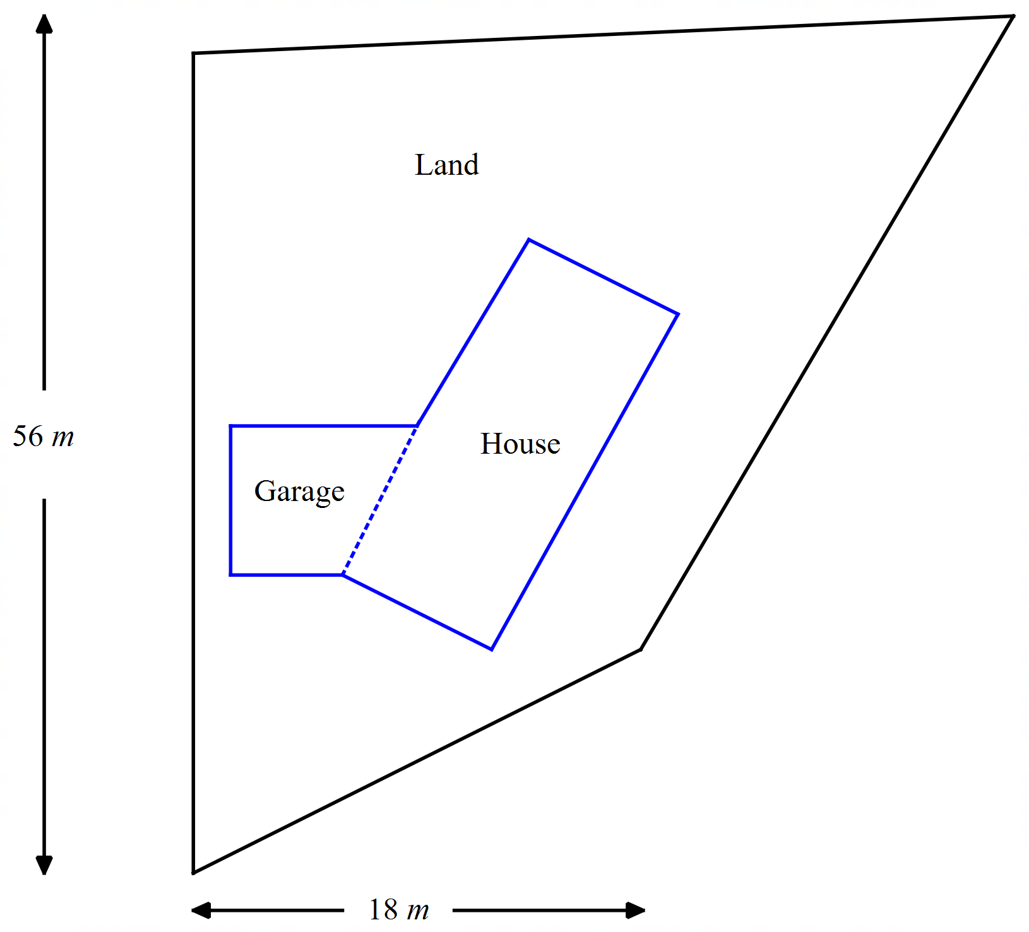
The restrictions on the design are:
- The land is 1800 m² in size.
- The size of the house and garage must be between 180 – 220 m².
- The house is built as a rectangle and the garage is built as a trapezium.
- The garage and house must be built so there is at least 1.5 m between any wall and the land boundary.
- The land shape cannot have any right angles.

Fomulation
Investigate the shape and size of the house, garage and land in order for these constraints to be met. If certain constraints cannot be met, suggest an alternative and explain your reasoning.

Communication
Construct a scaled image of the design including all relevant measurements (lengths, angles, areas) and present you findings in a concise report.

Areas of study
The following content from the areas of study is addressed through this learning activity.
Unit 2
Area of study | Topic | Content dot points
Space and measurement | Space, measurement and applications of trigonometry | 1, 2, 3, 4, 7, 8

Outcomes
The following outcomes, key knowledge and key skills are addressed through this task.
Unit 2
Outcome | Key knowledge dot point | Key skills dot point
1 | 1, 4, 5, 7, 8 | 2, 5, 6, 7
2 | 1, 2, 3, 4 | 1, 2, 3, 4
3 | 1, 2, 4, 5 | 1, 2, 3, 7, 8, 9, 10, 11, 12

