VCE General Mathematics Unit 2
There are three components to mathematical investigation:

Formulation
Overview of the context or scenario, and related background, including historical or contemporary background as applicable, and the mathematisation of questions, conjectures, hypotheses, issues or problems of interest.

Exploration
Investigation and analysis of the context or scenario with respect to the questions of interest, conjectures or hypotheses, using mathematical concepts, skills and processes, including the use of technology and application of computational thinking.

Communication
Summary, presentation and interpretation of the findings from the mathematical investigation and related applications.

Sample Mathematical Investigation: tent size and guy rope length

Formulation
The task involves the use of measurement and trigonometry in investigating the relationship between length, angle, perimeter and area of different sized standard triangular tents and a guy rope running from the top of the tent to the ground.

Exploration

Part 1
The profile of the front of a tent, ACD is in the shape of an equilateral triangle.
The base of the tent is on the ground and at the same horizontal level as points C and B. A guy rope attached to the tent at point A is also attached to the ground at point B.
Initially the side length of the tent and the distance between points B and C are equal at 2 metres.
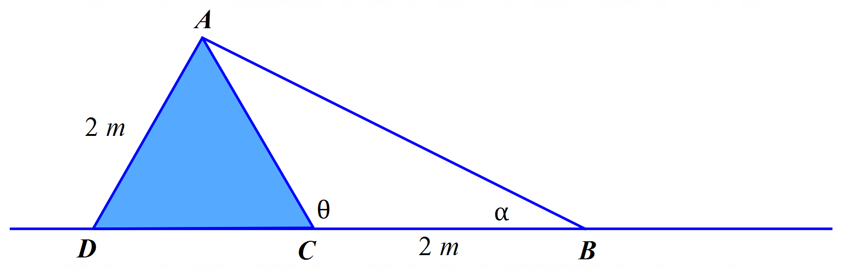
- Find the perimeter of the front of the tent.
- Find the size of the angle θ in degrees.
- Find the area of the front of the tent.
- Find the size of the angle α in degrees
- Find the length of the guy rope, AB.

Part 2
- If the side length of the tent and the distance between points B and C increased to 3 metres, investigate the changes that would occur in the perimeter and area of the tent front and the angles of θ and α.
- Choose two other lengths to represent the side length of the tent and the distance between points B
and C. Recalculate all the values and angles found previously.
- Discuss any patterns or relationships found between the different lengths investigated and the calculated values of perimeter, area and angles of θ and α. Justify any findings.

Part 3
- Investigate the change in calculations if the front of the tent is changed to an isosceles triangle and the distance between points B and C is independent of the side length of the tent.

Communication
Summarise the findings, including specific examples, showing the relationships and patterns found in the lengths, areas and angles of the side length of the tent and the guy rope length.
Present the findings in a well-organised report.

Areas of study
The following content from the areas of study is addressed through this learning activity.
Unit 2
Area of study | Topic | Content dot points
Space and measurement | Shape, measurement and applications of trigonometry | 1, 2, 3, 4, 7, 8

Outcomes
The following outcomes, key knowledge and key skills are addressed through this task.
Unit 2
Outcome | Key knowledge dot point | Key skills dot point
1 | 1, 2, 3, 4, 5, 7, 8 | 2, 3, 5, 6, 7
2 | 1, 2, 3, 4 | 1, 2, 3, 4
3 | 1, 2, 3, 5 | 1, 2, 3, 4, 5, 6, 8, 9, 10, 11, 12

