VCE General Mathematics Unit 3

Area of Study 1 sample application task: Data analysis
Exchange rates
The application task is to be of 4–6 hours’ duration over a period of 1–2 weeks.

Introduction
Exchange rates are an important financial and economic measure, and are relevant for business activity and personal travel between countries, such as on a holiday. Exchange rate calculators are commonly used for day-to-day conversions.
The following investigation looks at how exchange rates between the Australian dollar and several other currencies of interest have varied over time, and the process of establishing suitable mathematical models for some of the corresponding exchange rates trends.
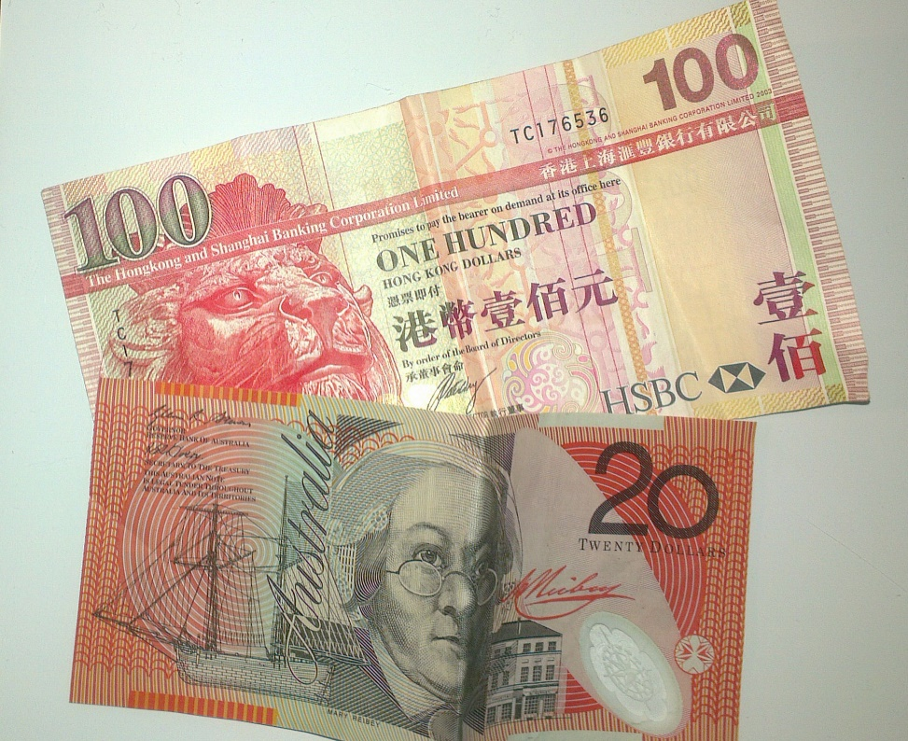

As part of this task, several data sets of historical exchange rates for countries of interest should be obtained, for example: RBA Exchange rates and RBA statistics.

Component 1
Select a currency for consideration, for example Hong Kong dollar, Euro, Pound, US dollar, Dirham, Yen or Renminbi.
- Choose several consecutive years of exchange rate data with a randomly selected starting point, for example a particular month in a given year.
- Using appropriate univariate analysis techniques, summarise and describe the distribution of the exchange rate in your sample.
- For your selected period, plot the exchange rate against time and discuss the relationship shown.

Component 2
Select a different currency for consideration and carry out analysis to construct a linear regression model.
- Draw a scatterplot of the data, determine the equation of the regression line, interpret the summary regression statistics in context, and draw the regression line on the scatterplot.
- Carry out a residual analysis, including a residual plot, based on your regression line and comment whether the linear model is suitable. Based on your analysis of residuals and the scatterplot, apply transformations to either of the variables (either exchange rate or time). Use residual plots and the coefficient of determination to determine a suitable model for this exchange rate.
- Use your preferred model to predict the exchange rate both one month and one year beyond your sample. Compare the predictions with the real data, using percentage error to determine the accuracy of your predictions.

Component 3
Select several different currencies, and state the current exchange rate for each of these.
- Construct models for the corresponding exchange rates relative to the Australian dollar, over the same period of time of several years, and draw the corresponding scatterplots and regression functions on the same set of axes.
- Comment on any similarities and differences in the exchange rate trend graphs.

Areas of study
The following content from the areas of study is addressed through this task.
Unit 3
Area of study | Topics | Content dot points
Data analysis, probability and statistics  Investigating data distributions | Investigating associations between two variables  Investigating and modelling linear associations  Investigating and modelling time series data | 2, 3, 4, 5  1, 4, 5, 6, 7  1, 2, 3, 4, 5, 6, 7, 8, 9, 10

Outcomes
The following outcomes, key knowledge and key skills are addressed through this task.
Unit 3
Outcome | Key knowledge dot point | Key skills dot point
1 | 1, 2, 3, 4, 7, 8, 9, 10, 11, 12 | 3, 4, 8, 9, 10, 11, 12, 13, 14, 17
2 | 1, 2, 3, 4 | 1, 4
3 | 1, 3, 4, 5, 7 | 1, 3, 4, 5, 6, 7, 8, 9, 10, 11, 12

