VCE General Mathematics Unit 4

Sample learning activity: Exploring Leslie matrices

Introduction
The Leslie matrix model is a population model that takes into account birth rates and survival rates of designated age groups within a population over time.
This task involves calculations with technology to investigate different Leslie matrix models.

Part 1
Consider a population of insects.
Only the females reproduce therefore we will model only the females of the population:
- the average female adult produces 2000 eggs before dying
- 1% of eggs survive to become nymphs each year
- 6% of nymphs survive to adulthood
- some die as eggs, some die as nymphs
- insects only reproduce during the adult stage of their life
- adults die soon after reproduction.
This information can be presented in a transition diagram and a Leslie matrix.

Transition diagram
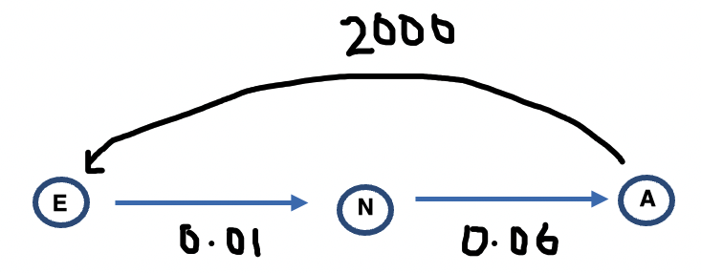

Leslie matrix
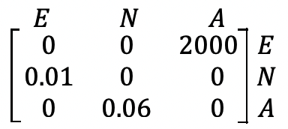
Use the matrix recurrence relation: $S_{0}=$ initial state matrix, and $S_{n+1}=LS_{n}$where $L$ is a Leslie matrix, and $S_{n}$ is a column state matrix, to investigate how the population of these female insects change over time.

- Consider how the population changes over time if:
  - the initial population only consisted of 100 adults and no nymphs and no eggs
  - the initial population only consisted of 100 adults, 100 nymphs and no eggs
  - the initial population only consisted of 100 adults, 100 nymphs and 1000 eggs.
- Describe any patterns which may emerge.

Part 2
Consider a second population of insects.
Only the females reproduce therefore we will model only the females of the population:
- the average female adult produces 1500 eggs before dying
- 2.5% of eggs survive to become female nymphs each year
- 7% of nymphs survive to adulthood
- some die as eggs, some die as nymphs
- insects only reproduce during the adult stage of their life
- adults die soon after reproduction.
- Using this information to prepare a transition diagram and Leslie matrix.
- Use the matrix recurrence relation: $S_{0}=$ initial state matrix, and $S_{n+1}=LS_{n}$where $L$ is a Leslie matrix, and $S_{n}$ is a column state matrix, to investigate how the population of these female insects change over time.

Areas of study
The following content from the areas of study is addressed through this task.
Unit 4
Area of study | Topic | Content dot point
Discrete mathematics | Transition matrices | 1, 3

Outcomes
The following outcomes, key knowledge and key skills are addressed through this task.
Unit 4
Outcome | Key knowledge dot point | Key skills dot point
1 | 1 | 2, 3, 4
2 | 1, 3, 4 | 3, 4
3 | 5 | 1, 3, 4, 5, 10

