VCE Mathematical Methods Unit 4

Sample modelling or problem-solving task: Wall and window
The modelling or problem-solving task is to be of 2–3 hours’ duration over a period of 1 week.

Introduction
A context such as the following could be used to develop a modelling or problem-solving task which involves modelling the shape of a designer two-part window feature for a section of wall, and the dimensions and area of the design.
The section of the wall is 4 m wide and 3.5 m high. The window is a symmetrical design which fits in the middle of the wall horizontally. The base of the window forms a straight line 0.5 m above and parallel to the floor and is 2 m in length. The lower part of the window has two straight line slant edges, and these are 1.5 m apart at the height of 1.5 m from the floor. The window designer is considering a range of possibilities for the upper part of the window, the highest point of which is to be at most 3 m from the floor.
The designer constructs a graph of the window design using a set of axes with the origin on the floor at the middle of the wall.

Part 1
Initially the designer considers and upper part consisting of two-line segments which join onto the top of the lower straight edges, at an angle of 45° to the horizontal, and extend to the point where they meet.
- Use functions to define the sections of the window’s edges and draw a graph showing the wall and the window, labelling all key points with their coordinates.
- Find the area of the window.
- Consider a family of related designs where the angle the edges of the upper part make with the horizontal is varied. Show several examples and calculate the area of the window in each case. What is the largest possible value for this angle, and the corresponding area of the window?

Part 2
As an alternative, the designer considers using an arch for the top part of the window.
- Draw the graph where the arch is a semi-circle. Calculate the area of the window. Do the lower and upper parts of the window join smoothly?
- Draw several graphs for the upper part defined by the family of functions with rule of the form$f(x)=ax^{2}+b$, where a and b are non-zero real constants.
- For the case where the lower and upper parts of the window join smoothly, calculate the corresponding area of the window.
- What happens when a function with rule of the form $g(x)=a\sin{(}bx)+c$ is used to model the upper arch, if the two parts are to be smoothly joined?

Part 3
The designer decides that while a smooth join of the two parts of the window is a critical requirement, it is not necessary for the arch to be smooth at its top point, so a symmetrical hybrid function based on part of the graph of some other function could be used to represent the arc.
Consider some other possible modelling functions and identify which of these gives the maximum window area for different choices of functions and defining parameters.
The following images show some arches from buildings along North Terrace in Adelaide.

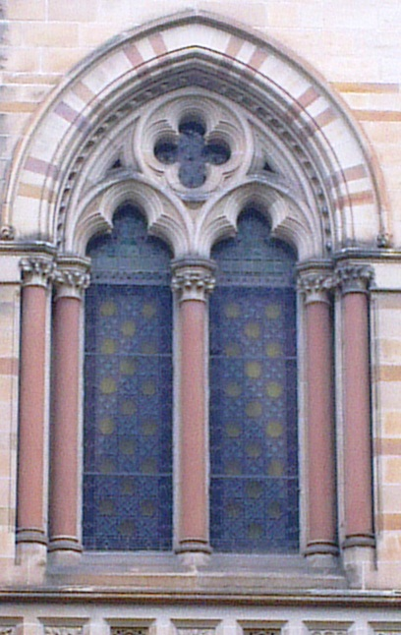 | 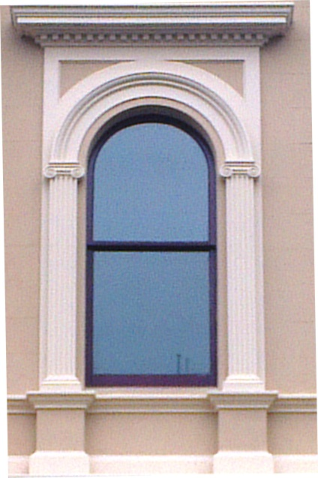 | 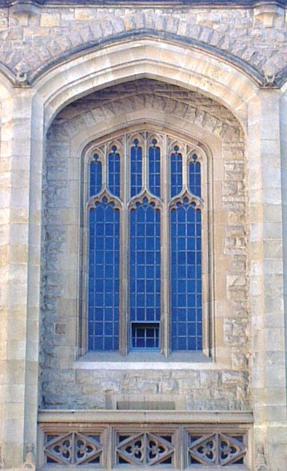

Areas of study
The following content from the areas of study is addressed through this task.
Area of study | Content dot points
Functions, relations and graphs | 2, 3, 6
Algebra, number and structure | 5, 6,
Calculus | 3, 4,, 5, 6, 10
Data analysis, robability and statistics | -

Outcomes
The following outcomes, key knowledge and key skills are addressed through this task.
Outcome | Key knowledge dot points | Key skills dot points
1 | 1, 2, 4, 7, 10, 12 | 1, 2, 6, 10, 12, 13, 14, 15
2 | 1, 2, 3, 5 | 1, 2, 3, 5, 7
3 | 2, 3, 4, 5, 8 | 2, 3, 4, 5, 6, 7, 9, , 11,12, 13

