VCE Specialist Mathematics   
Units 3 and 4

Sample application task – glassware

Introduction

A context such as the following can be used to develop an application task that investigates arc length, area, surface area and volume associated with curves, regions, surface and shapes defined by parts of graphs of functions, cross sections and shapes of revolution, with respect to design of glassware such as wine glasses or vases.

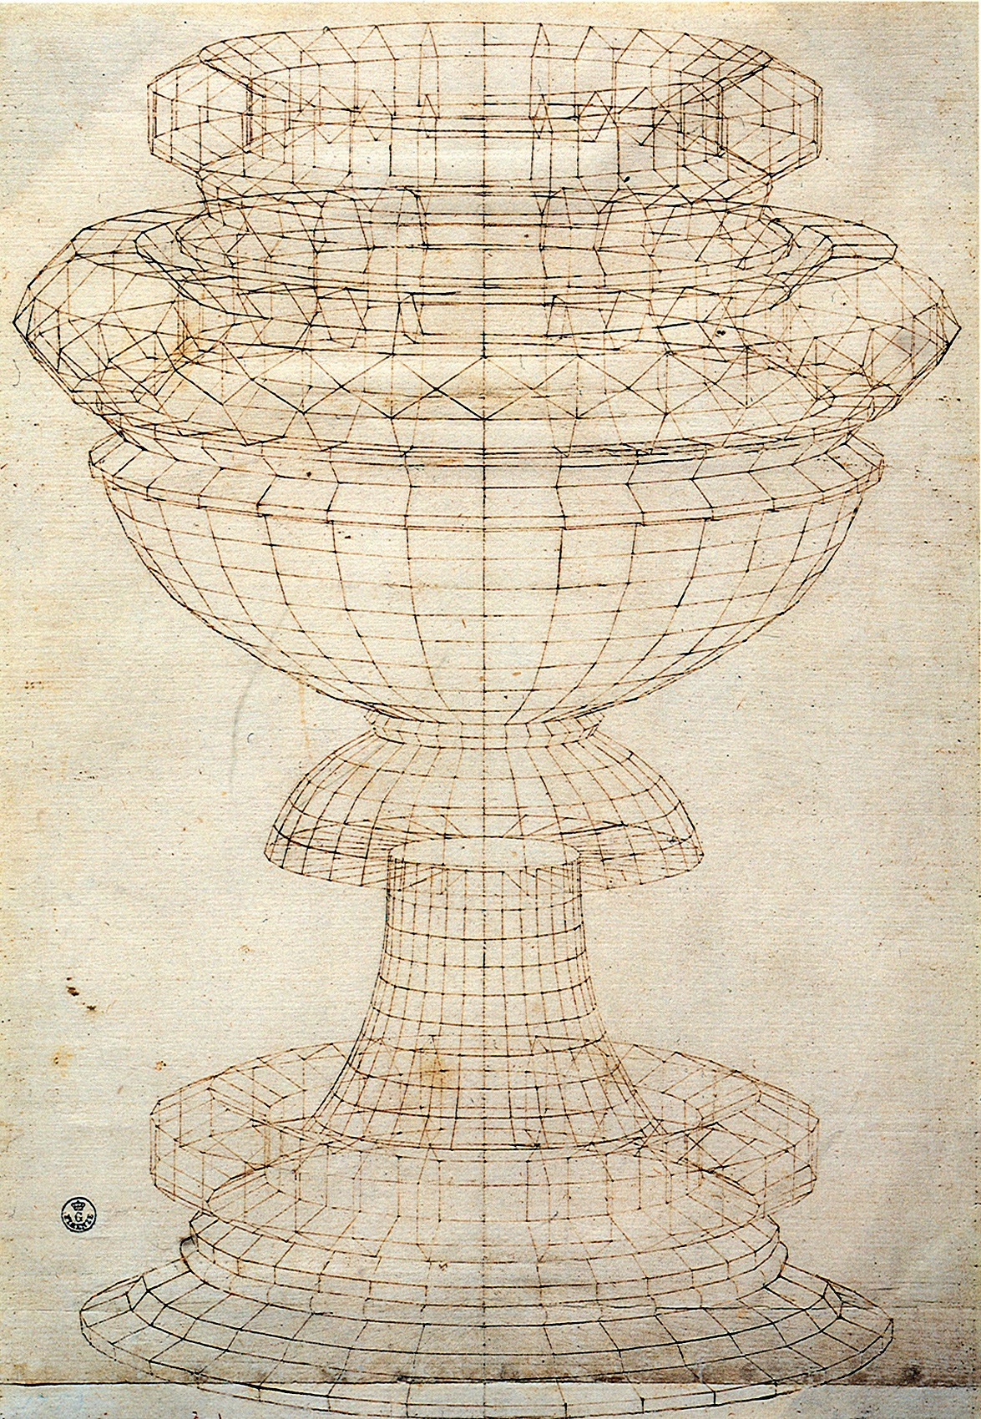

[Vase in perspective](https://commons.wikimedia.org/wiki/File:Paolo_uccello,_studio_di_vaso_in_prospettiva_02.jpg)

(Transcript) Paolo Uccello Vase in perspective pen on paper

A range of examples of design images can be accessed from websites such as:

[Champagne flutes](https://www.dartington.co.uk/drinkware/champagne.html)

[Wine Glasses](https://www.dartington.co.uk/drinkware/wine-glasses.html)

[Vases](https://www.coxandcox.co.uk/home-furnishings/accessories/vases/)

Part 1

Investigate curves defined by parts of graphs of functions that can be used to model the shape of the edge of a glass or vase as viewed from the side profile. Assume the design is symmetrical about a central axis. The graphs of the functions used should generally be smooth, with the possible exception where two different curves are joined to create a particular profile.

Dimensions of glasses or vases used to define such curves and related areas, surface areas or volumes should be realistic and obtained from practical measures. Composite shapes may be used for some designs as applicable.

1. Define a linear function that can be used to model the side profile of glass or vase in the shape of a truncated cone. Calculate the length of the line segment, the area between the graph and the horizontal and vertical coordinate axes respectively, and the surface and volume of the corresponding shapes of revolution with respect to horizontal and vertical coordinate axes respectively. Graph or draw the corresponding shapes of revolution.
2. Consider several other interesting designs produced by curves based on parts of the graph’s functions, in each case calculating the length of the curve, the area between the graph and the horizontal and vertical coordinate axes respectively, and the volume of the corresponding shapes of revolution with respect to horizontal and vertical coordinate axes respectively.   
   Graph or draw the corresponding shapes of revolution.
3. Consider a rectangle with a corner point at the origin, one corner along each of the coordinate axes and the fourth corner the first quadrant, and find a non-linear function which divides the rectangle into two equal areas. Consider whether there is an analogous idea for shapes of revolution with respect to volume.

Part 2

Investigate the use of a definite integral to define a measure of surface area for shapes of revolution.

1. Select part of the graph of a non-linear function in the first quadrant. Explain how definite integrals are used to define a measure of arc length, area beneath a curve, volume of a shape of revolution. Use your selected function to illustrate each of these.
2. Approximate a shape of revolution using a collection of truncated conical sections and use this to develop a definite integral as a measure for the surface area of a shape of revolution. Illustrate this for your selected function.
3. Apply your definite integral for surface area to shapes of revolution generated by a range of non-linear functions.
4. Explain why the cylindrical sections used to define the volume of a shape of revolution are not suitable for the surface area of a shape of revolution.

Part 3

Investigate the ratio of surface area to volume for a shape of revolution.

1. Construct a cylinder, cone and sphere as shapes of revolution, and use definite integrals to compare the ratio of *surface area*: *volume* for each of these shapes. Graph or draw the corresponding shapes of revolution.
2. Consider the ratio of *surface area*: *volume* for a range of shapes of revolution, including an ellipsoid, and comment on any general relationships you observe between shapes and the ratio. Graph or draw the corresponding shapes of revolution.
3. Consider the surface area and volumes of shapes of revolution defined by functions with graphs in the first quadrant that intersect the vertical axis, and are asymptotic to the horizontal axis. What happens to the ratio of surface area to volume as the right-hand endpoint of the curve that defines the shape of revolution becomes closer and closer to the horizontal axis?   
   Identify whether any of these functions have a finite surface area or volume as the *x*-value of the right-hand enpoint tends to infinity. Graph or draw the corresponding shapes of revolution.
4. Design your own shape of revolution for a glass or vase. Calculate the arc length of the side profile, the surface area and the volume. Graph or draw the corresponding design.

Areas of study

The following content from the areas of study is addressed through this task.

|  |  |  |
| --- | --- | --- |
| **Area of study** | **Topic** | **Content dot point** |
| Calculus | Differential an Integral calculus | 2, 3, 4, 5, 6 |

Outcomes

The following outcomes, key knowledge and key skills are addressed through this task.

|  |  |  |
| --- | --- | --- |
| **Outcome** | **Key knowledge dot point** | **Key skill dot point** |
| **1** | 3, 6, 7, 8 | 7, 8 |
| **2** | 1, 2, 3, 6 | 1, 2, 3, 5, 6, 7 |
| **3** | 1, 2, 3, 4, 5, 6, 7 | 2, 3, 4, 5 |