SEWB Webinar - Reflective Worksheet

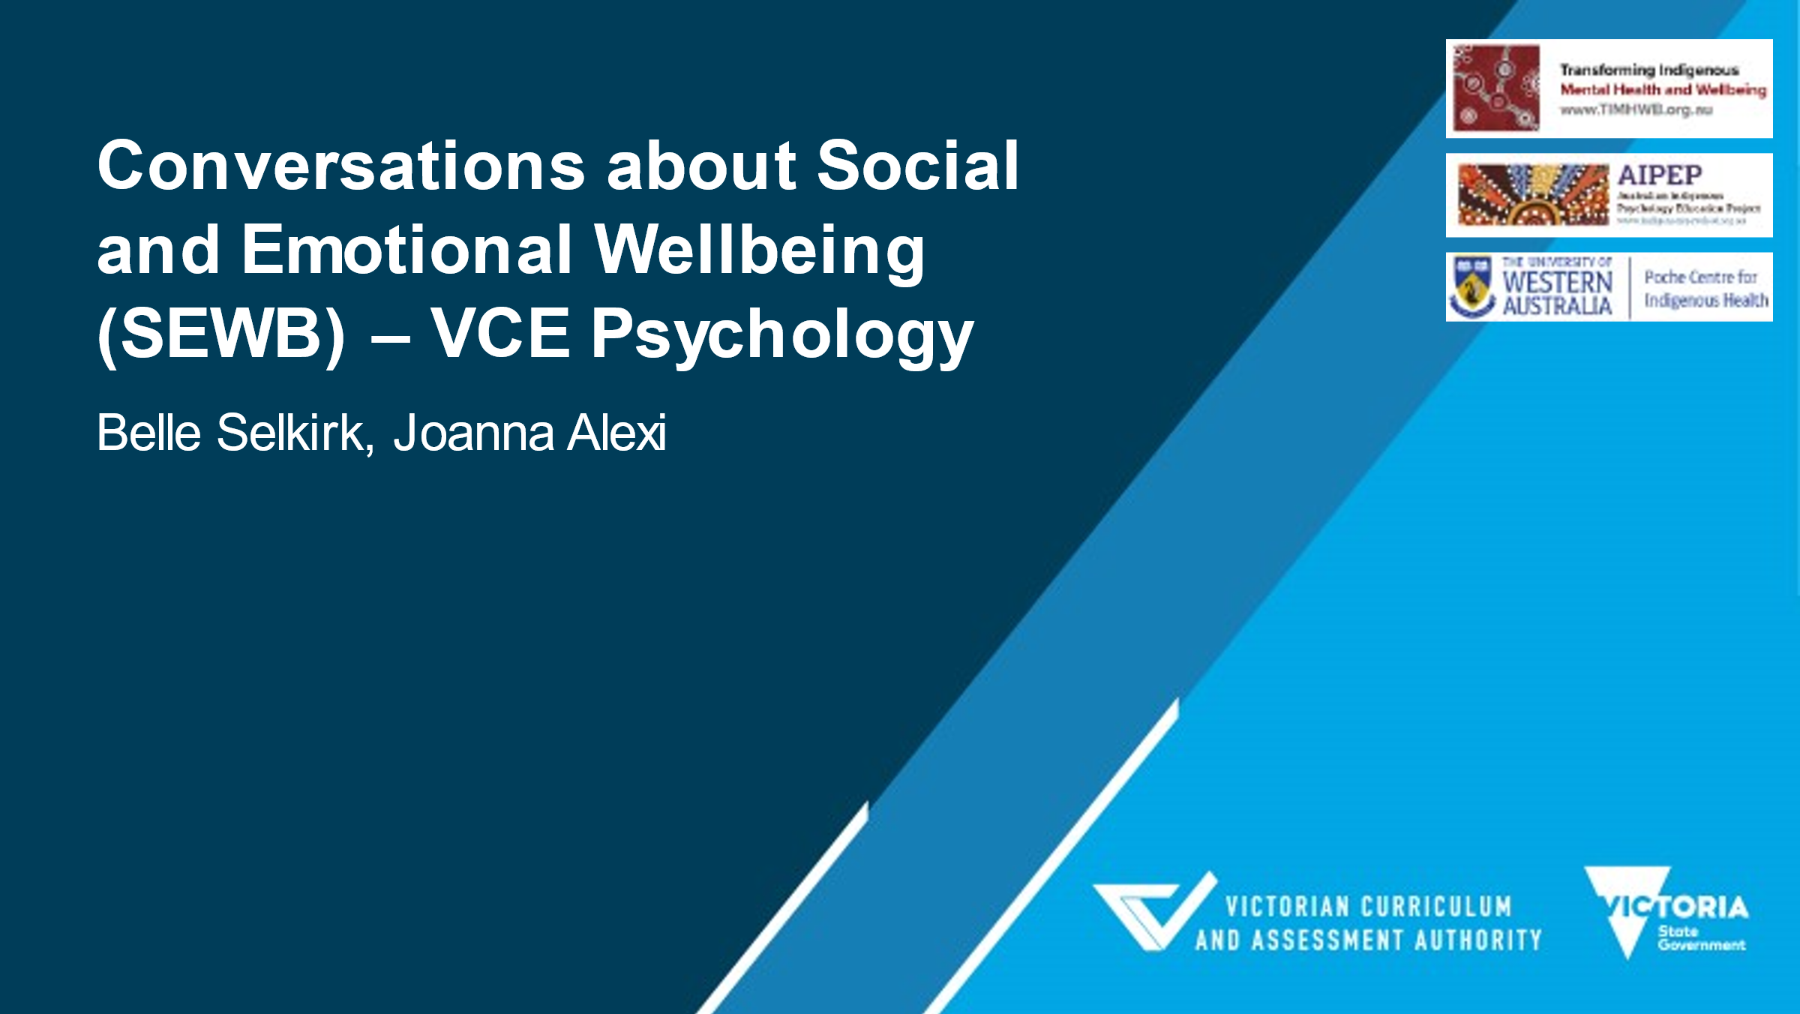
Question 1: Positionality
- Who am I? What is my cultural background? What are my values?
- How can I introduce my ‘whole’ self?

Question 2: Human Rights
- What stood out for me regarding discussion of the human rights approach to health?
- In thinking about your education and training, what cultural standpoint did this come from?

Question 3: Determinants of Health
- Imagine how you might explain determinants of health to someone. How might you explain this?
- Where do you see your role in determinants of health?

Question 4: Social and Emotional Wellbeing (SEWB)
- What does my wellness look like form a holistic perspective?

Question 5: The Learning Journey
- What has been the biggest learning from today?
- In addition to teaching SEWB in the classroom, what actions am I ready to commit to in my cultural responsiveness learning journey?

