Workplace Learning Record

VCE VET Civil Infrastructure
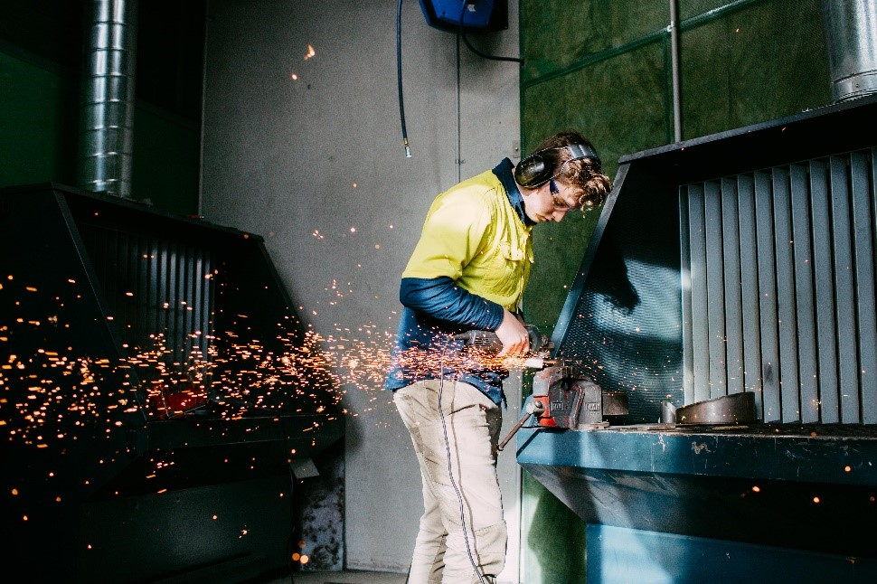

RII20715 Certificate II in Civil Construction
Student name:

Modification history
Version | Status | Release Date | Comments
1.0 | Current | July 2020 | Original document with minor updates
Authorised and published by the Victorian Curriculum and Assessment Authority
Level 7, 2 Lonsdale Street
Melbourne VIC 3000
ISBN: 978-1-74010-047-2
© Victorian Curriculum and Assessment Authority 2019

No part of this publication may be reproduced except as specified under the Copyright Act 1968 or by permission from the VCAA. Excepting third-party elements, schools may use this resource in accordance with the VCAA educational allowance. For more information go to: www.vcaa.vic.edu.au/Footer/Pages/Copyright.aspx.
The VCAA provides the only official, up-to-date versions of VCAA publications. Details of updates can be found on the VCAA website: www.vcaa.vic.edu.au.
This publication may contain copyright material belonging to a third party. Every effort has been made to contact all copyright owners. If you believe that material in this publication is an infringement of your copyright, please email the Copyright Officer: vcaa.copyright@edumail.vic.gov.au
Copyright in materials appearing at any sites linked to this document rests with the copyright owner/s of those materials, subject to the Copyright Act. The VCAA recommends you refer to copyright statements at linked sites before using such materials.

The VCAA logo is a registered trademark of the Victorian Curriculum and Assessment Authority.

SWL Recognition
Structured Workplace Learning (SWL) recognition provides you with the opportunity to gain credit into your VCE or VCAL for undertaking SWL that matches your VCE VET program.
To receive recognition and credit, you will be required to reflect on your experience in the workplace and how this relates to your VET course. Your reflections are to be recorded in the three sections of this Workplace Learning Record (WLR).

About this workplace learning record
This WLR helps you gather evidence for assessment and is part of the requirement for obtaining SWL recognition.
To be eligible for one unit of credit towards your VCE or VCAL, you must:
- be enrolled in a minimum of 180 nominal hours of units of competency (UoCs) from the RII20715 Certificate II in Civil Construction
- undertake a minimum of 80 hours (equivalent to 10 days of work) in a civil infrastructure industry placement
- reflect on a minimum of six UoCs from your program including the WHS UoC (RIIWHS201D – see page 8).

VCE VET Civil Infrastructure

RII20715 Certificate II in Civil Construction
The VCE VET Civil Infrastructure program is drawn from a national training package and offers portable qualifications which are recognised throughout Australia. These qualifications provide students with a broad range of skills and knowledge to pursue a career or further training in related industries for entry into one of the various sectors of the Australian resources and infrastructure industry.
The RII20715 Certificate II in Civil Construction provides participants with the knowledge, skills and competency that will enhance their training and employment prospects in the civil infrastructure industries.
Trade outcomes and pathways for this program include:
- coal mining
- metalliferous mining
- civil infrastructure
- drilling and quarrying.
The course will expose students to key skills, knowledge and attributes required to work effectively in various areas of the Australian resources and infrastructure industry.

Workplace Learning Record
The WLR is divided into three sections.
Section 1: Learner profile
Section 2: Learning about VET UoCs in the workplace
Section 3: Post-placement reflections
Please complete the details of your workplace.
Employer/Company/Business
Supervisor name
Contact phone number

Employer/Company/Business
Supervisor name
Contact phone number

Employer/Company/Business
Supervisor name
Contact phone number

Section 1: Learner profile
Complete the Learner profile and discuss this with your host employer on or before your first day of placement.
Name
School
Contact information
Within your VCE/VCAL why did you undertake this VET course?
What VCE/VCAL subjects are you also undertaking?
Why have you chosen this overall VCE/VCAL program?

Program outline

RII20715 Certificate II in Civil Construction
UoCs included in this program are listed below. There are compulsory UoCs, along with a selection of electives. You can make a note of any UoC that relates to your experiences in the workplace. Indicate the year you are undertaking each UoC.
Unit code | Unit of competency | Year | Page
VCE VET Units 1–4
Compulsory
RIIWHS201D | Work safely and follow WHS policies and procedures |  | 8
RIIBEF201D | Plan and organise work |  | 9
RIICOM201D | Communicate in the workplace |  | 10
RIICCM201D | Carry out measurements and calculations |  | 11
RIICCM202D | Identify, locate and protect underground services |  | 12
RIICCM203D | Read and interpret plans and job specifications |  | 13
RIICCM205E | Carry out manual excavation |  | 14
RIICCM207D | Spread and compact materials manually |  | 15
RIISAM203D | Use hand and power tools |  | 16
RIISAM204D | Operate small plant and equipment |  | 17
RIIWHS205D | Control traffic with stop-slow bat |  | 18
RIIWHS302D | Implement traffic management plan |  | 19
Elective
BSBDIV301 | Work effectively with diversity |  | 20
RIICCM208D | Carry out basic levelling |  | 21
List any other units you are undertaking and include comments regarding additional units on page 22.

What interests you about the industry?
What is your planned career path or future career aspiration?
Describe any workplace skills you have developed through previous work experience, SWL or part time employment?

Section 2: Learning about VET units of competency in the workplace
This WLR contains three key questions per UoC designed to draw out related experiences you may be exposed to in a civil infrastructure industry workplace.
This does not cover all the elements or performance criteria within the units and is not designed as a UoC assessment tool.
You should comment on the UoCs you have experienced in the workplace, and reflect on actual observations or activities that you have been exposed to. Your observations will:
- reinforce the training you have undertaken
- identify differences in practice or equipment
- identify areas requiring further training or practical experience.
You are encouraged to take photos and/or video where appropriate to showcase learning in the workplace. Evidence you collect can include:
- observations
- descriptions of activities and tasks
- conversations with employers and other staff
- participation in meetings
- workplace documents
- research in the workplace
- photos of equipment/processes/events
- video of workplace activities.
Note: please speak to your host employer before taking photos or video. This record does not require identifying actual people or events, as this may breach confidentiality.

VCE VET Units of competency

RIIWHS201D Work safely and follow work, health and safety policies and procedures
This unit describes the skills and knowledge required to work safely and follow work, health and safety (WHS) policies and procedures in the resource and infrastructure industries.
Respond to the following | Comments/observations
What personal protective equipment (PPE) do you need to wear in your workplace?
What WHS signs and procedures can you identify in your workplace?
What potential risks can you identify in your workplace? What preventative measures are in place?

RIIBEF201D Plan and organise work
This unit describes a participant’s skills and knowledge required to plan and organise work in the resources and infrastructure industries.
Respond to the following | Comments/observations
How did you work with others to plan workplace activities?
Describe a problem or issue that required problem solving.
At the end of your day, how was the work area cleared and cleaned? What processes were involved?

RIICOM201D Communicate in the workplace
This unit describes a participant’s skills and knowledge required to communicate in the workplace within the resources and infrastructure industries.
Respond to the following | Comments/observations
How was information communicated in your workplace?
Describe a situation when you communicated face to face with someone in your workplace?
What types of written documents were used in your workplace?

RIICCM201D Carry out measurements and calculations
This unit describes the skills and knowledge required to carry out measurements and calculations in civil construction.
Respond to the following | Comments/observations
Describe some of the measurement and calculation requirements you observed in the workplace?
What measuring materials and equipment were used in the workplace?
How were material quantities estimated and then measured in your workplace?

RIICCM202D Identify, locate and protect underground services
This unit describes the skills and knowledge required to identify, locate and protect underground services in civil construction.
Respond to the following | Comments/observations
Describe the underground services you observed in your workplace?
What sort of plant or equipment is used in your workplace?
How is matter disposed of or recycled in your workplace?

RIICCM203D Read and interpret plans and job specifications
This unit describes the skills and knowledge required to read and interpret plans and specifications in civil construction.
Respond to the following | Comments/observations
Describe the types of plans you viewed at the workplace?
List three pieces of information that appear on a site plan.
Why are drawings essential in a civil construction site?

RIICCM205E Carry out manual excavation
This unit describes the skills and knowledge required to carry out manual excavation in civil construction.
Respond to the following | Comments/observations
Did you observe any manual digging at your worksite?
How is the loose material disposed of?
Describe the process involved in cleaning the area after digging.

RIICCM207D Spread and compact materials manually
This unit describes the skills and knowledge required to spread and compact materials manually in civil construction.
Respond to the following | Comments/observations
What materials are used on your worksite or workplace?
How are materials transported or moved in a safe manner on your worksite or workplace?
What cleaning practices are followed on a daily basis?

RIISAM203D Use hand and power tools
This unit describes a participant’s skills and knowledge required to use hand and power tools in the resources and infrastructure industry.
Respond to the following | Comments/observations
List the hand and power tools most often used in the workplace.
What safety precautions are taken to prevent injury when using the hand and power tools?

How are hand and power tools stored when not being used?

RIISAM204D Operate small plant and equipment
This unit describes a participant’s skills and knowledge required to operate small plant and equipment in the resources and infrastructure industry.
Respond to the following | Comments/observations
What small plant or equipment is used on your worksite or workplace?
What personal protective equipment (PPE) is required when using the small plant or equipment?
How is the small plant or equipment stored after use?

RIIWHS205D Control traffic with stop-slow bat
This unit describes a participant’s skills and knowledge required to control traffic with stop-slow bat in the resources and infrastructure industries.
Respond to the following | Comments/observations
Did you observe a traffic management plan in your workplace?
Describe how traffic management occurred in your workplace.
Describe how messages were transmitted during traffic management operations?

RIIWHS302D Implement traffic management plan
This unit develops a participant’s skills and knowledge required to implement a traffic management plan in civil construction.
Respond to the following | Comments/observations
What traffic management documentation did you view on your worksite or workplace?
What traffic management signage or devices were used?
Describe how the work area was cleared after the job was completed.

BSBDIV301 Work effectively with diversity
This unit describes the skills and knowledge required to recognise and interact productively with diversity in the workplace. It covers sensitive responses to, and interactions with, all manner of diversity that might be encountered during the course of work.
Respond to the following | Comments/observations
Describe diversity within the workplace.
How does the diversity within the workplace help productivity?
How is respect for individual differences promoted in the workplace?

RIICCM208D Carry out basic levelling
This unit describes a participant’s skills and knowledge required to carry out basic levelling in civil construction.
Respond to the following | Comments/observations
List the equipment and devices used for levelling.
Describe the set up for levelling on the worksite.
Identify the traffic signage requirements used for the levelling work.

Comments/observations on any other unit(s) of competency not listed
Unit(s) | Comments/observations

Section 3: Student post-placement reflection
Employability skills are a set of eight skills we use every day in the workplace.
- Communication
- Team work
- Problem solving
- Self-management
- Planning and organising
- Technology
- Learning
- Initiative and enterprise
When you are on work placement, you will be using employability skills in many different ways.
This record will assist you when applying for jobs and in interviews. The skills you are developing may be transferred to a range of occupations. Assessment of SWL recognition is based on a discussion of each of the sections from this booklet with a school representative.
In Section 3, identify the employability skills you have used and how you have demonstrated them in the workplace. Identify how the skills you have acquired and used during your 80 hours of SWL might assist you in the future.

List of employability skills
How did you demonstrate communication skills? For example, by listening and understanding, speaking clearly and directly or reading and writing.
How did you demonstrate team work? For example, by working as part of a team or sharing ideas and resources with co-workers.

How did you demonstrate problem solving? For example, by identifying problems or developing solutions to workplace issues.
How did you demonstrate self-management? For example, by taking responsibility, managing time and tasks effectively, monitoring your own performance or having the ability to work unsupervised.

How did you demonstrate planning and organising? For example, by time management, setting priorities, making decisions, setting goals, collecting or analysing and organising information.
How did you demonstrate the use of technology? For example, by being prepared to use a range of technology systems, IT skills (typing or data entry) or being able to learn new skills from the technology used in this industry.

How did you demonstrate learning? For example, by being willing to learn new things, being open to new ideas or adapting to change.
How did you demonstrate initiative and enterprise? For example, being creative, adapting to new situations, turning ideas into actions, coming up with a variety of options.

Summary of industry learning
At the conclusion of your SWL for this VET Qualification, think about the experiences you have had in the workplace, your reflection of learning against the UoCs and the employability skills you have developed.
How will these learnings assist you in your pathway to employment or further training in this industry?

Student declaration
I confirm that I have undertaken work placement with:
Employer/Company/Business name | Total hours of placement
TOTAL

I have completed the reflections and evidence submitted in this WLR and they are from my own experiences.
Signed (Student)
Name (Block letters)
Date

