Workplace Learning Record

VCE VET Hair And Beauty
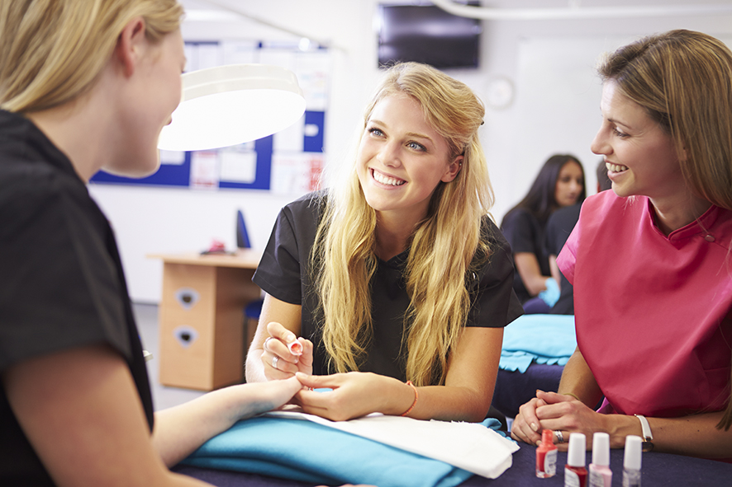

SHB30115 Certificate III in Beauty Services
Student name:

Modification history
Version | Status | Release Date | Comments
1.0 | Current | May 2022 | Original document
Authorised and published by the Victorian Curriculum and Assessment Authority
Level 7, 2 Lonsdale Street
Melbourne VIC 3000

© Victorian Curriculum and Assessment Authority 2022

No part of this publication may be reproduced except as specified under the Copyright Act 1968 or by permission from the VCAA. Excepting third-party elements, schools may use this resource in accordance with the VCAA educational allowance. For more information go to: www.vcaa.vic.edu.au/Footer/Pages/Copyright.aspx.
The VCAA provides the only official, up-to-date versions of VCAA publications. Details of updates can be found on the VCAA website: www.vcaa.vic.edu.au.
This publication may contain copyright material belonging to a third party. Every effort has been made to contact all copyright owners. If you believe that material in this publication is an infringement of your copyright, please email the Copyright Officer: vcaa.copyright@education.vic.gov.au
Copyright in materials appearing at any sites linked to this document rests with the copyright owner/s of those materials, subject to the Copyright Act. The VCAA recommends you refer to copyright statements at linked sites before using such materials.

The VCAA logo is a registered trademark of the Victorian Curriculum and Assessment Authority.

SWL Recognition
Structured Workplace Learning (SWL) recognition provides you with the opportunity to gain credit into your VCE or VCAL for undertaking SWL that matches your VCE VET program.
To receive recognition and credit, you will be required to reflect on your experience in the workplace and how this relates to your VET course. Your reflections are to be recorded in the three sections of this Workplace Learning Record (WLR).

About this workplace learning record
This WLR helps you gather evidence for assessment and is part of the requirement for obtaining SWL recognition.
To be eligible for one unit of credit towards your VCE or VCAL, you must:
- be enrolled in a minimum of 180 nominal hours of units of competency (UoCs) from the SHB30115 Certificate III in Beauty Services
- undertake a minimum of 80 hours (equivalent to 10 days of work) in a beauty industry placement
- reflect on a minimum of six UoCs from your program including the WHS UoC (SHBXWHS001 - see page 8).

VCE VET Hair And Beauty

SHB30115 / Certificate III in Beauty Services
The VCE VET Hair and Beauty program is drawn from a national training package and offers qualifications recognised throughout Australia.
These qualifications provide students with a broad range of knowledge and skills to pursue a career or further training in the hairdressing and beauty services industry.
This qualification reflects the role of individuals employed as beauticians to provide a range of beauty services including nail, waxing, lash and brow, and basic make-up services.
These individuals possess a range of well-developed technical and customer service skills where discretion and judgement is required and are responsible for their own outputs. This includes client consultation on beauty products and services.
A graduate of this course will:
- learn skills in a range of beauty services such as: basic make-up services, manicures and pedicures, lash and brow treatments and cosmetic tanning
- develop customer service skills and product knowledge to provide client consultation on beauty products and services
- apply safe work practices and follow Occupational Health and Safety procedures.
The course will provide students with an overview of the industry and help acquire practical skills in beauty services to assist in gaining employment.

Workplace Learning Record
The WLR is divided into three sections.
Section 1: Learner profile
Section 2: Learning about VET UoCs in the workplace
Section 3: Post-placement reflections
Please complete the details of your workplace.
Employer/Company/Business
Supervisor name
Contact phone number

Employer/Company/Business
Supervisor name
Contact phone number

Employer/Company/Business
Supervisor name
Contact phone number

Section 1: Learner profile
Complete the learner profile and discuss this with your host employer on or before your first day of placement.
Name
School
Phone number
Email
Explain why you decided to undertake this VET course?
List the other subjects that you are undertaking.
Explain why you have chosen this overall program.
Outline what interests you about the industry.
What is your planned career path or future career aspiration?
Describe any workplace skills you have developed through previous work experience, SWL or part time employment.
How have you developed these skills?

Section 2: Learning about VET units of competency in the workplace
This WLR contains three key questions per UoC designed to draw out related experiences you may be exposed to in a workplace.
This does not cover all the elements or performance criteria within the units and is not designed as a UoC assessment tool.
You should comment on the UoCs you have experienced in the workplace and reflect on actual observations or activities that you have been exposed to. Your observations will:
- reinforce the training you have undertaken
- identify differences in practice or equipment
- identify areas requiring further training or practical experience.
You are encouraged to take photos and/or video where appropriate to showcase learning in the workplace. Evidence you collect can include:
- observations
- descriptions of activities and tasks
- conversations with employers and other staff
- participation in meetings
- workplace documents
- research in the workplace
- photos of equipment/processes/events
- video of workplace activities.
Note: please speak to your host employer before taking photos or video. Do not use the names or details of any clients / stakeholders external to the organisation / other. This record does not require identifying actual people or events, as this may breach confidentiality.

Program outline

SHB30115 Certificate III in Beauty Services
UoCs included in this program are listed below. There are compulsory UoCs, along with a selection of electives. You can make a note of any UoC that relates to your experiences in the workplace. Indicate the year you are undertaking each UoC.
Unit code | Unit of Competency | Nominal Hours | Year | Page
Work, Health and Safety Units
BSBWHS201 | Contribute to health and safety of self and others | 20 |  | 8
Compulsory
SHBBBOS001 | Apply cosmetic tanning products | 16 |  | 9
SHBBCCS001 | Advise on beauty products and services | 30 |  | 10
SHBBFAS001 | Provide lash and brow services | 15 |  | 11
SHBBHRS001 | Provide waxing services | 85 |  | 12
SHBBMUP002 | Design and apply make-up | 45 |  | 13
SHBBNLS001 | Provide manicure and pedicare services | 50 |  | 14
SHBBRES001 | Research and apply beauty industry information | 20 |  | 15
SHBXCCS001 | Conduct salon financial transactions | 25 |  | 16
SHBXCCS002 | Provide salon services to clients | 40 |  | 17
SHBXIND001 | Comply with organisational requirements within a personal services environment | 45 |  | 18
Electives
SHBBMUP001 | Apply eyelash extensions | 30 |  | 19
SHBBMUP003 | Design and apply make-up for photography | 30 |  | 20
SHBBNLS004 | Apply nail art | 15 |  | 21
SIRRMER001 | Produce visual merchandise displays | 35 |  | 22
List any other units you are undertaking and include comments regarding additional units on page 23.

VCE VET units of competency

BSBWHS201 Contribute to health and safety of self and others
This unit describes the performance outcomes, skills and knowledge required to follow safe practices to minimise risks to self, client and colleagues in a salon environment.
Respond to the following | Comments/observations
In the day-to-day work functions in the salon, what infection control procedures did you use or observe?
Briefly outline the workplace procedure for effective decontamination of reusable equipment.
How did your workplace maintain a clean and healthy work environment?

SHBBBOS001 Apply cosmetic tanning products
This unit describes the performance outcomes, skills and knowledge required to select and apply cosmetic tanning products.
Respond to the following | Comments/observations
In the workplace how did you maintain client records to record contraindications (e.g. where a particular product should not be used on the client)?
How did you select a suitable colour choice for client skin and type?
How did you learn about the workplace ingredients of tanning products, exfoliators and moisturisers and their effects on skin?

SHBBCCS001 Advise on beauty products and services
This unit describes the performance outcomes, skills and knowledge required to advise clients on a range of professional beauty products and services.
Respond to the following | Comments/observations
How did you develop your knowledge of the workplace product and service range and prices?
What legal requirements relating to providing advice and sale of beauty products did you observe or learn?
What steps did you use to prepare a client for a product demonstration?

SHBBFAS001 Provide lash and brow services
This unit describes the performance outcomes, skills and knowledge required to provide lash and brow services that include shaping and colouring.
Respond to the following | Comments/observations
Describe the workplace requirements for preparing the treatment area.
What information did you collect from the client prior to a lash and brow service?
What process did you use to evaluate a client’s treatment plan?

SHBBHRS001 Provide waxing services
This unit describes the performance outcomes, skills and knowledge required to provide waxing services to remove unwanted facial and body hair.
Respond to the following | Comments/observations
Briefly describe the factors that may restrict a client treatment plan.
How did you or others ensure there was minimum risk of injury to self and client throughout the waxing service?
What experience did you have in monitoring client reactions and responses during the waxing service?

SHBBMUP002 Design and apply make-up
This unit describes the performance outcomes, skills and knowledge required to apply facial make-up products for day, evening or special occasions.
Respond to the following | Comments/observations
What were the workplace requirements for preparing the service area, equipment and yourself?
What experience did you have designing a make-up plan?
How did you seek client feedback on a make-up plan?

SHBBNLS001 Provide manicure and pedicare services
This unit describes the performance outcomes, skills and knowledge required to provide services and advice to clients requiring hand, foot and nail care.
Respond to the following | Comments/observations
How did you access a client treatment plan and how was the treatment plan reviewed?
What practices did you use in the workplace to use energy, water, products and other resources efficiently during the treatment process?
Describe two manicure and pedicure treatments that you provided for clients.

SHBBRES001 Research and apply beauty industry information
This unit describes the performance outcomes, skills and knowledge required to access information and update knowledge of the beauty industry and relevant industry legislation.
Respond to the following | Comments/observations
What sources of information were available in your workplace about the beauty industry?
What are three ethical industry practices you used or observed in the day-to-day work activities?
What are common ways you can monitor current industry developments and issues?

SHBXCCS001 Conduct salon financial transactions
This unit describes the performance outcomes, skills and knowledge required to conduct financial transactions for the sale of products and services within a personal services environment.
Respond to the following | Comments/observations
What secure payment handling procedures did you operate or observe in your workplace?
Describe the process for balancing the end of shift or daily takings in the workplace.
In your workplace what was the process used to report discrepancies in financial transactions?

SHBXCCS002 Provide salon services to clients
This unit describes the performance outcomes, skills and knowledge required to provide a complete customer service experience.
Respond to the following | Comments/observations
What was the workplace practice for recording client information?
What was the workplace practice for recording client information?
What procedures did you observe in the workplace for responding to client complaints?
What procedure did you use to schedule and confirm appointments with clients?

SHBXIND001 Comply with organisational requirements within a personal services environment
This unit describes the performance outcomes, skills and knowledge required to work in a personal services environment by integrating knowledge of workplace rights and responsibilities and organisational policies and procedures, and by using effective team and individual work practices to plan and organise daily work activities.
Respond to the following | Comments/observations
What did you learn about employment rights and responsibilities, whilst at the workplace?
Describe three key areas you learned about in the workplace policy and procedures manual.
What teamwork tasks/activities were you involved in?

SHBBMUP001 Apply eyelash extensions
This unit describes the performance outcomes, skills and knowledge required to apply eyelash extensions for added length and thickness of natural lashes to meet client needs.
Respond to the following | Comments/observations
What was the workplace procedure for patch testing prior to application of eyelash extensions?
Why is it important to record and maintain client treatment plans for each eyelash extension treatment?
What are the advantages of using different tweezers during the eyelash extension treatment?

SHBBMUP003 Design and apply make-up for photography
This unit describes the performance outcomes, skills and knowledge required to design and apply make-up for photographic shoots in natural and artificial light.
Respond to the following | Comments/observations
Why is it important to design and record make-up plans for clients?
What details did you record in the make-up plan at the workplace?
Briefly outline two photographic make-up principles used during a photographic make-up service.
What specific workplace requirements did you observe relating to equipment and product use and maintenance?

SHBBNLS004 Apply nail art
This unit describes the performance outcomes, skills and knowledge required to apply a range of nail art designs. It requires the ability to consult with clients, select suitable products and techniques, and apply hand painted designs, decals, or jewellery for finger or toe nails.
Respond to the following | Comments/observations
How did you prepare the treatment area, equipment and yourself for nail art services?
Describe two nail art techniques you provided for clients.
What local health and hygiene regulations and requirements are relevant to nail art services?
How did you learn about these?

SIRRMER001 Produce visual merchandise displays
This unit describes the performance outcomes, skills and knowledge required to display retail merchandise. It requires the ability to prepare, produce and maintain merchandise displays in accordance with visual merchandising requirements.
Respond to the following | Comments/observations
Briefly describe the workplace procedure for product labelling and pricing.
Why is it important to follow merchandising display guidelines?
What specific merchandise displays did you help with or set up in the workplace?

Comments/observations on any other unit(s) of competency not listed
Unit(s) | Comments/observations

Section 3: Student post-placement reflection
Employability skills are a set of eight skills we use every day in the workplace.
- Communication
- Teamwork
- Problem solving
- Self-management
- Planning and organising
- Technology
- Learning
- Initiative and enterprise
When you are on work placement, you will be using employability skills in many ways.
This record will assist you when applying for jobs and in interviews. The skills you are developing may be transferred to a range of occupations. Assessment of SWL recognition is based on a discussion of each of the sections from this booklet with a school representative.
In Section 3, identify the employability skills you have used and how you have demonstrated them in the workplace. Identify how the skills you have acquired and used during your 80 hours of SWL might assist you in the future.

List of employability skills
How did you demonstrate communication skills? For example, by listening and understanding, speaking clearly and directly, or reading and writing.
How did you demonstrate teamwork? For example, by working as part of a team or sharing ideas and resources with co-workers.

How did you demonstrate problem solving? For example, by identifying problems or developing solutions to workplace issues.
How did you demonstrate self-management? For example, by taking responsibility, managing time and tasks effectively, monitoring your own performance or having the ability to work unsupervised.

How did you demonstrate planning and organising? For example, by time management, setting priorities, making decisions, setting goals, collecting, or analysing and organising information.
How did you demonstrate the use of technology? For example, by being prepared to use a range of technology systems, IT skills (typing or data entry), or being able to learn new skills from the technology used in this industry.

How did you demonstrate learning? For example, by being willing to learn new things, being open to new ideas or adapting to change.
How did you demonstrate initiative and enterprise? For example, being creative, adapting to new situations, turning ideas into actions, coming up with a variety of options.

Summary of industry learning
At the conclusion of your SWL for this VET Qualification, think about the experiences you have had in the workplace, your reflection of learning against the UoCs and the employability skills you have developed.
How will these learnings assist you in your pathway to employment or further training in this industry?

Student declaration
I confirm that I have undertaken work placement with:
Employer/Company/Business name | Total hours of placement
TOTAL

I have completed the reflections and evidence submitted in this WLR and they are from my own experiences.
Signed (Student)
Name (Block letters)
Date

