Workplace Learning Record

VCE VET Integrated Technologies
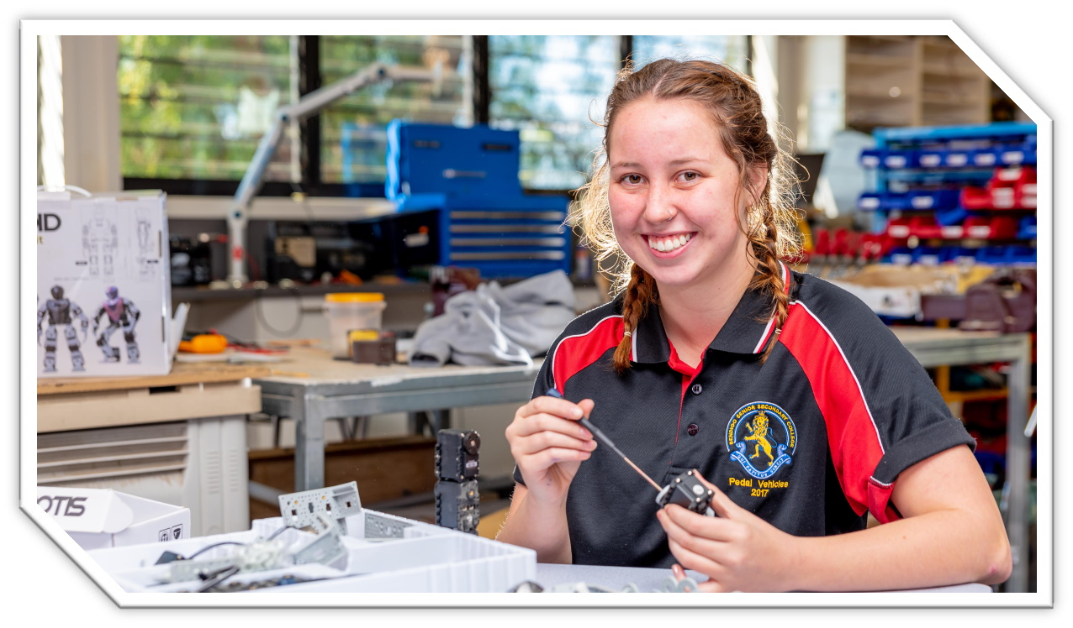

22586VIC Certificate II in Integrated Technologies
Student name:

Modification history
Version | Status | Release Date | Comments
1.0 | Current | May 2022 | Original document
Authorised and published by the Victorian Curriculum and Assessment Authority
Level 7, 2 Lonsdale Street
Melbourne VIC 3000

© Victorian Curriculum and Assessment Authority 2022

No part of this publication may be reproduced except as specified under the Copyright Act 1968 or by permission from the VCAA. Excepting third-party elements, schools may use this resource in accordance with the VCAA educational allowance. For more information go to: www.vcaa.vic.edu.au/Footer/Pages/Copyright.aspx.
The VCAA provides the only official, up-to-date versions of VCAA publications. Details of updates can be found on the VCAA website: www.vcaa.vic.edu.au.
This publication may contain copyright material belonging to a third party. Every effort has been made to contact all copyright owners. If you believe that material in this publication is an infringement of your copyright, please email the Copyright Officer: vcaa.copyright@education.vic.gov.au
Copyright in materials appearing at any sites linked to this document rests with the copyright owner/s of those materials, subject to the Copyright Act. The VCAA recommends you refer to copyright statements at linked sites before using such materials.

The VCAA logo is a registered trademark of the Victorian Curriculum and Assessment Authority.

SWL Recognition
Structured Workplace Learning (SWL) recognition provides you with the opportunity to gain credit into your VCE or VCAL for undertaking SWL that matches your VCE VET program.
To receive recognition and credit, you will be required to reflect on your experience in the workplace and how this relates to your VET course. Your reflections are to be recorded in the three sections of this Workplace Learning Record (WLR).

About this workplace learning record
This WLR helps you gather evidence for assessment and is part of the requirement for obtaining SWL recognition.
To be eligible for one unit of credit towards your VCE or VCAL, you must:
- be enrolled in a minimum of 180 nominal hours of units of competency (UoCs) from the 22586VIC Certificate II in Integrated Technologies
- undertake a minimum of 80 hours (equivalent to 10 days of work) in an integrated technology industry placement
- reflect on a minimum of six UoCs from your program including the WHS UoC (MEM13014A – see page 8).

VCE VET Integrated Technologies

22586VIC / Certificate II in Integrated Technologies
The VCE VET Integrated Technologies program is drawn from the state accredited curriculum and offers portable qualifications which are recognised throughout Australia.
This is a pre-vocational course that will provide learners with the skills required by industries, which broadly encompass electrotechnology, telecommunications, information technology and security systems to:
- continue vocational training
- gain work and further training through an apprenticeship, traineeship, or cadetship
- find employment in fields such as electronics, entertainment, wireless systems, technical support for computer and electronic equipment, energy generation, sustainability, computer-controlled applications, electronic equipment, or computer network support.

Workplace Learning Record
The WLR is divided into three sections.
Section 1: Learner profile
Section 2: Learning about VET UoCs in the workplace
Section 3: Post-placement reflections
Please complete the details of your workplace.
Employer/Company/Business
Supervisor name
Contact phone number

Employer/Company/Business
Supervisor name
Contact phone number

Employer/Company/Business
Supervisor name
Contact phone number

Section 1: Learner profile
Complete the learner profile and discuss this with your host employer on or before your first day of placement.
Name
School
Phone number
Email
Explain why you decided to undertake this VET course?
List the other subjects that you are undertaking.
Explain why you have chosen this overall program.
Outline what interests you about the industry.
What is your planned career path or future career aspiration?
Describe any workplace skills you have developed through previous work experience, SWL or part time employment.
How have you developed these skills?

Section 2: Learning about VET units of competency in the workplace
This WLR contains three key questions per UoC designed to draw out related experiences you may be exposed to in a workplace.
This does not cover all the elements or performance criteria within the units and is not designed as a UoC assessment tool.
You should comment on the UoCs you have experienced in the workplace and reflect on actual observations or activities that you have been exposed to. Your observations will:
- reinforce the training you have undertaken
- identify differences in practice or equipment
- identify areas requiring further training or practical experience.
You are encouraged to take photos and/or video where appropriate to showcase learning in the workplace. Evidence you collect can include:
- observations
- descriptions of activities and tasks
- conversations with employers and other staff
- participation in meetings
- workplace documents
- research in the workplace
- photos of equipment/processes/events
- video of workplace activities.
Note: please speak to your host employer before taking photos or video. Do not use the names or details of any clients / stakeholders external to the organisation / other. This record does not require identifying actual people or events, as this may breach confidentiality.

Program outline

22586VIC Certificate II in Integrated Technologies
UoCs included in this program are listed below. There are compulsory UoCs, along with a selection of electives. You can make a note of any UoC that relates to your experiences in the workplace. Indicate the year you are undertaking each UoC.
Unit code | Unit of Competency | Nominal Hours | Year | Page
Work, Health and Safety Units
MEM13014A | Apply principles of Occupational Health & Safety in the work environment | 10 |  | 8
UEECD0007 | Apply work health and safety regulations, codes and practices in the workplace | 20 |  | 9
Compulsory
VU21701 | Carry out an integrated technology project | 60 |  | 10
VU21702 | Prepare for working in the integrated technology sector | 20 |  | 11
VU23109 | Prepare to work in an integrated technologies environment | 20 |  | 12
VU23110 | Use routine work practices in an integrated technologies environment | 40 |  | 13
VU23111 | Apply electrotechnology knowledge and skills in integrated technologies work | 80 |  | 14
VU23112 | Use Computer Aided Drafting and Design software applications in integrated technologies work | 20 |  | 15
Electives
VU22338 | Configure and program a basic robotic system | 60 |  | 16
VU22340 | Use 3D printing to create products | 40 |  | 17
VU23118 | Install, test and verify correct operation of a by-wire control system | 30 |  | 18
VU23119 | Install, set up and test an embedded control system | 30 |  | 19
List any other units you are undertaking and include comments regarding additional units on page 20.

VCE VET units of competency

MEM13014A Apply principles of Occupational Health & Safety in the work environment
This unit describes the skills and knowledge required to work safely and follow work. This unit covers following occupational health and safety procedures in an engineering or similar work environment.
Respond to the following | Comments/observations
How did you learn about the WHS policies and procedures?
Briefly outline the purpose of a workplace safety meeting you attended, or a workplace consultative activity you participated in.
In your experience at this workplace, how were actual and foreseeable workplace hazards identified?

UEECD0007 Apply work health and safety regulations, codes and practices in the workplace
This unit covers following occupational health and safety procedures in an engineering or similar work environment.
Respond to the following | Comments/observations
How did you learn about the WHS policies and procedures?
Briefly outline the purpose of a workplace safety meeting you attended, or a workplace consultative activity you participated in.
In your experience at this workplace, how were actual and foreseeable workplace hazards identified?

VU21701 Carry out an integrated technology project
This unit of competency sets out the knowledge and skills required to carry out an integrated technology project by merging distinct electrotechnology domains to achieve an innovative and integrated technical solution.
Respond to the following | Comments/observations
Outline the integrated technology projects that you observed in the workplace.
Describe the project specifications that were used in the workplace including any project briefs, contracts or tender documents.
Describe your role in the workplace on an integrated technology project.

VU21702 Prepare for working in the integrated technology sector
This unit provides the skills and knowledge to prepare participants for working in the integrated technologies industry.
Respond to the following | Comments/observations
What different job roles did you observe within the workplace? What was the main function of each job?
Which areas of integrated technology work would you investigate further having experienced the workplace.
What are your personal strengths and weaknesses in relation to the job roles in this workplace?

VU23109 Prepare to work in an integrated technologies environment
This unit describes the performance outcomes, skills and knowledge required to prepare a person for work within an integrated technologies environment.
Respond to the following | Comments/observations
What job roles did you observe within the workplace? What was the main function of each job?
Which areas of integrated technology work would you investigate further having experienced the workplace?
What are your personal strengths and weaknesses in relation to the job roles in this workplace?

VU23110 Use routine work practices in an integrated technologies environment
This unit describes the performance outcomes, skills and knowledge required to apply routine work practices in an integrated technologies environment.
Respond to the following | Comments/observations
What devices and/or components did you use or observe being used in this workplace?
How did they ensure equipment or machine circuits were safe before work was commenced?
What test equipment did you use or observe being used in this workplace?

VU23111 Apply electrotechnology knowledge and skills in integrated technologies work
This unit describes the performance outcomes required for a person to use basic electrotechnology knowledge and skills in an integrated technologies environment.
Respond to the following | Comments/observations
Give an example of some calculations you had to carry out in the workplace.
Name a graph or chart used in this workplace.
What cable types did you use or observe being used in the workplace?

VU23112 Use Computer Aided Drafting and Design software applications in integrated technologies work
This unit describes the performance outcomes, skills and knowledge required to use computer aided drawing and design (CAD) software to support the application of technologies in an integrated environment.
Respond to the following | Comments/observations
Give an example of one way you used CAD in the workplace including describing any calculations you had to make.
Describe a 2D or 3D component you had to draw or observed being drawn using CAD in this workplace.
Describe a block diagram or flowchart you used or observed in the workplace.

VU22338 Configure and program a basic robotic system
This unit of competency sets out the knowledge and skills required to configure and program a basic robotic system. Typical tasks for basic robotics system operation include pick and place, motion, navigation.
Respond to the following | Comments/observations
Outline how the workplace planned the configuration and programming of basic robotics systems.
Describe how a robotic system was tested for correct operation in the workplace? How was this documented?
Describe the materials used in the construction of robots in the workplace and the drive mechanisms used.

VU22340 Use 3D printing to create products
This unit describes the skills and knowledge to utilise a three-dimensional (3D) printer to produce basic products.
Respond to the following | Comments/observations
Describe a product you created or observed being created using 3D printing in this workplace.
What 3D printing hardware and software did they use in this workplace and why did they choose those options?
What factors influenced the decision to use 3D printing for a particular project in this workplace?

VU23118 Install, test and verify correct operation of a by-wire control system
This unit of competency sets out the knowledge and skills required to test and verify correct operations of a by-wire control system.
Respond to the following | Comments/observations
What safety precautions did the workplace take when installing and testing “by-wire” control systems?
Describe the methods for dealing with unexpected situations that you observed being used in the workplace.
Outline any “by-wire” control system that you observed being installed and tested in the workplace.

VU23119 Install, set up and test an embedded control system
This unit of competency sets out the knowledge and skills required to install, set up and test embedded control systems used for automatic or semi-automatic operation of a wide range of consumer and industrial equipment.
Respond to the following | Comments/observations
What different types of embedded control systems did you observe in the workplace?
Outline the processes used in the workplace when installing and configuring an embedded control system.
What was your role in the process for testing embedded control systems?

Comments/observations on any other unit(s) of competency not listed
Unit(s) | Comments/observations

Section 3: Student post-placement reflection
Employability skills are a set of eight skills we use every day in the workplace.
- Communication
- Teamwork
- Problem solving
- Self-management
- Planning and organising
- Technology
- Learning
- Initiative and enterprise
When you are on work placement, you will be using employability skills in many ways.
This record will assist you when applying for jobs and in interviews. The skills you are developing may be transferred to a range of occupations. Assessment of SWL recognition is based on a discussion of each of the sections from this booklet with a school representative.
In Section 3, identify the employability skills you have used and how you have demonstrated them in the workplace. Identify how the skills you have acquired and used during your 80 hours of SWL might assist you in the future.

List of employability skills
How did you demonstrate communication skills? For example, by listening and understanding, speaking clearly and directly, or reading and writing.
How did you demonstrate teamwork? For example, by working as part of a team or sharing ideas and resources with co-workers.

How did you demonstrate problem solving? For example, by identifying problems or developing solutions to workplace issues.
How did you demonstrate self-management? For example, by taking responsibility, managing time and tasks effectively, monitoring your own performance or having the ability to work unsupervised.

How did you demonstrate planning and organising? For example, by time management, setting priorities, making decisions, setting goals, collecting, or analysing and organising information.
How did you demonstrate the use of technology? For example, by being prepared to use a range of technology systems, IT skills (typing or data entry), or being able to learn new skills from the technology used in this industry.

How did you demonstrate learning? For example, by being willing to learn new things, being open to new ideas or adapting to change.
How did you demonstrate initiative and enterprise? For example, being creative, adapting to new situations, turning ideas into actions, coming up with a variety of options.

Summary of industry learning
At the conclusion of your SWL for this VET Qualification, think about the experiences you have had in the workplace, your reflection of learning against the UoCs and the employability skills you have developed.
How will these learnings assist you in your pathway to employment or further training in this industry?

Student declaration
I confirm that I have undertaken work placement with:
Employer/Company/Business name | Total hours of placement
TOTAL

I have completed the reflections and evidence submitted in this WLR and they are from my own experiences.
Signed (Student)
Name (Block letters)
Date

