Workplace Learning Record

VCE VET Sport and Recreation
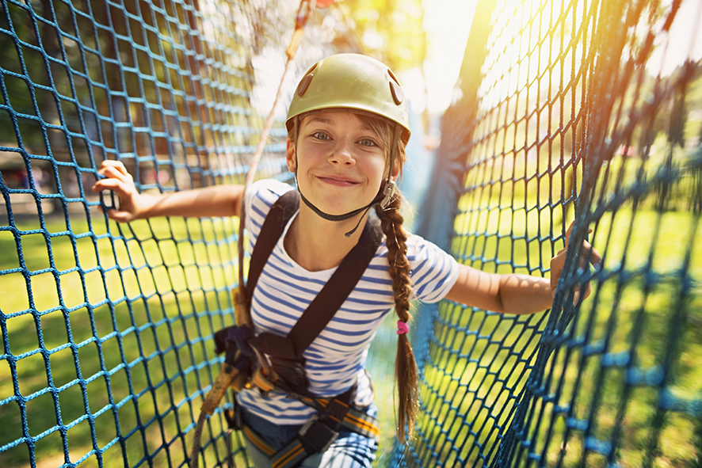

SIS20419 Certificate II in Outdoor Recreation
Student name:

Modification history
Version | Status | Release Date | Comments
1.0 | Current | May 2022 | Original document
Authorised and published by the Victorian Curriculum and Assessment Authority
Level 7, 2 Lonsdale Street
Melbourne VIC 3000

© Victorian Curriculum and Assessment Authority 2022

No part of this publication may be reproduced except as specified under the Copyright Act 1968 or by permission from the VCAA. Excepting third-party elements, schools may use this resource in accordance with the VCAA educational allowance. For more information go to: www.vcaa.vic.edu.au/Footer/Pages/Copyright.aspx.
The VCAA provides the only official, up-to-date versions of VCAA publications. Details of updates can be found on the VCAA website: www.vcaa.vic.edu.au.
This publication may contain copyright material belonging to a third party. Every effort has been made to contact all copyright owners. If you believe that material in this publication is an infringement of your copyright, please email the Copyright Officer: vcaa.copyright@education.vic.gov.au
Copyright in materials appearing at any sites linked to this document rests with the copyright owner/s of those materials, subject to the Copyright Act. The VCAA recommends you refer to copyright statements at linked sites before using such materials.

The VCAA logo is a registered trademark of the Victorian Curriculum and Assessment Authority.

SWL Recognition
Structured Workplace Learning (SWL) recognition provides you with the opportunity to gain credit into your VCE or VCAL for undertaking SWL that matches your VCE VET program.
To receive recognition and credit, you will be required to reflect on your experience in the workplace and how this relates to your VET course. Your reflections are to be recorded in the three sections of this Workplace Learning Record (WLR).

About this workplace learning record
This WLR helps you gather evidence for assessment and is part of the requirement for obtaining SWL recognition.
To be eligible for one unit of credit towards your VCE or VCAL, you must:
- be enrolled in a minimum of 180 nominal hours of units of competency (UoCs) from the SIS20419 Certificate II in Outdoor Recreation
- undertake a minimum of 80 hours (equivalent to 10 days of work) in an outdoor recreation industry placement
- reflect on a minimum of six UoCs from your program including the WHS UoC (HLTWHS001 - see page 8).

VCE VET Sport and Recreation

SIS20419 / Certificate II in Outdoor Recreation
The VCE VET Sport and Recreation program is drawn from a national training package and offers qualifications recognised throughout Australia.
These qualifications provide students with a broad range of knowledge and skills to pursue a career or further training in the sport and recreation industry.
SIS20419 Certificate II in Outdoor Recreation provides students with the knowledge and skills to be competent in performing core skills in outdoor recreation environments and assisting with the conduct of a range of outdoor activities.
Work may be undertaken as part of a team and would be performed under supervision in field locations such as camps or indoor recreation centres or facilities, in differing environments such as water-based, dry land and mountainous terrains, using a diverse range of equipment.
Electives can be chosen from a range of streams including Abseiling, Bushwalking, Cycling, Skiing, Surfing and more.
Possible job titles include:
- outdoor activity assistant
- indoor recreation centre assistant.

Workplace Learning Record
The WLR is divided into three sections.
Section 1: Learner profile
Section 2: Learning about VET UoCs in the workplace
Section 3: Post-placement reflections
Please complete the details of your workplace.
Employer/Company/Business
Supervisor name
Contact phone number

Employer/Company/Business
Supervisor name
Contact phone number

Employer/Company/Business
Supervisor name
Contact phone number

Section 1: Learner profile
Complete the learner profile and discuss this with your host employer on or before your first day of placement.
Name
School
Phone number
Email
Explain why you decided to undertake this VET course?
List the other subjects that you are undertaking.
Explain why you have chosen this overall program.
Outline what interests you about the industry.
What is your planned career path or future career aspiration?
Describe any workplace skills you have developed through previous work experience, SWL or part time employment.
How have you developed these skills?

Section 2: Learning about VET units of competency in the workplace
This WLR contains three key questions per UoC designed to draw out related experiences you may be exposed to in a workplace.
This does not cover all the elements or performance criteria within the units and is not designed as a UoC assessment tool.
You should comment on the UoCs you have experienced in the workplace and reflect on actual observations or activities that you have been exposed to. Your observations will:
- reinforce the training you have undertaken
- identify differences in practice or equipment
- identify areas requiring further training or practical experience.
You are encouraged to take photos and/or video where appropriate to showcase learning in the workplace. Evidence you collect can include:
- observations
- descriptions of activities and tasks
- conversations with employers and other staff
- participation in meetings
- workplace documents
- research in the workplace
- photos of equipment/processes/events
- video of workplace activities.
Note: please speak to your host employer before taking photos or video. Do not use the names or details of any clients / stakeholders external to the organisation / other. This record does not require identifying actual people or events, as this may breach confidentiality.

Program outline

SIS20419 Certificate II in Outdoor Recreation
UoCs included in this program are listed below. There are compulsory UoCs, along with a selection of electives. You can make a note of any UoC that relates to your experiences in the workplace. Indicate the year you are undertaking each UoC.
Unit code | Unit of Competency | Nominal Hours | Year | Page
Work, Health and Safety Units
HLTWHS001 | Participate in workplace health and safety | 20 |  | 8
Compulsory
SISOFLD001 | Assist in conducting outdoor recreation sessions | 30 |  | 9
SISOFLD002 | Minimise environmental impact | 15 |  | 10
SISXEMR001 | Respond to emergency situations | 18 |  | 11
SISXIND002 | Maintain sport, fitness and recreation industry knowledge | 30 |  | 12
Electives
SISCAQU002 | Perform basic water rescues | 10 |  | 13
SISOCLM001 | Top rope climb single pitches, artificial surfaces | 20 |  | 14
SISOCNE001 | Paddle a craft using fundamental skills | 20 |  | 15
SISOCVE001 | Traverse caves | 45 |  | 16
SISOCYT004 | Ride off road bicycles on easy trails | 20 |  | 17
SISOFLD006 | Navigate in tracked environments | 30 |  | 18
SISOKYS001 | Paddle a sea kayak in enclosed waters | 30 |  | 19
SISOSNK001 | Snorkel | 20 |  | 20
SISOSRF001 | Surf small waves using basic manoeuvres | 20 |  | 21
SISXFAC001 | Maintain equipment for activities | 5 |  | 22
List any other units you are undertaking and include comments regarding additional units on page 23.

VCE VET units of competency

HLTWHS001 Participate in workplace health and safety
This unit describes the skills and knowledge required for workers to participate in safe work practices to ensure their own health and safety, and that of others.
Respond to the following | Comments/observations
What safe work practices were explained to you during your time at the workplace?
What was the workplace procedure for reporting incidents and injuries?
Did any incidents or injuries occur that you observed?
If yes, explain what happened.
How was it handled and rectified?

SISOFLD001 Assist in conducting recreation sessions
This unit describes the performance outcomes, skills and knowledge required to assist in the conduct of any type of indoor or outdoor recreation activity session. It requires the ability to assist with equipment and participant preparation and to interact with participants to assist with activity technique and adherence to activity rules.
Respond to the following | Comments/observations
Outline the different recreation sessions that you observed in the workplace.
What was your role?
How were participants prepared for the sessions that you observed?
What methods were used to collect feedback from participants?
Was this effective?
Did the feedback change future sessions?

SISOFLD002 Minimise environmental impact
This unit describes the performance outcomes, skills and knowledge required to implement predetermined minimal environmental impact practices while delivering outdoor recreation activities. Environmental impact includes that to the natural environment and to Indigenous and non-Indigenous heritage and cultural sites.
Respond to the following | Comments/observations
What environmental impacts could have been caused by the participation in outdoor recreation activities conducted by the workplace?
How did the workplace communicate minimal impact practices to participants?
What minimal impact practices did the workplace use?
Were there any codes, standards or guidelines related to this that the workplace followed?

SISXEMR001 Respond to emergency situations
This unit describes the performance outcomes, skills and knowledge required to recognise and respond appropriately in emergency situations, such as those caused by fire, accident or weather. It requires the ability to maintain participant welfare when responding to emergency situations.
Respond to the following | Comments/observations
What emergency situations were planned for in sessions that you observed?
What equipment was available at sessions that you could have used in an emergency?
What communication systems were used by the workplace in the event of an emergency?
Were these effective?

SISXIND002 Maintain sport, fitness and recreation industry knowledge
This unit describes the performance outcomes, skills and knowledge required to develop and update current and emerging information on the sport, fitness and recreation industry. This unit requires the ability to source and comprehend general sport, fitness and recreation context.
Respond to the following | Comments/observations
What was the role of volunteers in the workplace?
What emerging technologies did the workplace use in day-to-day work activities?
How did staff in the workplace share information about the industry and incorporate this into day-to-day work activities?

SISCAQU002 Perform basic water rescues
This unit describes the performance outcomes, skills and knowledge required to perform basic water rescues in indoor or outdoor aquatic venues.
Respond to the following | Comments/observations
How did the workplace identify and evaluate aquatic emergencies?
Describe the basic water rescues that you observed in the workplace.
How did the workplace report details of aquatic emergencies and maintain records?

SISOCLM001 Top rope climb single pitches, artificial surfaces
This unit describes the performance outcomes, skills and knowledge required to climb single pitches on artificial surfaces using top rope techniques. It also requires the ability to belay top rope climbers. Artificial surfaces can be fixed or portable structures and can be in indoor or outdoor environments.
Respond to the following | Comments/observations
How did the workplace identify hazards associated with the climbing activity?
What equipment did the workplace use for this activity?
Outline the belaying techniques and devices used by the workplace.

SISOCNE001 Paddle a craft using fundamental skills
This unit describes the performance outcomes, skills and knowledge required to paddle a craft as part of a group on small inland flatwater areas such as small lakes, dams and rivers according to planned courses. It requires the ability to self-rescue from a capsize.
Respond to the following | Comments/observations
How did the workplace prepare for a canoeing activity?
What craft and equipment did the workplace use, and why was this equipment selected?
Outline the control, manoeuvring and capsize techniques that you observed being used in the workplace.

SISOCVE001 Traverse caves
This unit describes the performance outcomes, skills and knowledge required to travel through caves which feature frequently travelled tracks and a range of formations and features that may or may not be reliably marked on maps. It requires the ability to safely negotiate a range of terrain obstacles, hazards and cave formations using techniques that minimise environmental damage to the cave.
Respond to the following | Comments/observations
How did the workplace prepare for a caving activity?
What techniques for navigating through caves did you observe?

What techniques were used to minimise damage to equipment and the cave environment?

SISOCYT004 Ride off road bicycles on easy trails
This unit describes the performance outcomes, skills and knowledge required to ride mountain or other off-road bicycles as part of a group on easy trails and according to planned routes.
Respond to the following | Comments/observations
How did the workplace prepare for an off-road ride?
What types of bicycles were used in the workplace, and how were they set up?
What pre-departure checks were made on the bicycles?
Outline the off-road cycling skills that you observed being demonstrated in the workplace.

SISOFLD006 Navigate in tracked environments
This unit describes the performance outcomes, skills and knowledge required to navigate in environments which can include tracks or inland rivers according to planned routes.
Respond to the following | Comments/observations
Outline a planned route that you observed in the workplace.

Describe an adjustment that was made to a pre-determined route. Why was the adjustment necessary?

What navigation techniques used to determine location did you observe in the workplace?

SISOKYS001 Paddle a sea kayak in enclosed waters
This unit describes the performance outcomes, skills and knowledge required to paddle a sea kayak as part of a group in enclosed waters and according to planned courses. It requires the ability to self-rescue from a capsize and to rescue others in deep water.
Respond to the following | Comments/observations
How did the workplace prepare for the paddle?
Describe the safety procedures you observed in sea kayaking activities.
Outline the control, manoeuvring and capsize techniques that you observed being used in the workplace.

SISOSNK001 Snorkel
This unit describes the performance outcomes, skills and knowledge required to snorkel as part of a group in confined or open water. It requires the ability to use a snorkel while surface swimming and diving underwater.
Respond to the following | Comments/observations
How did the workplace prepare for a snorkelling activity?
What were the communication protocols for group snorkelling activities?
Describe the safety procedures followed in the workplace for snorkelling activities.

SISOSRF001 Surf small waves using basic manoeuvres
This unit describes the performance outcomes, skills and knowledge required to surf small waves up to 0.5 metre using a range of fundamental skills for riding surfboards.
Respond to the following | Comments/observations
How did the workplace prepare for a surfing activity?
What techniques did you observe for catching and riding a wave in the workplace?
Describe the safety procedures and surfing etiquette that you observed in the workplace.

SISXFAC001 Maintain equipment for activities
This unit describes the performance outcomes, skills and knowledge required to conduct routine maintenance and minor repairs on equipment.
Respond to the following | Comments/observations
How was equipment examined and checked in the workplace?
Provide details of any equipment repairs that you observed in the workplace.
What minor maintenance tasks did you undertake in the workplace?

Comments/observations on any other unit(s) of competency not listed
Unit(s) | Comments/observations

Section 3: Student post-placement reflection
Employability skills are a set of eight skills we use every day in the workplace.
- Communication
- Teamwork
- Problem solving
- Self-management
- Planning and organising
- Technology
- Learning
- Initiative and enterprise
When you are on work placement, you will be using employability skills in many ways.
This record will assist you when applying for jobs and in interviews. The skills you are developing may be transferred to a range of occupations. Assessment of SWL recognition is based on a discussion of each of the sections from this booklet with a school representative.
In Section 3, identify the employability skills you have used and how you have demonstrated them in the workplace. Identify how the skills you have acquired and used during your 80 hours of SWL might assist you in the future.

List of employability skills
How did you demonstrate communication skills? For example, by listening and understanding, speaking clearly and directly, or reading and writing.
How did you demonstrate teamwork? For example, by working as part of a team or sharing ideas and resources with co-workers.

How did you demonstrate problem solving? For example, by identifying problems or developing solutions to workplace issues.
How did you demonstrate self-management? For example, by taking responsibility, managing time and tasks effectively, monitoring your own performance or having the ability to work unsupervised.

How did you demonstrate planning and organising? For example, by time management, setting priorities, making decisions, setting goals, collecting, or analysing and organising information.
How did you demonstrate the use of technology? For example, by being prepared to use a range of technology systems, IT skills (typing or data entry), or being able to learn new skills from the technology used in this industry.

How did you demonstrate learning? For example, by being willing to learn new things, being open to new ideas or adapting to change.
How did you demonstrate initiative and enterprise? For example, being creative, adapting to new situations, turning ideas into actions, coming up with a variety of options.

Summary of industry learning
At the conclusion of your SWL for this VET Qualification, think about the experiences you have had in the workplace, your reflection of learning against the UoCs and the employability skills you have developed.
How will these learnings assist you in your pathway to employment or further training in this industry?

Student declaration
I confirm that I have undertaken work placement with:
Employer/Company/Business name | Total hours of placement
TOTAL

I have completed the reflections and evidence submitted in this WLR and they are from my own experiences.
Signed (Student)
Name (Block letters)
Date

