Workplace Learning Record

VCE VET Animal Studies
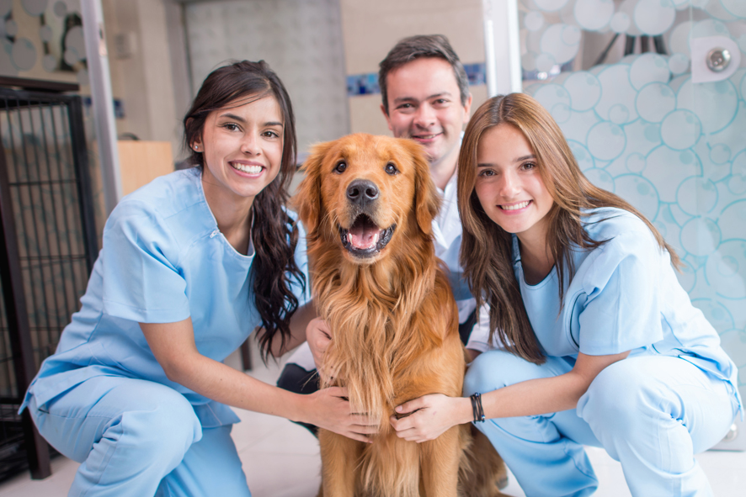

ACM20117 Certificate II in Animal Studies
Student name:

Modification history
Version | Status | Release Date | Comments
1.0 | Current | July 2020 | Original document with minor updates
Authorised and published by the Victorian Curriculum and Assessment Authority
Level 7, 2 Lonsdale Street
Melbourne VIC 3000
ISBN: 978-1-925676-48-8
© Victorian Curriculum and Assessment Authority 2017

No part of this publication may be reproduced except as specified under the Copyright Act 1968 or by permission from the VCAA. Excepting third-party elements, schools may use this resource in accordance with the VCAA educational allowance. For more information go to: www.vcaa.vic.edu.au/Footer/Pages/Copyright.aspx.
The VCAA provides the only official, up-to-date versions of VCAA publications. Details of updates can be found on the VCAA website: www.vcaa.vic.edu.au.
This publication may contain copyright material belonging to a third party. Every effort has been made to contact all copyright owners. If you believe that material in this publication is an infringement of your copyright, please email the Copyright Officer: vcaa.copyright@edumail.vic.gov.au
Copyright in materials appearing at any sites linked to this document rests with the copyright owner/s of those materials, subject to the Copyright Act. The VCAA recommends you refer to copyright statements at linked sites before using such materials.

The VCAA logo is a registered trademark of the Victorian Curriculum and Assessment Authority.

SWL Recognition
Structured Workplace Learning (SWL) recognition provides you with the opportunity to gain credit into your VCE or VCAL for undertaking SWL that matches your VCE VET program.
To receive recognition and credit, you will be required to reflect on your experience in the workplace and how this relates to your VET course. Your reflections are to be recorded in the three sections of this Workplace Learning Record (WLR).

About this workplace learning record
This WLR helps you gather evidence for assessment and is part of the requirement for obtaining SWL recognition.
To be eligible for one unit of credit towards your VCE or VCAL, you must:
- be enrolled in a minimum of 180 nominal hours of units of competency (UoCs) from the ACM20117 Certificate II in Animal Studies
- undertake a minimum of 80 hours (equivalent to 10 days of work) in an animal care industry placement
- reflect on a minimum of six UoCs from your program including the WHS UoC (ACMWHS201 — see page 8).

VCE VET Animal Studies

ACM20117 Certificate II in Animal Studies
The VCE VET Animal Studies program includes a general qualification for entry into sectors of the animal care and management industry, where workers provide care for animals in workplaces such as animal shelters, kennels, catteries, sanctuaries and veterinary clinics.
Specifically you will learn the skills needed for:
- workplace health and safety processes
- health care for animals
- basic first aid for animals
- animal care and hygiene routines
- sustainable work practices
- working in the animal care industry
- workplace communication
- distributing food and water to animals.
Job roles may include:
- animal care attendant
- animal shelter attendant
- kennel hand
- cattery attendant
- pet shop attendant
- assistant dog groomer.

Workplace Learning Record
The WLR is divided into three sections.
Section 1: Learner profile
Section 2: Learning about VET UoCs in the workplace
Section 3: Post-placement reflections
Please complete the details of your workplace.
Employer/Company/Business
Supervisor name
Contact phone number

Employer/Company/Business
Supervisor name
Contact phone number

Employer/Company/Business
Supervisor name
Contact phone number

Section 1: Learner profile
Complete the Learner profile and discuss this with your host employer on or before your first day of placement.
Name
School
Contact information
Within your VCE/VCAL why did you undertake this VET course?
What VCE/VCAL subjects are you also undertaking?
Why have you chosen this overall VCE/VCAL program?

Program outline

ACM20117 Certificate II in Animal Studies
UoCs included in this program are listed below. There are compulsory UoCs, along with a selection of electives. You can make a note of any UoC that relates to your experiences in the workplace. Indicate the year you are undertaking each UoC.
Unit code | Unit of Competency | Year | Page
VCE VET Units 1–4
Compulsory
ACMWHS201 | Participate in workplace health and safety processes |  | 8
ACMGAS201 | Work in the animal care industry |  | 9
ACMGAS202 | Participate in workplace communications |  | 10
ACMGAS203 | Complete animal care hygiene routines |  | 11
ACMGAS204 | Feed and water animals |  | 12
ACMGAS205 | Assist in the health care of animals |  | 13
ACMGAS206 | Provide basic first aid for animals |  | 14
ACMSUS201 | Participate in environmentally sustainable work practices |  | 15
Electives
ACMGAS208 | Source information for animal care needs |  | 16
ACMGAS209 | Provide information on companion animals, products and services |  | 17
ACMSPE304 | Provide basic care of domestic dogs |  | 18
ACMGAS102 | Catch and handle a range of quiet animals |  | 19
List any other units you are undertaking and include comments regarding additional units on page 20.

What interests you about the industry?
What is your planned career path or future career aspiration?
Describe any workplace skills you have developed through previous work experience, SWL or part time employment?

Section 2: Learning about VET units of competency in the workplace
This WLR contains three key questions per UoC designed to draw out related experiences you may be exposed to in a workplace providing animal care.
This does not cover all the elements or performance criteria within the units and is not designed as a UoC assessment tool.
You should comment on the UoCs you have experienced in the workplace, and reflect on actual observations or activities that you have been exposed to. Your observations will:
- reinforce the training you have undertaken
- identify differences in practice or equipment
- identify areas requiring further training or practical experience.
You are encouraged to take photos and/or video where appropriate to showcase learning in the workplace. Evidence you collect can include:
- observations
- descriptions of activities and tasks
- conversations with employers and other staff
- participation in meetings
- workplace documents
- research in the workplace
- photos of equipment/processes/events
- video of workplace activities.
Note: please speak to your host employer before taking photos or video. This record does not require identifying actual people or events, as this may breach confidentiality.

VCE VET units of competency

ACMWHS201
Participate in workplace health and safety processes
This unit of competency is intended for application during induction of new entrants to the workplace and where the employee has basic operational knowledge and skills for a limited range of tasks and problems. It includes apprentices, trainees and casual workers.
Respond to the following | Comments/observations
What personal protective gear and equipment did you use in the workplace to provide protection from hazards?
How did you know about the workplace procedures and instructions to ensure a safe workplace?
What were the emergency procedures to follow in case of fire?
How were common workplace hazards reported and reduced?

ACMGAS201
Work in the animal care industry
This unit of competency covers the terminology, culture and working conditions of an animal care workplace when working on an individual basis and with others.
Respond to the following | Comments/observations
What WHS guidelines did you follow in the workplace?
Describe the range of animals observed in the workplace.
Describe the hygiene protocols followed in the workplace to ensure animal health?

ACMGAS202
Participate in workplace communications
This unit of competency specifies the performance outcomes/skills and knowledge required to participate in workplace communications in an animal care and management environment.
Respond to the following | Comments/observations
Give an example of two routine instructions you followed in the workplace.
Describe the work related documents you observed, assisted with or completed in the workplace.
Describe how you communicated with colleagues and clients in the workplace.

ACMGAS203
Complete animal care hygiene routines
This unit of competency describes the performance outcomes/skills and knowledge required to provide daily care of animals, including the cleaning of animal housing, and grooming or cleaning of animals under supervision.
Respond to the following | Comments/observations
What steps did you follow to identify and perform a hygiene inspection of the animal?
Describe the typical tasks you followed to maintain animal care and hygiene principles in the workplace.
What safe animal handling techniques and procedures did you observe in the workplace?

ACMGAS204
Feed and water animals
This unit of competency specifies the performance outcomes/skills and knowledge required to prepare, present and distribute food and water for animals under supervision and according to animal dietary requirements.
Respond to the following | Comments/observations
What appropriate personal protective equipment (PPE) was used for animal feeding?
How was the feeding process monitored in the workplace to ensure animals were feeding effectively?
Describe how the feeding and watering process for animals was recorded in the workplace.

ACMGAS205
Assist in the health care of animals
This unit of competency specifies the performance outcomes/skills and knowledge required to provide assistance to experienced staff in the capture, restraint and assessment of animals and the preparation, application and documentation of treatments.
Respond to the following | Comments/observations
Describe the common methods used in the workplace to capture and restrain animals.
Describe the examination techniques you observed or assisted with to assess the health status of an animal.
How was the treatment and care of animals documented in the workplace?

ACMGAS206
Provide basic first aid for animals
This unit of competency specifies the performance outcomes/skills and knowledge required to provide essential first aid for animals by recognising and responding to an emergency using basic first aid measures. The first aider is not expected to deal with complex casualties or incidents, but to provide an initial response where first aid is required.
Respond to the following | Comments/observations
When providing first aid to animals, describe the risks to self, others and to animals that were observed in the workplace.
What first aid techniques for animals did you use or observe in the workplace?
Describe what assistance is available in the workplace for providing first aid to animals.

ACMSUS201
Participate in environmentally sustainable work practices
This unit of competency specifies the performance outcomes/skills and knowledge required to measure current resource use effectively, and to carry out improvements, including those that will reduce the negative impacts of work practices on the environment.
Respond to the following | Comments/observations
How did the workplace measure and document usage of resources?
What environment regulations did you observe or follow in the workplace?
What was the workplace procedure for reporting breaches of relevant environmental regulations?

ACMGAS208
Source information for animal care
This unit of competency specifies the performance outcomes/skills and knowledge required to gather information on medications and services for animals, and relate these to individual animal requirements.
Respond to the following | Comments/observations
Describe the process you followed to prepare a dose or application for an animal as directed by your supervisor.
What process did you follow to identify animal microchip and identification information?
How did you document an animal’s history of care?

ACMGAS209
Provide information on companion animals, products and services
This unit of competency specifies the performance outcomes/skills and knowledge to provide basic information to clients on companion animal training, grooming, breeding establishments and on products and services in a range of companion animal settings.
Respond to the following | Comments/observations
Describe how you communicated to clients to handle their enquiries courteously and promptly according to workplace policies and procedures.
Provide an example of when you provided information that addressed client requirements to a client in a timely and professional manner.
How do you know you provided information that met the client’s requirements?

ACMSPE304
Provide basic care of domestic dogs
This unit of competency specifies the skills and knowledge required to identify dogs and their behavioural and physical needs, and provide daily care requirements.
Respond to the following | Comments/observations
Describe the common dog breeds, their appearance, nutrition, health and behavioural characteristics that were common in the workplace.
What was an indicator that the animal was distressed, and how was this reported?
What process was followed to restrain a dog in distress?
Describe a feeding plan and treatment plan of one dog that you assisted with/observed.

ACMGAS102

Catch and handle a range of quiet animals
This unit covers the skills and knowledge required to approach, catch and handle a range of quiet, well-handled domestic animals under supervision.
Respond to the following | Comments/observations
Describe how you selected the correct type of catching and handling technique to minimise the risk of injury or distress for a quiet domestic animal.
What appropriate verbal and non-verbal communication skills were used when handling quiet domestic animals?
What are some of the common risks of working with animals that you observed in the workplace?

Comments/observations on any other unit(s) of competency not listed
Unit(s) | Comments/observations

Section 3: Student post-placement reflection
Employability skills are a set of eight skills we use every day in the workplace.
- Communication
- Team work
- Problem solving
- Self-management
- Planning and organising
- Technology
- Learning
- Initiative and enterprise
When you are on work placement, you will be using employability skills in many different ways.
This record will assist you when applying for jobs and in interviews. The skills you are developing may be transferred to a range of occupations. Assessment of SWL recognition is based on a discussion of each of the sections from this booklet with a school representative.
In Section 3, identify the employability skills you have used and how you have demonstrated them in the workplace. Identify how the skills you have acquired and used during your 80 hours of SWL might assist you in the future.

List of employability skills
How did you demonstrate communication skills? For example, by listening and understanding, speaking clearly and directly or reading and writing.
How did you demonstrate team work? For example, by working as part of a team or sharing ideas and resources with co-workers.

How did you demonstrate problem solving? For example, by identifying problems or developing solutions to workplace issues.
How did you demonstrate self-management? For example, by taking responsibility, managing time and tasks effectively, monitoring your own performance or having the ability to work unsupervised.

How did you demonstrate planning and organising? For example, by time management, setting priorities, making decisions, setting goals, collecting or analysing and organising information.
How did you demonstrate the use of technology? For example, by being prepared to use a range of technology systems, IT skills (typing or data entry) or being able to learn new skills from the technology used in this industry.

How did you demonstrate learning? For example, by being willing to learn new things, being open to new ideas or adapting to change.
How did you demonstrate initiative and enterprise? For example, being creative, adapting to new situations, turning ideas into actions, coming up with a variety of options.

Summary of industry learning
At the conclusion of your SWL for this VET Qualification, think about the experiences you have had in the workplace, your reflection of learning against the UoCs and the employability skills you have developed.
How will these learnings assist you in your pathway to employment or further training in this industry?

Student declaration
I confirm that I have undertaken work placement with:
Employer/Company/Business name | Total hours of placement
TOTAL

I have completed the reflections and evidence submitted in this WLR and they are from my own experiences.
Signed (Student)
Name (Block letters)
Date

