Workplace Learning Record

VCE VET Equine Studies
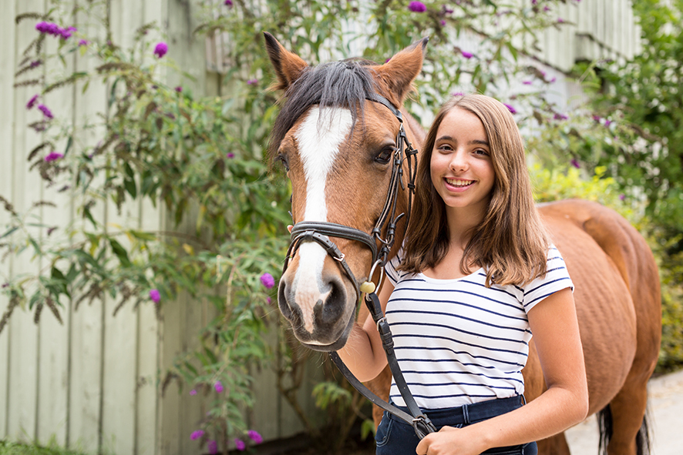

22246VIC Certificate II in Equine Studies
Student name:

Authorised and published by the Victorian Curriculum and Assessment Authority
Level 7, 2 Lonsdale Street
Melbourne VIC 3000
ISBN: 978-1-925676-50-1
© Victorian Curriculum and Assessment Authority 2017

No part of this publication may be reproduced except as specified under the Copyright Act 1968 or by permission from the VCAA. Excepting third-party elements, schools may use this resource in accordance with the VCAA educational allowance. For more information go to: www.vcaa.vic.edu.au/Pages/aboutus/policies/policy-copyright.aspx.
The VCAA provides the only official, up-to-date versions of VCAA publications. Details of updates can be found on the VCAA website: www.vcaa.vic.edu.au.
This publication may contain copyright material belonging to a third party. Every effort has been made to contact all copyright owners. If you believe that material in this publication is an infringement of your copyright, please email the Copyright Officer: vcaa.copyright@edumail.vic.gov.au
Copyright in materials appearing at any sites linked to this document rests with the copyright owner/s of those materials, subject to the Copyright Act. The VCAA recommends you refer to copyright statements at linked sites before using such materials.

The VCAA logo is a registered trademark of the Victorian Curriculum and Assessment Authority.

SWL Recognition
Structured workplace learning (SWL) recognition provides you with the opportunity to gain credit into your VCE or VCAL for undertaking SWL that matches your VCE VET program.
To receive recognition and credit, you will be required to reflect on your experience in the workplace and how this relates to your VET course. Your reflections are to be recorded in the three sections of this workplace learning record (WLR).

About this workplace learning record
This workplace learning record helps you gather evidence for assessment and is part of the requirement for obtaining SWL Recognition.
To be eligible for one Unit towards your VCE or VCAL, you must:
- be enrolled in a minimum of 180 hours of units of competency (UoC) from the 22246VIC Certificate in Equine Studies
- undertake a minimum of 80 hours (equivalent to 10 days of work) in business industry placement
- reflect on a minimum of six units of competency (UoC) from your program including the WHS UoC (VU21401 — see page 12).

VCE VET Animal Studies

22246VIC Certificate II in Equine Studies
The VCE VET Equine Studies is primarily an entry level vocational qualification which will enable successful graduates to apply for employment in different sectors of the equine industry or further study in a range of equine or equine related qualifications in horse breeding, sport or racing.
Specifically a graduate of this course may:
- safe work practices
- handling horses
- nutrition
- health and welfare
- daily care requirements
- anatomy and physiology
Job roles may include:
- stable hand
- stud hand
- groomer
- farm hand
- stock rider
- trail ride assistant

Workplace Learning Record
The workplace learning record is divided into three sections.
Section 1: Learner profile
Section 2: Learning about VET units of competency in the workplace
Section 3: Post-placement reflections
Please complete the details of your workplace.
Employer/Company/Business
Supervisor name
Contact phone number

Employer/Company/Business
Supervisor name
Contact phone number

Employer/Company/Business
Supervisor name
Contact phone number

Section 1: Learner profile
Complete the Learner profile and discuss this with your host employer on or before your first day of placement.
Name
School
Contact information
Within your VCE/VCAL why did you undertake this VET course?
What VCE/VCAL subjects are you also undertaking?
Why have you chosen this overall VCE/VCAL program?

Program outline

22246VIC Certificate II in Equine Studies
Units of competency (UoC) included in this program are listed below. There are compulsory UoC, along with a selection of electives. You can make a note of any UoC that relates to your experiences in the workplace. Also indicate the year you’re undertaking each UoC.
Unit code | Unit of Competency | Year | Page
VCE VET Units 1–2
Compulsory
AHCHBR203A | Provide daily care for horses |  | 8
AHCWRK204A | Work effectively in the industry |  | 9
HLTAID002 | Provide basic emergency life support |  | 10
SISOEQO201A | Handle horses |  | 11
VU21401 | Work safely in an equine organisation |  | 12
VU21405 | Equine anatomy |  | 13
Electives
SISOEQO202A | Demonstrate basic horse riding skills |  | 14
VU21409 | Assist in the preparation of a horse for an event |  | 15
VCE VET Units 3–4
Compulsory
VU21402 | Implement horse health and welfare practices |  | 16
VU21403 | Implement and monitor a horse feeding program |  | 17
VU21404 | Relate equine form and function |  | 18
VU21406 | Equine physiology |  | 19
List any other units you are undertaking and include comments regarding additional units on page 20.

What interests you about the industry?
What is your planned career path or future career aspiration?
Describe any workplace skills you have developed through previous work experience, SWL or part time employment?

Section 2: Learning about VET units of competency in the workplace
This workplace learning record contains three key questions per UoC designed to draw out related experiences you may be exposed to in an equine-based workplace or industry.
This does not cover all the elements or performance criteria within the units and is not designed as a UoC assessment tool.
You should comment on the units you’ve experienced in the workplace, and reflect on actual observations or activities that you have been exposed to. Your observations will:
- reinforce the training you have undertaken
- identify differences in practice or equipment
- identify areas requiring further training or practical experience.
You are encouraged to take photos and/or video where appropriate to showcase learning in the workplace. Evidence you collect can include:
- observations
- descriptions of activities and tasks
- conversations with employers and other staff
- participation in meetings
- workplace documents
- research in the workplace
- photos of equipment/processes/events
- video of workplace activities.
Note: please speak to your host employer before taking photos or video. This record does not require identifying actual people or events, as this may breach confidentiality.

VCE VET units of competency

AHCHBR203A Provide daily care for horses
This unit covers the process of providing daily care for horses and defines the standard required to: complete stable routines efficiently; complete daily horse maintenance; select horses for a range of purposes; catch and tie up a horse; groom or rug horses as required by the organisation; clean and maintain equipment; and work safely around horses.
Respond to the following | Comments/observations
Describe the tasks you undertook at the workplace to clean the stables and surrounding areas.
What did you look for when you were checking the conditions of the horses?
How did you catch the horses and fit them with the required working gear?

What steps did you follow to groom horses to the workplace standard?

AHCWRK204A Work effectively in the industry
This unit of competency specifies the performance outcomes/skills and knowledge required to work effectively on an individual basis and with others as well as within a hierarchy of management.
Respond to the following | Comments/observations
What information did the workplace have regarding the equine industry’s OHS policies and procedures, dress requirements and working conditions of enployees?

Give an example of how you worked co-operatively as an individual and as part of a team.

Describe some key activities in your daily schedule, including the start times, completion times, materials and equipment used.

HLTAID002 Provide basic emergency life support
This unit of competency describes the performance outcomes/skills and knowledge required to recognise and respond to life threatening emergencies in line with the Australian Resuscitation Council (ARC) guidelines.
Respond to the following | Comments/observations
Describe how the workplace recognised and responded to an emergency situation.

Provide examples of how hazards were identified and minimised ensuring the health and safety of all people in the workplace.

What types of workplace documentation were completed for reporting the details of emergency incidents, the first aid provided and preventative measures?

SISOEQO201A Handle horses
This unit of competency specifies the performance outcomes/skills and knowledge required to handle horses safely. This unit focuses on the identification and safe catching, management and handling of horses for the purposes of transporting, training and racing or recreational use.
Respond to the following | Comments/observations
What appropriate gear did you use to approach and catch a selected horse?

Give an example of how written and verbal instructions from supervisors were used to assist in the catching, leading and transport of horses safely.

How did you prepare horses for transport, apply protective gear and load horses?

VU21401 Work safely in an equine organisation
This unit of competency specifies the performance outcomes/skills and knowledge required to undertake work in the equine industry.
Respond to the following | Comments/observations
Describe three OHS requirements and safe work practices that you followed.

What personal protective clothing and equipment was required to be used by workers in the workplace?

How did you learn about the range of careers and pathways in the horse industry?

VU21405 Equine anatomy
This unit of competency specifies the performance outcomes/skills and knowledge required to identify and locate the external features of horses and the major anatomical components.
Respond to the following | Comments/observations
Describe the main coat colours of two horses you observed in the workplace, using appropriate terminology.

Describe the body of two horses observed in the workplace, using appropriate terminology.

Describe the head of two horses you observed in the workplace, using appropriate terminology.

SISOEQO202A Demonstrate basic horse riding skills
This unit focuses on the demonstration of basic horse riding skills through participation in supervised horse riding activities in controlled conditions.
Respond to the following | Comments/observations
What process was used to select the tack and fit appropriate personal equipment for safety and comfort?

Describe how you were required to mount, ride and dismount a horse in the workplace.

After the ride, how did you cool down the horse, check and pack the gear away and release the horse?

VU21409 Assist in the preparation of a horse for an event
This unit of competency specifies the performance outcomes/skills and knowledge required to enable an individual to assist a professional competitor or trainer in the preparation of a horse for a competition.
Respond to the following | Comments/observations
What exercise routine was used in the workplace to prepare a horse for competition?

Describe three grooming techniques required for a horse for a professional competition.

Describe the equipment that may be selected for professional competition.

VU21402 Implement horse health and welfare practices
This unit of competency specifies the performance outcomes/skills and knowledge required to monitor and identify signs of common illness and injury in horses and other signs of distress and to report observations accurately and in a timely fashion.
Respond to the following | Comments/observations
Describe how horse health and welfare was monitored in the workplace.

What common illnesses and injuries for horses did you observe in the workplace?

Describe the records and documentation completed to monitor health and welfare of horses in the workplace.

VU21403 Implement and monitor a horse feeding program
This unit of competency specifies the performance outcomes/skills and knowledge required to implement a feeding program, monitor the quality of feed and feed supplements and monitor feeding habits and variations of individual horses.
Respond to the following | Comments/observations
Describe the common feeds and supplements for horses observed in the workplace.

Describe the special nutritional requirements for two horses you observed in the workplace.

How was feed quality monitored for contamination?

VU21404 Relate equine form and function
This unit of competency specifies the performance outcomes/skills and knowledge required to recognise conformation features of horses.
Respond to the following | Comments/observations
Outline the conformation features of the major breeds and types of horses observed in the workplace.

Describe two desirable conformation features of horses observed in the workplace.

Describe one unsound feature and one blemish relating to equine conformation, observed in the workplace.

VU21406 Equine physiology
This unit of competency provides participants with an understanding of the physiology of horses being trained or used for racing, competitive performance, breeding and recreation.
Respond to the following | Comments/observations
Describe two common illnesses, injuries or abnormalities of the equine skeletal system.

Identify one common illness, injury or abnormality of the equine nervous system.

What processes were in place to identify and deal with illnesses, injuries or abnormalities of horses in the workplace?

Comment/observation on any other unit of competency/s not listed
Unit(s) | Comments/observations

Section 3: Student post-placement reflection
Employability skills are a set of eight skills we use every day in the workplace.
- Communication
- Team work
- Problem solving
- Self-management
- Planning and organising
- Technology
- Learning
- Initiative & enterprise
When you’re on work placement, you’ll be using employability skills in many different ways.
This record will assist you when applying for jobs and in interviews. The skills you’re developing may be transferred to a range of occupations. Assessment of SWL recognition is based on a discussion of each of the sections from this booklet with a school representative.
In Section 3, identify the employability skills you’ve used and how you’ve demonstrated them in the workplace. Identify how the skills you acquired and used during your 80 hours of SWL might assist you in the future.

List of employability skills
How did you demonstrate communication skills? For example, by listening and understanding, speaking clearly and directly or reading and writing skills.
How did you demonstrate team work? For example, by working as part of a team or sharing ideas and resources with co-workers.

How did you demonstrate problem solving? For example, by identifying problems or developing solutions to workplace activities.
How did you demonstrate self-management? For example, by taking responsibility, managing time and tasks effectively, monitoring your own performance or having the ability to work unsupervised.

How did you demonstrate planning and organising? For example, by time management, setting priorities, making decisions, setting goals, collecting or analysing and organising information.
How did you demonstrate the use of technology? For example, by being prepared to use a range of technology systems, IT skills (typing or data entry) or being able to learn new skills from the technology used in this industry.

How did you demonstrate learning? For example, by being willing to learn new things, being open to new ideas or adapting to change.
How did you demonstrate initiative and enterprise? For example,, being creative, adapting to new situations, turning ideas into actions, coming up with a variety of options.

Summary of industry learning
At the conclusion of your SWL for this VET Qualification, think about the experiences you’ve had in the workplace, your reflection of learning against the UoCs and the employability skills you have developed.
How will these learnings assist you in your pathway to employment or further training in this industry?

Student declaration
I confirm that I have undertaken work placement with:
Employer/Company/Business name | Total hours of placement
TOTAL

I have completed the reflections and evidence submitted in this workplace learning record and they are from my own experiences.
Signed (Student)
Name (Block letters)
Date

