Workplace Learning Record

VCE VET Hair and Beauty
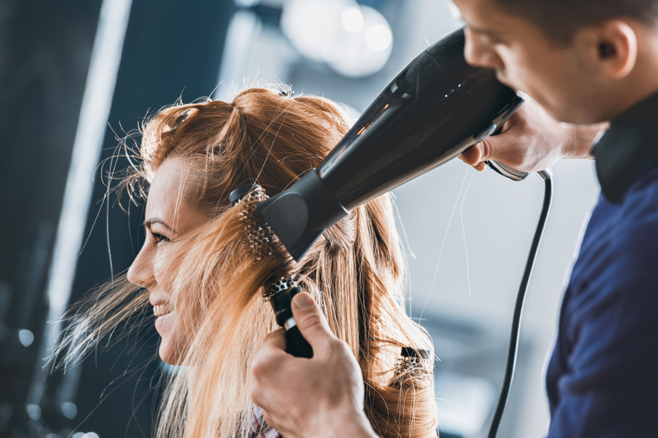

SHB20216 Certificate II in Salon Assistance
Student name:

Authorised and published by the Victorian Curriculum and Assessment Authority
Level 7, 2 Lonsdale Street
Melbourne VIC 3000
ISBN: 978-1-925676-11-2
© Victorian Curriculum and Assessment Authority 2017

No part of this publication may be reproduced except as specified under the Copyright Act 1968 or by permission from the VCAA. Excepting third-party elements, schools may use this resource in accordance with the VCAA educational allowance. For more information go to: www.vcaa.vic.edu.au/Pages/aboutus/policies/policy-copyright.aspx.
The VCAA provides the only official, up-to-date versions of VCAA publications. Details of updates can be found on the VCAA website: www.vcaa.vic.edu.au.
This publication may contain copyright material belonging to a third party. Every effort has been made to contact all copyright owners. If you believe that material in this publication is an infringement of your copyright, please email the Copyright Officer: vcaa.copyright@edumail.vic.gov.au
Copyright in materials appearing at any sites linked to this document rests with the copyright owner/s of those materials, subject to the Copyright Act. The VCAA recommends you refer to copyright statements at linked sites before using such materials.

The VCAA logo is a registered trademark of the Victorian Curriculum and Assessment Authority.

SWL Recognition
Structured workplace learning (SWL) recognition provides you with the opportunity to gain credit into your VCE or VCAL for undertaking SWL that matches your VCE VET program.
To receive recognition and credit, you will be required to reflect on your experience in the workplace and how this relates to your VET course. Your reflections are to be recorded in the three sections of this workplace learning record (WLR).

About this workplace learning record
This workplace learning record helps you gather evidence for assessment and is part of the requirement for obtaining SWL Recognition.
To be eligible for one Unit towards your VCE or VCAL, you must:
- be enrolled in a minimum of 180 hours of units of competency (UoC) from the SHB20216 Certificate II in Salon Assistance
- undertake a minimum of 80 hours (equivalent to 10 days of work) in an agriculture, horticulture and conservation and land management industry placement
- reflect on a minimum of six units of competency (UoC) from your program including the WHS UoC (BSBWHS201 — see page 10).

VCE VET Hair and Beauty

SHB20216 Certificate II in Salon Assistance
The VCE VET Hair and Beauty program is drawn from a national training package and offers qualifications recognised throughout Australia.
These qualifications provide students with a broad range of knowledge and skills to pursue a career or further training in the hairdressing and beauty services industry.
This is a preparatory qualification which prepares you for work in a hairdressing team as a salon assistant.
The certificate allows students to perform a limited range of hairdressing task, interact with customers and provide customer service, demonstrate effective hairdressing work practices, follow workplace safety procedures, provide assistance to colleagues and develop knowledge of the hairdressing industry.
Specifically a graduate of this course will:
- learn to work as part of team, communication skills, consulting with clients, selling products and services.
- perform general duties such as welcoming clients, making appointments and general housekeeping.
The course will provide students with an overview of the industry and help acquire practical skills in hairdressing to help gain employment as a hairdressing apprentice.

Workplace Learning Record
The workplace learning record is divided into three sections.
Section 1: Learner profile
Section 2: Learning about VET units of competency in the workplace
Section 3: Post-placement reflections
Please complete the details of your workplace.
Employer/Company/Business
Supervisor name
Contact phone number

Employer/Company/Business
Supervisor name
Contact phone number

Employer/Company/Business
Supervisor name
Contact phone number

Section 1: Learner profile
Complete the Learner profile and discuss this with your host employer on or before your first day of placement.
Name
School
Contact information
Within your VCE/VCAL why did you undertake this VET course?
What VCE/VCAL subjects are you also undertaking?
Why have you chosen this overall VCE/VCAL program?

Program outline

SHB20216 Certificate II in Salon Assistance
Units of competency (UoC) included in this program are listed below. There are compulsory UoC, along with a selection of electives. You can make a note of any UoC that relates to your experiences in the workplace. Also indicate the year you’re undertaking each UoC.
Unit code | Unit of Competency | Year | Page
VCE VET Units 1–2
Common Compulsory
SHBXCCS001 | Conduct salon financial transactions |  | 8
SHBXIND001 | Comply with organisational requirements within a personal services environment |  | 9
BSBWHS201 | Contribute to health and safety of self and others |  | 10
Compulsory
SHBHBAS001 | Provide shampoo and basin services |  | 11
SHBHDES001 | Dry hair to shape |  | 12
SHBHIND001 | Maintain and organise tools, equipment and work areas |  | 13
SHBXCCS003 | Greet and prepare clients for salon services |  | 14
SHBXIND002 | Communicate as part of a salon team |  | 15
Electives
SHBXCCS004 | Recommend products and services |  | 16
SIRRMER001 | Produce visual merchandise displays |  | 17
SHBHCLS001 | Apply hair colour products |  | 18
SHBHIND002 | Research and use hairdressing industry information |  | 19
List any other units you are undertaking and include comments regarding additional units on page 20.

What interests you about the industry?
What is your planned career path or future career aspiration?
Describe any workplace skills you have developed through previous work experience, SWL or part time employment?

Section 2: Learning about VET units of competency in the workplace
This workplace learning record contains three key questions per UoC designed to draw out related experiences you may be exposed to in a hair and beauty workplace.
This does not cover all the elements or performance criteria within the units and is not designed as a UoC assessment tool.
You should comment on the units you’ve experienced in the workplace, and reflect on actual observations or activities that you have been exposed to. Your observations will:
- reinforce the training you have undertaken
- identify differences in practice or equipment
- identify areas requiring further training or practical experience.
You are encouraged to take photos and/or video where appropriate to showcase learning in the workplace. Evidence you collect can include:
- observations
- descriptions of activities and tasks
- conversations with employers and other staff
- participation in meetings
- workplace documents
- research in the workplace
- photos of equipment/processes/events
- video of workplace activities.
Note: please speak to your host employer before taking photos or video. This record does not require identifying actual people or events, as this may breach confidentiality.

VCE VET units of competency

SHBXCCS001 Conduct salon financial transactions
This unit describes the performance outcomes, skills and knowledge required to conduct financial transactions for the sale of products and services within a personal services environment.
Respond to the following | Comments/observations
Outline secure payment handling procedures you operated or observed in your workplace.
Describe the process for balancing the end of shift or daily takings in the workplace.
In your workplace what was the process used to report discrepancies in financial transactions?

SHBXIND001 Comply with organisational requirements within a personal services environment
This unit describes the performance outcomes, skills and knowledge required to work in a personal services environment by integrating knowledge of workplace rights and responsibilities and organisational policies and procedures, and by using effective team and individual work practices to plan and organise daily work activities.
Respond to the following | Comments/observations
What did you learn about employment rights and responsibilities, whilst at the workplace?
Describe three key areas you learned about relating to workplace policy and procedures.
Where was this information found?
What teamwork tasks/ activities were you involved in?

BSBWHS201 Contribute to health and safety of self and others
This unit describes the skills and knowledge required to work in a manner that is healthy and safe in relation to self and others and to respond to emergency incidents. It covers following work health and safety (WHS) and emergency procedures and instructions, implementing WHS requirements and participating in WHS consultative processes.
Respond to the following | Comments/observations
How did you learn about the WHS policies and procedures?
Briefly outline the purpose of a workplace safety meeting, or a workplace consultative activity you participated in.
How did your workplace maintain a clean and healthy work environment?

SHBHBAS001 Provide shampoo and basin services
This unit describes the performance outcomes, skills and knowledge required to complete a range of hair services provided at the basin area including pre-service shampoos and treatments, and post treatment removal of residual colour and lightening products.
Respond to the following | Comments/observations
Briefly describe the health, safety and hygiene procedures for preparing a client for basin services.
How did you find out about the workplace procedure for removal of foils and colour product from hair?
What methods did you observe/use in the workplace to minimise product wastage?

SHBHDES001 Dry hair to shape
This unit describes the performance outcomes, skills and knowledge required to use a variety of styling tools to dry hair to shape after services are completed by hairdressers or barbers in the salon team.
Respond to the following | Comments/observations
What styling and finishing products did you use in the workplace?
What drying techniques did you use in the workplace?
What are some of the common WHS matters regarding safe use of electrical hair drying equipment that occur in the workplace?

SHBHIND001 Maintain and organise tools, equipment and work areas
This unit describes the performance outcomes, skills and knowledge required to maintain, organise and clean tools, equipment and work areas to ensure a clean and tidy client environment and the hygienic and safe provision of hair services.
Respond to the following | Comments/observations
Describe the infection control procedure to maintain, clean and disinfect scissors and combs.
Briefly outline the importance of setting up a safe hairdressing workstation area.
What specific work practices did you use to dispose of sharps, general and hazardous waste?

SHBXCCS003 Greet and prepare clients for salon services
This unit describes the performance outcomes, skills and knowledge required to meet, greet and prepare clients for a range of beauty treatments, hairdressing or barbering services.
Respond to the following | Comments/observations
Briefly describe how you welcomed arriving clients.
What salon booking system did you use at the workplace?
What was a key feature of the booking system?
What experience did you have in dealing with the late arrival of clients?

SHBXIND002 Communicate as part of a salon team
This unit describes the performance outcomes, skills and knowledge required to work as part of a team in a salon or retail cosmetics environment. It requires the ability to communicate with colleagues and senior staff and actively participate in a team work environment.
Respond to the following | Comments/observations
Using an example, explain the importance of clear communication with team members.
What experience did you have participating in teams?
What are your strengths and weaknesses in the way you communicate in the workplace?

SHBXCCS004 Recommend products and services
This unit describes the performance outcomes, skills and knowledge required to develop and update knowledge of the organisation’s product and service range and to recommend products and services suited to customer needs.
Respond to the following | Comments/observations
How did you access current accurate information about the range of products and services in the workplace?
In your observation, how did staff develop and maintain their product knowledge?
Describe a situation where you recommended a product or service to a client.

SIRRMER001 Produce visual merchandise displays
This unit describes the performance outcomes, skills and knowledge required to display retail merchandise. It requires the ability to prepare, produce and maintain merchandise displays in accordance with visual merchandising requirements.
Respond to the following | Comments/observations
What was the workplace procedure for product labelling and pricing?
Why is it important to follow merchandising display guidelines?
What specific merchandise displays did you help with/ or observe in the workplace?

SHBHCLS001 Apply hair colour products
This unit describes the performance outcomes, skills and knowledge required to apply a limited range of hair colour products including semi, demi and permanent products for full and re-growth services.
Respond to the following | Comments/observations
Describe a situation where you prepared equipment according to colour application methods.
What was the workplace practice for client comfort and safety during a colour service?
What workplace health and safety procedures did you use to avoid inhalation of fumes during product mixing?

SHBHIND002 Research and use hairdressing industry information
This unit describes the performance outcomes, skills and knowledge required to identify appropriate information sources and to research, develop and maintain knowledge which underpins effective performance of all hairdressing or barbering sales and service activities.
Respond to the following | Comments/observations
What sources of information were available in your workplace about the hairdressing industry?
What are three ethical industry practices used or observed in the day-to-day work activities?
What are common ways you can monitor current industry developments and issues?

Comment/observation on any other unit of competency/s not listed
Unit(s) | Comments/observations

Section 3: Student post-placement reflection
Employability skills are a set of eight skills we use every day in the workplace.
- Communication
- Team work
- Problem solving
- Self-management
- Planning and organising
- Technology
- Learning
- Initiative & enterprise
When you’re on work placement, you’ll be using employability skills in many different ways.
This record will assist you when applying for jobs and in interviews. The skills you’re developing may be transferred to a range of occupations. Assessment of SWL recognition is based on a discussion of each of the sections from this booklet with a school representative.
In Section 3, identify the employability skills you’ve used and how you’ve demonstrated them in the workplace. Identify how the skills you acquired and used during your 80 hours of SWL might assist you in the future.

List of employability skills
How did you demonstrate communication skills? For example, by listening and understanding, speaking clearly and directly or reading and writing skills.
How did you demonstrate team work? For example, by working as part of a team or sharing ideas and resources with co-workers.

How did you demonstrate problem solving? For example, by identifying problems or developing solutions to workplace activities.
How did you demonstrate self-management? For example, by taking responsibility, managing time and tasks effectively, monitoring your own performance or having the ability to work unsupervised.

How did you demonstrate planning and organising? For example, by time management, setting priorities, making decisions, setting goals, collecting or analysing and organising information.
How did you demonstrate the use of technology? For example, by being prepared to use a range of technology systems, IT skills (typing or data entry) or being able to learn new skills from the technology used in this industry.

How did you demonstrate learning? For example, by being willing to learn new things, being open to new ideas or adapting to change.
How did you demonstrate initiative and enterprise? For example,, being creative, adapting to new situations, turning ideas into actions, coming up with a variety of options.

Summary of industry learning
At the conclusion of your SWL for this VET Qualification, think about the experiences you’ve had in the workplace, your reflection of learning against the UoCs and the employability skills you have developed.
How will these learnings assist you in your pathway to employment or further training in this industry?

Student declaration
I confirm that I have undertaken work placement with:
Employer/Company/Business name | Total hours of placement
TOTAL

I have completed the reflections and evidence submitted in this workplace learning record and they are from my own experiences.
Signed (Student)
Name (Block letters)
Date

