Learning about bushfires

Lesson: The impact of radiant heat during bushfires

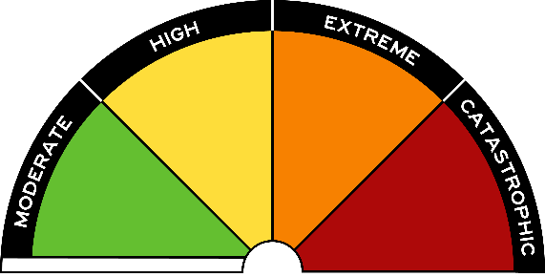
Overview
Curriculum levels: 1 and 2
Time: 50 minutes (approximately)
Links to the Victorian Curriculum F–10:
English, Level 2
Writing
Construct texts featuring print, visual and audio elements using software, including word processing programs (VCELY233)
Understand the use of vocabulary about familiar and new topics and experiment with and begin to make conscious choices of vocabulary to suit audience and purpose (VCELA237)
Science, Foundation to Level 2
Science Understanding
People use science in their daily lives (VCSSU041)
Science Inquiry Skills
Respond to and pose questions, and make predictions about familiar objects and events (VCSIS050)
Participate in guided investigations, including making observations using the senses, to explore and answer questions (VCSIS051)
Represent and communicate observations and ideas about changes in objects and events in a variety of ways (VCSIS055)
Learning intention:
Students will come to understand that although we need radiant heat, the heat that a fire gives off can be dangerous. Students will be aware that we do not have to be touched by the flames in order to be burnt or hurt by fire. The safety message of a person moving away from the heat source or putting something between themselves and the heat source will be made explicit.
Suggested resources:
- Student workbooks or paper
- Pens, pencils or markers
- Poster paper
- Materials for recording student responses, e.g. workbooks and markers, tablets, recording devices, including notes pertaining to previous sessions
- Online resources such as the images and linked resources listed in the Resources section of the VCAA Bushfire Education webpages

Other resources for experiments:
Depending on the activity selected, you may need some of the following items:
- a block of chocolate or two cups of water in dark-coloured cups
- thermometers
- an electric radiator heater
- digital or video cameras, so students can photograph or film the different stages of the experiment – these images or video clips may be used for other activities too

Activities

Starting
The initial discussion should focus on the following question:
- How can an object catch fire even though the flames have not yet reached it?
Guide the discussion towards:
- students’ experiences of an open log fire, wood heater or campfire
- the heat they felt from these sources.
Introduce the concept of radiant heat and relate this to a bushfire.

Exploring
Select from or adapt the following activities and experiments as appropriate for your group to demonstrate radiant heat.

Radiant heat from the sun
Leave a block of chocolate on a windowsill that receives full sun. Record observations of what happens to it (i.e. it melts). Alternatively, you could fill a dark-coloured cup with water and leave it on the windowsill, and place another in the middle of the room. Use a thermometer to measure the initial temperature of the water in each cup. An hour later, measure the temperatures again and compare the results.
Discuss and ask:
- What could be done to stop the chocolate from melting or the water from getting hot?
- What are some ways we could modify this change? (e.g. by moving the item out of the sun, closing the curtains or blinds, or covering the item with some form of insulation)
Students could set up their own experiments based on the suggested solutions and record their observations, noting the effects of moving or covering an object, evaluating changes in heating or melting, or observing temperature changes.

Radiant heat from a heater
Place a radiator heater at the front of the room and, after some time, ask if students notice the warmth. Students closer to the heater should feel the warmth faster and more intensely than those further away.
Discuss and ask:
- How did the heat travel to the various areas of the room?
- Why did warmth vary for different students?
Students could set up thermometers on several chairs at different distances from the radiator and record the temperature variation over a period of time, such as 10 or 15 minutes.

Radiant heat scenarios to explore
Present a scenario and have students discuss and/or write a solution based on their knowledge of radiant heat.
For example: ‘On a hot day, John is sitting on the sunny side of a room, next to the window. John is getting hot. What should he do?’ Possible answers include moving away from the window or closing the curtains or blinds.

Identifying radiant heat in images
Ask students to identify the sources of radiant energy in images of a radiator, the sun, people sitting outside on a sunny day, and a gas heater (see the Resources section of the VCAA Bushfire Education webpages to obtain images).
Discuss and ask:
- Do certain people or things need protection from the heat?
Example responses:
- If clothes were too near a radiator, the solution would be to move the clothes away.
- If people were outside in the hot weather, they could protect themselves from sunburn by moving into the shade.

Bringing it together

Create a labelled diagram/visual display
Have students draw and write a diagram or poster to demonstrate ‘What is radiant heat?’, including examples of safe and dangerous radiant heat. Students should make reference to radiant heat in bushfire situations.

Concluding discussion
Encourage students to share their ideas and responses.
Guide the discussion towards:
- an understanding that radiant heat problems can be resolved by putting something between you and the heat source, or by moving away from the heat source.

Bring the discussion back to bushfires by giving students the following prompts:
- Think about firefighters who experience lots of radiant heat when fighting fires.
- How do they protect themselves from this heat?
Possible answers could include wearing protective clothing and drinking lots of water.

Extending
Refer students to the section on radiant heat from the CFA resource Your guide to survival and complete the following activity.

Create a ‘How to be safe from radiant heat’ message
Using the knowledge from this session, and information provided on the linked resource, students create a poster/ brochure or other creative response outlining a safety message about keeping safe from radiant heat in a bushfire, including what steps can be taken to reduce the risks from radiant heat.

