Learning about bushfires

Lesson: Introducing the Fire Triangle

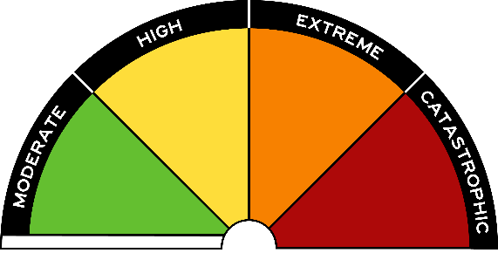
Overview
Curriculum levels: 1 and 2
Time: 50 minutes (approximately)
Links to the Victorian Curriculum F–10:
English, Level 2
Speaking and Listening
Understand the use of vocabulary about familiar and new topics and experiment with and begin to make conscious choices of vocabulary to suit audience and purpose (VCELA237)
Rehearse and deliver short presentations on familiar and new topics, speaking clearly and varying tone, volume and pace appropriately, and using supportive props (VCELY245)
Health and Physical Education, Levels 1 and 2
Personal, Social and Community Health
Recognise situations and opportunities to promote their own health, safety and wellbeing (VCHPEP074)
Science, Foundation to Level 2
Science Understanding
People use science in their daily lives (VCSSU041)
Science Inquiry Skills
Respond to and pose questions, and make predictions about familiar objects and events (VCSIS050)
Learning intention:
In this lesson students come to appreciate the elements a fire needs to start and continue burning. The model of the Fire Triangle is introduced, as well as key language such as ‘fuel’, ‘heat’ and ‘oxygen’.
Suggested resources:
- Student workbooks or paper
- Pens, pencils or markers
- Discussion notes of key words and themes from discussions
- Access to ICT tools
- Student workbooks or paper
- Work produced by students
- Online resources such as the images and linked resources listed in the Resources section of the VCAA Bushfire Education webpages

Resources for optional demonstration:
- Set of blocks in the shape of a triangle (or three blocks to lean together in the shape of a pyramid)

Activities

Starting
Engage students in a discussion or think-pair-share strategy to draw out students’ prior knowledge.
Initial discussion focus:
- What are some common elements of a fire?
- How does a bushfire start and stop?
Show and discuss a photo of a campfire or small burn-off.
Ask the following questions:
- Why is the fire burning? Will it keep burning? Why?
- What if it starts raining?
- What if someone throws dirt on the fire?
- How will different environmental elements affect the fire?
Introduce the Fire Triangle and display the image provided from the Resources section on the VCAA Bushfire Education webpages.
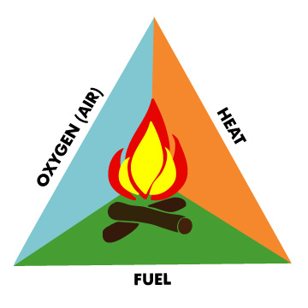
Explain that the Fire Triangle has three essential components (the following background information is provided for the educator):
- Fuel – Fuel is any kind of combustible material, and is characterised by its moisture content (how wet the fuel is), size and shape, quantity, and the arrangement in which it is spread over the landscape. The moisture content determines how easily the fuel will burn.
- Heat – A heat source is responsible for the initial ignition of fire. Heat is also needed to maintain the fire and enable it to spread. Heat allows fire to spread by removing the moisture from nearby fuel, warming surrounding air, and preheating the fuel in its path, enabling it to travel more easily.
- Oxygen in the air – Air contains about 21 per cent oxygen, and most fires require at least 16 per cent oxygen content to burn. Oxygen supports the chemical processes that occur during a wildland fire. When fuel burns, it reacts with oxygen from the surrounding air, releasing heat and generating combustion products (i.e. gases, smoke, embers). This process is known as oxidation.
Review the characteristics of each key word: fuel, heat, oxygen.
As this model demonstrates, if one element is missing, the fire will go out.
Guide the discussion towards:
- Who or what keeps a fire safe?
Key ideas:
- Make sure that a fire is always attended by an adult.
- Clear an area of at least 3 metres around the fire.
- Have plenty of water nearby.
- Why are these actions important to safety and preventing bushfires?
Refer back to the campfire and burn-off images to help link these good fires to the Fire Triangle.

Exploring
Introduce the terms ‘heat’, ‘flame’, ‘smoke’, ‘wind’.
Help students to develop definitions for these terms.
Ask students to think about how these elements relate to the Fire Triangle:
- Are there any other elements that could also affect the Fire Triangle?
- Why is knowing about the Fire Triangle important? (e.g. being able to make a campfire or light a barbecue)
Remind students about helpful fires, such as barbecues and campfires. Ask:
- What is the effect of sparks and embers (small pieces of burning leaves, twigs and bark) being blown away from the fire by the wind?
Make explicit:
- Everyone has a responsibility to help prevent bushfires by being careful with fires in the outdoors.
- Information about the danger of fire (i.e. knowing how to prevent them) helps everyone stay safe.

Optional demonstration
Using a set of blocks in the shape of a triangle, or three blocks leaned together in the shape of a pyramid, conduct a demonstration to show each of the three aspects of the Fire Triangle. Label the blocks ‘air’, ‘heat’ and ‘fuel’.
Students can record on a chart ‘Predictions’, ‘What happened’ and ‘Explanation’.
Teacher to demonstrate:
- Take away the block with ‘air’ on it. Why did the pretend fire go out? (We removed the air.)
- Take away the block with ‘heat’ on it. Why did the pretend fire go out? (We cooled the fuel down.)
- Take away the block with ‘fuel’ on it. Why did the pretend fire go out? (We cut off the fuel supply.)
Discuss how the Fire Triangle can help us understand bushfires.

Bringing it together

Students’ messages and signs
Give students an opportunity to create, discuss and display their own messages and signs about the Fire Triangle.
This may be done as voice recording, on posters, in workbooks, as a sign or using appropriate ICT programs, such as generating a slide show.

Extending

Presenting students’ messages and signs
Provide an audience for students to formally plan and then present their message about the elements of the Fire Triangle.

