Learning about bushfires

Lesson: Lessons from the past: Three major Victorian bushfires

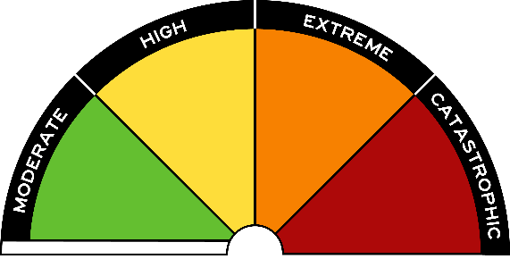
Overview
Curriculum levels: 7 and 8
Time: 50 minutes (approximately)
Links to the Victorian Curriculum F–10:
Geography, Years 7 and 8
Geographical Concepts and Skills
Explain processes that influence the characteristics of places (VCGGC099)
Collect and record relevant geographical data and information from useful primary and secondary sources, using ethical protocols (VCGGC102)
Geographical Knowledge
Causes of a geomorphological hazard and its impacts on places and human responses to it to minimise harmful effects on places in the future (VCGGK121)
Learning intention:
Students will develop an understanding of the nature of bushfires in relation to three significant fires in Australia’s history.
Suggested resource:
- CFA: ‘Lessons from the Past: Three Major Victorian Bushfires’

Activities

Starting
Show students the CFA video ‘Lessons from the Past: Three Major Victorian Bushfires’.
Discuss students’ initial responses to the video, including the similarities and differences between the three fire events, and the losses from each of the fires.

Exploring
If necessary, show students the video again. Working in pairs or in small groups, have students complete the following table.
 | 1939 | 1983 | 2009
Date of the fire
Weather conditions preceding the fire
Weather conditions on the day of the fire
Topography (the terrain)
Losses from the fire
Lessons learnt
Have students refer back to the three elements of the Fire Triangle:
- heat
- oxygen
- fuel.
Give examples of how each of these elements occurred in relation to these fires (e.g. oxygen – strong winds).
Ask: How were each of these fires eventually controlled?

Bringing it together
Discuss the responses to the table and the questions above.
What conclusions can be drawn about:
- the most dangerous season for bushfires
- the weather conditions leading up to fire season
- the weather conditions on the day that fires ignite
- the location and topography of bushfires?

Highlight the fact that we have a history of bushfires in Australia, and that we must expect that pattern to continue. Thefore, we must learn to live with them and be prepared.

Extending
Use the historical data from Forest Fire Management Victoria.
Have each student find, read and note information to contribute to a class spreadsheet under the following column headings:
- Date/Name of fire
- Location
- Number of hectares burnt
- Loss of property
- Loss of life
- Suspected cause
As a class, discuss:
- the part(s) of Victoria affected by bushfire
- the effects of fire
- reasons why fires occur.
Students then write a report titled ‘Bushfire danger in Victoria – Lessons from the Past’ based on the information gathered in this session.

