Learning about bushfires

Lesson: Living with bushfires: Marysville, 2009

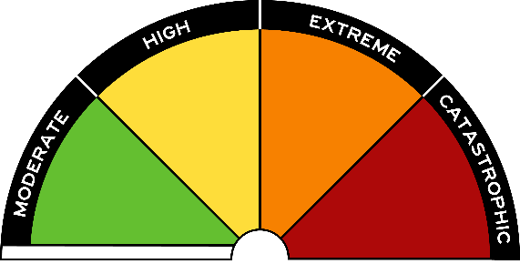
Overview
Curriculum levels: 7 and 8
Time: 50 minutes (approximately) × 2
Links to the Victorian Curriculum F–10:
Geography, Levels 7 and 8
Geographical Concepts and Skills
Collect and record relevant geographical data and information from useful primary and secondary sources, using ethical protocols (VCGGC102)
Geographical Knowledge
Causes of a geomorphological hazard and its impacts on places and human responses to it to minimise harmful effects on places in the future (VCGGK121)
Personal and Social Capability, Levels 7 and 8
Self-Awareness and Management
Describe how and why emotional responses may change in different contexts (VCPSCSE034)
Learning intention:
In this lesson students learn that bushfires are a fact of life in Victoria and across Australia. Students explore the Victorian ‘Black Saturday’ 2009 bushfires as an introduction to learning about bushfires.
Suggested resources:
- Online and linked resources in this lesson and listed in the Resources

Activities

Starting
Introduce the 2009 Black Saturday bushfires. Explain that the 2009 bushfires in Victoria were the most devastating in our history. Marysville was one of dozens of townships and communities engulfed by the disaster. Most of the town was destroyed, and many lives were lost.
As a class, watch the following YouTube videos, which were produced at the time of the Black Saturday bushfires and the 10-year anniversary in 2019.
- Marysville Fires – Australia
- Returning to Marysville, 10 years after Black Saturday, 7.30, ABC News
Have students discuss their responses to the videos, the effect of the images of the fire, and the responses of the people of Marysville, both at the time and 10 years later.

Exploring
Working in pairs or in small groups, have students investigate the following aspects of the 2009 Black Saturday bushfires:
- the locations of the 2009 bushfires on a map of Victoria
- the exceptional features of these fires compared with previous bushfires
- the nature and extent of the bushfires
- how well prepared people were for these bushfires
- how people recovered from these bushfires
- what policies and approaches to bushfire management were questioned as a result of these fires.
The following resources may be helpful for the teacher:
- About Black Saturday, Country Fire Authority
- Past bushfires, Forest Fire Management Victoria
- What has Australia learned from Black Saturday? SBS News
- Black Saturday bushfires, National Museum of Australia
- Bushfire – Black Saturday, Australian Institute for Disaster Resilience

Bringing it together
Have student pairs or groups present their findings to the class.
Hold a general class discussion on students’ reactions to the video extracts and to bushfires in general.

Extending
Students could:
- write a newspaper article on one aspect of the 2009 bushfires, using the information from the videos and the class reports
- present a visual display of images from Black Saturday to highlight the impact of bushfires on communities.

