Learning about bushfires

Lesson: The Fire Triangle and exploring what a fire needs to burn

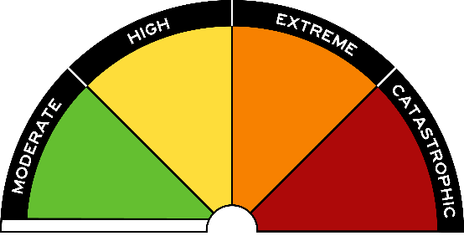
Overview
Curriculum levels: 5 and 6
Time: 50 minutes (approximately)
Links to the Victorian Curriculum F–10:
Science, Levels 5 and 6
Science Understanding
Changes to materials can be reversible, including melting, freezing, evaporating, or irreversible, including burning and rusting (VCSSU077)
Science Inquiry Skills
With guidance, pose questions to clarify practical problems or inform a scientific investigation, and predict what the findings of an investigation might be based on previous experiences or general rules (VCSIS082)
Construct and use a range of representations, including tables and graphs, to record, represent and describe observations, patterns or relationships in data (VCSIS085)
Learning intention:
In this lesson students find out how fire burns (oxygen, fuel and heat) and how it can be put out, by gaining an understanding of the Fire Triangle model.
Suggested resources:
- Student workbooks or paper
- Pens, pencils or markers
- Whiteboard, IWB or poster paper, and appropriate markers
- Materials as selected for recording student responses, e.g. workbooks and markers, tablets, recording devices
- Paper
- Matches or lighter
- Fireproof tray
- Bucket of water
- Online resources such as the images and linked resources listed in the Resources section of the VCAA Bushfire Education webpages

Activities

Starting
Conduct a class brainstorm:
- What does a fire need to start?
Explore the following key ideas about fire:
- something that burns
- dry flammable material
- sparks, or a match
- air and flames
- not to be left unattended.
Record ideas and key areas discussed on a whiteboard, IWB or poster paper to be referred back to throughout this and subsequent lessons.

Exploring

Teacher-led demonstration: Making and putting out fire
Ensuring that students are a safe distance away, light a piece of paper with a match/lighter over a fireproof tray in a well-ventilated area. Ensure you have a bucket of water handy. Watch the paper ignite and burn on the tray. Finally, the paper will smoulder into ashes and the flame will extinguish itself.
Working in groups, have students discuss the following focus questions and record their responses using a recording device, computer, tablet or paper and pen.
Focus questions:
- How was the fire started?
- What happened when the match was removed?
- Why did the paper keep burning?
- In which direction did the flame move across the paper?
- Would the flame have moved differently across the paper if the breeze had been blowing in a different direction?
- What happened when there was no paper left to burn?
- What does fire need to burn?
Further demonstrate what happens in other scenarios by varying the conditions as follows:
- Part of the paper is wet.
- An overturned glass is placed over the flame as the paper is burning.
- Water is sprayed over the burning paper.
In each scenario, have students predict what will happen, and then refer to their observations to explain what happened.
Have students write descriptions, take photos or draw ‘before and after’ pictures to explain:
- What happened to the paper?
- What does a fire need to start?
- How did the paper change?

Bringing it together
Introduce the Fire Triangle (for a copy of the Fire Triangle image, see ‘Images’ in the Resources section of the VCAA Bushfire Education webpages). The Fire Triangle has three essential components:
- fuel
- heat
- oxygen in the air
Explain the relationship between each of these three components. Relate your explanation to the teacher-led demonstration. Students can update their ‘before and after’ observations and add the correct terminology to reference them to the Fire Triangle.
Relate what students have discovered about fire to a bushfire, and ask questions such as:
- What are the potential fuels in a bushfire?
- How can those fuels ignite?
- What do firefighters do to control and extinguish a bushfire?
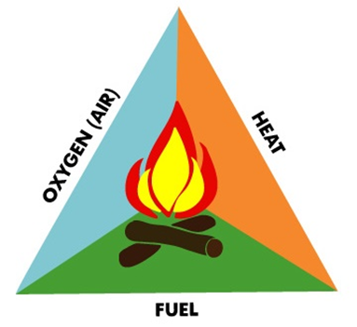

Concluding discussion
Encourage students to share their ideas and responses. Revise and add to the initial brainstorm list to describe what a fire needs to start.
Make explicit:
- Paper is a fine fuel that easily burns. When the paper is burnt, there is no fuel left, so the fire goes out (is extinguished).
- Paper changes to ash through a chemical reaction.
- When paper is wet, more heat is required to ignite the paper; a match cannot produce sufficient heat.
- When water is sprayed on burning paper, heat is removed and the fire is extinguished.
- When a glass is placed over the flame, the oxygen is completely consumed and the flame is extinguished.

Extending
Have students look into fine fuels vs larger fuels, and why things burn differently.

