Learning about bushfires

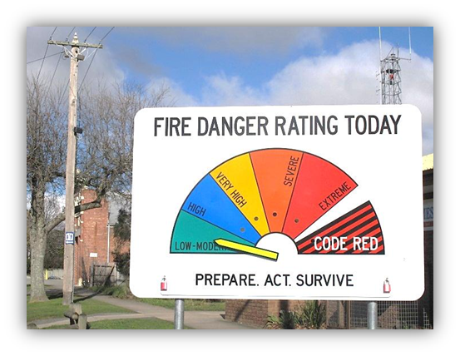
Lesson: Types of fires – good and bad

Overview
Curriculum levels: 1 and 2
Time: 50 minutes (approximately)
Links to the Victorian Curriculum F–10:
English, Level 2
Reading and Viewing
Discuss different texts on a similar topic, identifying similarities and differences between the texts (VCELY220)
Use comprehension strategies to build literal and inferred meaning and begin to analyse texts by drawing on growing knowledge of context, language and visual features and print and multimodal text structures (VCELY222)
Speaking and Listening
Understand the use of vocabulary about familiar and new topics and experiment with and begin to make conscious choices of vocabulary to suit audience and purpose (VCELA237)
Health and Physical Education, Levels 1 and 2
Personal, Social and Community Health
Recognise situations and opportunities to promote their own health, safety and wellbeing (VCHPEP074)
Learning intention:
In the initial session, students will be asked to reflect on their prior knowledge and experiences of fire. The exploration and tasks are intended to help students understand that some fires are helpful and others cause problems. Students will practise and use language related to fires and bushfires.
Suggested resources:
- Whiteboard, IWB or poster paper, and appropriate markers
- Student workbooks or paper
- Pens, pencils or markers
- Discussion notes of key words and themes from discussions
- Access to ICT tools
- Online resources such as the images and linked resources listed in the Resources section of the VCAA Bushfire Education webpages

Activities

Starting
Hold a class discussion to explore students’ prior knowledge.
Discussion focus:
- What do students know about fire?
Introduce related terms, such as ‘flames’, ‘heat’, ‘light’ and ‘burns’, and ask:
- What are the characteristics of fire?
- What does a fire do?
- Why is fire dangerous?
- What is fire safety?
Discuss a range of ideas to develop language and further thinking.
Guide the discussion towards different types of fires (e.g. home fires, campfires). Ask:
- How are they the same? How are they different?
- Are some good (or helpful)?
- Are some bad (or dangerous)?
- Why or why not?
Record some of the key areas discussed on a whiteboard, IWB or poster paper to be referred back to throughout this and subsequent sessions.

Exploring
Lead a discussion using images labelled ‘Helpful fire’ from the Resources section of the VCAA Bushfire Education webpages (e.g. images showing helpful fires, such as a gas stove, barbecue or campfire to cook food) and ask:
- How do these fires help us?
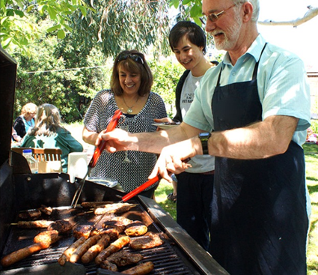
Invite students to suggest other examples of helpful fires and share their experiences with these types of fires.
Make explicit:
- Heat from fire lets us do many things, such as getting warm and cooking. Emphasise that these kinds of fires are under control, with adults looking after them.
Introduce the idea of fire safety and ask:
- Are all fires good or helpful?
- Why do we need to be careful around fire?
Introduce the terms ‘danger’ and ‘dangerous’ and ask:
- When might a helpful or good fire become a bad fire?
- What might a bad fire do?
- What are some examples of bad fires?
Be sure bushfires are mentioned, and that all students understand the term ‘the bush’.
Continue to record the key areas discussed on a whiteboard, IWB or poster paper to be referred back to throughout this and subsequent sessions.

Bringing it together
Drawing on ideas from the above discussion (and utilising the same images), have students work on the following activities according to their capabilities (to be determined by the teacher).

Fire role-play
Working in pairs or groups, students pretend they are a good fire and a bad fire, and use movement and sound to highlight the differences. This activity can set the context for discussing what we do when bad fires occur. This discussion should focus on being safe and staying away from the fire.

Guessing game: ‘Which photo is it?’
Revisit the images from the previous session and give clues to help students guess which photo you are thinking of. When students have guessed the type of fire correctly, they should describe that fire, stating whether it is good or bad and giving reasons for this. This game can also be played with partners taking turns to give the clues.

Guessing game: ‘What fire am I?’
Use an example of fire that the students have discussed (e.g. a barbecue), and give the students clues (words and actions) to help them guess what kind of fire it is.

Fire experiences
Working in pairs, students share any experiences they have had that relate to fire. Examples may include fire drills, seeing a fire station and firefighters, seeing fire trucks and hearing their sirens, seeing images of bushfires in the news, or seeing helpful fires, such as a campfire or barbecue.

Descriptive language brainstorm
Working in pairs or small groups, have students brainstorm descriptive language about good fires and bad fires. They could create a chart to record the terms under different column headings, such as ‘How fire sounds’, ‘How the fire behaves’ and ‘How we feel’.

Concluding discussion
Bring the discussion back to bushfires and ask:
- What makes bushfires bad or dangerous fires?
Make explicit:
- When there is a bushfire, people need to be safe and get help.
Encourage students to think and talk about the differences between a house fire or other building fire (i.e. the fire danger is inside) and a bushfire (i.e. the fire danger comes from outside).

Extending
Drawing on ideas from the previous discussion and tasks, students could begin creating one of the following, either individually or together:
- a mind map about bushfires and bushfire safety
- a classroom word wall
- a bushfire glossary.
These may be created on a wiki page or using other interactive digital tools.
If possible, have students return to these tasks progressively throughout the teaching and learning activities, encouraging students to revise or add to their initial ideas.

