Learning about bushfires

Lesson: Understanding bushfire behaviour and the Fire Danger Rating system

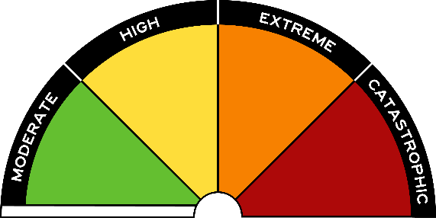
Overview
Curriculum levels: 7 and 8
Time: 50 minutes (approximately) × 2
Links to the Victorian Curriculum F–10:
Geography, Levels 7 and 8
Geographical Concepts and Skills
Identify, analyse and explain interconnections within places and between places and identify and explain changes resulting from these interconnections (VCGGC101)
Collect and record relevant geographical data and information from useful primary and secondary sources, using ethical protocols (VCGGC102)
Geographical Knowledge
Causes of an atmospheric or hydrological hazard and its impacts on places, and human responses to it to minimise harmful effects on places in the future (VCGGK110)
Different types of landscapes and their distinctive landform features (VCGGK116)
Causes of a geomorphological hazard and its impacts on places and human responses to it to minimise harmful effects on places in the future (VCGGK121)
Learning intention:
The conditions that influence bushfire behaviour are major determinants of the Fire Danger Rating system. The Fire Danger Ratings predict how a fire would behave if one started, including how difficult it would be to put out. The higher the rating, the more dangerous the conditions. The rating is your trigger to act, so to stay safe you need to stay aware of the Fire Danger Rating in your district.
Suggested resources:
- Online resources such as those listed below

Activities

Starting
Explain to students that they will be exploring the behaviour of bushfires using the example of the causes and progress of the Black Saturday bushfires. As a result of Black Saturday, bushfire warnings and advice have been revised.
Provide students with a copy of the bushfire ratings. As a class, view parts 1 and 2 of the BBC documentary ‘Australia Firestorm: BBC My Country Documentary’ (around 10 minutes each).
Students will look at the causes and spread of bushfires. Allocate one or two of the following causes of bushfires to each student, and have them take notes from the video on their topic(s).
- climate – drought
- temperatures
- humidity
- wind and wind changes
- topography and vegetation, including grasslands
- types of fires – grassfires, spot fires, fires in eucalypt forests
Have students discuss and report back on their findings.

Exploring
Working in pairs or in small groups, have students research one of the following focus questions using resources from the list below, as well as other online or print resources. Students should provide data and evidence in their responses to the following focus questions, and include illustrations where appropriate (e.g. types of terrain/fuel). Choose from the following topics and focus questions:
- Ignition of bushfires
Focus question: What are the main causes of bushfire ignition?
- Climate and seasons
Focus question: What climate conditions precede bushfires?
- Weather and seasons
Focus question: Which common weather elements contribute to increased fire danger?
- Topography
Focus question: How does terrain affect the movement of bushfires?
- Fuel (vegetation)
Focus question: How do the amount and types of fuel influence the bushfire starting and spreading?

Key resources
- Australian Bureau of Statistics: Causes of bushfires
- Geoscience Australia: Bushfire
- Forest Fire Management Victoria: Past bushfires
- Australian Academy of Science: Understanding bushfires
- ABC News: ‘Most bushfires in south-eastern Australia caused by humans’
- Bureau of Meteorology
- Sentinel Hotspots
- CFA: Am I at risk?

Bringing it together
Students share their research and responses to the focus questions with the whole class.
Provide each team with the Fire Danger Rating information sheet from the CFA Fire Ready Kit. As part of a class discussion, students use this information and the ideas developed in their research to describe how the factors that influence bushfire behaviour relate to the fire danger rating.
Students create a mock weather report for a ‘special edition’ bushfire report. They should relate the conditions that have changed over a week to the fire danger rating. Students are encouraged to bring together elements of their expert groups in this ‘special edition’ bushfire report.

