Learning about bushfires

Lesson: Understanding the Fire Danger Rating system

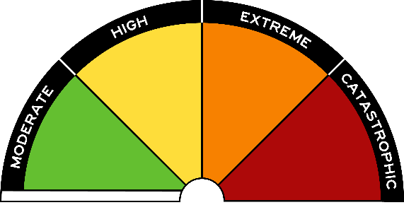
Overview
Curriculum levels: 1 and 2
Time: 50 minutes (approximately)
Links to the Victorian Curriculum F–10:
English, Level 2
Reading and Viewing
Understand that different types of texts have identifiable text structures and language features that help the text serve its purpose (VCELA212)
Speaking and Listening
Understand the use of vocabulary about familiar and new topics and experiment with and begin to make conscious choices of vocabulary to suit audience and purpose (VCELA237)
Health and Physical Education, Levels 1 and 2
Personal, Social and Community Health
Recognise situations and opportunities to promote their own health, safety and wellbeing (VCHPEP074)
Learning intention:
Students are encouraged to use their knowledge of how fires start (the Fire Triangle) to understand that there are many causes of bushfires. They will then explore the factors and conditions related to the Fire Danger Rating system used in Victoria, and learn that this is a safety system for alerting people to potential bushfire dangers.
Suggested resources:
- Student workbooks or paper
- Pens, pencils or markers
- Poster paper
- Materials as selected for recording student responses, e.g. workbooks and markers, tablets, recording devices, including notes pertaining to previous sessions
- Online resources such as the images and linked resources listed in the Resources section of the VCAA Bushfire Education webpages

Activities

Starting
Introduce the Fire Danger Rating system and explain that this is one way the CFA informs the community of bushfire danger.
Together, read through the information at About Fire Danger Ratings.
Conduct a brief discussion, encouraging students to share their ideas and responses about how this system is helpful. Who do they think needs to use it?

Bringing it together

Exploring each section of the Fire Danger Rating
Divide students into six groups and have each group explore and discuss one of the sections of the Fire Danger Rating system. Provide each group with the CFA’s Fire Danger Rating brochure.
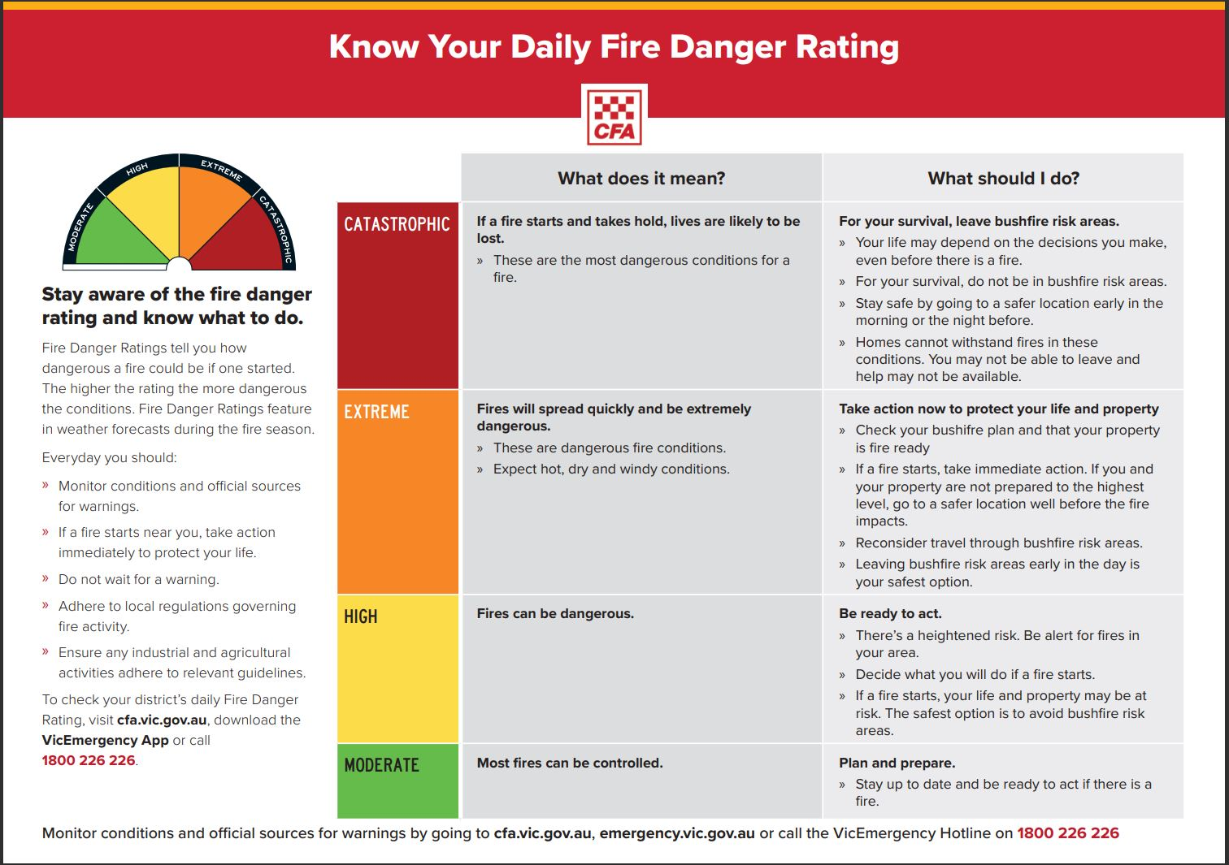
On poster paper, draw and cut out a large blank template for each of the six sections of the semi-circular Fire Danger Rating scale. Allocate one rating to each group, and provide them with the template for their rating section. These templates will then be assembled to form the semi-circular shape of the Fire Danger Rating scale.
Each group needs to record the appropriate heading and colour coding on their segment. They then populate the rest of the segment with the main aspects related to that particular danger rating. This may be words, sentences, images and safety reminders.
Each group will share and present their section to the class, then the six completed sections will be assembled to form the students’ own representation of the Fire Danger Rating scale.

Extending

Weather and Fire Danger Rating report
Students make up a weather report and link it to the appropriate Fire Danger Rating. They should describe the relevant conditions and how they affect the chance of a bushfire occurring.

Word wall
Have students brainstorm major concepts such as fire season, wind speed and direction, slope of the land, drought, humidity, fire fuel, fire speed and embers. Then, working in small groups or individually, students need to define, explore and explain particular terms with attention to how they relate to bushfires. Display the completed word exploration as a word wall to demonstrate and reinforce the key terms of this area of study.

Find out about your local Fire Danger Rating
Use the online resources below to help students read and investigate:
- how people find out about bushfires
- who to contact to find out about current fire weather warnings
- Fire Danger Ratings
- fire incidents
- fire restrictions
- total fire bans in the region.
Online resources:
- Bureau of Meteorology Bushfire Weather
- Bureau of Meteorology Fire Weather Services
- CFA About Fire Danger Ratings
- CFA Find Your Fire District
