Preparing for bushfires

Lesson: Preparing for the bushfire season

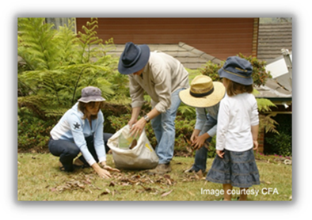
Overview
Curriculum levels: 5 and 6
Time: 50 minutes (approximately)
Links to the Victorian Curriculum F–10:
Geography, Levels 5 and 6
Geographical Concepts and Skills
Describe and explain interconnections within places and between places, and the effects of these interconnections (VCGGC087)
Geographical Knowledge
Impacts of bushfires or floods on environments and communities, and how people can respond (VCGGK095)
Science, Levels 5 and 6
Scientific Understanding
Scientific understandings, discoveries and inventions are used to inform personal and community decisions and to solve problems that directly affect people’s lives (VCSSU073)
Science Inquiry Skills
Communicate ideas and processes using evidence to develop explanations of events and phenomena and to identify simple cause-and-effect relationships (VCSIS088)
Learning intention:
Students explore safety measures related to their personal safety, as well as what families should do to prepare for the bushfire season.
Suggested resources:
- Materials as selected for recording student responses, e.g. workbooks and markers, tablets, recording devices
- Online resources such as the images and linked resources listed in the Resources section of the VCAA Bushfire Education webpages

Activities

Starting
Guide students to think about and discuss the following questions:
- How would a family in a high fire-risk area prepare to be safe in a bushfire/grassfire/scrub fire?
- How can each member of their family contribute to the preparation? What are suitable tasks for each family member?
Introduce the idea that there are two kinds of planning and preparation:
- Making sure that the house and property are as safe as possible
- Making plans to leave early on high fire-risk days
Discuss and explore each of these points separately, and have students record some of the key ideas discussed.

Exploring
Provide students with a copy of CFA’s ‘Preparing your property’ within the Fire Ready Kit, or via the CFA’s ‘How to Prepare Your property’ webpage.
Read and discuss the key preparation activities to undertake before bushfire season.
- As a class or individually, use the resources to generate a list of actions needed to be prepared for the summer season. Discuss the fire danger period, and how this relates to preparation.

Bringing it together
Create a timetable for fire danger period preparation tasks:
- Using the list of actions generated, students organise these actions into categories and develop a preparation timetable to be used leading up to a bushfire period. Next, students will organise these actions into a checklist, which they can then take home to share with their families.

Extending

Photo story about fire dangers in your area
Working in pairs, students produce a photo story that describes the fire danger risks in the area where they live. They should use photographs and text to describe their ideas, and incorporate terms such as ‘weather’, ‘vegetation’ and ‘flammable materials’ in their stories.

Actions to prepare
Working in pairs or in small groups, students explore the actions required to reduce bushfire risk and improve bushfire safety as a way of minimising available fuel around the home.

The Fire Triangle and safety
Working in pairs or in small groups, have students determine whether the following actions:
- affect the amount of fuel available
- affect the amount of oxygen available
- affect the amount of heat required.
Actions:
- Move the woodpile, which has been on the verandah since winter, away from the house.
- Trim plants and trees before bushfire season begins.
- Seal gaps in the roof so embers cannot get into the space below the roof.
- Remove leaves and twigs from gutters.
- Purchase a fire blanket in case a person’s clothes catch fire.

