Recovering from bushfires

Lesson: Coming to terms with feelings after a bushfire

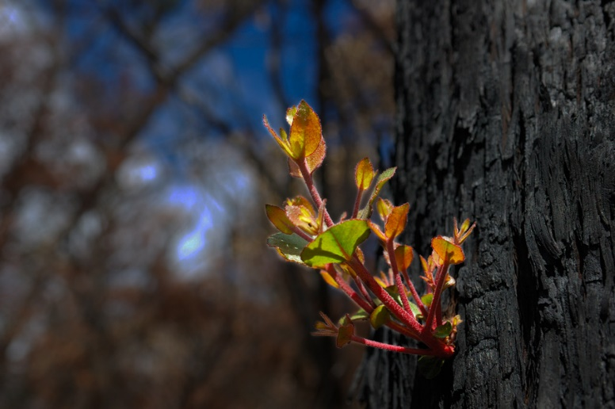
Overview
Curriculum levels: 5 and 6
Time: 50 minutes (approximately)
Links to the Victorian Curriculum F–10:
Personal and Social Capability, Levels 5 and 6
Self-Awareness and Management
Explore the links between their emotions and their behaviour (VCPSCSE025)
Describe what it means to be confident, adaptable and persistent and why these attributes are important in dealing with new or challenging situations (VCPSCSE027)
English, Level 5
Writing
Plan, draft and publish imaginative, informative and persuasive print and multimodal texts, choosing text structures, language features, images and sound appropriate to purpose and audience (VCELY329)
Visual Arts, Levels 5 and 6
Explore and Express Ideas
Explore visual arts practices as inspiration to create artworks that express different ideas and beliefs (VCAVAE029)
Visual Arts Practices
Select and apply visual conventions, materials, techniques, technologies and processes specific to different art forms when making artworks (VCAVAV030)
Learning intention:
Students will be prompted to consider the importance of thinking and talking about the feelings experienced by people who have experienced bushfires. They will explore some of the strategies people have used to cope and come to terms with their feelings after a traumatic bushfire event.
Suggested resources:
- Whiteboard, IWB or poster paper, and appropriate markers
- Materials as selected for recording student responses, e.g. workbooks and markers, tablets, recording devices
- Student workbooks or paper
- Pens, pencils or markers
- Online resources such as the images and linked resources listed in the Resources section of the VCAA Bushfire Education webpages

Activities

Starting
Read the following extract to the class. This is about a teacher’s experience in the tiny town of Cockatoo in the Dandenong Ranges, which was devastated by the 1983 Ash Wednesday fires.
Early in the morning after the fire, there was a very brief and very light shower of rain – little more than a few spots. But the result was a beautiful rainbow which stretched over the blackened town.
Cockatoo school was opened soon after the fire. It was something for the children to do, something to occupy their minds. Like their elders, they couldn’t concentrate for long.
They suffered alternating moods of vivacity and quiet introspection. For days they drew and drew − bushfire, bushfire, getting it all out of their minds and emotions.
Then teacher Val McLeod said to them, ‘Look, let’s all forget the fire for a while. Let’s just be happy. Let’s draw something bright and happy. Everybody draw something bright and happy’.
She moved between the rows of children to see what they were drawing. She smiled at the first few and nodded. But the smile faded. A feeling of awe grew, and a little shiver of the uncanny.
Independent of each other’s promptings, each other’s example, each child had drawn a symbol of the bright and the happy.
Each had drawn Cockatoo’s rainbow, spanning the night sky at the end of Ash Wednesday.
(extract from Cockatoo Ash Wednesday 1983: The People’s Story by Edward Mundie, Hyland House, Melbourne 1983)
Ask students to share responses to the following questions:
- What does the extract suggest the children were feeling?
- What might they have needed to recover from their experience of the fire?
Explain that the fire was a traumatic event for the students of Cockatoo.
Work with students to develop a working definition of ‘traumatic’ as being serious physical or psychological/emotional shock and stress.
Make explicit:
- There are degrees of trauma.
- We have all experienced stress to some degree in our lives.
Elicit some examples of trauma and stress from the class. For example:
- a bad accident or illness
- the loss of a pet
- the first day at a new school
- having to perform in front of a crowd
- having to shift house or relocate to another town.
Please note: All educators need to be aware that there is potential for discomfort or distress among some students when talking, viewing and reading about bushfires. Teachers need to preview, adapt and manage the teaching and learning activities and resources with respect to the particular needs and backgrounds of their students. For more information and support, see the Department of Education and Training’s Mental health support after an emergency.
Ask students to consider:
- Why do you think the Cockatoo teacher got her students to do drawing after their bushfire experience?
- What other activities could have helped the Cockatoo children recover from their traumatic experience?

Exploring
Provide a selection of hard copies or electronic access to allow students to carefully view a range of artwork from Yarra Glen Primary School and the Healesville Primary School Collection at Museums Victoria.
Ask students to talk about and list:
- What feelings and attitudes do you think are being expressed in these paintings and drawings?
- What emotions are being expressed? How have the students shown their emotions through their artwork?
- How do you think the children who created the artwork might be feeling now, long after the bushfire?
- What would you say to the children?

Bringing it together
Have the students write (or record) a private, reflective piece of prose, a short story or a poem entitled ‘Coming to terms’.
The piece should explore students’ ideas, responses, experiences and insights arising from their thinking and feeling about recovery from bushfires, or a different kind of trauma that they have experienced. Students may share their writing with the rest of the class if they wish to.

Extending
Choose appropriate student extension activities from the following suggestions, which relate to all four stages of this bushfire education inquiry.
- Students create their own artwork relating to any ideas explored in the module, with props or ideas from picture books, photos and illustrations.
- Explore the DVDs, CDs and books listed related to fires.
- Work collaboratively to create a class display or gallery with students’ artwork and labels, captions or any other messages about bushfires and fire safety they wish to include.
- Contribute to creating a book or multimedia presentation about staying safe in bushfires (and/or keeping safe more broadly).
- Create a bushfire safety glossary.
- Create a bushfire safety brochure.
- Create and present stories about bushfire safety.
- Students finalise their wiki pages and other web-based projects, if begun in earlier modules, and share them with the school community. This may include a discussion page to invite comments and feedback from other classes.
- Students prepare a simple article for the school newsletter about their work on bushfire safety.
- Students brainstorm ways of applying what they have learnt in the module in order to make a difference, or ways to take their learning further. For example:
- cleaning up around the school
- forming links with other schools to exchange ideas about bushfire safety
- planning ways in which they and their school community could help in the event of a bushfire.
- Invite family members to the classroom to see what the students have learnt about bushfires.

